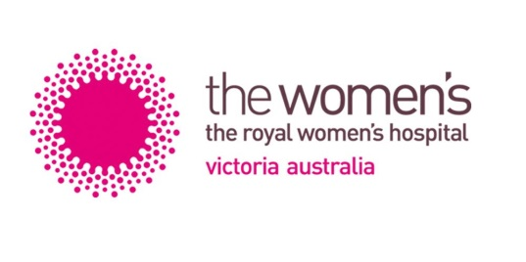

2021 THE ROYAL WOMEN’S HOSPITAL

GRADUATE NURSE PROGRAM PLACEMENT OPTIONS

Name:

There are three areas where graduate nurses are placed at the Women’s in our Graduate Nurse Program 2021:
- Neonates,
- Perioperative Services & Day Surgery Unit,
- Gynaecology and Women’s Cancer Services (5 North) and

The details of each area are listed below.

Graduate Nurse Positions in Theatre and Day Surgery Unit 0.9 EFT (4 days per week, 9 hour shifts) whilst Graduate Nurse Positions in Neonates, Emergency and Gynaecology and the Women’s Cancer services will be 0.8 EFT (4 days per week, 8 hour shifts). For those working at 0.8 there will be opportunities to pick up additional shifts in these areas as they become available.

The following are the placement options available in the Graduate Nurse Program at the Women’s Hospital for 2021. There are 12 month placements in each area as well as some combinations of 6 months in one area and 6 months in another area
Please rank your preferences below:
i.e. 1= most preferred area, 2= 2nd most preferred and 3 as 3rd most preferred area.
If you particularly do not wish to go to an area leave the space blank.

- Gynaecology and Women’s Cancer – 5 North (0.8 EFT)
A 24 bed gynaecological/oncology surgical ward. We care for women undertaking gynaecology and oncology surgical and medical procedures.

- Neonates (0.8 EFT)
Intensive Care Nursery (20 cots) provides respiratory support and other intensive treatments to very sick babies. Special Care Nursery (40 cots) provides high dependency care and convalescent care as a ‘step down’ service to Intensive Care.

- Perioperative Suites (0.9 EFT)/ Day Surgery Unit (0.9 EFT)
Graduates rotate through each of the following areas: Anaesthetics, Day Surgery Unit, Post- Acute Care Unit and Operating Suites (scrub & scout). Graduates will have exposure to many Women’s surgical procedures including Caesarean sections, breast surgery and hysterectomies.

Please also rank your preferences (1-3) re rotation structure below:
12 months placement in one area
6 months placement in one area & 6 months placement in another area
Either a 12 months placement in one area or a combination of 6 & 6 months placement.

