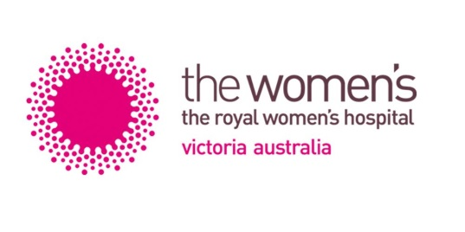

2024 ROYAL WOMEN’S HOSPITAL

GRADUATE NURSE PROGRAM PLACEMENT OPTIONS

Name:

There are three areas where graduate nurses are placed at The Women’s in their Graduate Nurse Program 2024:
- Neonates,
- Perioperative Services & Day Surgery Unit, and
- Gynaecology and Women’s Cancer Services (5 North)

The following are the placement options available within the Graduate Nurse Program at The Women’s Hospital for 2024. There are some 12 months placements in each area as well as combinations of 6 months in one area and 6 months in another area
Please rank your preferences below:
i.e. 1= most preferred area, 2= 2nd most preferred and 3 as 3rd most preferred area.
If you particularly do not wish to go to an area leave the space blank.

- Gynaecology and Women’s Cancer – 5 North (0.8 or 1.0 EFT)
A 24 bed gynaecological/oncology surgical ward. We care for women undertaking gynaecology and oncology surgical and medical procedures.

- Neonates (0.8 or 1.0 EFT)
Intensive Care Nursery (20 cots) provides respiratory support and other intensive treatments to very sick babies. Special Care Nursery (40 cots) provides high dependency care and convalescent care as a ‘step down’ service to Intensive Care.

- Perioperative Suites / Day Surgery Unit (0.9 or 1.0 EFT)
Graduates rotate through a range of the following areas: Anaesthetics, Day Surgery Unit, Post- Acute Care Unit and Operating Suites (scrub & scout). Graduates will have exposure to many Women’s surgical procedures including Caesarean sections, breast surgery and hysterectomies.

Please rank your preferences (1-3) regarding the rotation structure below:
- 12 months placement in one area
- 6 months placement in one area & 6 months placement in another area
- Either a 12 months placement in one area or a combination of 6 & 6 months placement.

