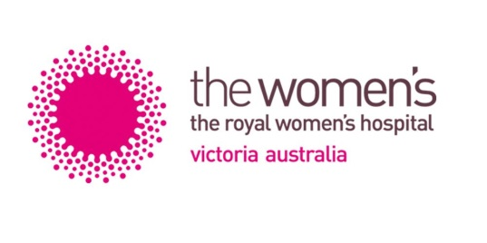

2025 THE ROYAL WOMEN’S HOSPITAL

GRADUATE NURSE PROGRAM PLACEMENT OPTIONS

Name:

There are three areas where graduate nurses are placed at The Women’s in their Graduate Nurse Program 2025:
- Neonates,
- Perioperative Services & Day Surgery Unit, and
- Gynaecology and Women’s Cancer Services (5 North)

The following are the placement options available within the Graduate Nurse Program at The Women’s Hospital for 2025. There are some 12 months placements in each area as well as combinations of 6 months in one area and 6 months in another area
Please rank your preferences below:
i.e. 1= most preferred area, 2= 2nd most preferred and 3 as 3rd most preferred area.
If you particularly do not wish to go to an area leave the space blank.

- Gynaecology and Women’s Cancer – 5 North (0.8 or 1.0 EFT)
A 22 bed gynaecological/oncology surgical ward. We care for women undertaking gynaecology, oncology, and breast surgical and medical procedures. Graduate will also have exposure to reproductive loss in early pregnancy and complications related to reproductive biology such as IVF.

- Neonates (0.8 or 1.0 EFT)
Intensive Care Nursery (20 cots) provides respiratory support and other intensive treatments to very sick babies. Special Care Nursery (40 cots) provides high dependency care and convalescent care as a ‘step down’ service to Intensive Care.

- Perioperative Suites / Day Surgery Unit (0.9 or 1.0 EFT)
Graduates will experience rotations in various Peri-operative areas, such as Scrub/Scout, Anaesthetics, Post-Anaesthetic Care and Day surgery.
Graduates will gain exposure to a variety of Women’s surgical procedures, including Caesarean section, IVF, breast, gynae, pelvic floor and laparoscopic surgeries.

Please rank your preferences (1-3) regarding the rotation structure below:
- 12 months placement in one area
- 6 months placement in one area & 6 months placement in another area
- Either a 12 months placement in one area or a combination of 6 & 6 months placement.

