Updated 6 June 2020

Family Violence Workplace Support Program Overview

Background

Family violence is a workplace issue that impacts upon staff personally, often affecting attendance at work, performance, productivity and workplace safety. As employers, it is important that we prioritise the safety and wellbeing of our staff who experience family violence. Not only does this priority arise from our role as an employer, as a health service provider we must support our staff personally so that they can support patients experiencing family violence.

The Family Violence Workplace Support program, outlined in this overview, was developed by the Royal Women’s Hospital in 2016 and is a key program within the Strengthening Hospital Responses to Family Violence (SHRFV) program. SHRFV uses a whole-of-hospital approach which recognises the importance of embedding gender equality and primary prevention across the entire hospital system. A whole-of-hospital approach incorporates challenging disrespect, sexism and discrimination, promoting and normalizing gender equality, and responding to victim survivors of violence.

A whole-of hospital-approach recognises that in order for change to be effective, the work needs to occur at a workplace culture level, at a practice level and a systems and policy level. It needs to be driven and resourced by leaders across the system, and initiatives should reach all staff and patients.

Since 2016 the Family Violence Workplace Support Program has focused primarily on health services developing and implementing policies and procedures to respond to victim survivors. The Gender Equality Act 2020 (Vic), which mandates Victorian hospitals to undertake gender equality auditing and actions, and which explicitly recognises that gender inequality drives family violence, provides an opportunity for health services to expand the primary prevention of family violence components of the Family Violence Workplace Support program and SHRFV.

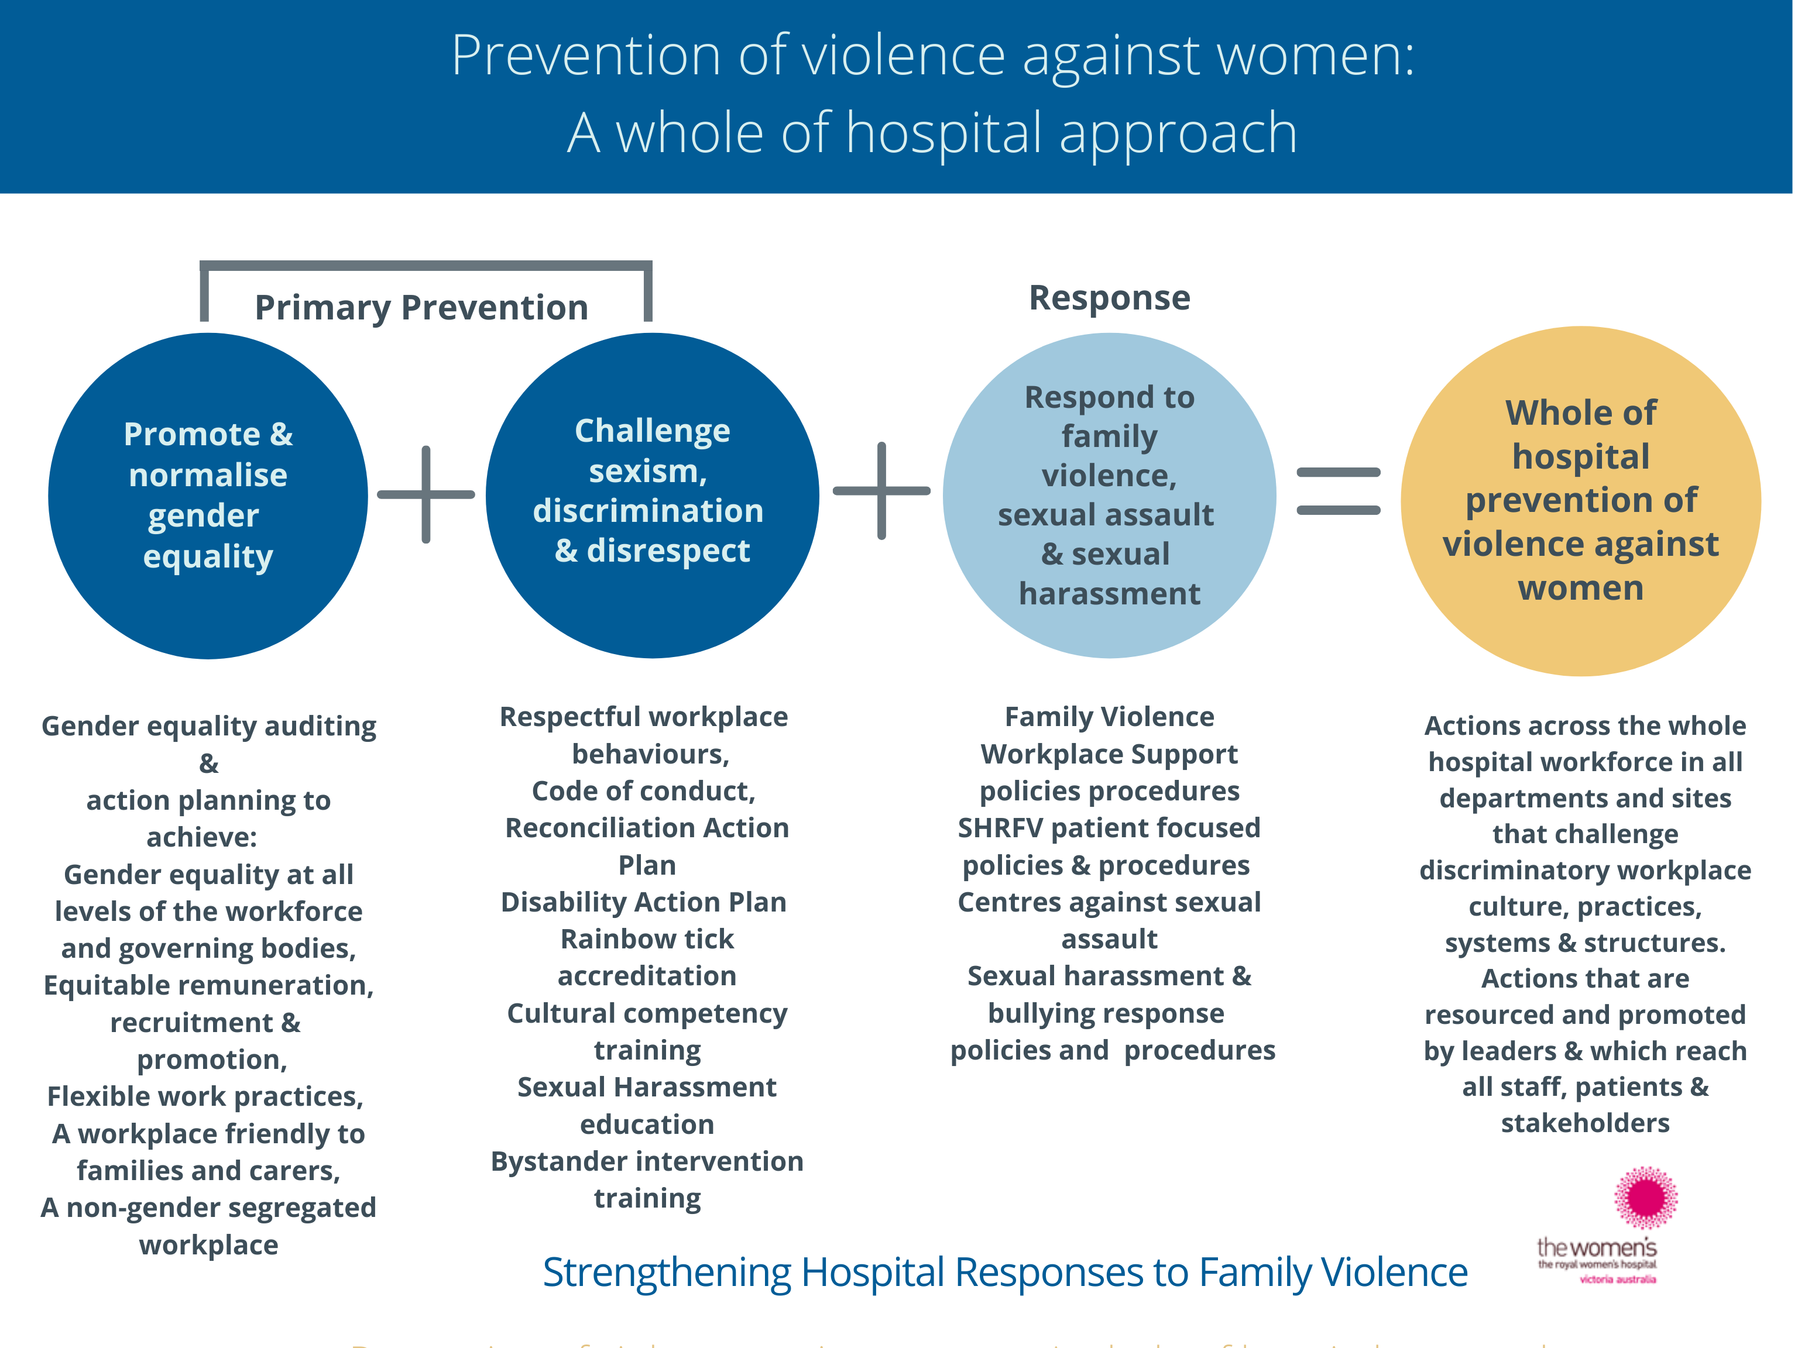

A whole-of-hospital approach to prevention of violence against women incorporating SHRFV and Workplace Support

The SHRFV Family Violence Workplace Support Program components

To create a safe, respectful and supportive work environment for those experiencing family violence your health service needs to adapt your operating environment to include the following key elements of the SHRFV Family Violence Workplace Support program. These elements can support work to respond to victim survivors of family violence as well as to prevent family violence and other forms of violence against women within the model above.



Leadership commitment

To ensure success, it is critical that your health service’s leadership team is demonstrably committed to supporting staff experiencing family violence and to preventing family violence. The leadership team should model and actively promote:

* the acknowledgement that family violence is a workplace issue and that staff experiencing family violence will be supported by the health service
* a workplace culture that fosters respectful relationships between men, women and people who identify as non-binary,
* gender equality and diversity within the workplace

Leadership commitment can be enhanced through Board and Executive briefings and the appointment of an Executive sponsor. Presentations or information sessions can be an effective forum to build a shared understanding of the project and to seek the buy in of the broader management group within your health service.

Organisational culture and strategic priorities

Your health service’s commitment to responding to employees experiencing family violence and prevention work can be strengthened by its inclusion in overarching documents such as your health service’s strategic plan, relevant organisational strategies – for example your People Strategy and, if possible, your Statement of Priorities (the annual accountability agreement between your health service and the Minister for Health).

Ideally, your health service’s culture and values should be actively aligned with family violence response and prevention work because the evidence shows that sexism and gender based discrimination within the workplace contributes to a society where family violence can flourish.

Your health service’s strategic documents should also take an intersectional approach, recognising that a person’s identity, social status and circumstances may result in them experiencing multiple forms of discrimination and that due to this discrimination, some groups experience family violence and violence against women at higher rates.

Taking an intersectional approach to your health service’s gender equality strategies is necessary to ensure that you are working towards equality for all women through addressing structures, practices and attitudes that discriminate, such as racism homophobia and ableism, in addition to sexism.

Policy, procedure and industrial instruments

Since late 2016, renegotiated enterprise bargaining agreements within the Victorian public health sector have included a Family Violence Leave clause, covering most employees within the sector. It is essential that your Family Violence Workplace Support program meets the requirements of the Family Violence Leave clause. Some of the key provisions arising from this clause include:

* the entitlement to paid/unpaid leave for those experiencing family violence and to use sick leave in particular circumstances to support others experiencing family violence
* the requirement to appoint and train Family Violence Contact Officers
* confidentiality requirements
* right to reasonable adjustments to provide support and enhance safety
* the provision of external referral information

However, a family violence workplace support program is more than compliance with this clause. Your health service needs clear policies, procedures and codes of conduct in place which communicate:

* that family violence is a gendered issue, is situated in the broader context of unequal relationships between men and women and that different aspects of an employee’s identity such as being Aboriginal or Torres Strait Islander, will overlap to shape experiences of family violence.
* how your health service will support employees experiencing family violence, including entitlements
* the expectation that employees and contractors will treat others with respect: they will not sexually harass, bully or discriminate against colleagues, patients and others in the course of their work
* the process for addressing inappropriate behaviour within the workplace
* the consequences for perpetrating an act of family violence using work resources and time
* health, safety and risk policies and procedures work to enhance workplace safety that may be compromised by family violence

An example policy and procedure your health service can adapt and use as part of your Family Violence Workplace Support Program is available in the SHRFV Toolkit of Resources. These documents reflect current practice within the Victorian Government MARAM guidelines.

Your health service’s policies, procedures and guidelines should also ensure that the needs of victim survivors from diverse communities are met, with the recognition that certain groups of people may be targeted for violence more often than others, and that some victims face increased barriers to accessing appropriate support and risk management response to increase their safety and recovery due to discrimination based on their identify, social status and/or circumstances.

Communication

Your health service will need to regularly and clearly communicate both to external and internal audiences to reinforce your key family violence response and prevention messages.

Employees should have access to information about the Family Violence Workplace Support Program, including external referral information, which should be tailored having regard to language and literacy levels, access to computers and working outside of standard business hours.

Examples of communication channels include orientation, newsletters, brochures, cards, intranet, posters, employee on-boarding information, meetings and events (such as staff BBQs, Grand Rounds, staff forums), CEO and leadership speeches.

Training

All those who manage or supervise staff need to attend training on preventing and responding to family violence. The training builds manager capability in understanding the drivers of family violence and to identify and respond to an employee experiencing family violence. Managers understand the impact of family violence within the workplace and the expectations and boundaries in relation to their role as managers in responding to employees experiencing family violence. It is important that managers understand the complexities and dangers that family violence presents and that their management practice in supporting an employee enhances the safety and wellbeing of that employee.

Manager training is also central to effectively communicating the importance of a respectful, inclusive and non-discriminatory workplace culture in effectively using the workplace as a setting for family violence prevention. Managers are given appropriate support to develop their capabilities in this area. It is strongly recommended that there is clear communication to managers on where they can seek assistance post training if they need further support. Health services should consider making manager training mandatory as part of the Family Violence Workplace Support Program.

Non managerial employees should also be given the (non-compulsory) opportunity to attend training in relation to understanding family violence, the workplace supports available to those experiencing family violence, including external referral information.

Training modules for managers and staff have been developed specifically for the SHRFV Workplace Support program (see the SHRFV Toolkit of Resources) and moderate adaptations can be made to suit your operating environment. It is recognised that health services may not have the internal expertise or capacity to deliver training and where this is the case, partnering with a credible external training provider to deliver this training is suitable.

Family Violence Contact Officers

Establishing the role of Family Violence Contact Officers as part of your Family Violence Workplace Support Program is a requirement under the Family Violence Leave clause. These roles need to be in place to assist employees with information about the workplace supports available such as referral information, family violence leave, safety planning and other workplace supports. They may be members of the Human Resources/People & Culture team and/or drawn from employees across your organisation and act as an alternative source of information where an employee does not wish to discuss their situation with a manager. Where your health service is in a rural/regional setting, consideration needs to be given to a model of Family Violence Contact Officer that enhances confidentiality if necessary. Examples of shared models may include employee access to Family Violence Contact Officers from neighbouring health services or a project lead hospital offering Family Violence Contact Officers centrally.

Family Violence Contact Officers should be provided with family violence training to build understanding of the drivers of family violence, appropriate responses to disclosures of family violence, confidentiality requirements, the range of workplace supports available to employees and responsibilities of the role as assigned by your health service. The name and contact details of Family Violence Contact Officers need to be well promoted with in the workplace.

Partnerships & collaboration

As part of the Family Violence Workplace Support Program your health service needs to develop and/or strengthen its partnerships with external organisations with expertise in family violence prevention and response to improve outcomes for employees. Organisations such as the Employee Assistance Program provider, local family violence services and women’s health organisations can be a source of consultation in relation to the Family Violence Workplace Support Program as well as providing referral pathways for staff.

Employees with relevant expertise within the health service should ideally work together to collaborate and support each other in developing, implementing and sustaining the Family Violence Workplace Support Program.

Evaluation and improvement

The Family Violence Workplace Support Program should be evaluated periodically to measure improvement in workforce understanding of family violence and to ensure that processes undertaken to support those experiencing family violence meet the needs of staff. Such information can be drawn from areas such as:

* pre and post training surveys and verbal feedback providing qualitative and quantitative data collected at all training sessions and other staff surveys
* data collection and record keeping around all program activities such training attendance, the number of staff who have accessed family violence leave and total hours taken, attendance at relevant grand rounds, staff forums and promotional events, number of visits to the relevant intranet page to access internal family violence information, reports from the EAP provider on family violence related contacts
* regular training content evaluation meetings to ensure continuous quality improvement and best practice
* periodic policy and procedure review and intranet information review
* regular meetings within Human Resources/People & Culture to keep up to date with current procedures relating to the Family Violence Workplace Support Program.

Further information/relevant tools

Further information/relevant tools

* Workplace Support: Responding to staff who are victim survivors of family violence: : Resources for Victorian hospitals and health services. This resource includes:
  + Family Violence Workplace Support Policy (Supporting Victim Survivors) - Template
  + ​Family Violence Workplace Support Procedure (Supporting Victim Survivors) - Template
  + Family Violence Workplace Support: Workplace Safety Planning Guidelines - Template
  + Family Violence Workplace Support Information Management Guidelines
  + Family Violence Workplace Support brochure – Template – DL 3-fold
  + Family Violence Workplace Support: Responding to staff: Quick reference

* Family Violence Workplace Support manager training – training presentation and facilitators guides:
  + 4-hour face-to-face module for line managers and HR managers and covers considerations and procedures related to providing  professional and personal support to staff who are victim survivors of family violence
  + 2.5 hour face-to-face or online presentation. This is an abbreviated and non-interactive version of the 4-hour module and recommended as a refresher training.
  + 1-hour Workplace Support policy and procedure presentation covering requirements and procedures related to the family violence leave clause in the Health Services' Enterprise Agreements.
* Workplace Support: Responding to staff who perpetrate family violence: Resources for Victorian hospitals and health services. This resource includes:
  + Family violence - Workplace responses to staff who perpetrate family violence - Policy
  + ​Family violence - Workplace responses to staff who perpetrate family violence – Manager Guidelines.
  + Family violence - Workplace responses to staff who perpetrate family violence – Guidelines for Human Resources staff
  + Family violence - Workplace responses to staff who perpetrate family violence –Clause
  + Case studies in responding to staff who perpetrate family violence