Strengthening Hospital Responses to Family Violence (SHRFV)
Family Violence Multi-Agency Risk Assessment and Management Framework (MARAM)

Intermediate Victim Survivor Training
Facilitators Guide
Contents

Overview
About the guide 3
Background 3
Design 3
Supporting resources 5
Delivery mode 5
Contextualising 6
Pre-requites 6

Module Session Outline
Module 1 7
Module 2 8
Module 3 9
Module 4 10

Module Guide
Module 1 11
Module 2 47
Module 3 82
Module 4 127

Activity Booklet
Contents 156
Module 1 157
Module 2 166
Module 3 185
Module 4 200

Overview

About the guide
This Facilitator Guide has been developed to support those delivering face-to-face SHRFV MARAM Intermediate victim survivor training to staff who have a role which aligns to the MARAM Intermediate responsibilities. This guide should be read in conjunction with the SHRFV MARAM Intermediate victim survivor module PowerPoint slides.

Background
The aim of the Strengthening Hospital Responses to Family Violence (SHRFV) program is to support Victorian hospitals to implement a whole-of-hospital response to family violence aligned to the Family Violence Multi-Agency Risk Assessment and Management (MARAM) Framework. The provision of training is a key element of building the capability of staff to understand their role and responsibilities under MARAM, develop the skills and knowledge required to respond effectively to family violence and contribute to an organisation meeting their legislative requirements.

The SHRFV MARAM Intermediate victim survivor training modules have been developed to support SHRFV Hospital and Health Services to train staff who have a role which aligns to the MARAM Intermediate responsibilities to develop the skills and knowledge required for their roles. This includes: a shared understanding of family violence, an applied understanding of MARAM, effective engagement with victim survivors; and practice skills to identify risk, undertake risk assessment and risk management at an Intermediate level. The training focuses on working with both adult and child victim survivors of family violence. This training does not cover working with perpetrators of family violence.
The modules have been contextualised to the health context by The Royal Women’s Hospital from the modules designed by the Domestic Violence Resource Centre Victoria (DVRCV) and endorsed by Family Safety Victoria and the Department of Health.

Design
The Facilitator Guide, incorporates:
- Module Session Outline
The purpose of the outline is to provide a brief overview of the content and activities, the suggested running time for each topic and activity and prompt the Trainer during the delivery of the training.

- Module Guide
The Module Guide provides detailed instructions for Trainers delivering the modules, and has been written using a narrative style. To navigate this document, Trainers should be aware of the following:
- Each topic includes a purpose, suggested facilitator dialogue, questions to ask the group, nominal duration and PowerPoint slide reference.
- The facilitator dialogue denotes content that the Trainer needs to cover. The dialogues does not need to be presented verbatim, Trainers can put content into their own words.
- The PowerPoint slides have been designed with animations and transitions through the content. Instruction of when to click to reveal a new state or content on the slides are indicated throughout the dialogue in italics.
- Each section has a ‘Resources for Trainers’ box (darker blue), which outlines resources a Trainer can refer to for more information about the content that is covered.
- Information in the ‘Notes’ box (light blue) provides additional information for Trainer support and context, but does not need to be specifically covered.
- Instructions for running activities are contained in clear boxes. As long as the purpose for an activity remains clear, a Trainer may use their judgement to adapt activities, as appropriate to timing and the group dynamic.
- Unless otherwise advised, where ‘sample answers’ are provided they give guidance for the Trainer to support discussion, but do not have to be covered comprehensively.
- For definitions of key terms used throughout the training, Trainers can refer participants to the Glossary in the Participant Guide, or the Glossary in the MARAM Framework Document.
- For some participants this content may be sensitive. It is normal for family violence content to have an impact, even on experienced workers. Encourage participants to practice self-care and take a break if needed. If participants need support, encourage them to contact 1800 Respect, the 24-hour family violence and sexual assault support line, both for victim survivors as well as their friends and professionals. In addition, support is available through organisation’s EAP and encourage conversations with managers.

- Activity Handouts
This section includes handouts for the activities in the training. Trainers are responsible for printing these out and bringing to the training. The case studies used in some activities have been contextualised within four health setting, with the intention that trainers would use the case studies with the professions that best fits with the roles of participants. The professional personas are:
- Mental Health clinician
- Social Worker in a Hospital
- Care Coordinator in an Emergency Department
- Hospital Admission Risk Program (HARP) clinician

Supporting resources
- PowerPoint slides
The trainer guide notes are repeated both in this document and under each slide for ease of use and reference. Slides can be provided to participants. It is recommended that prior to sharing the slides with participants Trainers would amend the slides to remove trainer notes and facilitate engagement with the training such as removing answers to ‘check your understanding’ slides. Trainers can either print out the amended slides for participants, or send to participants prior to the training to print out themselves.

- Participant guide
The Participant Guide includes information about the modules, its prerequisites, a resources list, information about specialist family violence services and a glossary. This resource should be sent to participants prior to attending the training. It is not required that participants bring this to the training.

- Evaluation/Feedback. Participants are required to complete the Victorian Government’s pre and post participation survey. The responses collected are anonymous and will only be utilised by the Department of Health, the Department of Families, Fairness and Housing and Family Safety Victoria for evaluation and reporting purposes. Trainers are responsible for facilitating this. Prior to and after attending the training, participants should be sent a link to these surveys, or if technology allows, participants can complete them in the training. The pre-survey takes approximately five minutes, and post-survey approximately ten minutes to complete.
  - Pre-training survey https://protect-au.mimecast.com/s/lJaaCWLVpXI5jAKrf6YArY?domain=forms.office.com
  - Post-training survey https://forms.office.com/Pages/ResponsePage.aspx?id=H2DgwKwPnESciKEExOufKJGLxR8YAdNJk75e8UYKTVlUOFFLN0xIM01LTjRQVjJOVFpUOTJQUk0yRiQlQCN0PWcu
Hospitals and Health services may also choose to ask participants to complete an organisation specific evaluation of the training.

Delivery mode
The training is designed to be delivered face to face as this facilitates the sharing of ideas and experience and the opportunity to build skills by participating in practical activities. To support optimal group learning, the training should ideally be delivered by two Trainers. The Trainer plays a crucial role in stimulating and guiding participants through the content and the activities and will ensure that:
- Different levels of experience and understanding will be recognised
- Activities will be well explained and contextualised for the group
- Activities will run on time and to intention
- Opportunities will be provided so that participants can reflect on and practice with the learning materials and link discussions and activities to their workplaces.

A training space is required that includes audio visual facilities with internet connection and audio speakers. Setting up the room to support small group discussion is generally considered the most conducive to interactive discussions during a training session. Trainers may also choose to bring butcher’s paper and pens for each table to be used in the activities.

A number of factors such as time available, resources, target audience and participant’s level of experience will determine what is suitable to deliver and how it is to be delivered. The training and associated activities have been designed to support delivery to a group of approximately 15-25 participants. It is advised that the maximum number of participants does not exceed 30.

Hospitals and Health Services may wish to develop and provide a certificate of completion at the completion of the modules.

Contextualising
The modules have been developed using Microsoft PowerPoint. Hospitals and Health services can edit and contextualise these modules to reflect their organisation’s procedures and operating environment.

Pre-requisites
Prior to undertaking these modules, it is recommended participants complete the three Victorian Government Information Sharing Schemes eLearn modules for Health and Community Services Professionals https://elearn.childlink.com.au/. Each module takes approximately 20 minutes to complete.

Module Session Outline

MODULE 1
Total running time 2 hours
Time | Content | Trainer | Slides
20 mins | TOPIC: Welcome, acknowledgement housekeeping, and introductions & overview |  | 1-6
20 mins | TOPIC: Overview of the Victorian Family Violence reform context and MARAM  Video: Helping end family violence - the Information Sharing Schemes and MARAM (3.58mins) |  | 7-18
15 mins | TOPIC: Foundational knowledge, understanding family violence |  | 19-28
15 mins | TOPIC: Understanding attitudes, structural inequality & discrimination  Video: Let's change the story: Violence against women in Australia (4.28mins) |  | 29-41
25 mins | TOPIC: Barriers to disclosure  Activity One:, Barriers to disclosure, case study (15mins)  Video: Everybody Matters: Inclusion and Equity Statement (4.12mins) |  | 42-44
20 mins | TOPIC: Conclusion  Activity: Quiz (10mins) |  | 45-48

MODULE 2
Total running time: 2 hours
Time | Content | Trainer | Slides
5 mins | TOPIC: Welcome, acknowledgement, introductions housekeeping & overview |  | 1-5
15 mins | TOPIC: Observable signs of trauma  Activity One: Observable signs of trauma, case study (10mins) |  | 6-9
65 mins | TOPIC: Effective engagement  - Promoting victim survivor agency  - Creating a safe environment to disclose  - Sensitive response  Activity Two: Effective engagement, case study (15 mins)  - Responding to discriminatory attitudes and beliefs  Activity Three: Helpful and unhelpful responses (15mins)  - Culturally safe, accessible and inclusive practice  Activity Four: Working with diverse groups (20 mins) |  | 10-23
25 mins | TOPIC: Child Focused Practice  Activity Five: Child focused practice when working with an adult victim survivor. (15mins) |  | 24-29
10 mins | TOPIC: Conclusion  Activity Six: Quiz (5 mins) |  | 30-33

MODULE 3
Total running time 2 hours
Time | Content | Trainer | Slides
20 mins | TOPIC: Welcome, acknowledgement housekeeping, and introductions & overview |  | 1-5
10 mins | TOPIC: Evidence-based risk factors  Activity One: Evidence-based risk factors (5mins) |  | 6-9
5 mins | TOPIC: MARAM Assessment Tools |  | 10-16
45 mins | TOPIC: Structured Professional Judgement Model  Activity Two: Risk Assessment in practice – Applying the Structured Professional Judgement Model (30mins) |  | 17-27
20 mins | TOPIC: Assessment of Seriousness of risk  Activity Three: MARAM risk categories (15mins) |  | 28-30
5 mins | TOPIC: Misidentification of the perpetrator and victim survivor |  | 31-34
15 mins | TOPIC: Conclusion  Activity: Quiz (5mins) |  | 35-39

MODULE 4
Total running time 2 hours
Time | Content | Trainer | Slides
20 mins | TOPIC: Welcome, acknowledgement housekeeping, and introductions & overview |  | 1-5
50 mins | TOPIC: Risk Management  Activity One: Safety planning (20mins)  Activity Two: Risk Management (10mins) |  | 6-20
15 mins | TOPIC: Keeping perpetrators in view and accountable |  | 21-24
10 mins | TOPIC: Workplace supports |  | 25-28
25 mins | TOPIC: Conclusion  Activity: Quiz (5mins) |  | 29-33

Trainer Guide

MODULE 1
Time: 2 hours
TOPIC: Welcome, acknowledgements, housekeeping, introductions & overview
Nominal duration: 20 minutes
Purpose: To make acknowledgements, establish expected behaviour in training environment and provide participants with an overview of the training.
Slide | Key message/s | Facilitator dialogue
Slide 1: Introduction  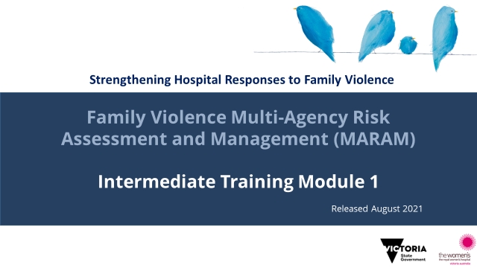 | Acknowledgement of traditional owners, victim survivors and language. | Welcome  - Introduce training. This training is designed for practitioner who work with victim survivors.  - Welcome participants.  Acknowledgement of country  - Acknowledge the Traditional Aboriginal Owners of country on which the training is taking place. Pay respects to them, their culture and their Elders past, present and emerging, as well as any community members here today in the room with us. Acknowledge that sovereignty of this land was never ceded.  - For the purposes of this module, we’ll be using the term Aboriginal to refer to both Aboriginal and Torres Strait Islander people.  Acknowledgement of victim survivors  - We wish to acknowledge victim survivors of family violence, particularly women and children that have been killed in the context of family violence.  - We hope what is presented in this training is respectful to their individual experiences.  Introductions  - Trainer introductions: Provide a 1-2 sentence introduction that explains your professional background, emphasising aspects that establish your authority to deliver the MARAM training.  Examples of Trainers relevant experience that lends authority may include clinical experience working at an Intermediate or Comprehensive MARAM level; experience in a specialist service/clinic; experience in the specialist family violence service; clinical educator.  Acknowledgement of language  - We want to acknowledge the language used in this training.  - This training refers to people who have experienced family violence as ‘victim survivors’. Not every person who has experienced family violence identifies with this term. The term is intended to acknowledge the strength and resilience shown by victim survivors who have experienced or currently live with family violence.  - This module uses the term ‘perpetrator’ to describe people who choose to use family violence, as this is the term used in the policy and practice guidance. We acknowledge the preferred term in practice and for Aboriginal people and some communities is a ‘person who uses violence’.  - While family violence is overwhelmingly gendered, the way this gendered experience of violence presents itself will vary between relationships and across communities.  - As such the terms ‘victim survivors’ and ‘perpetrators’ are not interchangeable with ‘women’ or ‘women and children’ and ‘men’ in order to be inclusive of diverse gender identities and experiences of family violence.  - However, at times this training will use gendered language and case examples to reflect the evidence base.  Housekeeping  - Outline duration of training, break times (if scheduled) and OH&S requirements (fire exits etc.).
NOTES
Acknowledgement of country
The Aboriginal Victoria website has an interactive map that allows you to search for the Traditional Owners of a particular area. It also documents areas where this is contested. Taking the time to be aware of and acknowledge the Traditional Owners of the area where training is being delivered is an opportunity to honour Victoria’s strong and proud Aboriginal and Torres Strait Islander history.

Gendered lens
MARAM recognise that family violence is a gendered crime, driven by gender inequality, and is overwhelmingly perpetrated by men against women and children. Family violence is about misusing power to achieve control over another person – and this can take place in any relationship where a power imbalance exists, and affects all genders, relationship and family types. For this reason MARAM doesn’t use gendered language to be inclusive of diverse gender identities and experiences of family violence.
The way this gendered experience of violence presents itself will vary between relationships and across communities. A gendered lens can also recognise that gender inequality in our society can have an impact on relationship structures and dynamics even outside of heterosexual relationships.

Slide 2: Safe learning environment  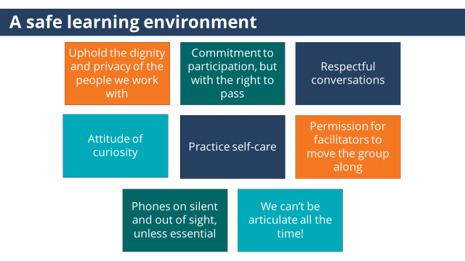 | Throughout the session be mindful of confidentiality, be respectful of diverse opinions and various levels of knowledge, and ways we can all support this to be a safe learning environment for everyone. | - Let’s talk about expectations within the group that will support us in our training to be a safe learning environment.  - Uphold dignity & privacy: Practice examples are welcome and enrich the group’s learning, but please be mindful of avoiding the use of identifying information to respect confidentiality when sharing, and consider the way you talk about those whose stories you share. Please also be mindful of each other’s privacy by not taking stories and examples others have shared around their practice or workplace outside of the training space.  - Respectful conversations: Use active listening skills; challenge ideas, not people.  - Commitment to participation & choice to respond/right to pass: The training is based on adult learning principles and people are encouraged to contribute what they already know as well as stepping into areas that may be uncomfortable or unfamiliar by raising questions. We encourage participants to give things a go, but also acknowledge everyone has a right to pass if they feel uncomfortable about or unable to contribute in a particular area.  - Attitude of curiosity: It is no secret that curiosity makes learning more effective and enjoyable. As Albert Einstein said “The important thing is not to stop questioning. Curiosity has its own reason for existing."  - Practice self-care: It is normal for family violence content to have an impact, even on experienced workers. Do what you need to do to look after yourself and take a break if you need one. As this is a learning space, not a therapeutic space, personal disclosures are not encouraged. This is not to shut down any experiences, but to ensure that the focus remains on the training for all participants, and supports the maintenance of a safe learning environment.  - Permission for the Trainers to move the group along: We could spend many hours discussing this material but we need this time to alert you to all the content that is available. We encourage you to see this session as one component of developing your knowledge and skills, and there will be more time for discussion within your own workplaces and through your partnerships and collaborations with others.  - Phones on silent: Phone usage can be disruptive to an individual’s learning as well as being distracting to colleagues. We recognise exceptions if people need to be on call or respond to a work or personal situation.  - We can’t be articulate all the time: This gives us all permission to be clunky/imperfect in our expression. As long as what is shared respects others’ identities, let’s allow mistakes and imperfection to support our learning.
Slide 3: Self-care  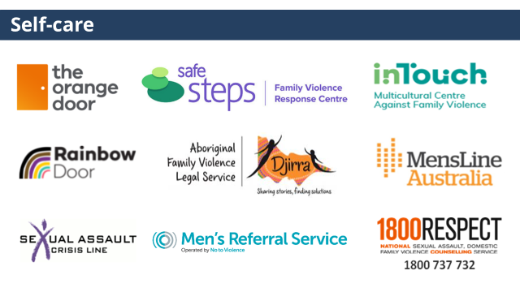 | To highlight the importance of self-care and for participants to be aware of services they can contact if they are impacted by the training. | - Discussing family violence can be distressing, particularly if you have experienced or been impacted by violence.  - If this training causes any concern for yourself or another you can discontinue at any time; however we encourage you to contact one of these services or your workplace Employee Assistance Program for support.  - Information about these services can be found in your Participant Guide.
Slide 4: Introductions  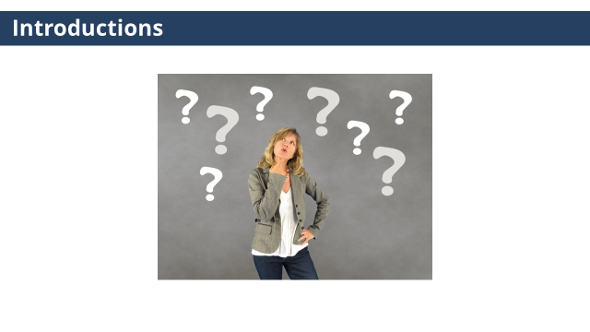 | Gauge participant expectations of the training. | Trainer to ask:  - Participants to introduce themselves (name, role etc.).  - Share what they are wanting to achieve or ‘get out of’ today’s training.
NOTES
Trainers may wish to set this up as an activity where participants share what they want to get out of the training (either verbally with the group or on a Post It note, with Trainers writing them on a wall/whiteboard, and returning to this at the conclusion of the session to see if they have been addressed.

Slide 5: Learning objectives  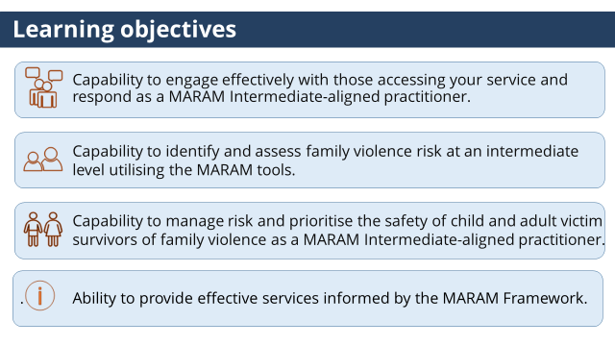 | At the conclusion of this training, participants will be aware of how to engage effectively with victim survivors, and how to identify, assess and manage risk at an MARAM Intermediate level. | - Learning objectives for the four modules:  - Capability to engage effectively with those accessing your service and respond as a MARAM Intermediate-aligned practitioner.  - Capability to identify and assess family violence risk at an intermediate level utilising the MARAM tools. The focus is on working with victim survivors.  - Capability to manage risk and prioritise the safety of child and adult victim survivors of family violence as a MARAM Intermediate-aligned practitioner.  - Ability to provide effective services informed by the MARAM Framework.
Slide 6: Training overview  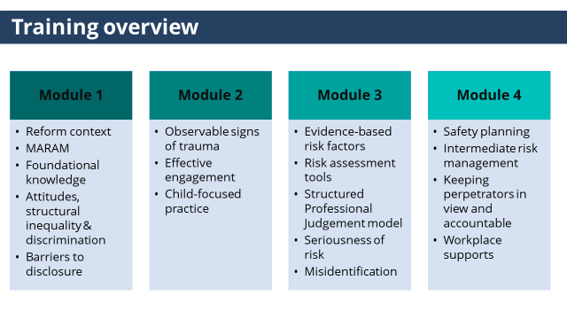 | This training aims to build the knowledge and skills required to respond effectively to victim survivors of family violence at an Intermediate level under MARAM.  This is Module 1. | - This training has 4 modules, and has been designed to cover the skills and knowledge required by practitioners whose role includes intermediate responsibilities under MARAM.  - It is likely these modules will cover content which is familiar and reflect the ways in which you are already working. Some of the content will be new and be an opportunity for reflection and learning.  - This training focuses on working with adult and child victim survivors of family violence. This training does not cover working with perpetrators or adolescents who use violence. Training for working with these cohorts will be available in 2022.  (click to reveal highlighted state)  - This is module 1, module 1 will cover:  - An overview of the Victorian Family Violence reform context and MARAM  - Foundational knowledge  - Understanding attitudes, structural inequality & discrimination  - Barriers to disclosure
NOTES
Practice Guidance for working with perpetrators has been released. https://www.vic.gov.au/maram-practice-guides-professionals-working-adults-using-family-violence Training will be available in 2022.
At the time of writing this Guide, Practice Guidance for working with adolescents has not been released.

TOPIC: Overview of the Victorian Family Violence reform context and MARAM.
Nominal duration: 20 minutes
Purpose: To provide participants with an understanding the Victorian family violence reform context and MARAM, the health sector’s role in responding to family violence and practitioners responsibilities at an Intermediate level.
Resources for Trainer
- MARAM Framework.
- Decision Guide for Organisations – MARAM Framework.
- Video: Family Safety Victoria (2019) Helping end family violence – the Information Sharing Schemes and MARAM.
- Family Violence Information Sharing Scheme.
- Child Information Sharing Scheme.
- Who can share information under the information sharing and MARAM reforms.
- Frequently asked questions about information sharing and MARAM.
- Royal Commission into Family Violence: Summary and recommendations, 2014-16.

Slide | Key message/s | Facilitator dialogue
Slide 7: Topic introduction.  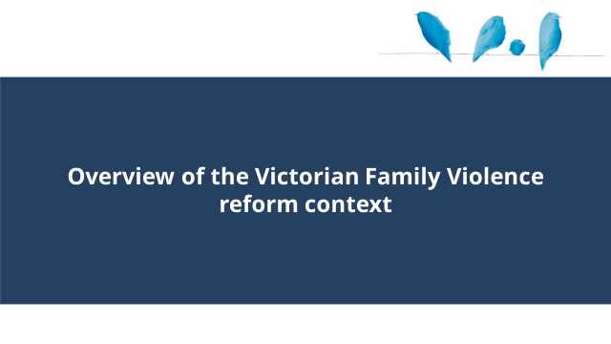 |  | - This section will cover an overview of the Victorian Family Violence reform context and MARAM.
Slide 8: Overview of the Victorian Family Violence reform context and MARAM  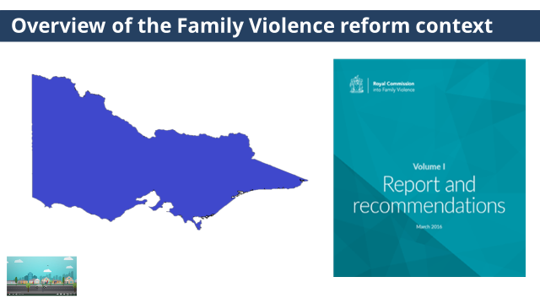 | Highlight the reforms being undertaken to improve Victoria’s responses to family violence. | - How Victoria responds to family violence is changing.  (click to reveal second image)  - The Royal Commission into Family Violence’s report, delivered in March 2016 made 227 recommendations to improve Victoria’s responses to family violence.  (click to reveal third image)  - We are now going to watch a video developed by Family Safety Victoria which highlights some of the key reforms that are occurring as a result of these recommendations.  (click on third image to be taken to the youtube video)
NOTES
If you can’t access youtube, the video can also be accessed through the following link, ‘Helping end family violence - the Information Sharing Schemes and MARAM’. Video is approximately 3.58 mins in length.

Slide 9: MARAM  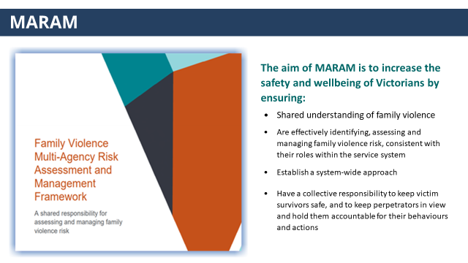 | MARAM supports best practice responses to family violence. | - What now guides family violence practice in Victoria is MARAM which stands for the Family Violence Multi-Agency Risk Assessment and Management Framework.  - MARAM is best practice for family violence risk assessment and management, based on current evidence and research.  (click to reveal each point below)  - The aim of MARAM is to increase the safety and wellbeing of Victorians by ensuring all prescribed services:  - Have a shared understanding of family violence  - Are effectively identifying, assessing and managing family violence risk, consistent with their roles within the service system  - Establish a system-wide approach  - Have a collective responsibility to keep victim survivors safe, and to keep perpetrators in view and hold them accountable for their behaviours and actions.
NOTES
The Victorian government is progressing 3 interrelated reforms that are integral to reducing family violence and promoting child wellbeing or safety: The Family Violence Multi-Agency Risk Assessment and Management Framework (MARAM), Child Information Sharing Scheme (CISS) and Family Violence Information Sharing Scheme (FVISS)

Public health services and denominational hospitals were prescribed under MARAM, CISS and FVISS on the 19th April 2021.
For more information about these reforms, please refer to the Victorian Government website, About the information sharing and MARAM reforms | Victorian Government (www.vic.gov.au)
Information concerning which workforces are prescribed can be found at the following website, Who can share information under the information sharing and MARAM reforms | Victorian Government (www.vic.gov.au).

Slide 10: Changing Framework  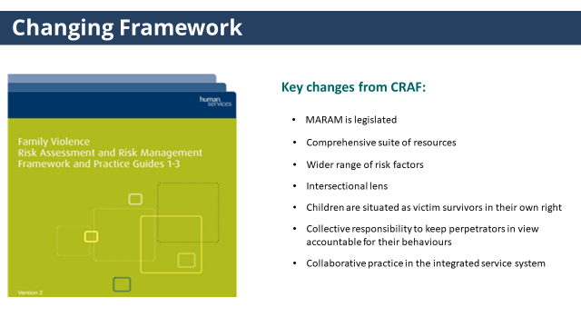 | Practitioners practicing under CRAF will need to be familiar with the changes in practice under MARAM. | - MARAM replaces the existing assessment framework CRAF (or the Victorian Common Risk Assessment Framework). For practitioners familiar with CRAF, some of the key elements of MARAM that represent a change from CRAF, are.  (click to reveal each point)  - There is now a legislative requirement for organisations to align practice to MARAM.  - MARAM supports practice with a comprehensive suite of resources.  - MARAM recognises a wider range of risk factors based on contemporary evidence  - MARAM applies a stronger intersectional lens.  - Children are situated as victim survivors in their own right.  - MARAM emphasises the importance of keeping perpetrators in view and holding them accountable for their behaviours.  - MARAM provides greater practice direction to support collaborative practice in the integrated service system.  - Some services will have been practicing in these ways already. However, for some it will mark a significant change to practice.
NOTES
The Family Violence Multi-Agency Risk Assessment and Management Framework (MARAM) has been developed in response to Recommendation One of the Royal Commission into Family Violence. MARAM addresses issues and gaps in the previous Framework, known as the Common Risk Assessment Framework or ‘CRAF,’ that were identified by the Royal Commission into Family Violence, the Coronial Inquest into the death of Luke Geoffrey Batty and the 2016 Monash Review of the Framework.
More than 1,600 stakeholders from the public, private and non-government sector have contributed to the redevelopment of the Framework, including specialists from family violence, child and family services, health, community services, justice and education professionals and specialists.

Slide 11: Integrated service system  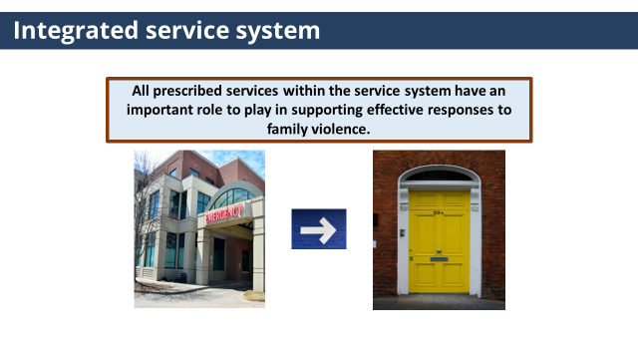 | All prescribed services within the service system have a role in supporting effective responses to family violence.  The Health sector has as a critical role as an entry point for identifying people affected by family violence and providing a pathway to specialist support. | - What underpins all the reforms is an understanding that all prescribed services within the service system have an important role to play in supporting effective responses to family violence.  (click to reveal image of hospital and specialist services)  - The Commission recognised the unique role the health sector has as a critical entry point for identifying people affected by family violence, offering early intervention and providing a pathway to specialist support.  - The critical importance of this role is reflected in recommendation 95 of the Commission which called for a whole- of-hospital approach when responding to family violence, the result of which is the Strengthening Hospital Responses to Family Violence initiative.
Slide 12: Pause and reflect.  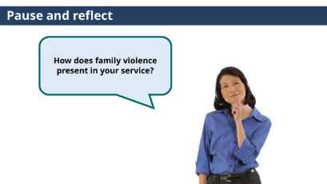 | Hospitals and health services are already supporting those experiencing family violence. | Trainer to ask: How does family violence present in your service?  - Due to the prevalence of family violence across the lifespan, hospitals and health services will already be supporting those who are experiencing family violence, whether they know it or not or have embedded policies.  - Given this, MARAM backs us as individual practitioners, organisations and as a system to understanding how family violence might present to our services, the issues present in the lives of those patients we work with and to set clear expectations around our roles and responsibilities in responding.
NOTES
If participants aren’t forthcoming with answers, Trainers may wish to prompt the discussion or raise the following ideas:
- Victim survivors may present to an Emergency Department to seek treatment for injuries or medical conditions arising from the violence.
- Victim survivors may present to Mental Health Services with symptoms of depression, anxiety, post-traumatic stress and suicidal ideation resulting from the impact of family violence.
- Victim survivors may disclose to AOD Services their partners encourage their substance use, or substance may be used to manage pain associated with injuries resulting from family violence.

Slide 13: Royal Commission: Health Services  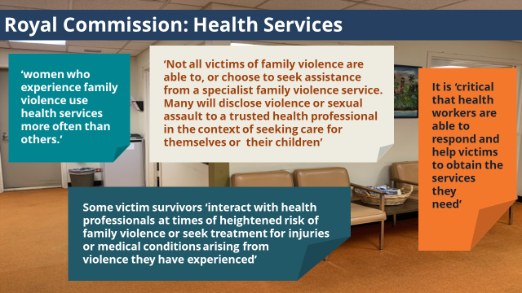 | The Commission highlighted the importance of health workers being able to respond to victims survivors who present to health services. | - The Commission’s recognised that health services are already supporting those who are experiencing family violence. The Commission noted that:  (click to reveal each quote)  - ‘women who experience family violence use health services more often than others.’  - ‘not all victims of family violence are able to, or choose to seek assistance from a specialist family violence service. Many will disclose violence or sexual assault to a trusted health professional in the context of seeking care for themselves or their children’.  - some victim survivors ‘interact with health professionals at times of heightened risk of family violence or seek treatment for injuries or medical conditions arising from violence they have experienced.’  - It is ‘critical that health workers are able to respond and help victims to obtain the services they need.’  - These quotes highlight the importance of health workers being able to respond to victims survivors who present to health services.
Slide 14: Empathetic and professional response  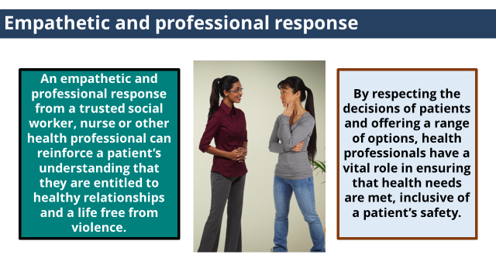 | An empathetic and professional response from a health professional can ensure victim survivors receive the support when they need it. | (click to reveal first text box)  - An empathetic and professional response from a trusted social worker, nurse, or other health professional can reinforce a patient’s understanding that they are entitled to healthy relationships and a life free from violence.  (click to reveal second text box)  - By respecting the decisions of patients and offering a range of options, health professionals have a vital role in ensuring that health needs are met, inclusive of a patient’s safety and patients receive the support when they need it.
Slide 15: MARAM Responsibilities  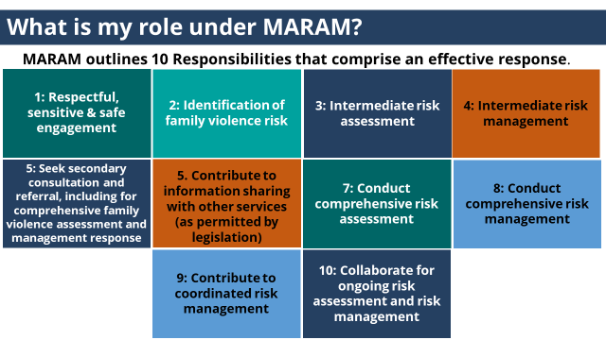 | MARAM outlines 10 Responsibilities that comprise an effective response. | - Everyone has a role to play in identifying, assessing and managing family violence risk.  - Your role will be dependent on the nature of your work and contact with those experiencing family violence.  - MARAM outlines 10 Responsibilities that comprise an effective response.  - These are the 10 Responsibilities:  - 1: Respectful, sensitive & safe engagement  - 2: Identification of family violence risk  - 3: Intermediate risk assessment  - 4: Intermediate risk management  - 5: Seek secondary consultation and referral, including for comprehensive family violence assessment and management response  - 6: Contribute to information sharing with other services (as permitted by legislation)  - 7: Conduct comprehensive risk assessment  - 8: Conduct comprehensive risk management  - 9: Contribute to coordinated risk management  - 10: Collaborate for ongoing risk assessment and risk management
Slide 16: What is my role under MARAM  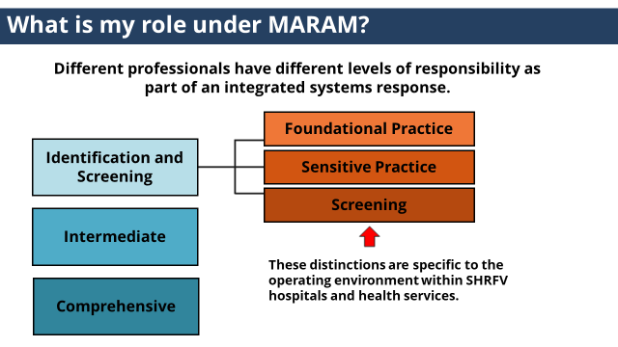 | MARAM is not asking everyone to be family violence experts. But everyone has a role to play in assessing and managing family violence risk. | - What is your role under MARAM?  - Different professionals have different levels of responsibility as part of an integrated system response.  - MARAM is not asking everyone to be family violence experts.  (click to reveal levels)  - Broadly, MARAM makes the distinction between those with Identification and Screening, Intermediate or Comprehensive responsibilities.  (click to reveal levels)  - Within health, at an Identification and Screening level, SHRFV have identified 3 levels of practice, Foundational Practice, Sensitive Practice and Screening.  (click to reveal note)  - These distinctions are specific to the operating environment within SHRFV hospitals and health services.  - Please note for some sectors the Intermediate level training is also called ‘Brief and Intermediate’.
Slide 17: MARAM Intermediate responsibilities  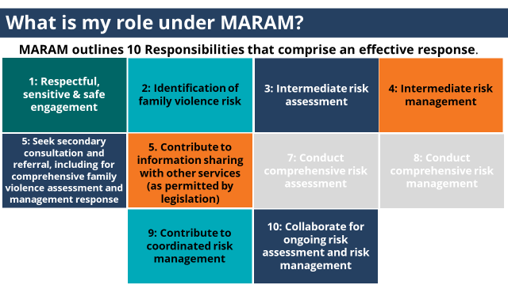 | As a professional with Intermediate responsibilities under MARAM you are required to align your practice to responsibility 1 through 6,9 & 10.  It is important to remember that development of this practice will take time. | - As a professional with Intermediate responsibilities under MARAM you are required to align your practice to responsibility 1 through 6,9 & 10.  - This training covers different elements of these responsibilities. Some of which reflect ways in which you will already be working.  - It is important to remember that development of this practice will take time.  - Responsibilities would 7 & 8 apply to roles mapped at a Comprehensive level such as case managers within specialist family violence services.
NOTES
It is possible that participants will raise concerns or frustrations around added workload and change, as well as uncertainties around what MARAM implementation will look like in practice. Some participants may be overwhelmed by the new information and implications for practice. The Trainer has an important role in validating these concerns while maintaining and promoting a positive attitude towards the reforms.
MARAM – including its legislative mandate, Framework document and extensive practice tools and Practice Guidance – represents significant and unprecedented development in the integrated service sector. This is something that will have a huge impact on the quality of response to family violence. However, it is important to recognise that it is something that will take time.
Tips for Trainers to maintain these themes throughout the session include:
- Validating the impact of change but connecting the reasons for change to the wider vision of MARAM reforms.
- Articulating that the new areas of practice build on all that we do know.
- Emphasising that implementing MARAM is a process, and that it is understood that changes will need to done gradually, as family violence literacy across organisations and the sector continue to develop.
- Genuinely validating participant concerns and frustrations.
- Facilitating conversation in the room to support brainstorming solutions or ways practitioners are managing the challenges.
- Supporting participants to sit with the grey areas and the unknowns, in relation to new areas of practice.
- Emphasising that no-one is alone in this process – the aim of the reforms is that there is a whole service system to support and work together.
- Responding to family violence shouldn’t sit with one practitioner or one services, MARAM recognises this through the need to develop collaborative practice, which has positive outcomes for staff and patients.
- Similar to other reforms, such as mandatory reporting or suicide prevention, responding to family violence shouldn’t be an add on, but part of usual practice. Recognising that embedding this work will take time.
Slide 18: MARAM Practice Guides  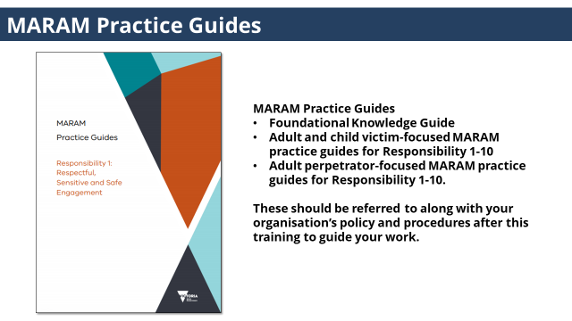 | Practice guides are valuable resources to guide your work. | - Practice Guides for Foundational Knowledge and for each of the 10 responsibilities for working with adult and child victim survivors and adult perpetrators have been developed, and should be referred to along with your organisation’s policy and procedures after this training to guide your work.  Links to the adult and child victim-focused MARAM practice guides can be found in your Participant Guide.
NOTES
The practice guides include:
- Foundation Knowledge Guide – which is for all professionals, whether you are working with adult or child victim survivors, or adults using family violence.
- Adult and child victim-focused MARAM practice guides (Responsibilities for Practice Guides 1-10).
- Adult perpetrator-focused MARAM practice guides (Responsibilities for Practice Guides 1-10).

TOPIC: Foundational knowledge: understanding family violence.
Nominal duration: 15 minutes
Purpose: To provide participants with an understanding of the definition and nature of family violence, its prevalence and gendered nature.

Resources for Trainer
- MARAM Practice Guides: Foundation Knowledge Guide
- Duluth Power and Control Wheels: These document the most common abusive behaviours or tactics that were used against women involved in a research project undertaken by the Domestic Abuse Intervention Project in 1984.
- Video: Professor Peter Hopkins, Newcastle University (2018) What is Intersectionality?
- Video: Our Watch (2015) Let’s change the story: Violence against women in Australia.
- Dhelk Dja: Safe Our Way - Strong Culture, Strong Peoples, Strong Families (2018) This document is the Aboriginal 10-year family violence agreement for 2018-2028, and is a community-led Aboriginal agreement to address family violence.

Slide | Key message/s | Facilitator dialogue
Slide 19: Foundational knowledge: a shared understanding family violence  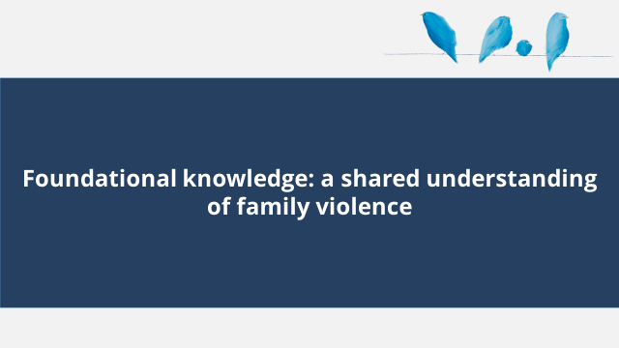 |  | - This section covers foundational knowledge: understanding family violence.
Slide 20: Definition of family violence  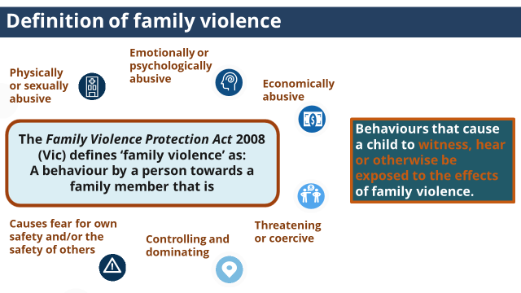 | The Family Violence Protection Act provides a working definition of family violence. Family violence is much more than physical, it is a pattern of behaviour distinguished by the use of power and coercive control causing victims to feel fear. | - The Family Violence Protection Act 2008 (Vic) defines ‘family violence’ as: A behaviour by a person towards a family member that is  (click to reveal each behaviours)  - Physically or sexually abusive  - Emotionally or psychologically abusive  - Economically abusive  - Threatening or coercive  - Controlling and dominating  - Causes fear for own safety and/or the safety of others  - Family violence takes many forms, it is not just physical or just an argument. Family violence is generally a pattern of behaviour distinguished by the use of power and coercive control causing victims to feel fear.  (click to reveal note)  - This definition also includes behaviours that cause a child to witness, hear or otherwise be exposed to the effects of family violence.
NOTES
Family violence differs from other forms of violence. It is generally a pattern of behaviour underpinned by coercion, control and domination by one person over another.
The Act takes a very broad understanding of ‘family’ – it includes extended kinship structures in Aboriginal and Torres Strait Islander communities, and family- like relationships such as a carer of a person with a disability.
The Act recognises children as victim survivors of family violence in their own right, whether they are directly targeted by a perpetrator, or being exposed to or witnessing violence or its impacts on other family members. Exposure to violence includes:
- Hearing violence
- Being aware of violence or its impacts
- Being used or blamed as a trigger for family violence
- Seeing or experiencing the consequences of family violence, including impacts on availability of the primary caregiver and on the parent-child relationship

Slide 21: Definition of family violence  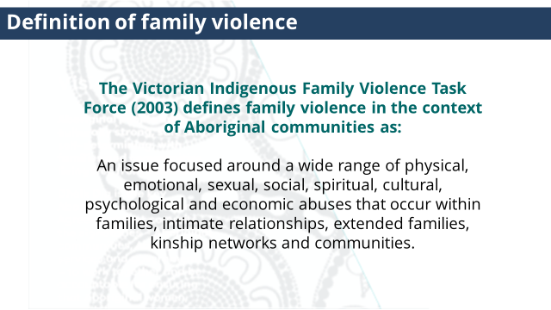 | The definition of family violence in the context of Aboriginal communities is broader and reflective of the communities’ experience. | - The Victorian Indigenous Family Violence Task Force (2003) defines family violence in the context of Aboriginal communities as:  - ‘An issue focused around a wide range of physical, emotional, sexual, social, spiritual, cultural, psychological and economic abuses that occur within families, intimate relationships, extended families, kinship networks and communities.’  (Dhelk Dja: Safe Our Way - Strong Culture, Strong Peoples, Strong Families, 2018)
NOTES
It is important to challenge any assumption that family violence is inherent in Aboriginal and Torres Strait Islander communities. ‘Violence against Aboriginal and Torres Strait Islander women is not a part of culture. When violence occurred prior to colonisation, it was regulated and controlled, and bore no resemblance to the kinds of violence and abuse seen today. Many aspects of traditional culture and customary law were respectful and protective of women.’
Our Watch, (2018) ‘Changing the Picture, A national resource to support the prevention of violence against Aboriginal and Torres Strait Islander women and their children’
This resources identifies the drivers of family violence toward Aboriginal and Torres Strait Islander people include the ongoing impacts of colonisation, including the impact of colonisation on gender roles, and dominant racist attitudes that condone violence.

It is important to challenge the assumption that it is Aboriginal men perpetrating high rates of violence: violence against Aboriginal women is often perpetrated by non-Indigenous men.
Slide 22: Check your understanding  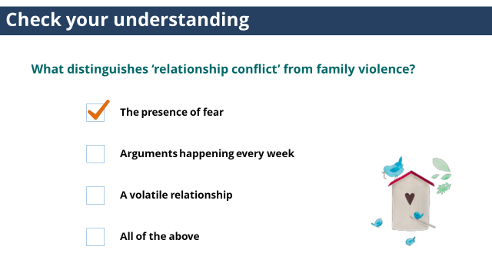 |  | Trainer to ask: What distinguishes ‘relationship conflict’ from family violence?  - The presence of fear  - Arguments happening every week  - A volatile relationship  - All of the above  (click to reveal answer)  Answer: The presence of fear.  - The presence of fear here is very important.  - Family violence is not ‘relationship conflict’, and using this term disregards the power differential which underpins family violence relationships.  - Conflict in healthy relationships does not involve one person feeling fearful of the other, having to change their behaviour to be physically or emotionally safe or unable to say no/express their opinions without feeling fear.
NOTES
A couple may have arguments every week as part of healthy conflict within their relationship or their relationship may be viewed by others as ‘volatile’ but it does not mean family violence is occurring if this isn’t underpinned by one person feeling physically or emotionally fearful. A belief that family violence occurs because a relationship is ‘volatile’ has the effect of mutualising the responsibility for the violence, disregards the power differential and removes responsibility from the person choosing to use violence.

Slide 23: Family violence is complex  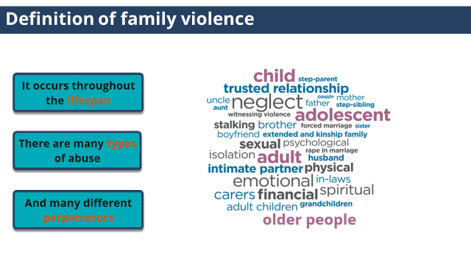 | Family violence is complex. It can sometimes be hard for victims to recognise their experience of family violence because of the complexities involved. | - Family violence is complex. It can sometimes be hard for victims to recognise their experience of family violence because of the complexities involved.  (click to reveal lifespan description)  - Family violence occurs throughout the lifespan: It affects children, adolescents, adults and older people.  (click to reveal types description)  - There are many types of abuse: Family violence is unacceptable in any form, across any community or culture. All are a violation of human rights and are unacceptable  (click to reveal perpetrator description)  - There are many different perpetrators: Family violence can occur in a range of relationships, including between current and former spouses or partners, parent/carer-child relationships, and relationships between siblings and other relatives, such as grandparents or extended family members. It also includes ‘family-like’ relationships such as paid or unpaid carers for people with disability, families of choice for LGBTIQ people, and cultural kinship networks in multicultural and Aboriginal communities.
Slide 24: Prevalence and gendered nature  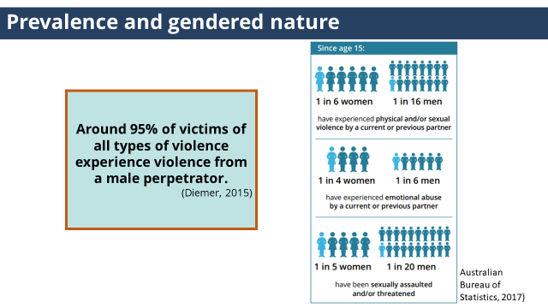 | These statistics show that victims of family violence are predominantly women and children and that men perpetrate the majority of all violence. | - The following statistics show that victims of family violence are predominantly women and children and that men perpetrate the majority of all violence in Australia against women, children and others.  - 1 in 6 women and 1 in 16 men have experienced physical and/or sexual violence by a current or previous partner.  - 1 in 4 women and 1 in 6 men have experienced emotional abuse by a current or previous partner.  - 1 in 5 women and 1 in 20 men have been sexually assaulted and/or threatened.  (Australian Bureau of Statistics,2017)  - Around 95% of victims of all types of violence experience violence from a male perpetrator. (Diemer, 2015)
Slide 25: Prevalence and gendered nature  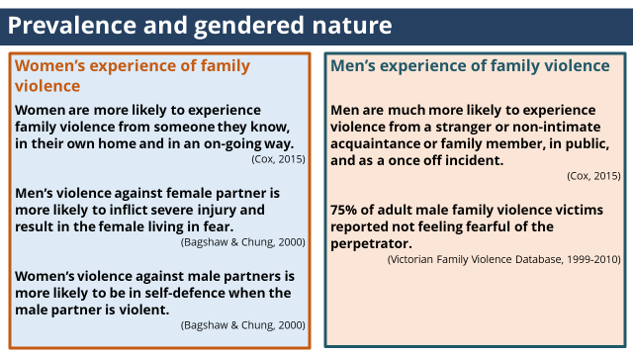 | Women and men both experience family violence. However, the way they experience family violence is different. | - Women and men both experience family violence. However, the way they experience family violence is different.  (click to reveal women’s experience)  - Women are more likely to experience family violence from someone they know, in their own home and in an on-going way. (Cox, 2015).  - Men’s violence against female partner is more likely to inflict severe injury and result in the female living in fear. (Bagshaw & Chung, 2000).  - Women’s violence against male partners is more likely to be in self-defence when the male partner is violent. (Bagshaw & Chung, 2000).  (click to reveal men’s experience)  - Men are much more likely to experience violence from a stranger or non-intimate acquaintance or family member, in public, and as a once off incident. (Cox, 2015)  - 75% of adult male family violence victims reported not feeling fearful of the perpetrator  - (Victorian Family Violence Database, 1999-2010)
NOTES
It is important to remember there may be participants that disbelieve or object to the messages in your training. It is important that facilitators are prepared to respond with appropriate facts, research and key messaging.
When asked ‘What about violence towards men?’ or ‘Why are you saying only males commit violence?’ in the training.
- It is important to clarify that the SHRFV approach and MARAM does not deny that males are victims of family violence, nor that only males perpetrate violence. All violence is unacceptable irrespective of gender.
- Understanding what the research tells us about the experiences and nature of family violence is important to be able to address the problem.
- Reiterate the statistics highlighted on the above slides.
- Refer to information and statistics in MARAM Framework. Including the section in Pillar 1 ‘Drivers of family violence include power imbalances and gender inequality.’

Slide 26: Prevalence and gendered nature  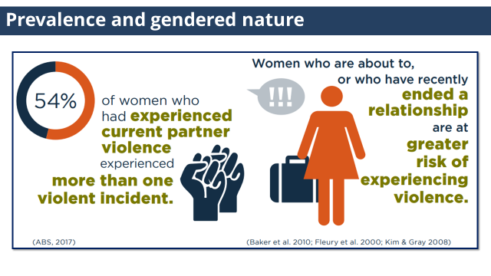 | These statistics highlight the on-going nature of family violence and why leaving a violent relationship is difficult for many women as this is a time of increased risk of harm. | - 54% of women who had experienced current partner violence experienced more than one violence incident. (ABS, 2017)  - Women who are about to, or who have recently ended a relationship are at greater risk of experiencing violence. (Barker et al, 2010, Fleury et al, 2000, Kim & Gray, 2008)  - These statistics highlight the on-going nature of family violence and why leaving a violent relationship is difficult for many women as this is a time of increased risk of harm.
NOTES
Leaving includes the most straightforward definition of the victim survivor leaving or the perpetrator being removed from the home due to being excluded as a result of an Intervention Order. However, what constitutes leaving may also include when the perpetrator realises that the relationship will not resume or his sense of control or power is challenged. For example, when the victim survivor begins a new relationship, or family court orders are initiated or finalised. This may even be years after the relationship itself has ended.

Slide 27: Family violence is a health issues  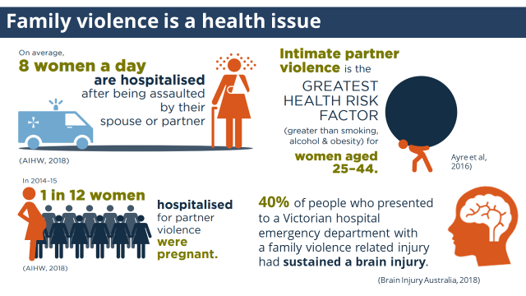 | Family violence is a health issue with severe and persistent impacts on a person’s physical, psychological and social well-being. | - Family violence is a health issue with severe and persistent impacts on a person’s physical, psychological and social well-being.  - Intimate partner violence is the greatest health risk factor for women aged 25-44. (VicHealth, 2004)  - On average, 8 women a day are hospitalised after being assaulted by their spouse or partner. (AIHW, 2018)  - 1 in 12 women that were hospitalised due to partner violence were pregnant. (AIHW, 2018)  - 40% of people who presented to a Victorian hospital emergency department with a family violence related injury had sustained a brain injury. (Brain Injury Australia, 2018)
Slide 28: Check your understanding  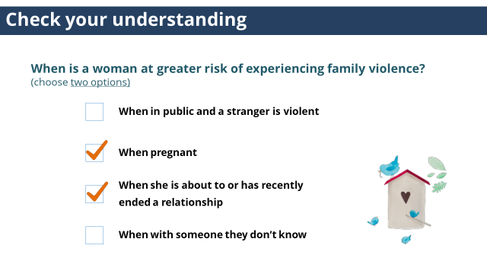 |  | Trainer to ask: When is a woman at greater risk of experiencing family violence? (choose two options)  - When in public and a stranger is violent  - When pregnant  - When she is about to or has recently ended a relationship  - When with someone they don’t know  (click to reveal answer)  Answer: 2&3  When she is about to or has recently ended a relationship:  - Leaving a violent relationship is difficult and many women will attempt to leave a number of times before finally separating. There are many reasons for this including an increased risk of harm.  - Violence often escalates when the woman is planning to leave or actually leaves, with an increased risk of assault, stalking and murder. Many family violence homicides occur during the separation period (DV Vic, 2015).  Pregnancy:  - Family violence often commences or intensifies during pregnancy (MARAM Framework).
NOTES
The above research showed that women are more likely to experience family violence in their own home and men are more likely to experience violence in public.
These statists also highlight two serious evidence based risk factors, physical assault while pregnant/following new birth and planning to leave or recent separation, which will be covered in later modules. Trainers may wish to highlight this point.

References
- Australia Bureau of Statistics (2017b). Personal Safety Survey 2016. ABS cat. No. 4519.0. Canberra: ABS.
- Australian Institute of Health and Welfare (2013). Aboriginal and Torres Strait Islander Health Performance Framework 2012 report: Australian Capital Territory. Cat. no. IHW 96. Canberra: AIHW.
- Bagshaw, D. & Chung, D. (2000). Women, Men and Domestic Violence. University of South Australia. Accessed on 6 September 2016 from: http://www.xyonline.net/sites/default/files/Bagshaw,%20Women,%20men%20and%20domestic%20violence.pdf
- Baker CK, Cook SL & Norris FH 2010. Domestic violence and housing problems: a contextual analysis of women’s help-seeking, received informal support, and formal system response. Violence Against Women9(7):754–83.
- Cox, P. (2015). Violence against women in Australia: Additional analysis of the Australian Bureau of Statistics’ Personal Safety Survey, 2012, Australia’s National Research Organisation for Women’s Safety (ANROWS). Accessed on 6 September 2016 from: http://anrows.org.au/publications/horizons/PSS
- Department of Justice (2012) Measuring Family Violence in Victoria: Victorian Family Violence Database Volume 5 Eleven Year Trend Analysis 1999-2010, State Government of Victoria.
- Diemer, K. (2015). ABS Personal Safety Survey: Additional analysis on relationship and sex of perpetrator.
- Fleury RE, Sullivan CM & Bybee DI 2000. When ending the relationship does not end the violence:women’s experiences of violence by former partners. Violence Against Women 6(12):1363–83.
- Gabbe, B., Ayton, D., Pritchard, E. K., Tsindos, T., O'Brien, P., King, M., Braaf, S., Berecki-Gisolf, J., & Hayman, J. (2018). The Prevalence of Acquired Brain Injury Among Victims and Perpetrators of Family Violence. Brain Injury Australia.
- Kim J & Gray KA 2008. Leave or stay? Battered women’s decision after intimate partner violence. Journal of Interpersonal Violence 23(10):1465–82.
- VicHealth (2004). The health costs of violence: Measuring the burden of disease caused by intimate partner violence. Accessed on 6 September 2016 from: <https://www.vichealth.vic.gov.au/media-and-resources/publications/the-health-costs-of-violence>

TOPIC: Understanding attitudes, structural inequalities & discrimination

Nominal duration: 15 minutes
Purpose: To provide participants with an understanding of how attitudes, structural inequalities and discrimination create the condition for violence to occur and for certain groups to experience increased risks of family violence.

Resources for Trainer
- MARAM Framework.
- Dhelk Dja: Safe Our Way - Strong Culture, Strong Peoples, Strong Families (2018) This document is the Aboriginal 10-year family violence agreement for 2018-2028, and is a community-led Aboriginal agreement to address family violence.
- Everybody matters: Inclusion and Equity Statement (2018) - This document is the Victorian Government’s 10-year vision for a more inclusive, safe, responsive and accountable family violence system.
- Video: Family Safety Victoria (2019) Everybody Matters: Inclusion and Equity Statement.
- The Our Watch ‘Change The Story: A shared framework for the primary prevention of violence against women and their children in Australia’ (2015) is a primary prevention framework based on international research identifying gender inequality as the key driver of family violence. The Our Watch ‘Changing the Picture, A national resource to support the prevention of violence against Aboriginal and Torres Strait Islander women and their children’ (2018) resource looks at how gender inequality interacts with other forms of structural discrimination including colonisation to drive violence against Aboriginal and Torres Strait Islander people.

Slide | Key message/s | Facilitator dialogue
Slide 29: Understanding attitudes, structural inequality & discrimination  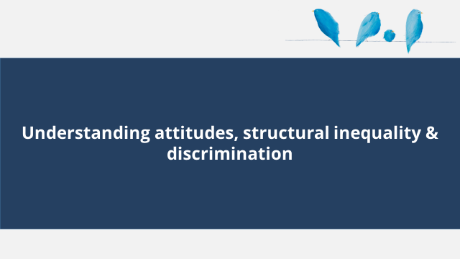 |  | - This section covers understanding attitudes, structural inequality & discrimination.
Slide 30: Attitudes and gender inequality 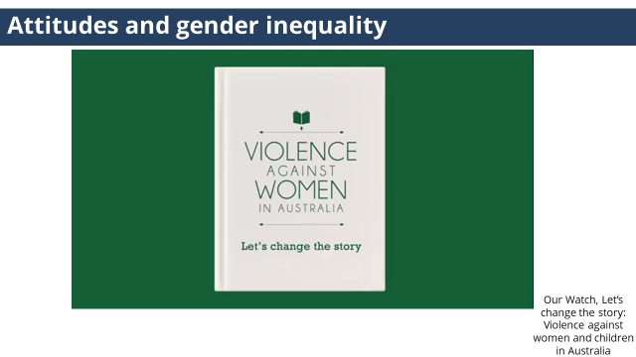 |  | - We are now going to watch a short video about attitudes of violence and gender inequality. This resource was developed by Our Watch who is the national leader in the primary prevention of violence against women and their children in Australia.  (click on image to be taken to the youtube video)
NOTES
For more information refer to the Our Watch ‘Change The Story: A shared framework for the primary prevention of violence against women and their children in Australia’ (2015) is a primary prevention framework based on international research identifying gender inequality as the key driver of family violence.
If you can’t access youtube, the video can also be accessed through the following link, Change the story | Our Watch | Preventing violence against women - Our Watch. Video is approximately 4.28 mins in length.

Slide 31: Check your understanding  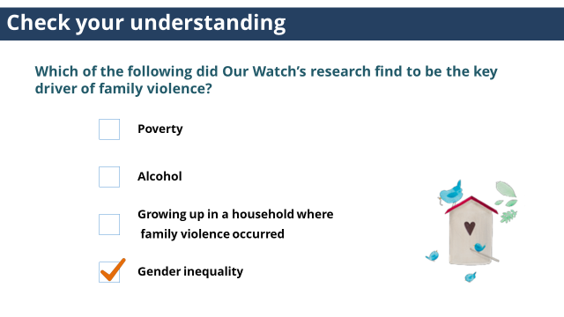 |  | Trainer to ask: Which of the following did Our Watch’s research find to be the key driver of family violence?  - Poverty  - Alcohol  - Growing in up in a household where family violence occurred  - Gender inequality  (click to reveal answer)  Answer: Gender inequality  - Family violence is a deeply gendered issue rooted in structural inequalities and an imbalance of power between men and women and community attitudes towards women. Gender inequality creates the necessary conditions in which violence against women occurs.  - A gendered lens can also recognise that gender inequality in our society can have an impact on relationship structures and dynamics even outside of heterosexual relationships such as same sex relationships.
NOTES
Poverty, alcohol use or childhood experience of family violence may increase the likelihood, frequency or severity of violence but are not causes of family violence themselves.
Most people who consume alcohol do not perpetrate family violence. Perpetrators including those who drink alcohol, will not be violent towards others, only towards a specific person, demonstrating when and to whom violence is used is a choice. However in a situation where family violence is already occurring intoxication may lead to an increase in severity of the violence.
Poverty is often assumed to be a cause of family violence because family violence can be more visible in communities with less access to resources and support.
Experience of, and exposure to violence as a child is described as a ‘reinforcing factor’, and can make some people more accepting of violence against women, but conversely it can make others highly intolerant, having experienced its effects, as such this is not a cause of family violence.

Slide 32: Prevalence  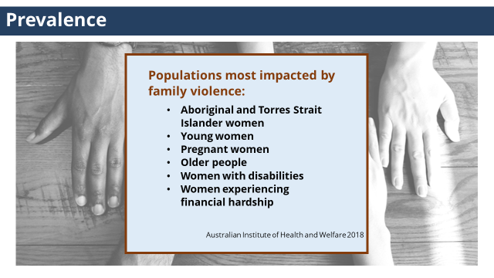 | There are a number of factors that when they intersect with gender can greatly increase the risk of experiencing family violence. | - There are a number of factors that when they intersect with gender can greatly increase the risk of experiencing family violence.  - Populations most impacted by family violence:  - Aboriginal and Torres Strait Islander women  - Young women  - Pregnant women  - Older people  - Women with disabilities  - Women experiencing financial hardship  (Australian Institute of Health and Welfare 2018)
Slide 33: Prevalence  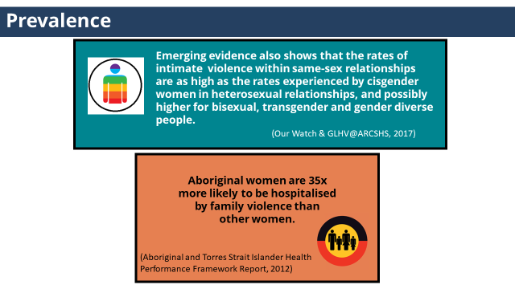 | It is important to understanding that the rates of intimate partner violence within same-sex relationships are as high as the rates experienced by cisgender women in heterosexual relationships and Aboriginal women experience higher rates and severity of violence. | - Emerging evidence also shows that the rates of intimate partner violence within same-sex relationships are as high as the rates experienced by cisgender women in heterosexual relationships, and possibly higher for bisexual, transgender and gender diverse people.[Our Watch & GLHV@ARCSHS (2017)]  - Aboriginal women are 35 times more likely to be hospitalised by family violence than other women. This reflects the higher rates and severity of violence experienced by Aboriginal women.  (Aboriginal and Torres Strait Islander Health Performance Framework Report, 2012)
NOTES
The term “cicgender” (pronounced “sis-gender”) refers to people whose gender identify and expression matches the biological sex they were assigned when they were born. Australian Pride Network

Slide 34: Prevalence  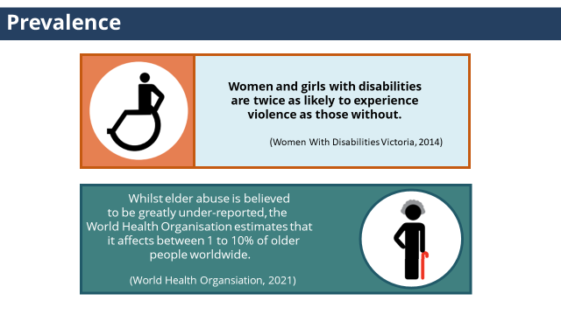 | It is important to understand the experiences of family violence for women and girls with a disability and older people. | - Women and girls with disabilities are twice as likely to experience violence as those without.  (Women With Disabilities Victoria, 2014)  - Whilst elder abuse is believed to be greatly under-reported, the World Health Organisation estimates that it affects between 1 to 10% of older people worldwide. (World Health Organisation, 2021)
References
- Australian Institute of Health and Welfare (2013). Aboriginal and Torres Strait Islander Health Performance Framework 2012 report: Australian Capital Territory. Cat. no. IHW 96. Canberra: AIHW.
- Australian Institute of Health and Welfare (2018). Family, domestic and sexual violence in Australia 2018. Cat. no. FDV 2. Canberra: AIHW.
- Our Watch & GLHV@ARCSHS (2017). An analysis of exiting research: primary prevention of family violence against people from LGBTI communities. Melbourne, Vic: Our Watch.
- Women with Disabilities Victoria (2014). Violence Against Women With Disabilities, Fact Sheet 3, Women with Disabilities. Victoria, Melbourne.
- World Health Organisation, 2021, accessed 8th March 2021, <https://www.who.int/ageing/projects/elder_abuse/en/>

Slide 35: Structural inequality and discrimination  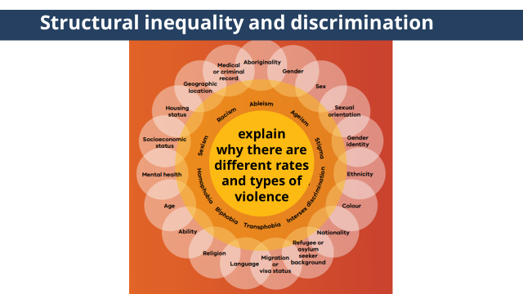 | In addition to gender inequality, women often experience other forms of structural inequality which leads to different rates and types of violence experienced by women and others. | Trainer to ask: What leads to increased rates of family violence towards some women and others in our community?  (click to reveal image)  - What these statistics show to is not that violence is more inherent in some communities,  (click to reveal second state of image)  - but that in addition to gender inequality, women often experience  (click to reveal third state of image)  - other forms of structural inequality and discrimination, such as racism, ableism, ageism, homophobia and colonisation.  (click to reveal forth state of image)  - This helps to explain why there are different rates and types of violence experienced by different women and others.
Slide 36: Intersectionality  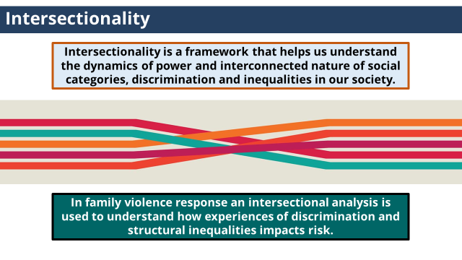 | Intersectionality is a framework that helps us understand the impact of discrimination and inequalities in our society. | - Intersectionality is a framework that helps us understand the dynamics of power and interconnected nature of social categories, discrimination and inequalities in our society.  (click to reveal second text)  - In family violence response context, an intersectional analysis is used to understand how experiences of discrimination and structural inequalities impact risk.
Slide 37: Intersectionality  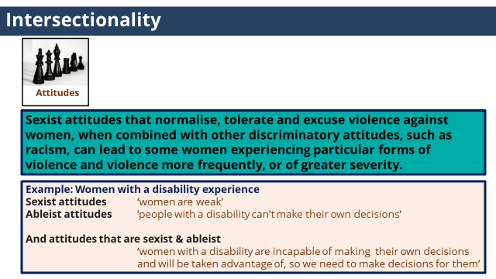 | Sexist attitudes, when combined with other discriminatory attitudes, can lead to some women experiencing particular forms of violence and violence more frequently, or of greater severity. | - Applying intersectionality within the context of family violence means understanding that.  (double click to show attitude image and notes)  - Sexist attitudes that normalise, tolerate and excuse violence against women, when combined with other discriminatory attitudes, such as racism, can lead to some women experiencing particular forms of violence and violence more frequently, or of greater severity.  (click to reveal example)  - For example, women with a disability experience  - sexist attitudes, for example ‘women are weak’,  - Ableist attitudes, for example “people with a disability can’t make their own decisions’  - And attitudes that are ableist & sexist, for example ‘women with a disability are incapable of making their own decisions and will be taken advantage of, so we need to make decisions for them’.
Slide 38: Intersectionality  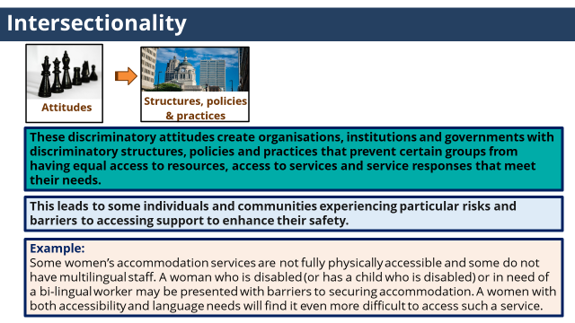 | Discriminatory attitudes create organisations, institutions and governments with discriminatory policies and practices that prevent certain groups from having, access to services and service responses that meet their needs and enhance their safety. | (double click to show attitude image and notes)  - These discriminatory attitudes create organisations, institutions and governments with discriminatory structures, policies and practices that prevent certain groups from having equal access to resources, access to services and service responses that meet their needs.  (click to reveal note)  - This leads to some individuals and communities experiencing particular risks, forms of family violence and barriers to accessing support to enhance their safety.  (click to reveal example)  - For example, some women’s accommodation services are not fully physically accessible and some do not have multilingual staff. A woman who is disabled (or has a child who is disabled) or in need of a bi lingual worker may be presented with barriers to securing accommodation. A women with both accessibility and language needs will find it even more difficult to access such a service.
Slide 39: Intersectionality  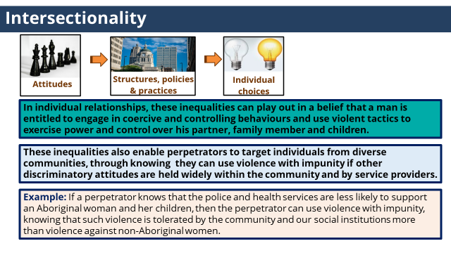 | In individual relationships, these inequalities can play out in a belief that a man is entitled to engage in coercive and controlling behaviours and use violent tactics to exercise power and control over others.  These inequalities also enable perpetrators to target individuals from diverse communities, through knowing they can use violence with impunity. | (double click to show attitude image and notes)  - In individual relationships, these inequalities can play out in a belief that a man is entitled to engage in coercive and controlling behaviours and use violent tactics to exercise power and control over his partner, family member and children.  (click to reveal note)  - These inequalities also enable perpetrators to target individuals from diverse communities, through knowing they can use violence with impunity if other discriminatory attitudes are held widely within the community and by service providers.  (click to reveal example)  - For example, if a perpetrator knows that the police and health services are less likely to support an Aboriginal women and her children, then the perpetrator can use violence with impunity, knowing that such violence is tolerated by the community and our social institutions more than violence against non-Aboriginal women.
Slide 40: Intersectionality  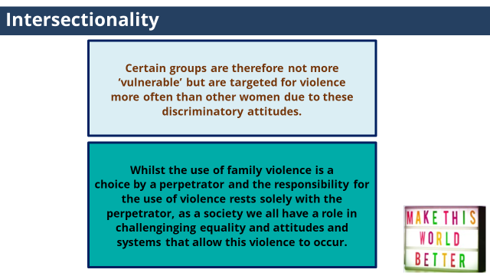 | As a society we all have a role in challenging inequality, attitudes and systems that allow violence to occur. | - Certain groups are therefore not more ‘vulnerable’ but are targeted for violence more often than other women due to these discriminatory attitudes.  (click to reveal second state)  - Whilst the use of family violence is a choice by a perpetrator and the responsibility for the use of violence rests solely with the perpetrator, as a society we all have a role in challenging inequality, attitudes and systems that allow this violence to occur.
NOTES
Participants may suggest certain groups experience higher rates of violence because they are “vulnerable”. These ideas and attitudes should be explored and reframed.

The term “vulnerable” is problematic as it:
- reinforces power imbalances (if we see someone as vulnerable then it is often also thought they need “protection” which often serves to impose limits and control over their autonomy)
- locates responsibility for the violence with the victim (or their membership of a diverse population group) rather than with the perpetrator.

Instead of referring to groups of people as “vulnerable” to violence we can name the issue and locate responsibility with the perpetrator by saying that “perpetrators of violence may target women with disabilities”.

Slide 41  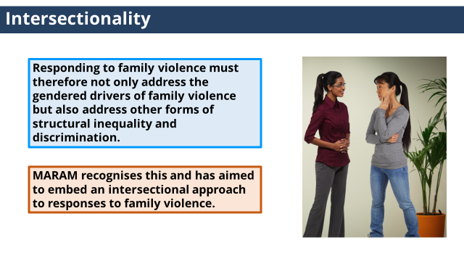 | To be effective, responding to family violence must address other forms of structural inequality and discrimination. | - Responding to family violence must therefore not only address the gendered drivers of family violence but also address other forms of structural inequality and discrimination.  - MARAM recognises this and has aimed to embed an intersectional approach to responses to family violence.  - Throughout this training we will come back to this concept through applying an intersectional approach in different elements of practice.

TOPIC: Barriers to disclosure

Nominal duration: 25 minutes
Purpose: To provide participants with an understanding of barriers victim survivors may experience to disclosing family violence and seeking support and safety.

Resources for Trainers
- MARAM Framework.
- Dhelk Dja: Safe Our Way - Strong Culture, Strong Peoples, Strong Families (2018) This document is the Aboriginal 10-year family violence agreement for 2018-2028, and is a community-led Aboriginal agreement to address family violence.
- Everybody matters: Inclusion and Equity Statement (2018) - This document is the Victorian Government’s 10-year vision for a more inclusive, safe, responsive and accountable family violence system.
- Video: Family Safety Victoria (2019) Everybody Matters: Inclusion and Equity Statement.

Slide | Key message/s | Facilitator dialogue
Slide 42: Barriers to disclosure  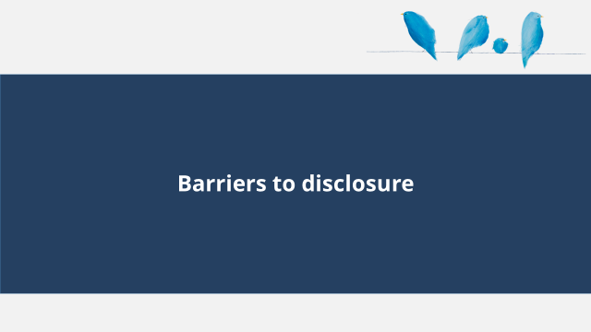 |  | - This section covers barriers to disclosure
Slide 43: Barriers to disclosure  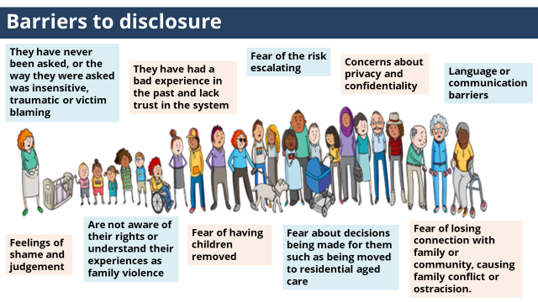 | It is important to understand the barriers victim survivors may face to disclosing family violence and seeking support and safety. | Trainer to ask: What stops people from disclosing family violence and seeking support and safety?  - There are many barriers to victim survivors disclosing family violence and seeking support and safety.  (click to reveal first group of examples)  - They have never been asked, or the way they were asked was insensitive, traumatic or victim blaming  - Fear of the risk escalating  - Language or communication barriers  - Are not aware of their rights or understand their experiences as family violence  - Fear about decisions being made for them such as being moved to residential aged care  (click to reveal second group of examples)  - They have had a bad experience in the past and lack trust in the system  - Concerns about privacy and confidentiality  - Feelings of shame and judgement  - Fear of having children removed  - Fear of losing connection with family or community, causing family conflict or ostracision.  - How barriers manifest for an individual will differ, and will depend on their lived experience.  - One element of an intersectional approach in responses to family violence is to actively seek to understand a person’s experiences of inequality and discrimination and how these have created additional barriers to disclosing and seeking support and safety.  - Let’s look at some case studies to understand some of the barriers faced by particular communities within our society.
ACTIVITY ONE: Barriers to disclosure
Purpose: The purpose of this activity is to build participants awareness of the different barriers diverse group may face to leave an abusive relationship or seek support, and how it may present for a patient.

Time: 15 mins

Instructions:
- Trainer to hand out a copy of Activity One to each participants (or a few copies per group).
Trainer to choose the version of the activity with the professions that best fits with the roles of each participant.
- Trainer to introduce the activity by outlining the purpose of the activity.
- Trainer to ask participants to work in small groups and read through each of the three case studies and the common barriers, and then as a group discuss which of the common barriers the case study highlights.
- Allow participants approximately 5 mins to work on the activity
- Trainer to facilitate large group discussion about answers.

Answers:
The presentation of the case studies differs for the different professions, however the answers are the same.
Case Study One:
Below are some common barriers for a newly arrived individual to leave an abusive relationship.
In Phuong’s case what barrier has she described facing?
(choose the one that most applies)

- Victim survivors on a spousal visa may have limited options to leave as they are not able eligible for income support or public housing.
- Victim survivors with limited English may face barriers to accessing appropriate support.
- Fear of authority such as police due to experiences in their home country may create barriers to seeking support.
- Service responses that reinforce incorrect beliefs that wrongly attributing violence as being ‘part of her culture’.

Answer: 2. Victim survivors with limited English may face barriers to accessing appropriate support.
Phuong said she had difficulty understanding some of the questions and telling her story as no interpreter was used can be seen as an example of a victim survivors with limited English facing a barriers to accessing appropriate support

Case Study Two:
Below are some common barriers for an Aboriginal woman to seek support.
In Darlene’s case what barrier has she described facing?
(choose the one that most applies)

- Lack of culturally safe services.
- Fear of police involvement due to high rates of Aboriginal and Torres strait islander deaths in custody.
- Previous experiences of racist attitudes that condone discrimination and violence towards Aboriginal peoples.
- Fear of children being taken away due to the historical context of child removal and current higher rates of Aboriginal children in care.

Answer: 1. Lack of culturally safe services.
Darlene’s experience of having her Aboriginal identity questioned and feeling her identify was not believed can be seen as an example of a culturally unsafe response and has created a barriers to future help seeking.

Case Study Three:
Below are some common barriers to seeking support for a gay man.
In Michael’s case what barrier has he described facing?
(choose the one that most applies)
- Current and historical discriminatory laws against people on the basis of sexuality contribute to a fear of reporting to police
- Homophobic attitudes that have resulted in isolation from their family or community of orgin may deter reporting due to fear of further isolation
- Poor levels of understanding by mainstream services about violence against gay people can limit support options.
- Communities who experience discrimination may face the additional burden of wanting to present a positive image of their community which can create barriers to disclosing and seeking support.

Answer: 2: Homophobic attitudes that result in having less support from their family of origin may deter reporting of family violence due to fear of isolation or losing community support or connections.
Michael’s family not accepting his sexuality or relationship is likely the result of homophobic attitudes and to have resulted in his isolation from family or community of origin. Michael’s concern that his friend’s won’t believe Dave is abusive may deter him from disclosing out of a fear of further isolation.

Slide 44: Accessible and inclusive services  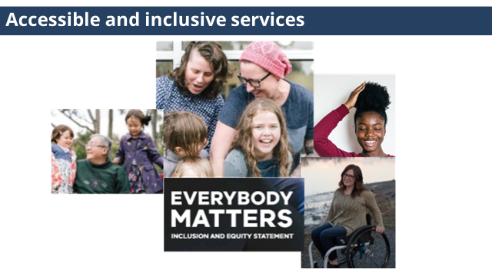 | We can’t support someone if they don’t want to - or can’t - access our service. | - To address attitudes, structural inequalities and discrimination and respond effectively to family violence our services need to be accessible, inclusive and non-discriminatory. We can’t support someone if they don’t want to - or can’t - access our service.  - This video highlights the strategy the Victorian Government is taking to build an inclusive, safe, responsive and accountable family violence service system.  (click on image to open you tube video)
NOTES
If you can’t access youtube, the video can also be accessed through the following link, Everybody Matters: Inclusion and Equity Statement | Victorian Government (www.vic.gov.au). Video length 4.12 mins.

TOPIC: Conclusion
Nominal Time: 20 mins
ACTIVITY TWO: Quiz
Purpose: The check participant’s knowledge of key knowledge covered in Module 1.

Time: 5mins

Instructions:
- Trainer to hand out Activity Two to each participant.
- Trainer to introduce the activity by outlining the purpose of the activity.
- Trainer to ask participants to complete Quiz individually.
- Trainer to facilitate large group discussion about answers.

Answers:
1. As a staff member with Intermediate responsibilities under MARAM, my role includes:
- Engaging respectfully, sensitively and safely with patients
- Identifying family violence
- Undertaking intermediate risk assessment
- Undertaking intermediate risk management
- Sharing information in line with my organisational policy to collaborate on family violence risk assessment and risk management
- Seek secondary consultation and make referrals as required
- Contribute to coordinated and collaborative risk management and ongoing risk assessment
Answer: all of the above
These reflect the MARAM responsibilities, that pracitioners with Intermediate responsibilities are required to align their practice to.

2. True or False
Family violence differs from other forms of violence. It is generally a pattern of behaviour underpinned by coercion, control and domination by one person over another.
Answer: True
This was covered in the definition of family violence.

3. True or false
Gender inequality contributes to the murder of one women every week in Australia.
Answer: True
This statistic was covered in the Our Watch video.

4. What groups are considered to be at greater risk of family violence?
- Aboriginal and Torres Strait Islander women
- Pregnant women
- Women separating from their partners
- All of the above
Answer: all of the above.
This was covered in the statistics in the prevalence and gendered nature slides.

Slide 45: Module 1 summary  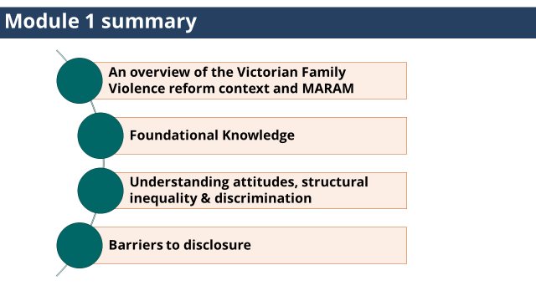 |  | - Module 1 summary  - An Overview of the Victorian Family Violence reform context and MARAM  - Foundational Knowledge  - Understanding attitudes, structural inequality, and discrimination.  - Barriers to disclosure
Slide 46: Reflection  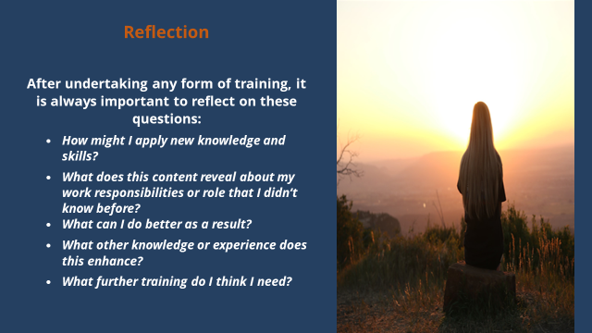 | After undertaking any form of training, it is always important to reflect on your learnings. | Trainer to ask:  - After undertaking any form of training, it is always important to reflect on what you have learnt.  - The questions on the slide can be used to facilitate this reflection.  - Trainer to invite participants to turn to the person next to them and share a key learning for them from this training.
Slide 47: Self-care  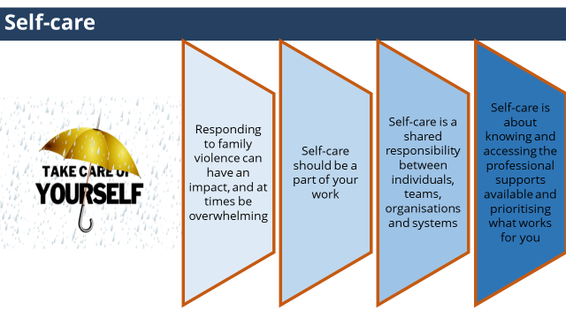 | Self-care should be a part of your work and is a shared responsibility between individuals, teams, organisations and systems. | - While this work can be experienced as a privilege, knowing the difference that we can make to the lives of those that we assist.  - It is important to acknowledge you can be personally affected by hearing about traumatic events, and by witnessing the impact and distress that it causes.  - It can also become personally draining, and at times overwhelming.  - Self-care should be a part of your work and is a shared responsibility between individuals, teams, organisations and systems.  - Self care is any activity that we do deliberately in order to take care of our mental, emotional and physical health and can include:  Self-care is about knowing and accessing the professional supports avilable.  - Manager or supervisor  - Debriefing (formal and informal)  - Professional/clinical supervision  - Family violence workplace contact via the Workplace Support Program  - Clinical champions  - Employee Assistance Program  - Centre Against Sexual Assault - 24/7 counselling for professionals  - 1800 RESPECT - 24/7 counselling for professionals  And knowing and prioritising what works for you.  - Talking with someone you trust  - Taking regular breaks and annual leave  - Healthy eating and exercise  - Work-life balance and keeping work and your personal life separate  - Prioritise activities you find enjoyable outside of work  Trainer to ask:  Trainer to invite particpants to turn to the person next to them and share two things that supports their self-care.
Slide 48: Thankyou |  | - Thank particpants for coming.  - Trainer to let paritpants know the scheduled time for Module 2.

MODULE 2
Time: 2 hours
TOPIC: Welcome, acknowledgements, housekeeping & overview
Nominal duration: 5 minutes
Purpose: To make acknowledgements, establish expected behaviour in training environment and provide participants with an overview of the training.
Slide | Key message/s | Facilitator dialogue
Slide 1: Introduction  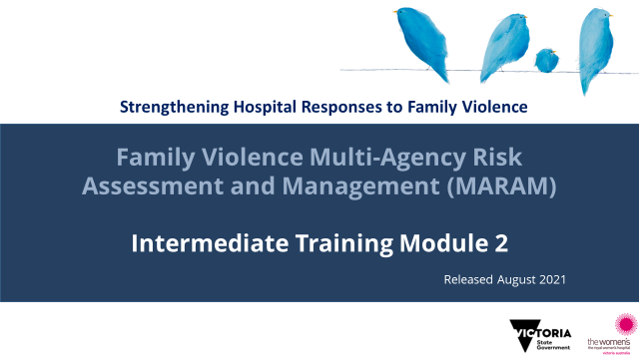 | Acknowledgement of traditional owners, victim survivors module outline. | Welcome  - Introduce training.  - Welcome participants.  Acknowledgement of country  - Acknowledge the Traditional Aboriginal Owners of country on which the training is taking place. Pay respects to them, their culture and their Elders past, present and emerging, as well as any community members here today in the room with us. Acknowledge that sovereignty of this land was never ceded.  Acknowledgement of victim survivors  - We wish to acknowledge victim survivors of family violence, particularly women and children that have been killed in the context of family violence.  - We hope what is presented in this training is respectful to their individual experiences.  Housekeeping  - Outline duration of training, break times (if scheduled) and OH&S requirements (fire exits etc.).
NOTES
The Aboriginal Victoria website has an interactive map that allows you to search for the Traditional Owners of a particular area. It also documents areas where this is contested. Taking the time to be aware of and acknowledge the Traditional Owners of the area where training is being delivered is an opportunity to honour Victoria’s strong and proud Aboriginal and Torres Strait Islander history.

Slide 2: Safe learning environment | Throughout the session be mindful of confidentiality, be respectful of diverse opinions and various levels of knowledge, and ways we can all support this to be a safe learning environment for everyone. | - Remind participants of the group expectations to support a safe learning environment that were covered in Module 1.
Slide 3: Self-care | To highlight the importance of self-care and for participants to be aware of services they can contact if they are impacted by the training. | - Discussing family violence can be distressing, particularly if you have experienced or been impacted by violence.  - If this training causes any concern for yourself or another you can discontinue at any time; however we encourage you to contact one of these services or your workplace Employee Assistance Program for support.  - Information about these services can be found in your Participant Guide.
Slide 4: Training overview  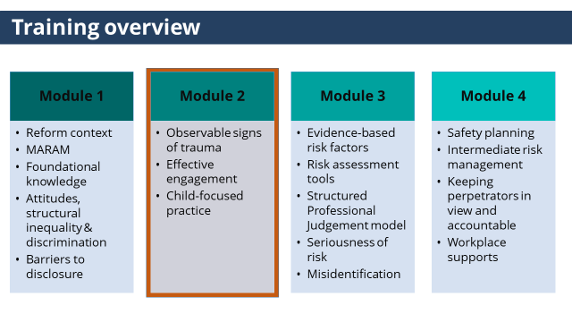 | This training aims to build the knowledge and skills to respond effective to victim survivors of family violence at an Intermediate level under MARAM.  This is Module 2. | - This training has 4 modules, and has been designed to cover the skills and knowledge required by practitioners whose role includes intermediate responsibilities under MARAM.  (click to reveal highlighted state)  - This is module 2, module 2 will cover:  - Observable signs of trauma  - Effective engagement  - Promoting victim survivor agency  - Creating a safe environment to disclose  - Sensitive response  - Responding to discriminatory attitudes and beliefs  - Culturally safe, accessible and inclusive practice  - Child-focused practice
Slide 5: Introductions | Gauge participant expectations of the training. | Trainer to ask:  - Participants to introduce themselves (name, role etc.).  - Share what they are wanting to achieve or ‘get out of’ today’s training.
NOTES
Trainers may wish to set this up as an activity where participants share what they want to get out of the training (either verbally with the group or on a Post It note, with Trainers writing them on a wall/whiteboard, and returning to this at the conclusion of the session to see if they have been addressed.

TOPIC: Observable Signs of Trauma

Nominal duration: 15 minutes
Purpose: To build participants knowledge of observable signs of trauma and practice identifying observable signs of trauma in practice.

Resources for Trainers
- MARAM Practice Guides: Responsibility 2: Identification of Family Violence Risk.
Appendix 1 of the above practice guide has a list of observable signs of trauma.

Slide | Key message/s | Facilitator dialogue
Slide 6: Observable signs of trauma  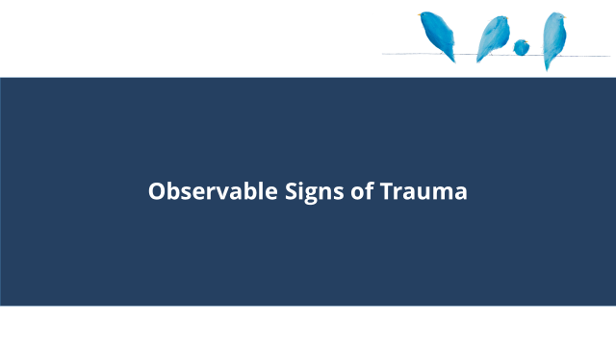 |  | - This section will cover observable signs of trauma.
Slide 7: What are observable signs of trauma?  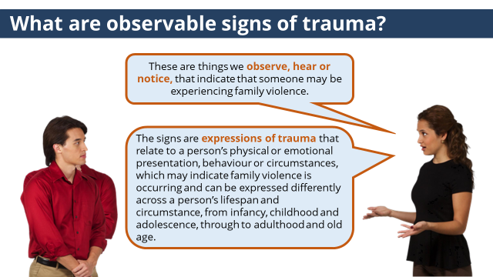 | Observable signs of trauma are things we observe, hear or notice, that indicate that someone may be experiencing family violence before family violence has been disclosed. | - You may be working with someone before family violence has been identified, so it’s important to understand the observable signs of trauma that may indicate someone is experiencing family violence to prompt a sensitive enquiry and offer of support.  Trainer to ask: What do we mean by observable signs of trauma?  (click to reveal answer)  - These are things we observe, hear or notice, that indicate that someone may be experiencing family violence.  (click to reveal second answer)  - The signs are expressions of trauma that relate to a person’s physical or emotional presentation, behaviour or circumstances, which may indicate family violence is occurring and can be expressed differently across a person’s lifespan and circumstance, from infancy, childhood and adolescence, through to adulthood and old age.  - In a hospital or health service setting observable signs of trauma may also be referred to as clinical indicators of family violence.
Slide 8: Observable signs of trauma  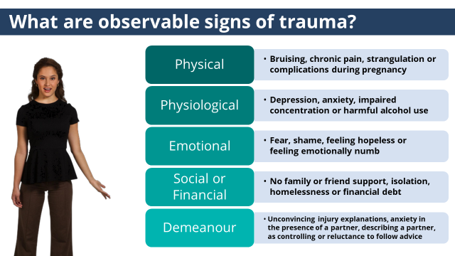 | It is important to be familiar with the observable signs of trauma outlined in the MARAM Framework. | - Observable signs of trauma can be:  - Physical such as bruising, chronic pain, strangulation or complications during pregnancy  - Physiological such as depression, anxiety, impaired concentration or harmful alcohol use  - Emotional such as fear, shame, feeling hopeless or feeling emotionally numb  - Social or financial such as no family or friend support, isolation, homelessness or financial debt  - Demeanour such as having unconvincing explanations of injury; anxiety in the presence of a partner, family member or carer; describing a partner, family member or carer as controlling or prone to anger; or reluctance to follow advice
Slide 9: Observable signs of trauma  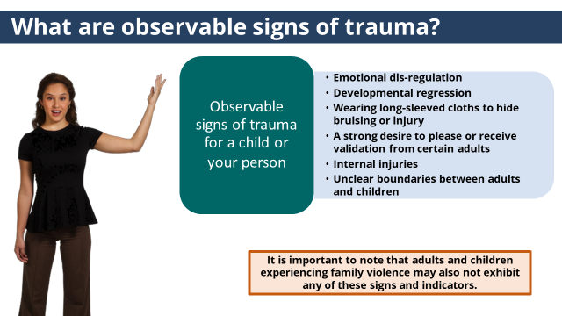 | It is important to be familiar with the observable signs of trauma for a child or young person.  If you don’t observe any signs but think that something is ‘not quite right’, you should continue with a sensitive enquiry to explore whether family violence might be occurring and offer of support. | - Observable signs of trauma for a child or young person  - Emotional dis-regulation  - Developmental regression  - Wearing long-sleeved clothes to hide bruising or injury  - A strong desire to please or receive validation from certain adults  - Internal injuries  - Unclear boundaries between adults and children  - It is important to note that observable signs of trauma do not by themselves indicate family violence. In some situations and combinations however, they may raise a suspicion of family violence.  (click to reveal note)  - It is important to note that adults and children experiencing family violence may also not exhibit any of these signs and indicators.  - If you don’t observe any signs or indicators but think that something is ‘not quite right’, you should continue with a sensitive enquiry to explore whether family violence might be occurring and offer of support.  - Appendix 1 of MARAM Practice Guide Responsibility 2 lists observable signs of trauma.
ACTIVITY ONE: Observable signs of trauma
Purpose: The purpose of this activity is to give participants an awareness of how family violence may present in a health setting and practice identifying observable signs of trauma before family violence has been disclosed.

Time: 10 mins

Instructions:
- Trainer to hand out a copy of Activity One to each participant (or a few copies per group).
Trainer to choose the version of the activity with the professions that best fits with the roles of each participant.
- Trainer to introduce the activity by outlining the purpose of the activity.
- Trainer to ask participants to work in small groups and read through each part of the case study and identify the observable signs of trauma present in the case study.
- Trainer to facilitate large group discussion about answers.
- Conclude activity with sentence such as ‘From the information provided there are observable signs of trauma that may indicate Ania is experiencing family violence, and if you were working with Ania you should proceed with a sensitive inquiry to confirm this.’

Answers:

SOCIAL WORKER IN A HOSPTIAL AND MENTAL HEALTH CLINICIAN
The presentation of the case studies differ for the professions, however the answers are the same.
Part 1:
Which three observable signs of trauma for an adult are present in Ania’s case?
- Isolation
- Indicators of strangulation
- Needing to be back home by a certain time and becoming stressed about this
- Describe a partner as controlling or prone to anger

Answer: 1, 3 & 4
Isolation: Imran not liking Ania spending time with friends is a sign Iman is using tactics to isolate Ania.
Describe a partner as controlling: Ania describing Imran as a bit of a control freak is a sign Imran is controlling.
Needing to be back home by a certain time and becoming stressed about this: Ania left her appointment early as she needed to be back home, and appeared stressed about this.

Part 2:
Which two observable signs of trauma for a child or young person are present for Sabina?
- Acting like a much younger child
- Limited tolerance and poor impulse control
- Poor school performance
- Being excessively clingy to certain adults

Answer: 1 & 4
Acting like a much younger child: ‘Ania disclosed Sabina has been using baby talk a lot lately’.
Being excessively clingy to certain adults: Ania disclosed that Sabina ‘doesn’t like being a part and always clings to her’.

CARE COORDINATOR IN AN EMERGENCY DEPARTMENT
Part 1:
Which three observable signs of trauma for an adult are present for Ania?
- Isolation
- Indicators of strangulation
- Needing to be back home by a certain time and becoming stressed about this
- Describe a partner as controlling or prone to anger

Answer: 1, 3 & 4
Isolation: Imran not liking Ania spending time with family and friends is a sign Iman is using tactics to isolate Ania.
Needing to be back home by a certain time and becoming stressed about this: Ania decided to return home as Imran wanted her back home, and appeared stressed about this.
Describe a partner as controlling: Ania describing Imran as a bit of a ‘control freak’ is a sign Imran is controlling.

Part 2:
Which two observable signs of trauma for a child or young person are present for Sabina?
- Delayed or poor language skills
- Acting like a much younger child
- Being excessively clingy to certain adults
- Complaining of headaches or stomach pains

Answer: 1 & 3
Delayed or poor language skills: Ania disclosed Sabina has delayed speech.
Being excessively clingy to certain adults: Ania disclosed that Sabina ‘doesn’t like being a part’ and ‘always clings’ to her.

HOSPTIAL ADMISSION RISK PROGRAM (HARP) CLINICIAN
Part 1
Which three observable signs of trauma in adult victims are present for Ania?
- No friends or family support
- Physical exhaustion
- Describe a partner, carer or family member as controlling or prone to anger
- Unconvincing explanations of any injuries

Answer: 1, 2 & 3
No friends or family support : Ania said she doesn’t have any family or friend support’.
Physical exhaustion: Ania said she is physically exhausted
Describe a partner, carer or family member as controlling or prone to anger: Ania described Imran as a bit of a ‘control freak’ is a sign Imran is controlling.

Part 2:
Which two observable signs of trauma for a child or young person are present for Sabina?
- Delayed or poor language skills
- Acting like a much younger child
- Sleep issues
- Complaining of headaches or stomach pains

Answer: 1, 3 & 4
Delayed or poor language skills: Ania said Sabina has delayed speech
Sleep issues: Ania said Sabina is having trouble sleeping
Complaining of headaches or stomach pains: Ania said Sabina has been complaining of headaches

TOPIC: Effective Engagement

Nominal duration: 65 minutes
Purpose: To build participants knowledge of elements of effective engagement in family violence response and practice applying them in practice.

Resources for Trainers
- MARAM Framework.
- MARAM Practice Guides: Responsibility 1: Respectful, Sensitive and Safe Engagement.
- World Health Organization (2013). Responding to intimate partner violence and sexual violence against women. In WHO clinical and policy guidelines. Geneva, Switzerland: WHO.
- State of Victoria, Department of Health and Human Services, (2018), ‘Dhelk Dja: Safe Our Way - Strong Culture, Strong Peoples, Strong Families’

Slide | Key message/s | Facilitator dialogue
Slide 10: Effective engagement - Promoting victim survivor agency  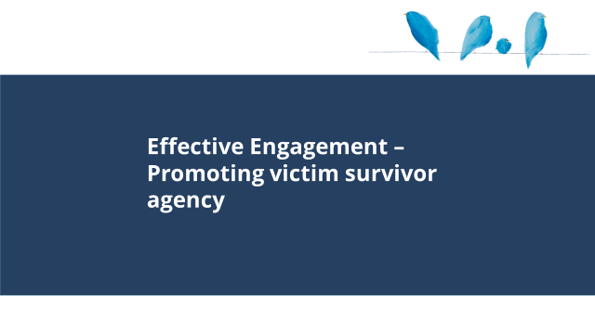 |  | - Promoting victim survivor agency should be central to any engagement with victim survivors of family violence.
Slide 11: Promoting victim survivor agency  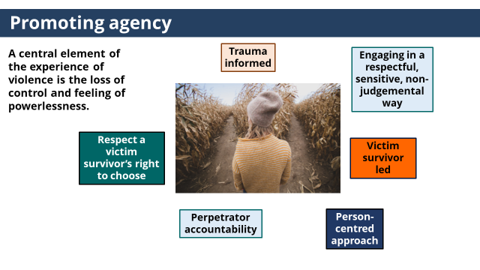 | The agency, dignity and intrinsic empowerment of victim survivors must be respected by partnering with them as active decision-making participants in risk assessment and management. | - A central element of the experience of violence is the loss of control and feeling of powerlessness.  - Therefore the governing principle in engagement is to promote a victim survivor’s agency and give individuals experiencing family violence as much control over their engagement as possible.  - Taking this approach will help address barriers to disclosure and support seeking for victim survivors.  - A MARAM Framework Principle - is the agency, dignity and intrinsic empowerment of victim survivors must be respected by partnering with them as active decision-making participants in risk assessment and management.  Trainer to ask: How can a victim survivor’s agency be promoted in practice?  Trainer to facilitate conversation, ensuring the following points are covered:  - Promoting a victim survivor agency involves  (click to reveal each principles)  - Engaging in a respectful, sensitive, non-judgemental way - Respond in a non-judgemental way and in a way that demonstrates you believe them.  - Maintain a person-centred approach - Recognise the victim survivor’s strengths and tailor support to their needs and unique circumstances.  - Respect a victim survivor’s right to choose - Support informed decision making by providing information and discussing options.  - Perpetrator accountability - Place the responsibility for the violence and the impacts of the violence with the person choosing to use violence.  - Victim survivor led - The victim survivor is the expert in her own safety and should lead discussions about any risk or safety issues identified.  - Trauma informed- Recognise that presentations such as anxiety, fear or dissociation may relate to experiences of trauma and respond appropriately.
NOTES
- Individual agency is the freedom to act independently and based on one’s own choices.
- A MARAM Framework Principle - the agency, dignity and intrinsic empowerment of victim survivors must be respected by partnering with them as active decision-making participants in risk assessment and management, including being supported to access and participate in justice processes that enable fair and just outcomes.

Slide 12: Creating a safe environment  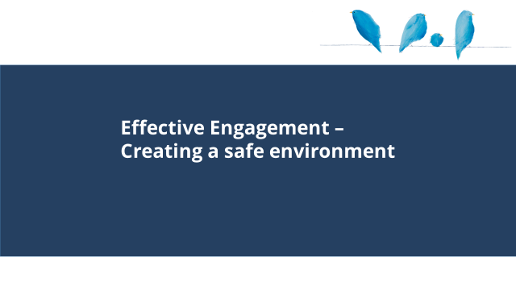 |  | - Effective engagement- creating a safe environment.
Slide 13: Creating a safe environment  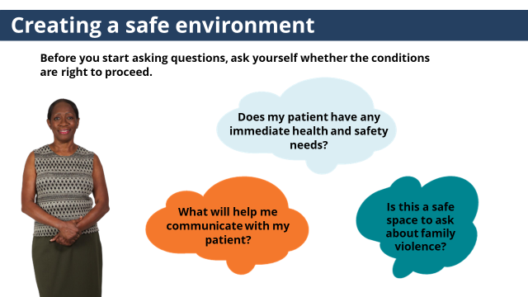 | If the conditions are not right to support a safe environment for a disclosure, you should take steps in consultation with your manager to address this before proceeding. | - Creating a safe environment to support disclosures is an important part of effective engagement.  - Before you start asking questions, ask yourself whether the conditions are right to proceed.  (click to reveal first question)  - Is this a safe space to ask about family violence?  - Ensure :  - Conversations are conducted in a private space/room/area.  - The patient is alone unless accompanied by a child under the age of 2.  - You ask about things the patient needs to feel comfortable to signal their safety is important.  - Disability access.  - A welcoming environment with inclusive signage and posters e.g. an Aboriginal or rainbow flag.  (click to reveal first question)  - Does my patient have any immediate health and safety needs?  - Ensure:  - The perpetrator is not present in the hospital.  - Immediate risks or threats to the patient's safety have been addressed.  - The patient is not in pain or anxious about their medical care.  - It is a suitable time to ask about family violence.  (click to reveal third question)  - What will help me communicate with my patient?  - Ensure:  - An interpreter or other communication aids or adjustments are provided. When using an interpreter ask if the patient would prefer a person of the same gender.  - You confirm the patient has understood the information provided.  - An Aboriginal patient is offered a referral to an Aboriginal liaison officer.  - Information is provided about how their information can be shared.  - If the conditions are not right to proceed, you should take steps in consultation with your manager to address this before proceeding.
Slide 14: Effective engagement – sensitive response  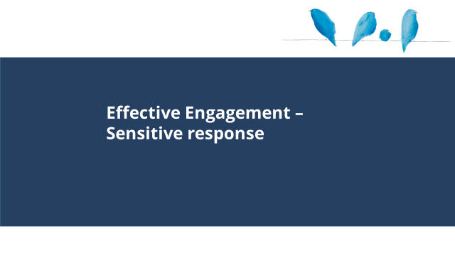 |  | - Effective engagement – sensitive response
Slide 15: Sensitive response  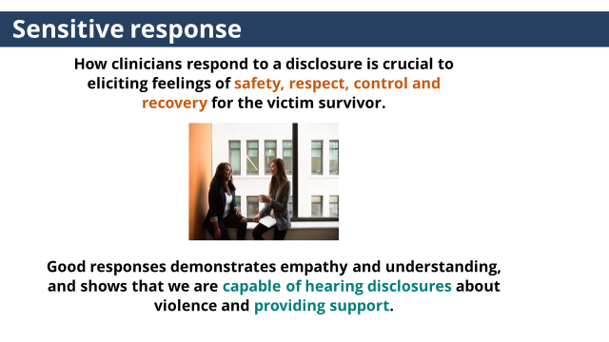 | How you respond to a victim survivors is really important, it is important to take the time to think about how to do this. | - How clinicians respond to a disclosure is crucial to eliciting feelings of safety, respect, control and recovery for the victim survivor.  - Don’t underestimate the power of a good response when someone is sharing their experience of family violence.  - This might be the first time the victim survivor has disclosed, or they may not have received a positive response in the past.  - Good responses demonstrate empathy and understanding, and shows that we are capable of hearing disclosures about violence and providing support.
Slide 16: Sensitive response  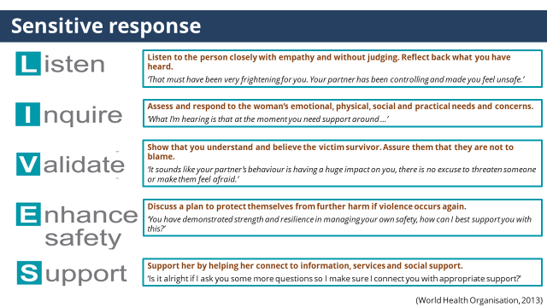 | LIVES is the World Health Organisation’s model that guides a response to a victim survivor. | - LIVES is the World Health Organisation’s model that guides a response to the victim survivor’s emotional and practical needs and supports being present with them and their story. This response is trauma informed and can empower an individual experiencing violence.  - Responding in this way may seem simple but is often rushed over or missed completely when practitioners are focused on asking direct questions for the purpose of a risk assessment and responding or trying to ‘fix’ the problem.  - Responding in this way is essential in family violence response work, as victim/survivors experience and feelings have often been minimised or denied as part of the pattern of abuse.  - LISTEN  (click to reveal)  Listen to the person closely with empathy and without judging. Reflect back what you have heard.  ‘That must have been very frightening for you. Your partner has been controlling and made you feel unsafe.’  - INQUIRE  (click to reveal)  Assess and respond to the woman’s emotional, physical, social and practical needs and concerns.  ‘What I’m hearing is that at the moment you need support around …’  - VALIDATE  (click to reveal)  Show that you understand and believe the victim survivor. Assure them that they are not to blame.  ‘It sounds like your partner’s behaviour is having a huge impact on you, there is no excuse to threaten someone or make them feel afraid.’  - ENHANCE SAFETY  (click to reveal)  Discuss a plan to protect themselves from further harm if violence occurs again.  ‘You have demonstrated strength and resilience in managing your own safety, how can I best support you with this?’  This will be further in more detail in Module 4.  - SUPPORT  (click to reveal)  Support her by helping her connect to information, services and social support.  ‘Is it alright if I ask you some more questions so I make sure I connect you with appropriate support?’  This will be covered in more detail in Module 4.  - The LIVES model reflects elements of practice covered in MARAM Practice Guides: Responsibility 1: Respectful, Sensitive and Safe Engagement.
NOTES
The LIVES model reflects elements of practice covered in MARAM Practice Guides: Responsibility 1: Respectful, Sensitive and Safe Engagement.
In particular:
1.3. Creating a Safe Environment to ask about Family Violence
- ‘Creating a Safe Environment to ask about Family Violence Key steps to creating an environment where the person feels safe and respected to talk about their experiences of family violence include considering.’ p. 5
- ‘Creating a safe environment means actively listening with empathy and without judgement. Validate the information provided by showing you believe the victim survivor and are seeking to understand their experience, so you can work together to find ways to help.’ p7

ACTIVITY TWO: Effective engagement
Purpose: The purpose of this activity is to give participants an opportunity to consider what a sensitive response that applies the LIVES model looks like in practice when responding to a disclosure of family violence.

Time: 15mins

Instructions:
- Trainer to hand out a copy of Activity Two to each participant (or a few copies per group).
Trainer to choose the version of the activity with the professions that best fits with the roles of each participant.
- Trainer to introduce the activity by outlining the purpose of the activity.
- Trainer to ask participants to work in small groups and read through the three case studies in the activity and sample response to the patient’s disclosure and consider which of the responses would best make the patient feel heard and validated.
- Trainer to facilitate large group discussion about answers.
- Conclude activity with sentence such as ‘How you respond to victim survivors is really important and will take time to develop. Don’t underestimate the impact of listening and validating a victim survivor’s experience.’

Answer
The presentation of the case studies differ for the different professions, however the answers are the same.

Case study One - Rahmo
During your conversation with Rahmo she disclosed:
‘I’m pretty tired. I was so worried that my ex-partner would come to the house last night as he threatened to, that I didn’t sleep at all. I reported the threat to the police, I was hoping the Intervention Order was going to stop his behaviour’

How might you respond to Rahmo in a way that makes her feel heard and validated?
Options:
  - ‘It sounds like managing his behaviour is exhausting. You have done the right thing reporting the threat to the police. It’s not ok that he has threatened you and made you feel worried for your safety.’
Correct Answer
Explanation: This response acknowledges how Rahmo has been managing her safety and reflects back her experience, feelings and the impacts of the violence and holds the perpetrator responsible.

  - ‘It’s important you get enough sleep as lack of sleeps puts you at a higher risk of having elevated blood sugar.’
Incorrect Answer
Explanation: This is important information to support treatment, however the response is not responding in a way that would make Rahmo feel heard or validated or safe to disclose her experiences of family violence.

  - ‘Ok, has he ever physically hurt you in any way?’
Incorrect Answer
Explanation: Asking a direct question about physical abuse is important and part of assessing risk. However going straight into asking this question before responding to what Rahmo has just said misses an opportunity to acknowledge and validate Rahmo’s experience, feelings and the impact of her ex-partner’s behaviour.

Case study Two - Kate
During your conversation with Kate she disclosed:
‘I feel I have tried everything. I’ve tried doing what she asks, it makes no difference the violence doesn’t stop and she still blames me for her violence.’

How might you respond to Kate in a way that makes her feel heard and validated?
Options:
  - ‘It sounds like you are doing everything you can to keep yourself safe’
Maybe
While it is important to take a strengths approach to your response, reflecting back a statement like this is not necessarily incorrect. However, it is important not to miss an opportunity to respond to Kate’s disclosure about blame in case she has internalised this belief.

  - ‘What I’m hearing is that your partner blames you for her behaviour, and it sounds like that is pretty confusing and upsetting. It doesn’t matter what you did or didn’t do, there is never any excuse for violence.’
Correct Answer
This statements reflects back Kate’s experience and feelings about the violence and responds to her partner blaming her.

  - That sounds difficult, it sounds like you and Karen might need some support.
Maybe
This statement is not necessarily incorrect as it reflects back Kate’s feelings about the experience, however it misses an opportunity to recognise the behaviour as family violence and locate the responsibility of the violence with the perpetrator. This is important in LGBTIQ+ relationships where there might be the belief that family violence only happens in heterosexual cis gender relationships.

Case Study Three – Bob
During a conversation with Bob he disclosed:
‘My son hit me last night, it hurt a bit. His work is really stressful and he forgot to pick up my medication on his way home, so when I asked him he got angry and told me I’m difficult to deal with, which I know I can be’

How could you respond to Bob in a way that makes him feel heard and validated?
Options:
  - ‘It sounds like the way your son behaved last night was hurtful and that your son is making you feel responsible for his behaviour. Violence is never ok. Stress doesn’t cause someone to use violence, we all deal with stress, but most people don’t choose to use violence when they are stressed.’
Correct Answer
This option reflects Bob’s experience of the violence and responds to Bob blaming himself and his son’s stress for the violence.

  - It sounds like your son is a bad person, you should probably think about leaving?
Incorrect
It is important to recognise that Bob and many victim survivors may want to maintain a relationship with the perpetrator and have a range of conflicting emotions towards that person (including love), but want the violence to stop. Focusing on the issue with the behaviour rather than the person allows for this complexity to coexist. Such as responding with ‘it sounds like your son is important to you, but the way he behaved last night was really hurtful’.
Also, it is important not to give advice in a way that can lead to the victim survivor feeling judged if they make a different decision, as this may lead to disengagement.

  - ‘That’s no good, I will talk to your son.’
Incorrect
It is important that any response is patient led and promotes their agency. You should not engage with a person directly about their use of family violence, unless it is part of your role and you have been trained to do so. This is because confrontation and intervention may increase risk for the victim survivor.

Slide 17: Effective engagement: Responding to discriminatory attitudes and beliefs  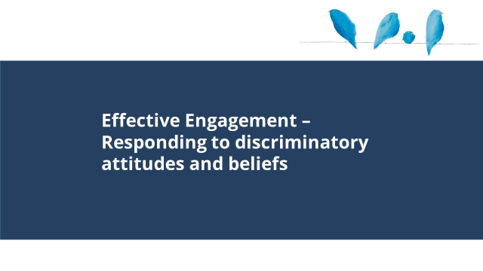 |  | - This section covers responding to discriminatory attitudes and beliefs.
Slide 18: Attitudes and beliefs  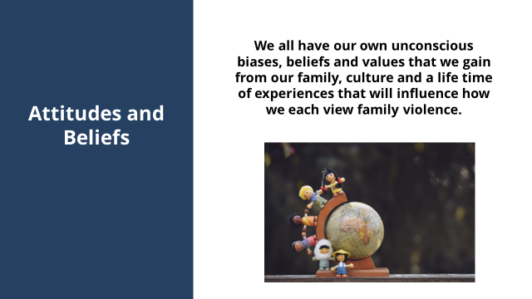 | We all have our own unconscious biases, beliefs and values that we gain from our family, culture and a life-time of experiences that will influence how we each view family violence. | - We all have our own unconscious biases, beliefs and values that we gain from our family, culture and a life-time of experiences that will influence how we each view family violence.
Slide 19: Attitudes and beliefs  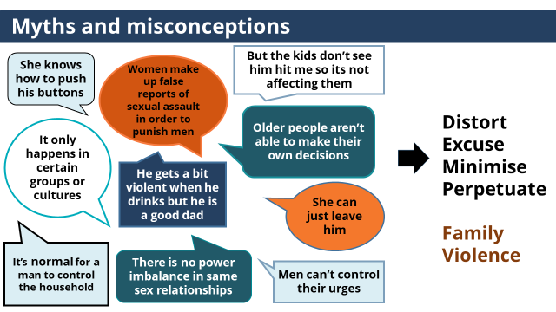 | It’s important that we challenge discriminatory attitudes and beliefs that blame victim survivors and justify a perpetrator’s use of violence. | - Here are some statements about family violence that you may be familiar with.  (double click to reveal all statements)  Allow time for participants to read through)  (click to reveal statement)  - These statements reflect attitudes and beliefs that distort, excuse, minimise and perpetuate family violence.  - As professionals, it’s important that we challenge discriminatory attitudes and beliefs that blame victim survivors and justify a perpetrator’s use of violence when we hear them from patients, colleagues and community members to ensure we are not inadvertently colluding with perpetrators.
Slide 20: Communicating key messages  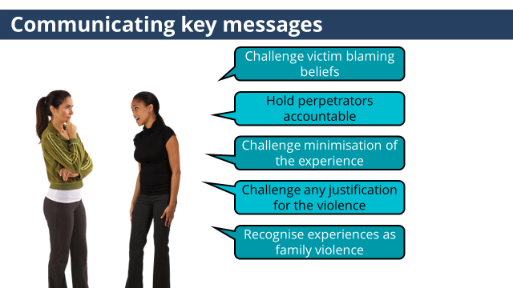 | Incorporating statements which challenge discriminatory attitudes and beliefs into your response to the victim survivor is an important element of family violence response work. | - It’s likely a victim survivor has heard messages that justify, excuse and blame them for the violence from perpetrators and society for a long time, mixed with fear and control and have internalised these beliefs.  (click to reveal second statement)  - Incorporating statements which challenge discriminatory attitudes and beliefs into your response to the victim survivor is an important element of family violence response work.  - It is important to reflect back statements that  (click to reveal key messages)  - Challenge victim blaming beliefs: Make it clear that victims are not to blame for the abuse.  - Hold perpetrators accountable: Be clear that perpetrators are responsible for their behaviours, and that their usage of violence is a choice.  - Challenge minimisation of the experience  - Often a victim survivor’s experience of the violence is minimised.  - It is important to challenge this and acknowledge their experience and impact of the experience of violence on a victim survivor  - Challenge any justification for the violence: Be clear that there is no excuse for abuse or violence.  - Recognise experiences as family violence  - Because of these attitudes and beliefs some victim survivors may not recognise their experience as family violence.  - Use statements which support a victim survivor to understand their experience within the context of family violence.
ACTIVITY THREE: Helpful & Unhelpful responses
Purpose: The purpose of this activity is to provide participants with practice examples of responses that communicate the key messages.

Time: 15mins

Instructions
- Trainer to hand out a copy of Activity Three to each participant (or a few copies per group).
- Trainer to introduce the activity by outlining the purpose of the activity.
- Trainer to ask participants to work in small groups and read through the responses and match them as a helpful or unhelpful example of the key messages.
- Trainer to facilitate large group discussion about answers.
- Conclude activity with sentence such as ‘It’s likely a victim survivor has heard messages that justify and excuse perpetrators behaviour and blame them for the violence from perpetrators and society and have their experience ignored or minimised from society for a long time and have internalised these beliefs. Thinking about ways we can send clear messages that undo this is an important part of effective engagement in family violence.

Answers
Key  message | Helpful response | Unhelpful response
Challenge victim-blaming belief | It’s not your fault | What did you do before he became angry?
Hold perpetrators accountable | He is responsible for his choice to use violence | He is a good dad
Challenge the minimisation of the experience | It sounds like it’s been really difficult for you and the children | It mustn’t have been too bad or you would have left.
Challenge any justification for the violence | Violence is not ok, ever | It sounds like an anger management issue
Recognise experiences as family violence | We would consider that kind of behaviour as family violence | I don’t like that behaviour

Slide 21: Effective engagement - culturally safe, accessible and inclusive practice  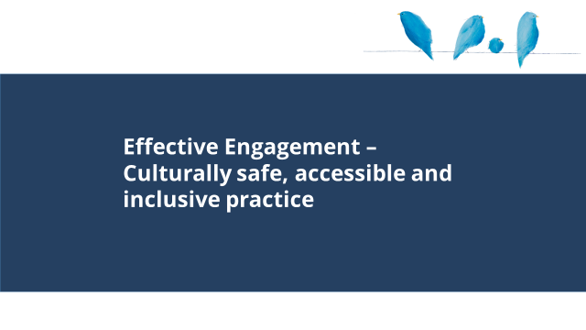 |  | - This section covers culturally safe, accessible and inclusive practice.
Slide 22: culturally safe, accessible and inclusive practice  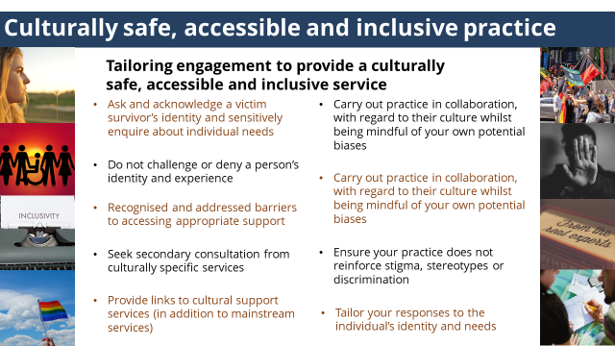 | All practitioners are responsible for providing a culturally safe, accessible and inclusive practice. | - All people have a right to receive a culturally safe, accessible and inclusive service and is a principle underpinning the MARAM Framework.  - All practitioners are responsible for providing a culturally safe, accessible and inclusive practice, such as ensuring you:  (click to reveal each point)  - Ask and acknowledge a victim survivor’s identity and sensitively enquire about individual needs  - Do not challenge or deny a person’s identity and experience  - Recognise and address barriers to accessing appropriate support  - Seek secondary consultation from culturally specific services  - Provide links to cultural support services (in addition to mainstream services)  - Carry out practice in collaboration, with regard to their culture whilst being mindful of your own potential biases  - Ensure your practice does not reinforce stigma, stereotypes or discrimination  - Tailor your responses to the individual’s identity and needs
NOTES
- MARAM Principles - Services and responses provided to diverse communities and older people should be accessible, culturally responsive and safe, client-centred, inclusive and non-discriminatory.
- Self-awareness and ongoing self-reflection are an important aspect of ensuring that practitioners do not situate clients as the ‘other’ – we are all impacted by culture and all have multiple aspects to our identities. Considering the identities of others necessitates internal self-reflection on the privileges (or inequalities) associated with our own identities. Being part of the dominant culture in a society can make that membership ‘invisible’ because it is constantly represented and reinforced.
- Trainer may wish to prompt participants to consider this. Trainers may consider discussing the role of Cultural Awareness training in supporting the development of this reflection.

Slide 23: Aboriginal and Torres Strait Islander self-determination  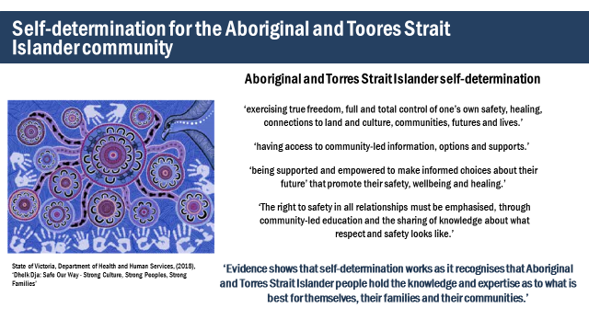 | ‘Evidence shows that self-determination works as it recognises that Aboriginal and Torres Strait Islander people hold the knowledge and expertise as to what is best for themselves, their families and their communities.’ | - When supporting a person from the Aboriginal and Torres Strait Islander community, it is important to prioritise and promote self-determination.  - This is a principle of MARAM.  - ‘Dhelk Dja: Safe Our Way - Strong Culture, Strong Peoples, Strong Families’ report wrote that self-determination means  (click to reveal each point)  - ‘exercising true freedom, full and total control of one’s own safety, healing, connections to land and culture, communities, futures and lives.’  - ‘having access to community-led information, options and supports. ‘  - ‘being supported and empowered to make informed choices about their future’ that promote their safety, wellbeing and healing.  - ‘The right to safety in all relationships must be emphasised, through community-led education and the sharing of knowledge about what respect and safety looks like.’  (click to reveal point)  - ‘Evidence shows that self-determination works as it recognises that Aboriginal and Torres Strait Islander people hold the knowledge and expertise as to what is best for themselves, their families and their communities.’
NOTES
MARAM Principle - Services and responses provided to people from Aboriginal communities should be culturally responsive and safe, recognising Aboriginal understanding of family violence and rights to self-determination and self-management, and take account of their experiences of colonisation, systemic violence and discrimination and recognise the ongoing and present day impacts of historical events, policies and practices.

ACTIVITY FOUR: Working with diverse groups – implementing recommendations
Purpose: The purpose of this activity is to provide participants with an opportunity to consider what best practice principles for working with different groups looks like in practice.

Time: 20mins

Instructions
- Handout Activity Four to each group.
- Trainer to introduce the activity by outlining the purpose of the activity.
- Allocate one part to each group (Part 1: Aboriginal and Torres Strait Islander communities, Part 2: culturally and linguistically diverse groups, Part 3: individuals living with disability)
- Direct groups to look at the two recommendations for facilitating accessible, inclusive and non-discriminatory service delivery for that community. Let participants know these have been drawn from work done by those communities (references in answer section below).
- Ask participants to work in their groups and consider how they could demonstrate these principles in practice.
- Allow groups approximately 10 minutes to work on the task.
- Trainer to facilitate feedback to group, (to manage time, trainers can ask for 1-2 points for each recommendation).
- Conclude activity with sentence such as ‘Developing our practice to be culturally safe and inclusive is an on-going process, but important to ensure we are not creating additional barriers for patients to access the support they need.

NOTES
It is important to preface this section by being clear that no two individuals are the same or have the same experiences or support needs. No community is homogeneous. However, discussing common experiences, common issues and common needs of particular communities can help build our awareness and culturally responsive practice. This will enable us to ask the right questions and to understand whether any of these common experiences/needs are present in an individual’s life.

Answers
Part 1: Aboriginal and Torres Strait Islander Communities
Prioritising and strengthening culture and self-determination
How would you acknowledge and support the culture of Aboriginal and Torres Strait Islander people?
Sample answers
- Consider and talk about the person’s identity, language, spirituality, connection to country, family and community.
- Explore what the person’s cultural identity means to them.
- Self-reflecting on one’s own identity to articulate who you are and what your culture is.
How would you ensure your practice promotes self-determination?
Sample answers
- Showing respect, listening.
- Offering choices including which service to access (Aboriginal or Torres Strait Islander or non-specific), not making assumptions.
- Validating changes of mind.
- Sharing stories/finding solutions.
Recommendations adapted from:
- Our Watch, (2018), ‘Changing the Picture, A national resource to support the prevention of violence against Aboriginal and Torres Strait Islander women and their children’.
- State of Victoria, Department of Health and Human Services, (2018), ‘Dhelk Dja: Safe Our Way - Strong Culture, Strong Peoples, Strong Families’.

Part 2: Culturally and Linguistically Diverse Groups
How might you demonstrate respect for culture in your practice?
Sample answers
- Don’t make assumptions about culture – sensitively explore what this means for a person.
- Signage in office space.
- Explore, ask about and respect important aspects of someone’s life, such as religious observations, key dates, festivals and celebrations.
- Be open to and support victim/survivor in sharing aspects of their culture with you and assisting you to learn about their culture.
- Show a genuine interest in learning about a victim survivor’s culture and ask about their values and beliefs.
- Demonstrate warmth, curiosity and openness.
- Explore who a victim survivor would go to for support.
- Consider different ways non-verbal interactions may vary across cultures. For example, consider nodding or eye contact.
What terms, concepts and services would you need to consider explaining in your practice about the family violence service system?
Sample answers
- Risk, safety, violence, consent.
- Family violence within the Australian legal context.
- Role of statutory bodies including child protection, courts and police.
- Role of specialist family violence services.
- Available support.
- Entry and exit points in the system such as L17’s and self-referrals.
- How family violence affects children and the concept of protecting children may differ in Australia. For example, a victim survivor may prioritise staying in an abusive relationship to protect her children due to a cultural value of children having a relationship with their father.
- Family violence refuges.
- Centrelink.
- Role of professional interpreters.

Recommendations adapted from:
- Kalapac, V, (2016), ‘inLanguage, inCulture, InTouch: Integrated model of support for CaLD women experiencing family violence’. Final Evaluation Report. Jean Hailes for Women’s Health, Melbourne, Australia.
- Immigrant Women’s Domestic Violence Service 2006, Rural Research Project.
- InTouch & 1800 Respect, ‘Working with women and children from culturally and linguistically diverse communities’, Video. https://intouch.org.au/how-we-can-help/information-for-professionals/resources-to-help-you-work-better/

Part 3: Individual with a Disability

How might you ensure resources and services are accessible for people with a disability?
Sample answers
- Access to building, toilets, rooms, transport.
- Inclusion of plain English resources that avoid jargon, and use sufficiently-sized font.
- Ensure practitioners are trained to use services like the National Relay Service.
- Practitioners undertake training in working with non-verbal and vision impaired victim survivors.
- Provision of a variety of ways a victim/ survivor can engage and communicate such as writing, drawing, picture cards.

How could you describe a person’s disability using factual language that doesn’t reinforce stereotypes, imply weakness or alienate them?
Sample answers
- Not speaking about having a disability as being an inherent vulnerability – about how society is structured.
- Person living with disability.
- Intellectual disability.
- Cognitive disability.
- Do not use of common discriminatory terms such as “a bit slow” or “not all there”.

Recommendations adapted from:
- Women with Disabilities Victoria, (2014), ‘Our Right to Safety and Respect, Guidelines for developing resources with women with disabilities about safety from violence and abuse’.
- WDV DV Senate Inquiry submission
- (2016), ‘Invisible women, invisible violence: Understanding and improving data on the experiences of domestic and family violence and sexual assault for diverse groups of women: State of knowledge paper’.
- DVRCV & Women with Disabilities Victoria, ‘Working with Women with disabilities tip sheet’.

TOPIC: Child focused practice
Nominal duration: 25 minutes
Purpose: To build participants knowledge of children’s experience of family violence and how to apply a child focus in practice when working with an adult victim survivor.
Resources for Trainers
- MARAM Framework.
- MARAM Practice Guides: Responsibility 1: Respectful, Sensitive and Safe Engagement.
- MARAM Practice Guides: Responsibility 3: Intermediate Risk Assessment.
- Statewide Children's Resource Program. Through a Child's Eyes.
- University of New South Wales (NSW), Australian Domestic & Family Violence Clearinghouse (ADFVC) (2011). The Impact of Domestic Violence on Children: A Literature Review.

Slide 24: Effective engagement – child focused practice  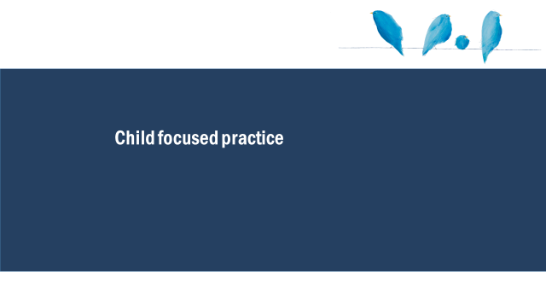 |  | - This section covers a child-focused practice
Slide 25: Child focused practice  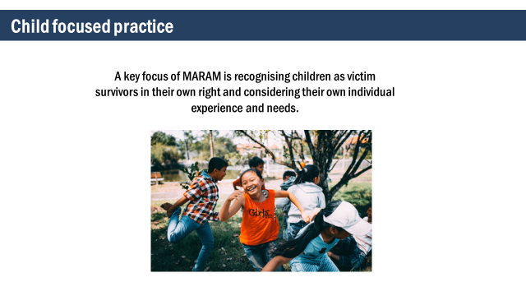 | A key focus of MARAM is recognising children as victim survivors in their own right and considering their own individual experience and needs. | - A key focus of MARAM is recognising children as victim survivors in their own right and considering their own individual experience and needs.
NOTES
- MARAM Principles
  - Family violence may have serious impacts on the current and future physical, spiritual, psychological, developmental and emotional safety and wellbeing of children, who are directly or indirectly exposed to its effects, and should be recognised as victim survivors in their own right.
  - Services provided to child victim survivors should acknowledge their unique experiences, vulnerabilities and needs, including the effects of trauma and cumulative harm arising from family violence.
Slide 26: Child focused practice  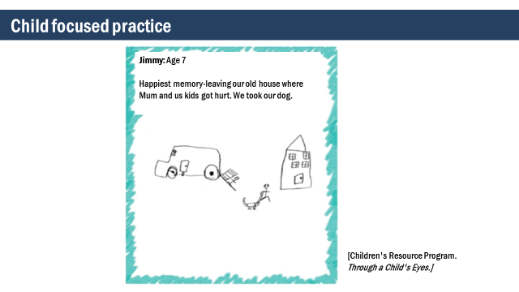 | Each child will have their own experience of the violence. | - This is a drawing by Jimmy aged 7 about his happiest memory.  - Just seeing this simple drawing can tell us so much about Jimmy’s world and his separate experience of the violence.  Trainer to invite reflections on drawing.  Trainer to ask: What do we know about children and young people’s experience of family violence?
Slide 27: Children and young people’s experience of family violence  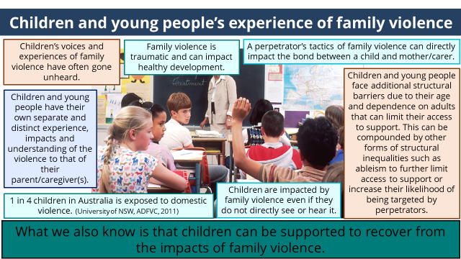 | What we know is that children can be supported to recover from the impacts of family violence. | (click to reveal each point)  - Children’s voices and experiences of family violence have often gone unheard.  - Children and young people have their own separate and distinct experience, impacts and understanding of the violence to that of their parent/caregiver(s).  - 1 in 4 children in Australia is exposed to domestic violence (University of NSW, ADFVC, 2011)  - Children are impacted by family violence even if they do not directly see or hear it.  - Children and young people face additional structural barriers due to their age and dependence on adults that can limit their access to support. This can be compounded by other forms of structural inequalities such as ableism to further limit access to support or increase their likelihood of being targeted by perpetrators.  - A perpetrator’s tactics of family violence can directly impact the bond between a child and mother/carer.  - Family violence is traumatic and can impact healthy development.  (click to reveal point)  - What we also know is that children can be supported to recover from the impacts of family violence.
Slide 28: Child focused practice  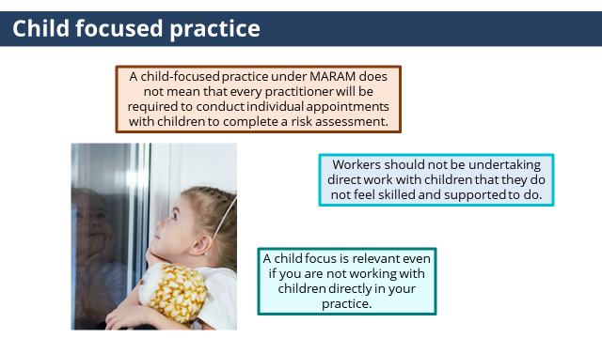 | A child focus is relevant even if you are not working with children directly in your practice. | - It is important to remember that a child-focused practice under MARAM does not mean that every practitioner will be required to conduct individual appointments with children to complete a risk assessment.  - Workers should not be undertaking direct work with children that they do not feel skilled and supported to do.  - A child focus is relevant even if you are not working with children directly in your practice.  A child-focussed lens informs how we talk and work with parents/carers and conceptualise children as clients in their own right.
Slide 29: Child focused practice at an Intermediate practice level  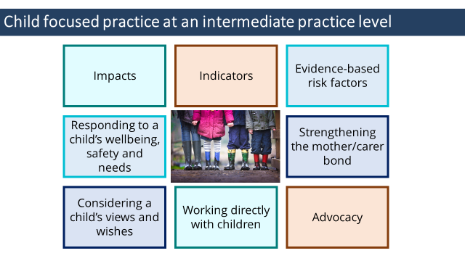 | At an intermediate level you are not required to be experts at working with children but to know how you can bring a child focus to your practice. | - Child focused practice at an intermediate practice level  - Impacts - Understanding how family violence and trauma impact child development and attachment.  - Indicators - Knowing observable signs of trauma in a child or young person that may indicate family violence is occurring.  - Evidence-based risk factors  - Know the evidence-based risk factors specific to children.  - Ask questions of an adult about risk to children as part of an intermediate risk assessment.  - Referring a child for a comprehensive assessment.  - Responding to a child’s wellbeing, safety and needs - Consider child/ren’s wellbeing, safety and recovery in support and interventions.  - Strengthening the mother/carer bond  - A perpetrator’s tactics of family violence can directly impact the bond between a child and mother/primary carer, such as by undermining parenting, restricting the mother/carers ability to parent or shaping the violence as the mother/carer’s fault.  - Professionals need to be aware of these tactics to avoid making judgements about parenting and respond in ways that strengthen the mother/carer bond and parenting confidence and capability.  - Considering a child’s views and wishes - Considering a child’s views and wishes where safe and appropriate when sharing information under the Family Violence and Child Information Sharing Schemes.  - Working directly with children - If this is a part of your role it will include asking an older child or young person directly using the Child Assessment Tool or the adult Intermediate tool (or completing a safety plan) with an older young person (15 and over).  - Advocacy - Advocating with other services to ensure children’s needs are considered and addressed.  - At an intermediate level you are not required to be experts at working with children but to know how you can bring a child focus to your practice and this will include assessing risk to children.
ACTIVITY FIVE: Child focused practice when working with an adult victim survivor
Purpose: The purpose of this activity is to support participants to consider applying a child focus in practice when working with an adult victim surivor.

Time: 15 mins

Instructions
- Trainer to hand out a copy of Activity Five to each participant (or a few copies per group).
Trainer to choose the version of the activity with the professions that best fits with the roles of each participant.
- Trainer to introduce the activity by outlining the purpose of the activity.
- Trainer to ask participants to work in small groups, and read through the medical record which has additional information for the case study of Ania, Sabina and Imran who they met in an earlier activity. And consider if you were planning for an appointment with Ania, what opportunities are there to bring in a child-focus during your conversation with Ania?
- Allow groups approximately 5-10 minutes to work on the task.
- Trainer to facilitate feedback to group, (to manage time, trainers can ask for 1-2 points from each group).
- Conclude activity with sentence such as ‘At an intermediate level you are not required to be experts at working with children but to know how you can bring a child focus to your practice.’

Answer:
SOCAIL WORKER IN A HOSPITAL & MENTAL HEALTH CLINICIAN
Sample answers
- The case study stated that Sabina has been home from school a lot lately.
This highlights an opportunity to ask about why Sabina has been home from ‘school at lot lately’ and whether there are any support needed to assist her to re-engage with school.
School refusal/avoidance absenteeism/disengagement) can be a sign of family violence trauma. This may be due to trouble making friends due to delayed social skills or because she has moved schools numerous times, or she may be staying at home to protect mum or to avoid constantly feeling worried about what was happening at home.
- The case study stated Sabina uses baby talk.
This highlights an opportunity to ask Ania to talk more about Sabina’s use of baby talk and whether there are any emotional, social, psychological or wellbeing needs.
When responding to any behavioural concerns it is important to support Ania to understand Sabina’s behaviours within the context of the impact of family violence and ensure Ania does not feel to blame for the violence or the impacts.
- The case study stated when the family was eating dinner he became really angry.
This highlights an opportunity to ask Ania questions about Sabina’s experience of Imran’s anger and using the MARAM Intermediate tool to ask questions to understand the risk to Sabina.

CARE COORDINATOR IN AN EMERGENCY DEPATMENT
Sample answers
- The case study stated that Sabina has been home from school a lot lately
This highlights an opportunity to ask about why Sabina has been home from ‘school at lot lately’ and whether there are any support needed to assist her to re-engage with school.
School refusal/avoidance (absenteeism/disengagement) can be a sign of family violence trauma. This may be due to trouble making friends due to delayed social skills or because she has moved schools numerous times, or she may be staying at home to protect mum or to avoid constantly feeling worried about what was happening at home.
- The case study stated Sabina acts like a little kid
This highlights an opportunity to ask Ania to talk more about Sabina acting like a little kid and whether there are any emotional, social, psychological or wellbeing needs.
When responding to any behavioural concerns it is important to support Ania to understand Sabina’s behaviours or emotions within the context of the impact of family violence and ensure Ania does not feel to blame for the violence or the impacts.
- The case study stated that when the family was eating dinner he became really angry
This highlights an opportunity to ask Ania questions about Sabina’s experience of Imran’s anger and using the MARAM Intermediate tool to ask questions to understand the risk to Sabina.

HOSPTIAL ADMISSION RISK PROGRAM (HARP) CLINICIAN
Sample answers
- The case study stated Sabina has been home from school a lot lately.
This highlights an opportunity to ask about why Sabina have been home from ‘school at lot lately’ and whether there are any support needed to assist her to re-engage with school.
School refusal/avoidance (absenteeism/disengagement) can be a sign of family violence trauma. This may be due to trouble making friends due to delayed social skills or because she has moved schools numerous times, or she may be staying at home to protect grandma or to avoid constantly feeling worried about what was happening at home.
- The case study stated Sabina has been a lot to handle.
This highlights an opportunity to ask Ania to talk more about Sabina being a ‘lot to handle’ and whether there are any emotional, social, psychological or wellbeing needs.
When responding to any behavioural concerns it is important to support Ania to understand Sabina’s behaviours or emotions within the context of the impact of family violence and ensuring she does not feel to blame for the vilence or the impacts.
- The case study stated When the family was eating dinner he became really angry.
This highlights an opportunity to ask Ania questions about Sabina’s experience of Imran’s anger and using the MARAM Intermediate tool to ask questions to understand the risk to Sabina.

NOTES
Participants might bring up other relevant examples such as relating to identification of signs of trauma, Sabina’s experience or impacts of the violence or bringing Sabina’s needs into view. Trainers should help participants to explore and reframe how these examples would informs how they talk and work with the parent/carer and conceptualise children as clients in their own right.

It is important to emphasise that when responding or engaging with a non-offending parent/caregiver, practitioners should ensure they do not feel blame for the violence or the impacts and care is taken to strengthen the child-parent/carer bond.

A perpetrator’s tactics of family violence can directly impact the bond between a child and mother or primary carer, by undermining parenting, shaping the violence as the mother/carer’s fault, and destroying the relationship between the parent/carer and child. A risk factor under MARAM is undermining the child/parent relationship. Research has found that having a strong maternal-child bond/relationship is one of the factors which is protective in reducing negative outcomes for children who have experienced family violence. Examples of ways a practitioner can strengthen the child-parent/carer bond is through discussing and validating a parent/caregiver’s strengths and efforts to keep the children safe in the context of family violence.

Participants may have some anxiety around the implications of a child-focused practice under MARAM. It will be important to acknowledge that for some a child focused practice will be a shift in practice and will take time to develop. Also reiterate that unless it is part of a practitioner’s role and they have been further trained to do so, working directly with children will not be a part of their practice.
Responsibility 3 Practice Guide provides detailed guidance on how to determine if assessing risk directly with a child is appropriate, safe and reasonable for their age, developmental stage or circumstances and on using the child assessment tool, if that is relevant to your staff.

TOPIC: Conclusion
Time: 10mins
Quiz
Activity Six: Quiz

Time: 5mins

Instructions:
Handout: Activity Six.
Trainer to ask participants to complete Quiz individually.
Trainer to facilitate large group discussion about answers.

Answers:
- Observable signs of trauma are:
- Things we observe, hear or notice, that indicate that someone may be experiencing family violence.
- Are expressions of trauma that relate to a person’s physical or emotional presentation, behaviour or circumstance
- Can be expressed differently across a person’s lifespan
- All of the above
Answer: all of the above.
This was covered on slide 7 ‘What do we mean by observable signs of trauma?’

- True or False
When working with an Aboriginal person it is important to promote self-determination.
Answer: True
This was covered in slide 19 – Self determination for the Aboriginal and Torres Strit Islander community.

- True or False
Incorporating statements which challenge victim blaming beliefs and hold perpetrators responsible for their choice to use violence is an important part of effective egagement.
Answer: True

- A Child-focused practice: (choose the 3 that apply)
- Informs how we talk and work with parents/carers
- Always involves direct work with children
- Strengthens the mother/carer bond
- Is about understanding a child’s unique experience and needs
Answer: 1, 3 & 4
Pracitioners are not required to undertake direct work with children unless it is your role to do so.

Slide 30: Module 2 summary  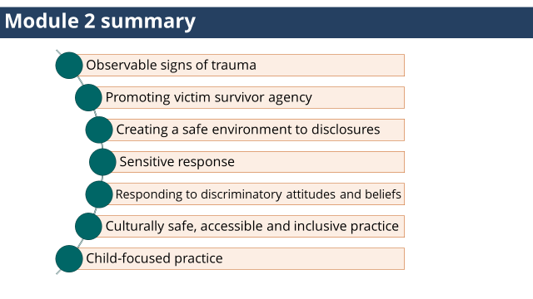 |  | - Module 2 summary  - Observable signs of trauma  - Effective engagement  - Promoting victim survivor agency  - Creating a safe environment to disclosures  - Sensitive response  - Responding to discriminatory attitudes and beliefs  - Culturally safe, accessible and inclusive practice  - Child-focused practice
Slide 31: Reflection  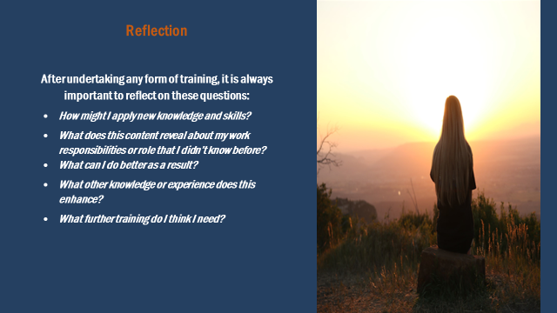 |  | Trainer to invite participants to turn to the person next to them and share a key learning for them from this training.
Slide 32: Self-care  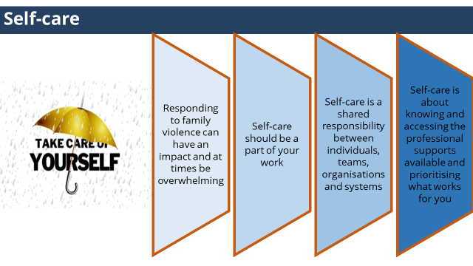 | Self-care should be a part of your work and is a shared responsibility between individuals, teams, organisations and systems. | - While this work can be experienced as a privilege, knowing the difference that we can make to the lives of those that we assist.  - It is important to acknowledge you can be personally affected by hearing about traumatic events, and by witnessing the impact and distress that it causes.  - It can also become personally draining, and at times overwhelming.  - Self-care should be a part of your work and is a shared responsibility between individuals, teams, organisations and systems.  - Self-care is about knowing and accessing the professional supports avilable.  - And knowing and prioritising what works for you.  Trainer to invite particpants to turn to the person next to them and share two things that supports their self-care.
Slide 33: Thankyou |  | - Thank particpants for coming.  - Trainer to let paritpants know the scheduled time for Module 3.

MODULE 3
TOPIC: Welcome, acknowledgements, housekeeping, introductions & overview
Nominal duration: 20 minutes
Purpose: To make acknowledgements, establish expected behaviour in the training environment and provide participants with an overview of the training.
Slide | Key message/s | Facilitator dialogue
Slide 1: Introduction  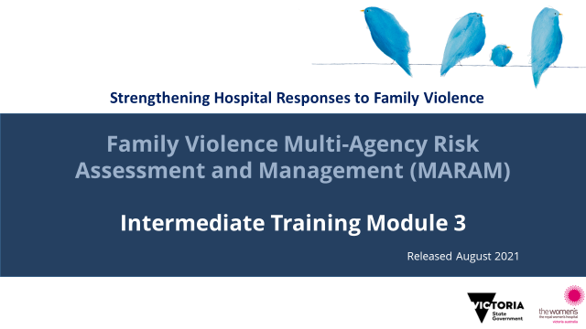 | Acknowledgement of traditional owners, victim survivors and language. | Welcome  - Introduce training.  - Welcome participants.  Acknowledgement of country  - Acknowledge the Traditional Aboriginal Owners of country on which the training is taking place. Pay respects to them, their culture and their Elders past, present and emerging, as well as any community members here today in the room with us. Acknowledge that sovereignty of this land was never ceded.  - For the purposes of this module, we’ll be using the term Aboriginal to refer to both Aboriginal and Torres Strait Islander people.  Acknowledgement of victim survivors  - We wish to acknowledge victim survivors of family violence, particularly women and children that have been killed in the context of family violence.  - We hope what is presented in this training is respectful to their individual experiences.  Introductions  - Trainer introductions: Provide a 1-2 sentence introduction that explains your professional background, emphasising aspects that establish your authority to deliver the MARAM training.  Examples of Trainers relevant experience that lends authority may include clinical experience working at an Intermediate or Comprehensive MARAM level; experience in a specialist service/clinic; experience in the specialist family violence service; clinical educator.  Housekeeping  - Outline duration of training, break times (if scheduled) and OH&S requirements (fire exits etc.).
NOTES
The Aboriginal Victoria website has an interactive map that allows you to search for the Traditional Owners of a particular area. It also documents areas where this is contested. Taking the time to be aware of and acknowledge the Traditional Owners of the area where training is being delivered is an opportunity to honour Victoria’s strong and proud Aboriginal and Torres Strait Islander history.
Slide 2: Safe learning environment | Throughout the session be mindful of confidentiality, be respectful of diverse opinions and various levels of knowledge, and ways we can all support this to be a safe learning environment for everyone. | - Remind participants of the group expectations to support a safe learning environment that were covered in earlier modules.
Slide 3: Self-care | To highlight the importance of self-care and for participants to be aware of services they can contact if they are impacted by the training. | - Discussing family violence can be distressing, particularly if you have experienced or been impacted by violence.  - If this training causes any concern for yourself or another you can discontinue at any time; however we encourage you to contact one of these services or your workplace Employee Assistance Program for support.  - Information about these services can be found in your Participant Guide.
Slide 4: Training overview  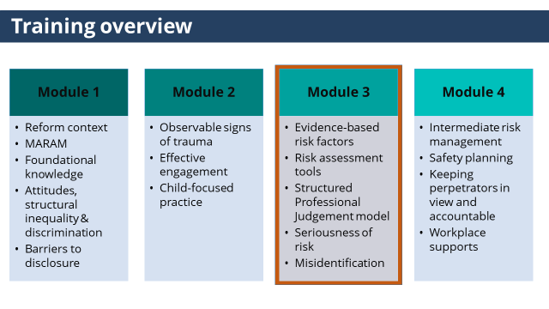 | This training aims to build the knowledge and skills to respond effective to victim survivors of family violence at an Intermediate level under MARAM.  This is Module 3. | - This training has 4 modules, and has been designed to cover the skills and knowledge required by practitioners whose role includes intermediate responsibilities under MARAM.  (click to reveal highlighted state)  - This is module 3, module 3 will cover:  - Evidence-based risk factors  - The MARAM risk assessment tools  - The Structured Professional Judgement model  - Assessment of seriousness of risk  - And misidentification of the perpetrator and victim survivor.
Slide 5: Introductions | Gauge participant expectations of the training. | - Participants to introduce themselves (name, role etc.).  - Share what they are wanting to achieve or ‘get out of’ today’s training.
NOTES
Trainers may wish to set up this as an activity where participants share what they want to get out of the training (either verbally with the group or on a Post It note, with Trainers writing them on a wall/whiteboard, and returning to this at the conclusion of the session to see if they have been addressed.

TOPIC: Evidence-based risk factors
Nominal duration: 10 minutes
Purpose: To give participants an understanding of evidence-based risk factors under MARAM.

Resources for Trainers
- MARAM Practice Guides: Foundation Knowledge Guide (pages 23-29).

Slide | Key message/s | Facilitator dialogue
Slide 6: Evidence-based risk factors  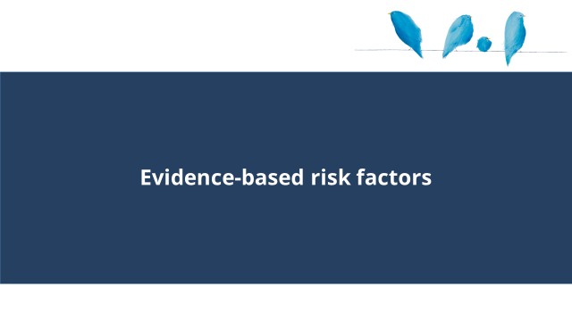 |  | - This section will cover evidenced-based risk factors.
Slide 7: Evidence-based risk factors  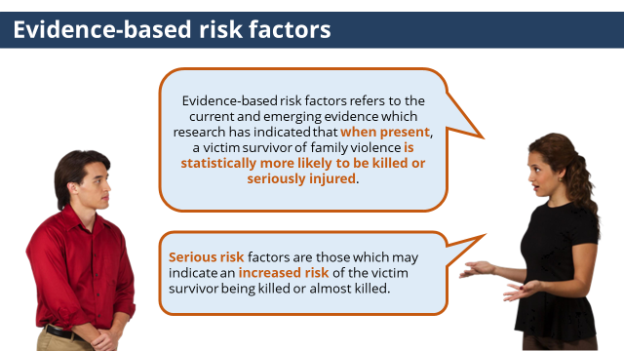 | Evidence-based risk factors when present, a victim survivor of family violence is statistically more likely to be killed or seriously injured. | Trainer to ask: What are evidence-based risk factors?  (click to reveal definition)  - Evidence-based risk factors refers to the current and emerging evidence which research has indicated that when present, a victim survivor of family violence is statistically more likely to be killed or seriously injured.  (click to reveal second statement)  - Serious risk factors are those which may indicate an increased risk of the victim survivor being killed or almost killed.
Slide 8: Changes from CRAF  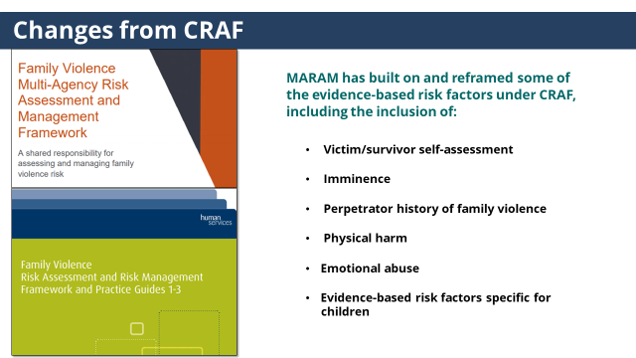 | MARAM has built on and reframed some of the evidence-based risk factors under CRAF. | - MARAM has built on and reframed some of the evidence-based risk factors under CRAF (Common Risk Assessment Framework). For those who are familiar with CRAF, the key changes are:  (click to reveal points)  - Victim/survivor self-assessment: this has always been included as part of a family violence risk assessment, but is now recognised as an evidence-based risk factor.  - Imminence has been added.  - Perpetrator history of family violence is now explicitly named.  - Physical harm and emotional abuse were previously under the generic category of ‘harm’ and have now been emphasised as standalone evidence-based risk factors.  - MARAM includes evidence-based risk factors specific for children.
Slide 9: Practice Guides  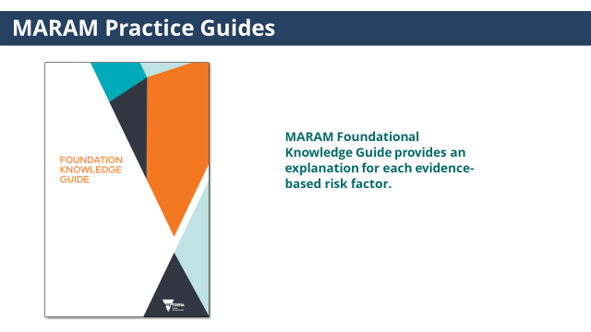 | MARAM Foundational Knowledge Guide provides an explanation for each evidence-based risk factor. | - MARAM Foundational Knowledge Guide provides an explanation for each evidence-based risk factor.
ACTIVITY ONE: Evidence-based risk factors
Purpose: The purpose of this activity is give participants time to look at the evidence-based risk factors under MARAM.
Time: 5 mins
Instructions:
- Trainer to hand out a copy of Activity One to each participant (or a few copies per group).
- Trainer to introduce the activity by outlining the purpose of the activity.
- Trainer to ask participants to read through the list of evidence-based risk factors. Let participants know that the risk-factors that are in bold indicate the serious risk factors.
- Trainer to ask group for reflections or questions.
- Conclude activity with sentence such as ‘Having a strong understanding of the evidence-based risk factors is vital to assessing risk’.

NOTES
- Trainer to refer to p24- 29 Foundational Guide for explanation of each risk factor to facilitate discussion. Serious risk factors are highlighted in orange in Guide.
- In addition to the MARAM Foundational Knowledge Guide, a full rationale behind the inclusion of each risk factor is in the MARAM Framework document.
- If participants ask about factors that are not part of the list, Trainers can emphasise that included factors are supported by evidence of their relevance. This doesn’t mean that other things aren’t relevant to family violence risk, but it does mean that we don’t have the evidence to support their inclusion in this list. Other factors can be incorporated into the Structured Professional Judgement Model as a component of professional judgement and intersectional analysis.
- Participants who are familiar with CRAF may notice that some victim survivor factors such as ‘mental health issue’ or ‘substance usage’ are no longer listed as evidence-based risk factors. They were removed due to the review research process finding that there was insufficient evidence to support their inclusion. If relevant to a victim survivor’s situation, these elements will now be part of intersectional analysis and professional judgement.
- MARAM includes risk factors specific to children, which marks a significant development from CRAF and provides workers with a stronger foundation to identify and assess risk to children.

TOPIC: MARAM Assessment Tools
Nominal duration: 5 minutes
Purpose: To give participants an understanding of the assessment tools that support risk assessment at an Intermediate level.
Resources for Trainers
- MARAM Practice Guides Responsibility 3: Intermediate Risk Assessment.
- Appendix 5 of the above practice guide is the adult Brief risk assessment tool.
- Appendix 6 of the above practice guide is the adult Intermediate risk assessment tool.
- Appendix 7 of the above practice guide is the child victim survivor risk assessment tool.
- Appendix 8 of the above practice guide covers Intermediate risk assessment and practice guidance for adult and child victim survivors.

Slide | Key message/s | Facilitator dialogue
Slide 10: MARAM assessment tools  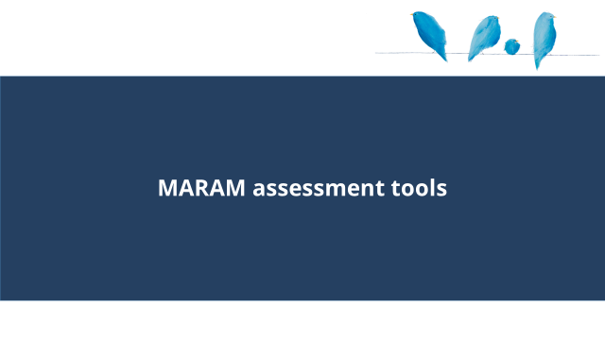 |  | - This section covers MARAM assessment tools.
Slide 11: MARAM identification and screening tool  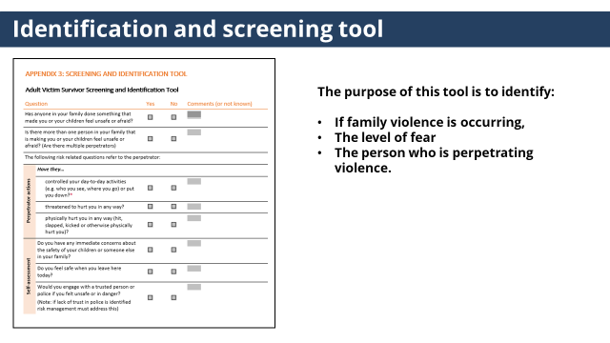 | The identification and screening tool is used to identify if family violence is occurring, identify the level of fear, and identify the person who is perpetrating violence | Identification and Screening tool  (click to reveal text)  - The purpose of this tool is to identify if family violence is occurring, identify the level of fear, and identify the person who is perpetrating violence.  - It has been developed to be used with an adult victim survivor to identify family violence for both adult and child victim survivors.  - The tool should be used when family violence is suspected and when signs/indicators of family violence have been observed, or to start a conversation if someone discloses they are experiencing family violence.  - It may also be part of routine screening.  - Appendix 2 of the Responsibility 2 Practice guides can be referred to for guidance on using the tool.  - Within hospitals and health services, this tool is used by staff trained at the Sensitive Practice level or who undertake screening in Antenatal settings.  - The Intermediate Tool asks if these questions have been asked, and prompts you to record this information or ask additional questions to capture additional information about a perpetrator’s actions.  - If a patient has not been screened at the point you come in contact with a patient you may they want to start with some basic screening questions too before deciding a risk assessment is necessary
Slide 12: MARAM assessment tools  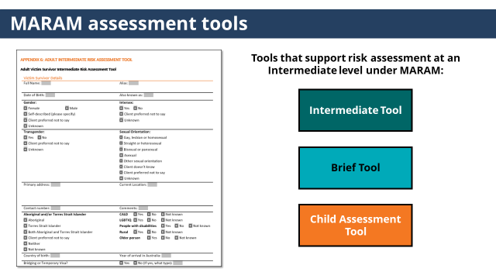 | These three tools support risk assessment at an Intermediate level. | - The tools that support risk assessment at an Intermediate level under MARAM are:  - The Intermediate Tool  - Brief Tool  - And Child Assessment Tool.
Slide 13: Intermediate assessment tool  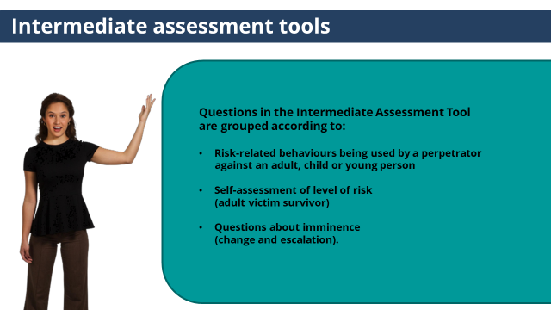 | The intermediate tools has questions to understand behaviours being used by a perpetrator, self-assessment of risk and questions about imminence. | (click to reveal text box)  - The Intermediate risk assessment tool contains detailed questions based on common presentations of the evidence-based risk factors.  - Questions in the Intermediate Assessment Tool are grouped according to:  - Risk-related behaviours being used by a perpetrator against an adult, child or young person  - Self-assessment of level of risk (adult victim survivor)  - Questions about imminence (change and escalation).
Slide 14: Intermediate assessment tool  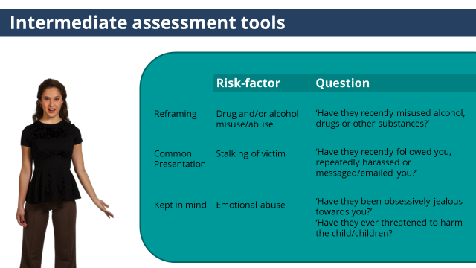 | How the questions relate to the risk factors varies.  It is important to ‘keep in in mind’ all the evidence based risk factors as every case presents differently. | (click to reveal text box)  - All questions in the tools relate to the evidence-based risk factors.  - What you will notice when you look at the tool is that:  (click to reveal first line)  - Some questions are a small reframing of the evidence-based risk factors.  For example: for the risk factor drug and/or alcohol misuse/abuse the question is ‘Have they recently misused alcohol, drugs or other substances?’  (click to reveal second line)  - Other questions represent a common presentation of the evidence-based risk factor.  For example: The question which relates to the evidence-based risk factor stalking of victim is ‘Have they recently followed you, repeatedly harassed or messaged/emailed you?’  - There is not a direct question for each evidence-based risk factor, but all the evidence-based risk factors relate to a question/s, which MARAM refers to as ‘kept in mind’.  (click to reveal third line)  - For example, there is no direct question about the evidence-based risk factor emotional abuse, but this evidence-based risk factor is ‘kept in mind’ in the questions ‘Have they been obsessively jealous towards you?’ and ‘Have they ever threatened to harm the child/children?  - This is a different format than the CRAF tools, which listed all the risk factors.  - The way risk factors present for each individual will be unique. Therefore it is vital you have a strong understanding of the evidence-based risk factors, and take a narrative approach to understanding how each evidence-based risk factor presents for a victim survivors.  - Practice Guide Responsibility 3: Appendix 8 provides detailed practice guidance for each question in the tool.
NOTES
The following risk factors do not have a direct questions which relates to them in the tools.
- Risk Factors for adult or child victims caused by perpetrator behaviours
- Isolation
- Property damage
- Emotional abuse.
- Risk Factors specific for children caused by perpetrator behaviours
- Sexualised behaviours towards a child by the perpetrator
- Change in behaviour not explained by other circumstances
- Child as victim in other forms of harm.

Slide 15: Brief assessment tool  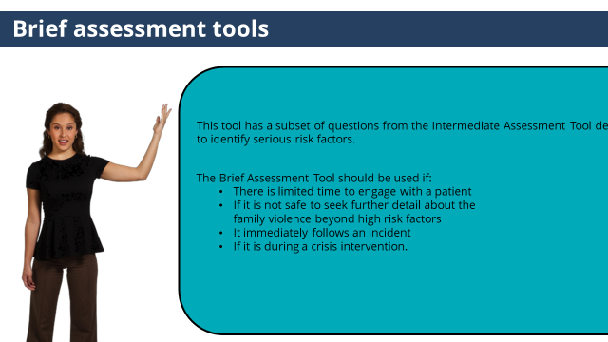 | The Brief Tool has a subset of questions designed to be used in time critical, or crisis situations. | - The Brief Assessment Tool  (click to reveal text box)  - This tool has a subset of questions from the Intermediate Assessment Tool designed to identify serious risk factors.  (click to reveal text)  - The Brief Assessment Tool should be used if:  - There is limited time to engage with a patient  - If it is not safe to seek further detail about the family violence beyond high risk factors  - It immediately follows an incident  - If it is during a crisis intervention.
Slide 16: Child assessment tool  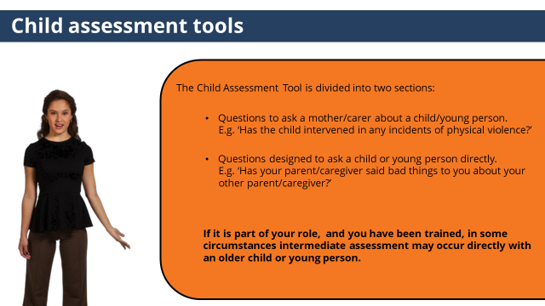 | The Child assessment tool has questions to ask a mother/carer and questions to ask a child if it is part of your role and you have been trained. | (click to reveal third box)  - The Child Assessment Tool is divided into two sections:  (click to reveal text)  - Questions to ask a mother/carer about a child/young person.  - E.g. ‘Has the child intervened in any incidents of physical violence?’  (click to reveal text)  - Questions designed to ask a child or young person directly.  - E.g. ‘Has your parent/caregiver said bad things to you about your other parent/caregiver?’  - The Child Assessment Tool is part of the Intermediate Assessment Tool, but can be used as a stand-alone tool.  - Each child needs to be considered individually.  - As an Intermediate aligned practitioner, you need to know the evidence-based risk factors specific to children, and ask questions to the adult victim survivor.  (click to reveal text)  - If it is part of your role, and you have been trained, in some circumstances Intermediate assessment may occur directly with an older child or young person, appropriate to their age and developmental stage, and if required by their unique situation.  - Responsibility 3 Practice Guide provides detailed guidance on how to determine if assessing risk directly with a child is appropriate, safe and reasonable for their age, developmental stage or circumstances and on using the child assessment tool.
NOTES
- The Adult Screening and Identification Tool can be used by all workers when they suspect or have identified family violence is occurring, or as part of routine screening. The tool include questions to identify if family violence is occurring, the level of fear and the person perpetrating violence. This is the tool used by staff with Identification & Screening or Sensitive Practice responsibilities.
- The Adult Comprehensive Assessment Tool builds on the Intermediate tool but includes additional questions for diverse communities and at-risk age cohorts. This tool is used by specialist family violence practitioners.
- Practice Guide Responsibility 3: Appendix 8 – Practice guidance on Intermediate tool and provides detailed practice guidance for each question in the tools, including:
  - Clarification on which risk factors the question relates to.
  - Why it is important to ask the question.
  - What should be kept in mind when asking each question.
  - And follow up questions to ask if particular presentations of the risk factor is present.

TOPIC: Structured Professional Judgement Model
Nominal duration: 45 minutes
Purpose: To give participants an understanding of the elements of the Structured Professional Judgement model and practice applying them in practice.
Resources for Trainers
- MARAM Practice Guides: Responsibility 3: Intermediate Risk Assessment.

Slide | Key message/s | Facilitator dialogue
Slide 17: Structured Professional Judgement Model  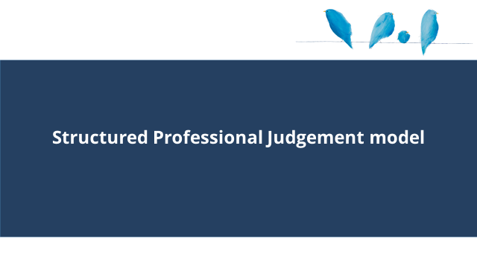 |  | - This section covers the Structured Professional Judgement model.
Slide 18: Structured Professional Judgement Model  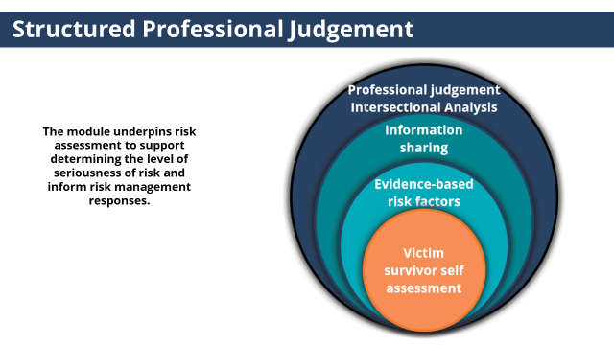 | The Structured Professional Judgement model is the practice model that underpins risk assessment to support determining the level of seriousness of risk and informs risk management responses. | - The Structured Professional Judgement model is the practice model that underpins risk assessment to support determining the level of seriousness of risk and informs risk management responses.  - Some of you will remember the Structured Professional Judgement model that was used under CRAF. This model has been expanded to include information sharing and an intersectional analysis.  - Let’s look at each element of the module.
Slide 19: Victim survivor self-assessment  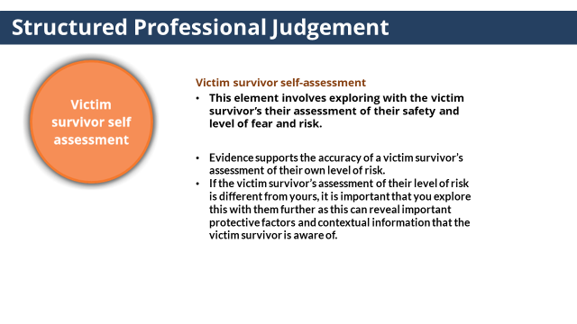 | Evidence supports the accuracy of a victim survivor’s assessment of their own level of risk. | - The victim survivor’s self-assessment.  - This element involves exploring with the victim survivor’s their assessment of their safety and level of fear and risk.  - The Intermediate tool includes questions to support this assessment.  (click to reveal text)  - Evidence supports the accuracy of a victim survivor’s assessment of their own level of risk.  - If the victim survivor’s assessment of their level of risk is different from yours, it is important that you explore this with them further as this can reveal important protective factors and contextual information that the victim survivor is aware of.
Slide 20: Check your understanding  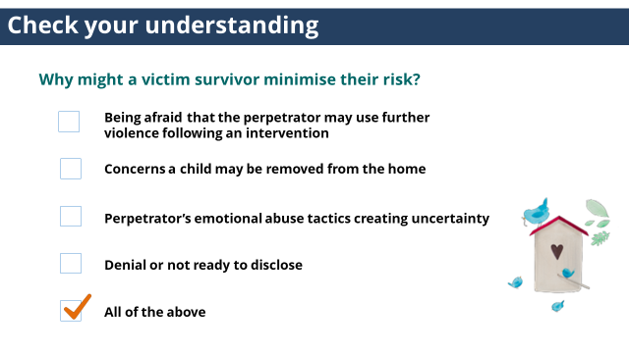 | There are many reasons why a victim survivor may minimise their risk. | Trainer to ask: Why might a victim survivor minimise their risk?  - Being afraid that the perpetrator may use further violence following an intervention  - Concerns a child may be removed from the home  - Perpetrator’s emotional abuse tactics creating uncertainty  - Denial or not ready to disclose  - All of the above  (click to reveal answer)  Answer: all of the above.
NOTES
While it is possible that at times family violence risk may become normalised to a victim survivor due to high risk or multiple experiences of violence, it is important that a practitioner always explores the situation and finds out why the victim survivor is less concerned than the practitioner before making assumptions that they are minimising.
Using a ‘scaling question’ is a good way to explore this, and is discussed further in MARAM Practice Guide Responsibility 3: Intermediate Risk Assessment. This involves asking a client where they would put themselves on a scale of 1-10, where 1 is totally safe and 10 is fearful the perpetrator will kill them.
For example, if a victim survivor puts themselves at a 5, but the worker feels they are at higher risk the worker can explore further, such as by asking: ‘has there ever been a time where you would have put yourself at a 9?’. This can reveal important protective factors and contextual information that the victim survivor is aware of.

Slide 21: Evidence-based risk factors  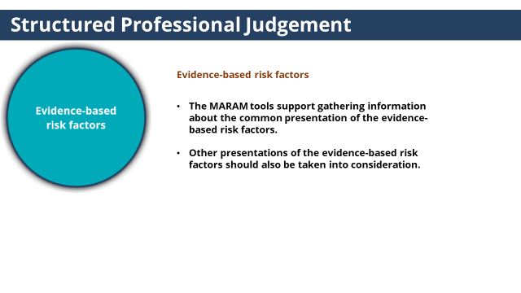 | All presentations of the evidence-based risk factors should also be taken into consideration. | - Evidence-based risk factors  - Knowing and recognising evidence-based risk factors are core knowledge in our shared understanding of family violence and informing our Structured Professional Judgement.  - The MARAM tools support gathering information about the common presentation of the evidence-based risk factors.  - Other presentations of the evidence-based risk factors should also be taken into consideration. For example disclosure of property damage and tactics a perpetrator has used to isolation a victim survivor from their family or friends.
Slide 22: Information sharing  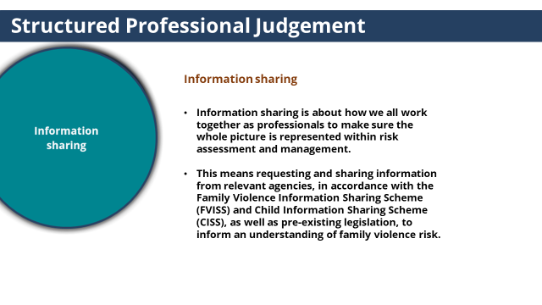 | Information sharing is about how we all work together as professionals to make sure the whole picture is represented within risk assessment and management. | - Information sharing is about how we all work together as professionals to make sure the whole picture is represented within risk assessment and management.  (click to reveal text)  - This means requesting and sharing information from relevant agencies, in accordance with the Family Violence Information Sharing Scheme (FVISS) and Child Information Sharing Scheme (CISS), as well as pre-existing legislation, to inform an understanding of family violence risk.
NOTES

Overview of the FVISS
The Royal Commission into Family Violence acknowledged that organisations that work with victims and perpetrators of family violence collect a wide variety of information in order to keep victims safe and hold perpetrators to account.
The Commission also identified barriers that prevent information from being shared as effectively as it could be and found that the failure to share crucial information with frontline workers can have catastrophic consequences.
In response to the Commission’s findings, a family violence information sharing scheme has been created by Part 5A of the Family Violence Protection Act 2008.
The scheme began on 26 February 2018, and it authorises a select group of prescribed information sharing entities (ISEs) to share information between themselves for family violence risk assessment and risk management.
The scheme does not interfere with existing legislation that allows information to be shared, such as privacy or child protection legislation.
Changes have also been made to Victorian privacy legislation that information can be shared in order to lessen or prevent a serious threat to the life, health, safety or welfare of a person.
The key elements of the scheme are:
- If you can already share under other laws – then continue to do so
- Requests must be complied with unless exemptions apply
- Consent is not required from anyone when victim is a child; where there is no children, you must have adult victim or third party consent, unless there is serious risk to a person’s safety
- Information Sharing Entities can share information without perpetrator consent

Overview of the CISS
The Child Information Sharing Scheme responds to over a decade of reviews and enquiries recommending reform to the way information is shared about children which have all recommended streamlining Victoria’s information sharing arrangements to improve outcomes for children by promoting shared responsibility for their wellbeing and safety and increasing collaboration across the service systems.
They also identified the need to modify a risk-averse culture, which has resulted in some practitioners being hesitant to share information even when it would benefit children to do so.
Requests must relate to promoting the wellbeing or safety of children.
Under this scheme, information sharing entities (ISE) can share information (on request and voluntarily) and request information from other ISEs to promote the wellbeing and safety of a child or group of children provided the information is relevant to that purpose, is not excluded and sharing the information does not contravene another law.
Training focus
It is assumed that prior to undertaking these modules participants would have completed the three Victorian Government Information Sharing Schemes eLearn modules for Health and Community Services Professionals https://elearn.childlink.com.au/.

In recognition of the complexity of these reforms, Trainers are not expected to respond to questions that are out of scope of what is covered in the trainer manual and should ensure they do not provide information about information sharing that is beyond their knowledge in the area. Participants should be referred to Information Sharing training, as well as back to the information sharing enquiry line ((03) 91 943 330) as well as back to the guidelines and other resources outlined in the Participant Guide and their organisation’s policy and procedure.

Slide 23: Check your understanding  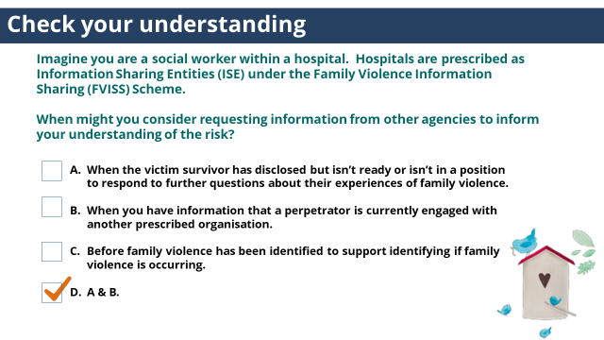 |  | Trainer to ask: Imagine you are a social worker within a hospital.  Hospitals are prescribed as Information Sharing Entities (ISE) under the Family Violence Information Sharing (FVISS) Scheme.  When might you consider requesting information from other agencies to inform your understanding of the risk?  - When the victim survivor has disclosed but isn’t ready or isn’t in a position to respond to further questions about their experiences of family violence.  - When you have information that a perpetrator is currently engaged with another prescribed organisation.  - Before family violence has been identified to support identifying if family violence is occurring.  - A & B  (click to reveal answer)  Answer: D. A & B.  A & B are examples of when might you consider requesting information from other agencies to inform your understanding of the risk.  Answer C is incorrect. Under FVISS, only organisations prescribed as Risk Assessment Entities (RAE) can request information to establish or identify whether risk of family violence is present. Hospitals are not prescribed RAEs as such can only request information after risk has been established or identified.
Slide 24: Professional Judgment  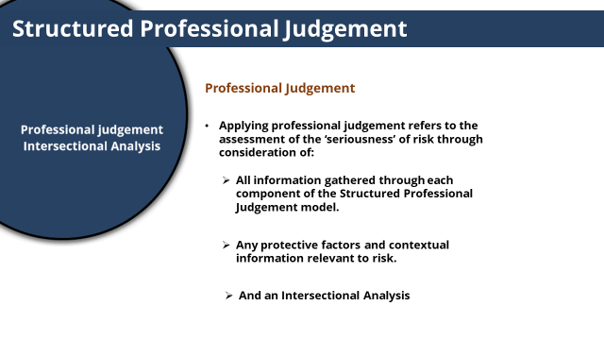 | Professional judgement refers to the assessment of the ‘seriousness’ of risk through consideration of all relevant information. | - Professional Judgement.  - Applying professional judgement refers to the assessment of the ‘seriousness’ of risk through consideration of:  (click to reveal each point)  - All information gathered through each component of the Structured Professional Judgement model.  - Any protective factors and contextual information relevant to risk.  - And an Intersectional Analysis
Slide 25: Protective Factors  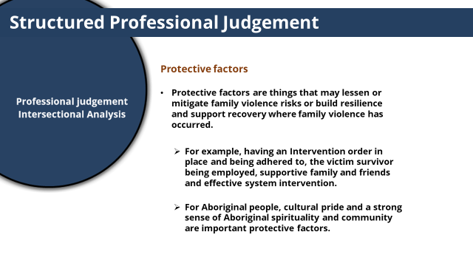 | Protective factors are things that may lessen or mitigate family violence risks or build resilience and support recovery where family violence has occurred. | - Protective factors are one part of professional judgement.  - Protective factors are things that may lessen or mitigate family violence risks or build resilience and support recovery where family violence has occurred.  (click to reveal each point)  - For example, having an Intervention order in place and being adhered to, the victim survivor being employed, supportive family and friends and effective system intervention.  - For Aboriginal people, cultural pride and a strong sense of Aboriginal spirituality and community are important protective factors.
Slide 26: Intersectional Analysis  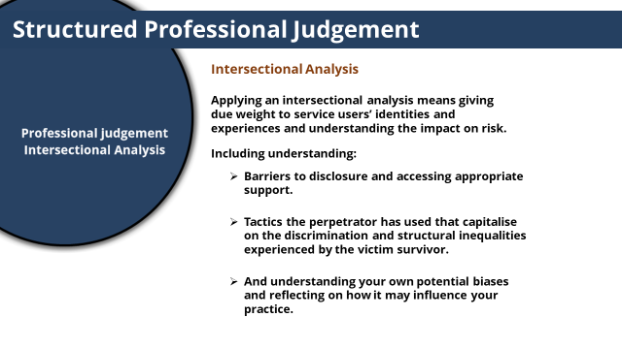 | Applying an intersectional analysis means giving due weight to service users’ identities and experiences and understanding the impact on risk. | - Intersectional Analysis.  - Applying an intersectional analysis means giving due weight to service users’ identities and experiences and understanding the impact on risk.  (click to reveal each point)  - Including understanding  - Barriers to disclosure and accessing appropriate support. We covered barriers in Module 1.  - Tactics the perpetrator has used that capitalise on the discrimination and structural inequalities experienced by the victim survivor.  For example: A perpetrator who uses the social context of laws and practices that have discriminated against transgender people to give weight to threats towards a transgender woman such as no-one would believe she is experiencing family violence or if she chose to seek help.  - And understanding your own potential biases and reflecting on how it may influence your practice.
Slide 27: Check your understanding  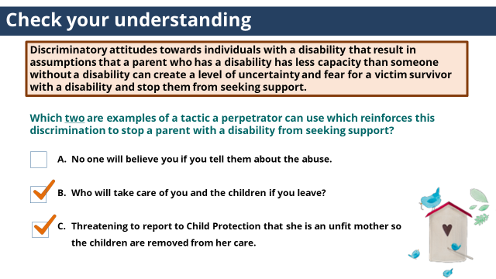 |  | Trainer to ask:  Discriminatory attitudes towards individuals with a disability that result in assumptions that a parent who has a disability has less capacity than someone without a disability can create a level of uncertainty and fear for a victim survivor with a disability and stop them from seeking support.  Which two are examples of a tactic a perpetrator can use which reinforces this discrimination to stop a parent with a disability from seeking support?  - No one will believe you if you tell them about the abuse.  - Who will take care of you and the children if you leave?  - Threatening to report to Child Protection that she is an unfit mother so the children are removed from her care.  (Click to reveal answer)  Answer: B& C  These are examples of a tactic a perpetrator can use which reinforces discriminatory attitudes that a parent who has a disability has less capacity than someone without a disability and create a level of uncertainty and fear for a victim survivor with a disability and stop them from seeking support.
NOTES
A is incorrect. Telling a victim survivor that no one will believe her if she discloses abuse is a tactic a perpetrator can use that capitalises on a common experience of victim survivors of family violence. However, this is not an example of a tactic that relates specifically to a parent with a disability.

ACTIVITY TWO: Risk Assessment in practice - Appling the Structured Professional Judgement Model
Purpose: The purpose of this activity is to give participants the opportunity to work through applying the Structured Professional Judgement model in practice.
Time: 30 mins
Instructions:
- Trainer to hand out a copy of one of the four case studies in Activity One to each participant (or a few copies per group).
Trainer to choose the case studies with the professions that best fits with the roles of participants.
- Trainer to introduce the activity by outlining the purpose of the activity.
- Trainer to ask participants to work in small groups, and to read through the additional case study information about Ania, Imran and Sabina
and work through the questions in the activity.
- Trainer to facilitate large group discussion about answers.
- Conclude activity with sentence such as ‘The elements of the Structured Professional Judgment collectively assist practitioners to assess the seriousness of risk’.

Answers:

SOCIAL WORKER IN A HOSPTIAL

Part 1: Evidence-based risk factors
Which three risk factors are present in this part of Ania’s story?
- Physical harm
- Emotional abuse
- Access to weapons
- Property damage
- Obsessive/jealous behaviour
Answer: Physical harm, emotional abuse, property damage
Which two risk factors are present in this part of Ania’s story?
- Planning to leave
- Has ever threatened to kill
- Imminent threat
- Controlling behaviours
- Sexual assault of victim
Answer: Controlling behaviours, Sexual assault of victim
Which three risk factors are present in this part of Ania’s story
- Has ever tried to strangle or choke the victim
- Escalation (severity & frequency)
- Physical harm
- Stalking of victim
- Exposure to family violence (of a child)
Answer: escalation, physical harm, exposure to family violence (of a child)

Part 2: Victim- Survivors self-assessment
Which three of the following statements reflect Ania’s safety concerns and level of fear?
- Immediate safety concerns
- Current fear level 3 (on a scale from 1-5)
- Concerned Imran would become physically abusive to Sabina
- Potential for Imran’s behaviour to make her fear level 5 (on a scale from 1-5)
- Further violent behaviour is likely
Answer: Current fear level 3 (on a scale from 1-5), Potential for Imran’s behaviour to make her fear level 5 (on a scale from 1-5), Further violent behaviour is likely

Part 3: Information sharing
What two agencies might you consider requesting information from under FVISS to inform your understanding of the risk to Ania and Sabina?
- Child Protection
- Housing service
- Religious leaders
- Mental Health Service
Answer: Child Protection and Mental Health Service
Ania has indicated that she has a mental health illness and Child Protection are involved.
Ania has not disclosed any housing services involvement.
Religious institutions are not prescribed under FVISS or CISS, thus requesting or sharing information with Religious leaders under these schemes are not permitted.

Part 4: Intersectional Analysis
Identifying barriers to disclosure and support seeking
- True or False. Ania describing her hospitalisation for depression as ‘traumatic’ may have created a barrier to Ania’s future help seeking?
Answer: True
Previous negative and discriminatory experiences with services may exacerbate barriers to disclosing or seeking support. However it will be important for the practitioner explore this further with Ania to confirm this.
- In Australia ‘research has demonstrated that anti-Islamic and anti-Semitic sentiment, as well as racism, have led communities to avoid seeking help for fear of stigmatisation from secular services.’ (Vaughan et al, 2020)
Does the below disclosure form Ania indicate she may be experiencing this barrier?
Ania said she hasn’t told anyone about Imran’s behaviour, as her community view issues between couples as a private issue and would try to dissuade her from seeking help from services so not to present a negative image of the community.
Answer: Yes
Ania’s disclosure indicates there may be barriers for her seeking support from mainstream services due to fear of stigmatisation.
It will be important for you to explore this further with Ania to confirm this.

Perpetrator tactics that capitalise on societal discrimination
Which tactic has Imran used that capitalises on aspects of Ania’s identity and health status (Muslim faith and living with a mental health issue) and the social situation of discrimination against those of Muslim faith and those living with a mental health issue?
- Threatening to tell police she was having an episode and needed mental health support so she would be hospitalised if she ever called the police.
- Using her faith as a way to justify controlling her use of contraception.
- Threatening to report to Child Protection that Ania is having another mental health episode, as a way to deter her from reporting his use of violence.
Answer: Using her faith as a way to justify controlling her use of contraception.
Ania disclosed Imran won’t let her use contraception and says she is immoral to consider it.
It is important to note that no culture or religion condones family violence and examples of non-violence can be found in all cultures.
Evidence suggests that religious texts and teachings can be misinterpreted or manipulated to justify and condone violence against women and wifely submission. (Vaughan et al, 2020)

Incorrect answers
Threatening to tell police she was having an episode and needed mental health support so she would be hospitalised if she ever called the police.
Ania has not disclosed Imran has used this tactic. However this is a tactic Imran could uses as it takes advantage of Ania’s previous lived experience and the social context of discrimination against people living with mental health issues.
Threatening to report to Child Protection that Ania is having another mental health episode, as a way to deter her from reporting his use of violence.
Ania has not disclosed Imran has used this tactic.
However this is a tactic Imran could use as it takes advantage of previous Child Protection involvement.

Protective Factors
Which protective factors is present for Ania and Sabina?
- An Intervention order is in place and being adhered to.
- Ania’ is employed and financially independent.
- Ania’s Muslim faith and community is a great source of strength.
- Sabina is engaged in school.
Answer: Ania has disclosed that her Muslim faith and community is a great source of strength for her.

Incorrect Answers:
The other options are protective factors, however from the information provided are not present in the case study.
Ania has not disclosed that an Intervention order is in place.
Ania disclosed that would like to go back to work from which you can infer she is not employed.
Ania disclosed that Sabina has been home from school a lot lately. So it is not clear school is a protective environment for Sabina. Engagement with school is a protective factor as it increases contacts with professionals who may be able to notice any concerns, and supports resilience and development.

Contextual information
What other contextual information is likely to be relevant to understanding Ania and Sabina’s risk?
(Choose the answer that most applies)
- Nature of Child Protection involvement
- Impact of living with depression.
- Imran victim blaming attitudes towards his use of violence
- All of the above
Answer: All of the above. When assessing the risk it will be important to consider how all of these factors impact the risk to Ania and Sabina.
MENTAL HEALTH CLINICIAN

Part 1: Evidence-based risk factors
Which three risk factors are present in this part of Ania’s story?
- Physical harm
- Emotional abuse
- Access to weapons
- Property damage
- Obsessive/jealous behaviour
Answer: Physical harm, emotional abuse, property damage
Which two risk factors are present in this part of Ania’s story?
- Planning to leave
- Has ever threatened to kill
- Imminent threat
- Controlling behaviours
- Sexual assault of victim
Answer: Controlling behaviours, Sexual assault of victim
Which three risk factors are present in this part of Ania’s story
- Has ever tried to strangle or choke the victim
- Escalation (severity & frequency)
- Physical harm
- Stalking of victim
- Exposure to family violence (of a child)
Answer: escalation, physical harm, exposure to family violence (of a child)

Part 2: Victim- Survivors self-assessment
Which three of the following statements reflect Ania’s safety concerns and level of fear?
- Immediate safety concerns
- Current fear level 3 (on a scale from 1-5)
- Concerned Imran would become physically abusive to Sabina
- Potential for Imran’s behaviour to make her fear level 5 (on a scale from 1-5)
- Further violent behaviour is likely
Answer: Current fear level 3 (on a scale from 1-5), Potential for Imran’s behaviour to make her fear level 5 (on a scale from 1-5), Further violent behaviour is likely

Part 3: Information sharing
Which agency might you consider requesting information from under FVISS to inform your understanding of the risk to Ania and Sabina?
- Child Protection
- Housing service
- Religious leaders
- Child FIRST
Answer: Child Protection
Ania has indicated Child Protection are involved.
Ania has not disclosed any housing services or child FIRST involvement.
Religious institutions are not prescribed under FVISS or CISS, thus requesting or sharing information with Religious leaders under these schemes are not permitted.

Part 4: Intersectional Analysis
Identifying barriers to disclosure and support seeking
- True or False. Ania describing her hospitalisation for depression as ‘traumatic’ may have created a barrier to Ania’s future help seeking?
Answer: True
Previous negative and discriminatory experiences with services may exacerbate barriers to disclosing or seeking support. However it will be important for the practitioner explore this further with Ania to confirm this.

- In Australia ‘research has demonstrated that anti-Islamic and anti-Semitic sentiment, as well as racism, have led communities to avoid seeking help for fear of stigmatisation from secular services.’ (Vaughan et al, 2020)
Does the below disclosure form Ania indicate she may be experiencing this barrier?
Ania said she hasn’t told anyone about Imran’s behaviour, as her community view issues between couples as a private issue and would try to dissuade her from seeking help from services so not to present a negative image of the community.
Answer: Yes
Ania’s disclosure indicates there may be barriers for her seeking support from mainstream services due to fear of stigmatisation.
It will be important for you to explore this further with Ania to confirm this.

Perpetrator tactics that capitalise on societal discrimination
Which tactic has Imran used that capitalises on aspects of Ania’s identity and health status (Muslim faith and living with a mental health issue) and the social situation of discrimination against those of Muslim faith and those living with a mental health issue?
- Threatening to tell police she was having an episode and needed mental health support so she would be hospitalised if she ever called the police.
- Using her faith as a way to justify controlling her use of contraception.
- Threatening to report to Child Protection that Ania is having another mental health episode, as a way to deter her from reporting his use of violence.
Answer: Using her faith as a way to justify controlling her use of contraception.
Ania disclosed Imran won’t let her use contraception and says she is immoral to consider it.
It is important to note that no culture or religion condones family violence and examples of non-violence can be found in all cultures.
Evidence suggests that religious texts and teachings can be misinterpreted or manipulated to justify and condone violence against women and wifely submission. (Vaughan et al, 2020)

Incorrect answers
Threatening to tell police she was having an episode and needed mental health support so she would be hospitalised if she ever called the police.
Ania has not disclosed Imran has used this tactic. However this is a tactic Imran could uses as it takes advantage of Ania’s previous lived experience and the social context of discrimination against people living with mental health issues.
Threatening to report to Child Protection that Ania is having another mental health episode, as a way to deter her from reporting his use of violence.
Ania has not disclosed Imran has used this tactic.
However this is a tactic Imran could use as it takes advantage of previous Child Protection involvement.

Protective Factors
Which protective factors is present for Ania and Sabina?
- An Intervention order is in place and being adhered to.
- Ania’ is employed and financially independent.
- Ania’s Muslim faith and community is a great source of strength.
- Sabina is engaged in school.
Answer: Ania has disclosed that her Muslim faith and community is a great source of strength for her.

Incorrect Answers:
The other options are protective factors, however from the information provided are not present in the case study.
Ania has not disclosed that an Intervention order is in place.
Ania disclosed that would like to go back to work from which you can infer she is not employed.
Ania disclosed that Sabina has been home from school a lot lately. So it is not clear school is a protective environment for Sabina. Engagement with school is a protective factor as it increases contacts with professionals who may be able to notice any concerns, and supports resilience and development.
Contextual information
What other contextual information is likely to be relevant to understanding Ania and Sabina’s risk?
(Choose the answer that most applies)
- Nature of Child Protection involvement
- Impact of living with depression.
- Imran victim blaming attitudes towards his use of violence
- All of the above
Answer: All of the above. When assessing the risk it will be important to consider how all of these factors impact the risk to Ania and Sabina.

CARE COORDINATOR IN AN EMERGENCY DEPARTMENT

Part 1: Evidence-based risk factors
Which three risk factors are present in this part of Ania’s story?
- Physical harm
- Emotional abuse
- Access to weapons
- Property damage
- Obsessive/jealous behaviour
Answer: Physical harm, emotional abuse, property damage
Which two risk factors are present in this part of Ania’s story?
- Planning to leave
- Has ever threatened to kill
- Imminent threat
- Controlling behaviours
- Sexual assault of victim
Answer: Controlling behaviours, Sexual assault of victim
Which three risk factors are present in this part of Ania’s story
- Has ever tried to strangle or choke the victim
- Escalation (severity & frequency)
- Physical harm
- Stalking of victim
- Exposure to family violence (of a child)
Answer: escalation, physical harm, exposure to family violence (of a child)
Part 2: Victim- Survivors self-assessment
Which three of the following statements reflect Ania’s safety concerns and level of fear?
- Immediate safety concerns
- Current fear level 3 (on a scale from 1-5)
- Concerned Imran would become physically abusive to Sabina
- Potential for Imran’s behaviour to make her fear level 5 (on a scale from 1-5)
- Further violent behaviour is likely
Answer: Current fear level 3 (on a scale from 1-5), Potential for Imran’s behaviour to make her fear level 5 (on a scale from 1-5), Further violent behaviour is likely
Part 3: Information sharing
What two agencies might you consider requesting information from under FVISS to inform your understanding of the risk to Ania and Sabina?
- Child Protection
- Housing service
- Religious leaders
- Mental Health Service
Answer: Child Protection and Mental Health Service
Ania has indicated that she has a mental health illness and Child Protection are involved.
Ania has not disclosed any housing services involvement.
Religious institutions are not prescribed under FVISS or CISS, thus requesting or sharing information with Religious leaders under these schemes are not permitted.

Part 4: Intersectional Analysis
Identifying barriers to disclosure and support seeking
- True or False. Ania describing her hospitalisation for depression as ‘traumatic’ may have created a barrier to Ania’s future help seeking?
Answer: True
Previous negative and discriminatory experiences with services may exacerbate barriers to disclosing or seeking support. However it will be important for the practitioner explore this further with Ania to confirm this.
- In Australia ‘research has demonstrated that anti-Islamic and anti-Semitic sentiment, as well as racism, have led communities to avoid seeking help for fear of stigmatisation from secular services.’ (Vaughan et al, 2020)
Does the below disclosure form Ania indicate she may be experiencing this barrier?
Ania said she hasn’t told anyone about Imran’s behaviour, as her community view issues between couples as a private issue and would try to dissuade her from seeking help from services so not to present a negative image of the community.
Answer: Yes
Ania’s disclosure indicates there may be barriers for her seeking support from mainstream services due to fear of stigmatisation.
It will be important for you to explore this further with Ania to confirm this.

Perpetrator tactics that capitalise on societal discrimination
Which tactic has Imran used that capitalises on aspects of Ania’s identity and health status (Muslim faith and living with a mental health issue) and the social situation of discrimination against those of Muslim faith and those living with a mental health issue?
- Threatening to tell police she was having an episode and needed mental health support so she would be hospitalised if she ever called the police.
- Using her faith as a way to justify controlling her use of contraception.
- Threatening to report to Child Protection that Ania is having another mental health episode, as a way to deter her from reporting his use of violence.
Answer: Using her faith as a way to justify controlling her use of contraception.
Ania disclosed Imran won’t let her use contraception and says she is immoral to consider it.
It is important to note that no culture or religion condones family violence and examples of non-violence can be found in all cultures.
Evidence suggests that religious texts and teachings can be misinterpreted or manipulated to justify and condone violence against women and wifely submission. (Vaughan et al, 2020)

Incorrect answers
Threatening to tell police she was having an episode and needed mental health support so she would be hospitalised if she ever called the police.
Ania has not disclosed Imran has used this tactic. However this is a tactic Imran could uses as it takes advantage of Ania’s previous lived experience and the social context of discrimination against people living with mental health issues.
Threatening to report to Child Protection that Ania is having another mental health episode, as a way to deter her from reporting his use of violence.
Ania has not disclosed Imran has used this tactic.
However this is a tactic Imran could use as it takes advantage of previous Child Protection involvement.

Protective Factors
Which protective factors is present for Ania and Sabina?
- An Intervention order is in place and being adhered to.
- Ania’ is employed and financially independent.
- Ania’s Muslim faith and community is a great source of strength.
- Sabina is engaged in school.
Answer: Ania has disclosed that her Muslim faith and community is a great source of strength for her.

Incorrect Answers:
The other options are protective factors, however from the information provided are not present in the case study.
Ania has not disclosed that an Intervention order is in place.
Ania disclosed that would like to go back to work from which you can infer she is not employed.
Ania disclosed that Sabina has been home from school a lot lately. So it is not clear school is a protective environment for Sabina. Engagement with school is a protective factor as it increases contacts with professionals who may be able to notice any concerns, and supports resilience and development.

Contextual information
What other contextual information is likely to be relevant to understanding Ania and Sabina’s risk?
(Choose the answer that most applies)
- Nature of Child Protection involvement
- Impact of living with depression.
- Imran victim blaming attitudes towards his use of violence
- All of the above
Answer: All of the above. When assessing the risk it will be important to consider how all of these factors impact the risk to Ania and Sabina.
HOSPITAL ADMISSION RISK PROGRAM (HARP) CLINICIAN

Part 1: Evidence-based risk factors
Which three risk factors are present in this part of Ania’s story?
- Physical harm
- Emotional abuse
- Access to weapons
- Property damage
- Obsessive/jealous behaviour
Answer: Physical harm, emotional abuse, property damage
Which two risk factors are present in this part of Ania’s story?
- Has ever threatened to kill
- Financial abuse
- Controlling behaviours
- Stalking of victim
Answer: Financial abuse, Controlling behaviours
Which three risk factors are present in this part of Ania’s story
- Escalation (severity & frequency)
- Physical harm
- Unemployed
- Exposure to family violence (of a child)
Answer: Escalation, physical harm, exposure to family violence (of a child)

Part 2: Victim- Survivors self-assessment
Which three of the following statements reflect Ania’s safety concerns and level of fear?
- Immediate safety concerns
- Current fear level 3 (on a scale from 1-5)
- Concerned Imran would become physically abusive to Sabina
- Potential for Imran’s behaviour to make her fear level 5 (on a scale from 1-5)
- Further violent behaviour is likely
Answer: Current fear level 3 (on a scale from 1-5), Potential for Imran’s behaviour to make her fear level 5 (on a scale from 1-5), Further violent behaviour is likely

Part 3: Information sharing
What agency might you consider requesting information from under FVISS to inform your understanding of the risk to Ania and Sabina?
- Child Protection
- Housing service
- Religious leaders
- Mental Health Service
Answer: Mental Health Service
Ania has indicated that she has a mental health illness and Child Protection are involved.
Ania has not disclosed any housing services involvement.
Religious institutions are not prescribed under FVISS or CISS, thus requesting or sharing information with Religious leaders under these schemes are not permitted.

Part 4: Intersectional Analysis
Identifying barriers to disclosure and support seeking
- True or False. Ania describing her hospitalisation for depression as ‘traumatic’ may have created a barrier to Ania’s future help seeking?
Answer: True
Previous negative and discriminatory experiences with services may exacerbate barriers to disclosing or seeking support. However it will be important for the practitioner explore this further with Ania to confirm this.
- In Australia ‘research has demonstrated that anti-Islamic and anti-Semitic sentiment, as well as racism, have led communities to avoid seeking help for fear of stigmatisation from secular services.’ (Vaughan et al, 2020)
Does the below disclosure form Ania indicate she may be experiencing this barrier?
Ania said she hasn’t told anyone about Imran’s behaviour, as her community view issues within families as a private issue and would try to dissuade her from seeking help from services so not to present a negative image of the community.
Answer: Yes
Ania’s disclosure indicates there may be barriers for her seeking support from mainstream services due to fear of stigmatisation.
It will be important for you to explore this further with Ania to confirm this.

Perpetrator tactics that capitalise on societal discrimination
Which tactic has Imran used that capitalises on aspects of Ania’s identity and health status (Muslim faith and living with a mental health issue) and the social situation of discrimination against those of Muslim faith and those living with a mental health issue?
- Threatening to tell police she was having an episode and needed mental health support so she would be hospitalised if she ever called the police.
- Using her faith as a way to justify his abusive behaviour.
- Threatening to put her in an aged care home as a way to deter her from reporting his use of violence.
Answer: Threatening to tell police she was having an episode and needed mental health support so she would be hospitalised if she ever called the police.
Ania disclosed Imran threatened to tell the police she was having another mental health episode so she would be hospitalised again if she called the police.

It is important to note that no culture or religion condones family violence and examples of non-violence can be found in all cultures.
Evidence suggests that religious texts and teachings can be misinterpreted or manipulated to justify and condone violence against women and wifely submission. (Vaughan et al, 2020)

Protective Factors
Which protective factors is present for Ania and Sabina?
- An Intervention order is in place and being adhered to.
- Ania’ is employed and financially independent.
- Ania’s Muslim faith and community is a great source of strength.
- Sabina is engaged in school.
Answer: Ania has disclosed that her Muslim faith and community is a great source of strength for her.

Incorrect Answers:
The other options are protective factors, however from the information provided are not present in the case study.
Ania has not disclosed that an Intervention order is in place.
Ania disclosed that would like to go back to work from which you can infer she is not employed.
Ania disclosed that Sabina has been home from school a lot lately. So it is not clear school is a protective environment for Sabina. Engagement with school is a protective factor as it increases contacts with professionals who may be able to notice any concerns, and supports resilience and development.

Contextual information
What other contextual information is likely to be relevant to understanding Ania and Sabina’s risk?
(Choose the answer that most applies)
- Ania’s age and health needs
- Impact of living with depression.
- Imran victim blaming attitudes towards his use of violence
- All of the above
Answer: All of the above. When assessing the risk it will be important to consider how all of these factors impact the risk to Ania and Sabina.

TOPIC: Assessment of Seriousness of Risk
Nominal duration: 20 minutes
Purpose: To give participants knowledge of the risk ratings under MARAM and practice determining the level of seriousness of risk.
Resources for Trainers
- MARAM Practice Guides: Responsibility 3: Intermediate Risk Assessment.

Slide | Key message/s | Facilitator dialogue
Slide 28: Assessment of Seriousness of Risk  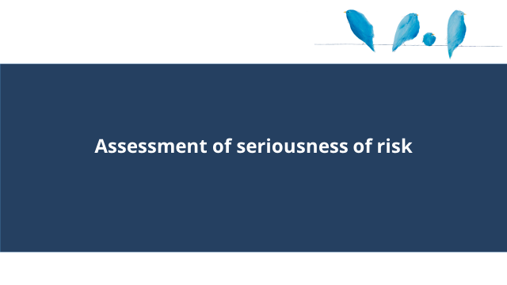 |  | Trainer to cover the following:  - This section covers assessment of Seriousness of Risk.
Slide 29: Seriousness of Risk  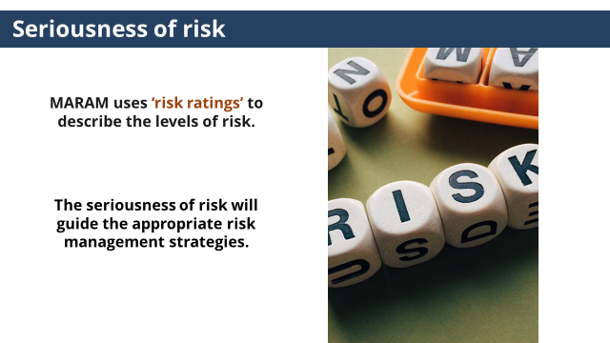 | It is important to be familiar with the principles of determining seriousness. The seriousness of risk will guide the appropriate risk management strategies. | - Now that we’ve looked at the different elements of the Structured Professional Judgement model, we can consider how we put all of this information together to determine the seriousness of risk.  - MARAM uses ‘risk ratings’ to describe the levels of risk.  - Professionals are required to use the Intermediate tools and they are also required to be familiar with risk ratings and principles of determining seriousness.  - The seriousness of risk will guide the appropriate risk management strategies.  - Part of your role will be ensuring you are able to clearly communicate a client’s level of risk and the rationale behind this to the client and other practitioners to support collaborative practice.
Slide 30: Seriousness of Risk  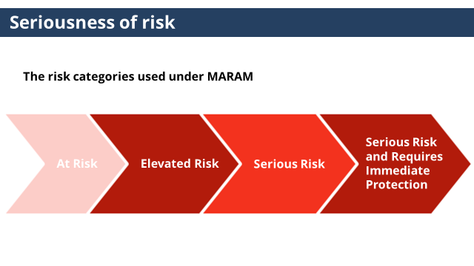 | It is important to be familiar with the risk categories under MARAM | - The risk categories used under MARAM:  - At risk  - Elevated risk  - Serious risk  - Serious risk and requires immediate protection
NOTES
- It is essential that a risk level is accompanied by a clear rationale. This helps ensure the professional judgement that went into the assessment is clearly communicated – this supports communication between services. An assessment in an integrated system is only useful if it can be understood properly.
- An assessment is a ‘point in time’, but it needs to consider a pattern of behaviour. Assessment needs to be regularly revisited and seriousness of risk can change over time.
- Formulating an assessment of risk level requires consideration of severity, frequency, pattern of behaviour, impact, changes of behaviour, escalation and likelihood.
- Development of the Professional Judgement to determine the risk level will take time to develop.

ACTIVITY THREE: MARAM risk categories
Purpose: The purpose of this activity is to give participants time to review the descriptions of the risk categories under MARAM and the opportunity to work through determining the level of the seriousness of risk in practice.

Time: 15 mins

Instructions:
- Trainer to hand out a copy of Activity Three to each participant (or a few copies per group).
- Trainer to introduce the activity by outlining the purpose of the activity.
- Trainer to ask participants to read through the descriptions of the risk categories under MARAM and in small groups develop a rationale for which level they would rate Ania and Sabina’s risk?
- Trainer to facilitate large group discussion about answer.
- Conclude activity with sentence such as ‘Development of the Professional Judgement to determine the seriousness of risk level will take time, understanding the different risk categories provides guidance on determining the level’. Part of your role will be ensuring you are able to clearly communicate a client’s level of risk and the rationale behind this to clients and other practitioners to support collaborative practice.'

If participants aren’t sure how to approach this activity, suggest that they review the descriptions and highlight which elements of the descriptions are present in the case study (similar to sample answer below) to support determining the level.
While the sample answer below indicates the most appropriate answer, there may be differences of opinion within the group, which is ok. Trainers should focus the discussion with the group on the rationale behind their assessment as this skill is critical in developing the professional judgement required to assess the level of risk.

Answer: Elevated. The factors present for Ania and Sabina indicate an Elevated Risk level, as they most align with the description of this risk category.
Elevated Risk | Present
A number of risk factors are present | Emotional abuse, property damage, physical harm, exposure to family violence (of a child).
Including some high-risk factors (serious) | Controlling behaviours, sexual assault of victim, escalation.
Behaviours are likely to continue
The likelihood of a serious outcome is not high.
Perpetrator is affecting the victim survivor’s day-to-day functioning
Victim survivor self-assessed level of fear and risk is elevated and safety is medium | Current level 3, with potential for 5 (on scale 1-5).
Victim survivor self-assessed level of fear and risk is high but not imminent

Incorrect answers
At Risk: A few factors indicating At Risk are present for Ania and Sabina, not enough to assess the the At Risk level.
At Risk | Present
High risk factors are not present. | X  Serious risk factors present (controlling behaviours, sexual assault of victim, escalation).
Family violence risk factors are present. | Emotional abuse, property damage, physical harm, exposure to family violence (of a child).
Protective factors and risk management strategies are in place to manage (lessen or remove) the risk from the perpetrator. | X
Victim survivor self-assessed level of fear and risk are low and safety is high | X  Current level 3, with potential for 5 (on scale 1-5).

Serious. Some factors indicating Serious Risk are present for Ania and Sabina but not enough to assess the Serious Risk level.
Serious Risk | Present
A number of high-risk factors (serious) are present. | Controlling behaviours, sexual assault of victim, escalation.
Risk factors may have changed/escalated in frequency
Serious outcomes from current violence has occurred | X
Further serious outcomes is likely, and may be imminent. | X
Immediate risk management is required to lessen or prevent a serious outcome. | X
Victim survivor self-assessed level of fear and risk is high-extremely high and safety is low. | X  Current level 3, with potential for 5 (on scale 1-5).

Requiring immediate protection. Only one factors indicating Requiring immediate protection are present for Ania and Sabina, not enough to assess the Requiring immediate protection.
Serious Risk and Requiring immediate protection | Present
A number of high-risk factors (serious) are present. | Controlling behaviours, sexual assault of victim, escalation.
Risk factors may have changed/escalated in frequency
Serious outcomes from current violence has occurred | X
Further serious outcomes is likely, and may be imminent. | X
Immediate risk management is required to lessen or prevent a serious outcome. | X
Victim survivor self-assessed level of fear and risk is high-extremely high and safety is low. | X  Current level 3, with potential for 5 (on scale 1-5).
Previous risk management strategies have been unsuccessful | X  Limited risk management strategies enacted
Formally structure service and agency response is required to lessen serious risk that is likely to result in lethality or serious physical or sexual violence. | X

TOPIC: Misidentification of the perpetrator and victim survivor

Nominal duration: 5 minutes
Purpose: To give participants an understanding that misidentification can occur and how to respond.
Resources for Trainers
- MARAM Framework.
- MARAM Practice Guides: Responsibility 3: Intermediate Risk Assessment.

Slide | Key message/s | Facilitator dialogue
Slide 31: Misidentification of the perpetrator and victim survivor  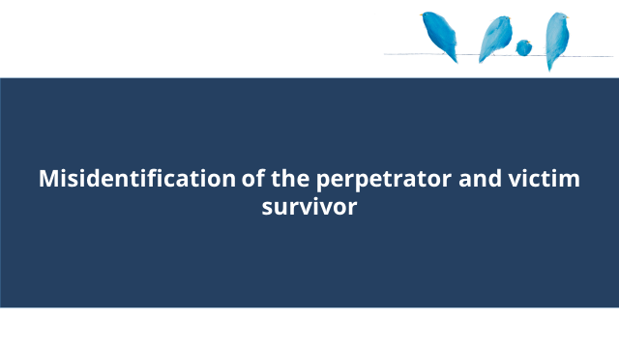 |  | - This section covers misidentification of the perpetrator and victim survivor.
Slide 32: Misidentification of the perpetrator and victim survivor  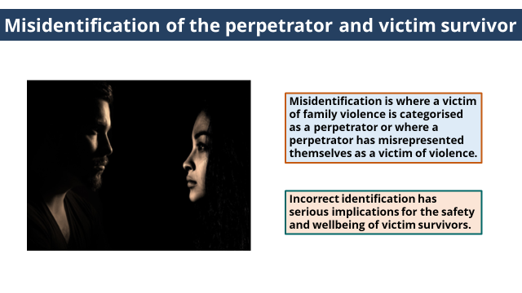 | Misidentification is where a victim of family violence is categorised as a perpetrator or where a perpetrator has misrepresented themselves as a victim of violence.  It is a common problem. | - It is important to understand that misidentification can occur.  - Misidentification is where a victim of family violence is categorised as a perpetrator or where a perpetrator has misrepresented themselves as a victim of violence.  - This is a common problem.  - Incorrect identification has serious implications for the safety and wellbeing of victim survivors.
Slide 33: Misidentification of the perpetrator and victim survivor  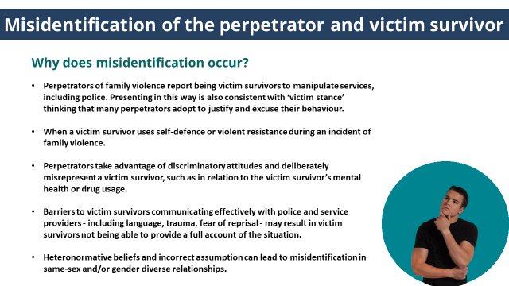 | There are many reasons why misidentification can occur, all have implications for the safety and wellbeing of victim survivors. | Trainer to ask: Why does misidentification occur?  (click to reveal answers)  - Perpetrators of family violence report being victim survivors to manipulate services, including police. Presenting in this way is also consistent with ‘victim stance’ thinking that many perpetrators adopt to justify and excuse their behaviour.  - When a victim survivor uses self-defence or violent resistance during an incident of family violence.  - Perpetrators take advantage of discriminatory attitudes and deliberately misrepresent a victim survivor, such as in relation to the victim survivor’s mental health or drug usage.  - Barriers to victim survivors communicating effectively with police and service providers - including language, trauma, fear of reprisal - may result in victim survivors not being able to provide a full account of the situation.  - Heteronormative beliefs and incorrect assumption can lead to misidentification in same-sex and/or gender diverse relationships.
Slide 34: Misidentification of the perpetrator and victim survivor  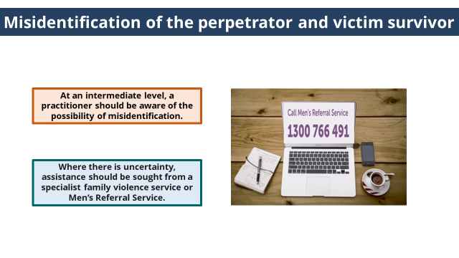 | If misidentification is identified assistance should be sought from a specialist family violence service or Men’s Referral Service. | - At an intermediate level, a practitioner should be aware of the possibility of misidentification.  - Where there is uncertainty and support required on how to respond, assistance should be sought from a specialist family violence service or Men’s Referral Service.

Topic: Conclusion
Time: 15 mins
ACTIVITY FOUR: Quiz
Purpose: To check participant’s knowledge of key knowledge covered in the module.
Time: 5mins
Instructions:
- Handout: Activity Four.
- Trainer to ask participants to complete Quiz individually.
- Trainer to facilitate large group discussion about answers.

Answers:
- True or False
Risk Factors relate to the current and emerging evidence which research has indicated that when present, a victim survivor of family violence is statistically more likely to be killed or seriously injured.
Answer: True
Covered slide 7.

- This Child Assessment tool should be used directly with an older child or young person if it is appropriate to their age and developmental stage and if it is your role to do so.
Answer: True
Covered slide 16.

- The elements of the Structured Professional Judgement model are: (choose all that apply)
- Victim/survivor self-assessment
- Evidence based risk factors
- Information Sharing
- Professional Judgement and Intersectional Analysis
Answer: all
Covered slide 17-27.

- Which of the following risk categories is not used under MARAM when determining seriousness of risk.
- At risk
- Elevated risk
- Imminent risk
- Serious risk
- Serious risk and requires immediate protection
Answer: 3. Imminent risk
Covered slide 30.

Slide | Key message | Facilitator dialogue
Slide 35: Module 3 summary  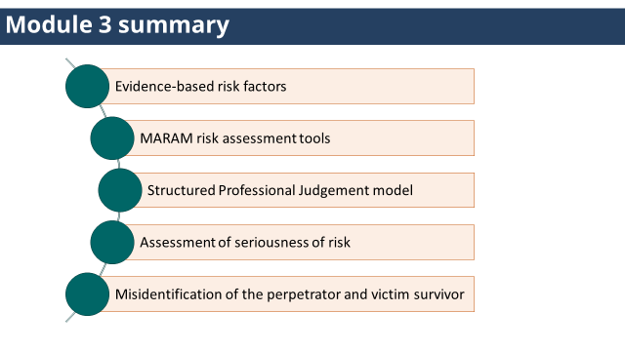 |  | - Module 3 summary  - Evidence-based risk factors  - MARAM risk assessment tools  - Structured Professional Judgement model  - Assessment of seriousness of risk  - Misidentification of the perpetrator and victim survivor
Slide 36: Quotes from victim survivors  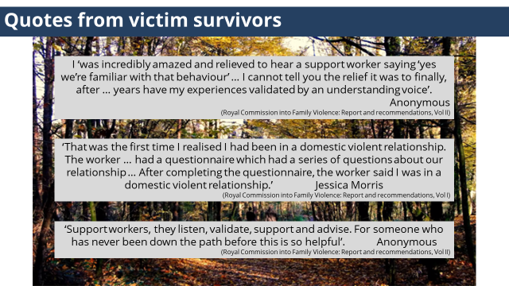 |  | - Here are some quotes from victim survivors about their engagement with the service system.  (click to reveal and hide each quote, allow time for participants to read each quote)
Slide 37: Reflection |  | Trainer to invite participants to turn to the person next to them and share a key learning for them from this training.
Slide 38: Self-care | Self-care should be a part of your work and is a shared responsibility between individuals, teams, organisations and systems. | - While this work can be experienced as a privilege, knowing the difference that we can make to the lives of those that we assist.  - It is important to acknowledge you can be personally affected by hearing about traumatic events, and by witnessing the impact and distress that it causes.  - It can also become personally draining, and at times overwhelming.  - Self-care should be a part of your work and is a shared responsibility between individuals, teams, organisations and systems.  - Self-care is about knowing and accessing the professional supports avilable.  - And knowing and prioritising what works for you.  Trainer to invite participants to turn to the person next to them and share two things that supports their self-care.
Slide 39: Thankyou |  | - Thank participants for coming.  - Trainer to let participants know the scheduled time for Module 4.

MODULE 4
Time: 2 hours
TOPIC: Welcome, acknowledgements, housekeeping, introductions & overview
Nominal duration: 20 minutes
Purpose: To make acknowledgements, establish expected behaviour in the training environment and provide participants with an overview of the training.
Slide | Key message/s | Facilitator dialogue
Slide 1: Introduction  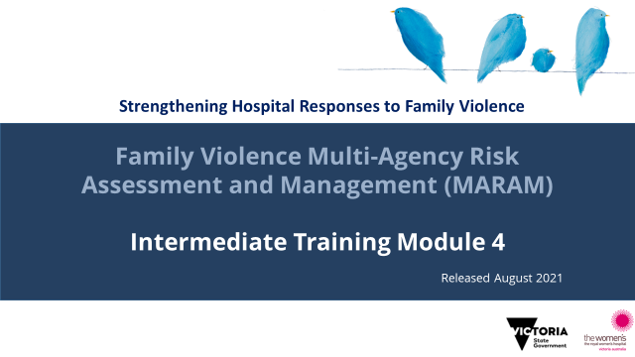 | Acknowledgement of traditional owners, victim survivors and language. | Welcome  - Introduce training.  - Welcome participants.  Acknowledgement of country  - Acknowledge the Traditional Aboriginal Owners of country on which the training is taking place. Pay respects to them, their culture and their Elders past, present and emerging, as well as any community members here today in the room with us. Acknowledge that sovereignty of this land was never ceded.  - For the purposes of this module, we’ll be using the term Aboriginal to refer to both Aboriginal and Torres Strait Islander people.  Acknowledgement of victim survivors  - We wish to acknowledge victim survivors of family violence, particularly women and children that have been killed in the context of family violence.  - We hope what is presented in this training is respectful to their individual experiences.  Introductions  - Trainer introductions: Provide a 1-2 sentence introduction that explains your professional background, emphasising aspects that establish your authority to deliver the MARAM training.  Examples of Trainers relevant experience that lends authority may include clinical experience working at an Intermediate or Comprehensive MARAM level; experience in a specialist service/clinic; experience in the specialist family violence service; clinical educator.  Housekeeping  - Outline duration of training, break times (if scheduled) and OH&S requirements (fire exits etc.).
NOTES
The Aboriginal Victoria website has an interactive map that allows you to search for the Traditional Owners of a particular area. It also documents areas where this is contested. Taking the time to be aware of and acknowledge the Traditional Owners of the area where training is being delivered is an opportunity to honour Victoria’s strong and proud Aboriginal and Torres Strait Islander history.

Slide 2: Safe learning environment | Throughout the session be mindful of confidentiality, be respectful of diverse opinions and various levels of knowledge, and ways we can all support this to be a safe learning environment for everyone. | - Remind participants of the group expectations to support a safe learning environment that were covered in earlier modules.
Slide 3: Self-care | To highlight the importance of self-care and for participants to be aware of services they can contact if they are impacted by the training. | - Discussing family violence can be distressing, particularly if you have experienced or been impacted by violence.  - If this training causes any concern for yourself or another you can discontinue at any time; however we encourage you to contact one of these services or your workplace Employee Assistance Program for support.  - Information about these services can be found in your Participant Guide.
Slide 4: Training overview  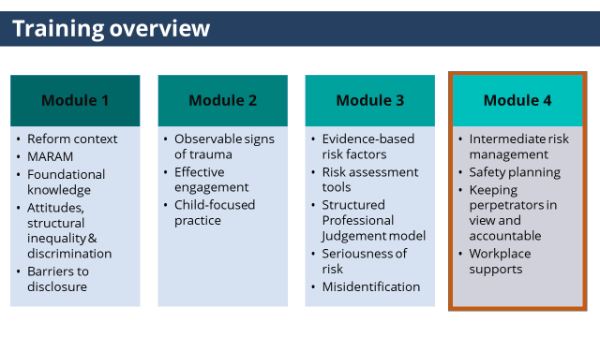 | This training aims to build the knowledge and skills to respond effective to victim survivors of family violence at an Intermediate level under MARAM.  This is Module 3. | - This training has 4 modules, and has been designed to cover the skills and knowledge required by practitioners whose role includes Intermediate responsibilities under MARAM.  (click to reveal highlighted state)  - This is module 4, module 4 will cover:  - Intermediate risk management  - Responding to immediate risk  - Safety planning  - Options and connection to relevant services.  - Ongoing risk assessment and management  - Keeping perpetrators in view and accountable  - Workplace Supports
Slide 5: Introductions | Gauge participant expectations of the training. | - Participants to introduce themselves (name, role etc.).  - Share what they are wanting to achieve or ‘get out of’ today’s training.
NOTES
Trainers may wish to set up this as an activity where participants share what they want to get out of the training (either verbally with the group or on a Post It note, with Trainers writing them on a wall/whiteboard, and returning to this at the conclusion of the session to see if they have been addressed.

TOPIC: Risk Management
Nominal duration: 50 minutes
Purpose: To give participants an understanding of risk management and Intermediate risk management responsibilities under MARAM.
Resources for Trainers

- MARAM Practice Guides: Responsibility 4: Intermediate Risk Management
- Appendix 9 is an adult safety plan template.
- Appendix 10 is a safety plan for older children and young people.
- MARAM Practice Guides: Responsibility 5: Secondary Consultations and Referral, including for comprehensive family violence assessment and management response.
- MARAM Practice Guides: Responsibility 6: Contribute to information sharing with other services (as authorised by legislation).
- MARAM Practice Guides: Responsibility 9: Contribute to coordinated risk management.
- MARAM Practice Guides: Responsibility 10: Collaborate for on-going risk assessment and risk management.
- Video: Northern Integrated Family Violence Services Partnership (2018) Knowledge to Advocate: Intervention Orders and Legal Support.

Slide | Key message/s | Facilitator dialogue
Slide 6: Risk Management  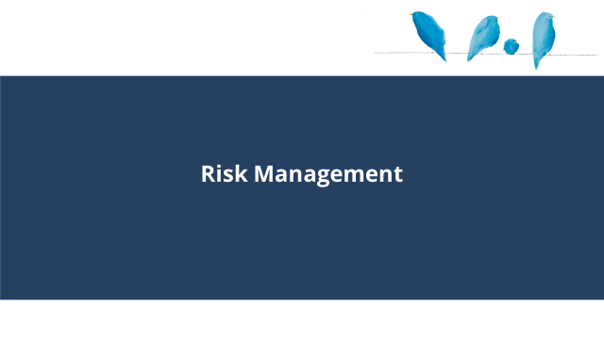 |  | - This section will cover risk management.
Slide 7: Risk Management  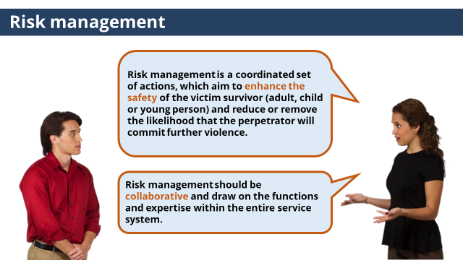 | Risk management enhances the safety of victim survivors and reduces and removes the likelihood the perpetrator will commit further violence. Risk management should be collaborative. | Trainer to ask: What is risk management?  (click to reveal answer)  - Risk management is a coordinated set of actions, which aim to enhance the safety of the victim survivor (adult, child or young person) and reduce or remove the likelihood that the perpetrator will commit further violence.  (click to reveal answer)  - Risk management should be collaborative and draw on the functions and expertise within the entire service system.
Slide 8: System accountability  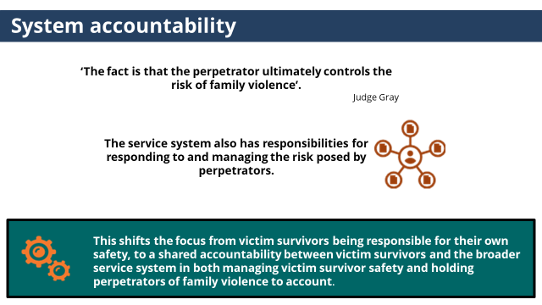 | The service system has responsibilities for responding to and managing the risk posed by perpetrators. | - In the Coroner’s Inquest into Luke Batty’s death, Judge Gray stated ‘The fact is that the perpetrator ultimately controls the risk of family violence’.  (click to reveal each second point)  - However, the service system also has responsibilities for responding to and managing the risk posed by perpetrators.  (click to reveal text box)  - This shifts the focus from victim survivors being responsible for their own safety, to a shared accountability between victim survivors and the broader service system in both managing victim survivor safety and holding perpetrators of family violence to account.  - It is important to acknowledge that the development of this collaborative system will take time, and will in part require us all to have the courage to step into the unknown together, while also recognising that we have great examples in the system of where there is collaborative practice.
Slide 9: Intermediate risk management  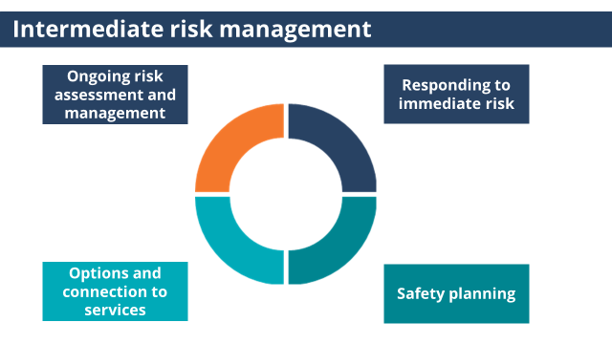 |  | - Intermediate risk management is primarily focused on:  (click to reveal each point)  - Responding to immediate risk  - Safety planning  - Talking to victim survivors about options and connection to services  - Ongoing risk assessment and management  - Practice Guidance: Responsibility 4: Intermediate Risk Management covers these tasks.
Slide 10: Responding to immediate risk 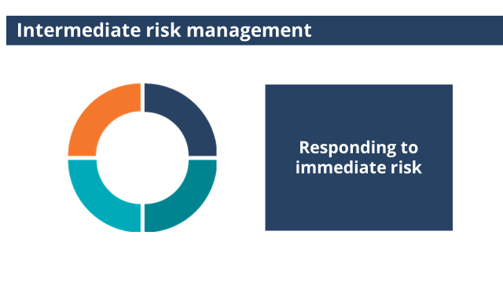 |  | - Part of Intermediate risk management is responding to immediate risk.
Slide 11: Responding to immediate risk  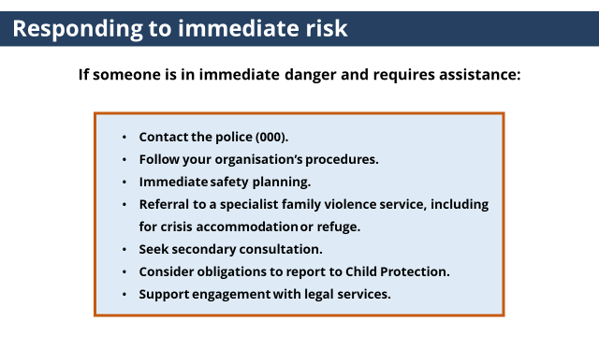 | If someone is in immediate danger and requires assistance it is important you know what to do. | - If someone is in immediate danger and requires assistance :  - Contact the police.  - Follow your organisation’s procedures.  - Support immediate safety planning.  - Discuss making a referral to a specialist family violence service, including for crisis accommodation or refuge.  - Seek secondary consultation from your manager and/or a specialist family violence service.  - Consider any obligations to report to Child Protection if children are involved.  - Support engagement with legal services including to make an application for a family violence intervention order.  - We will cover referrals and safety planning in more detail in this module.
Slide 12: Safety planning  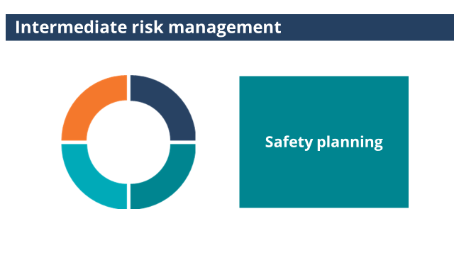 |  | - Part of Intermediate risk management is safety planning.
Slide 13: Safety planning  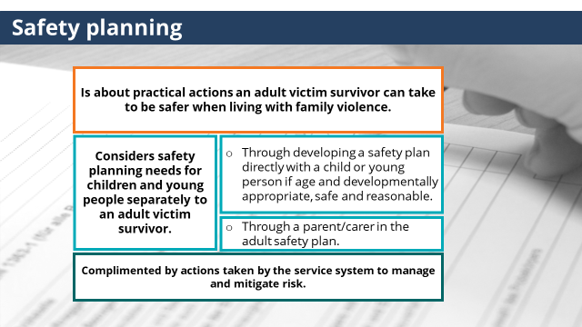 | Safety planning is about practical actions a victim survivor can take to be safer when living with family violence and is complimented by actions taken by the service system to manage and mitigate risk. | - Safety planning is an important part of risk management.  (click to reveal each point)  - Safety planning is about practical actions an adult victim survivor can take to be safer when living with family violence.  - Safety planning should consider safety planning needs for children and young people separately to an adult victim survivor.  - Through developing a safety plan directly with a child or young person if age and developmentally appropriate, safe and reasonable or  - Through a parent/carer in the adult safety plan.  - Safety planning is complimented by actions taken by the service system to manage and mitigate risk.
Slide 14: Safety planning  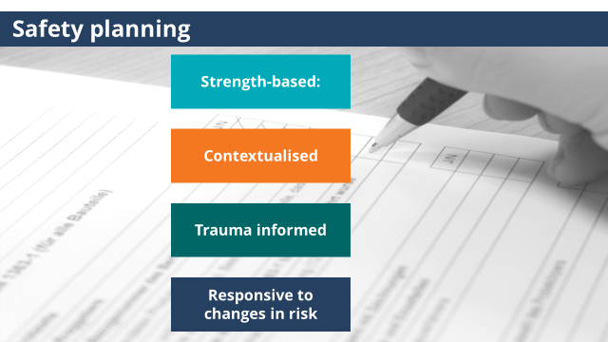 | Safety planning should be led by victim survivors, build on what they are already doing, consider multiple scenarios, be trauma informed and plan for changes to risk. | Trainer to ask: When talking to a victim survivor about their safety plan, you should consider these principles (on slide). What are some examples of what this looks like in practice?  (Trainer may consider asking about each principle separately, i.e. what does a strength-based approach to safety planning look like?)  - Principles of Safety Planning:  - Strength-based: It should be led by, and build on the strategies the victim survivor is already using to resist control, manage the perpetrator, and keep themselves and children safe.  - Contextualised: Plans should consider multiple scenarios e.g. at home, at school drop off and pick up times, when in public, at work, if the risk escalated.  - Trauma Informed:  - Plans are made with an understanding of how the victim survivor responds to experiences of family violence.  - Principles of planning recognise that during a time of crisis or when impacted by trauma victim survivors may have a trauma response.  - Pre-preparing and practising safety strategies during a time of safety can help prepare practically for this.  - Responsive to changes in risk: Plans should consider how any intervention can increase or decrease risk and plan around this.  - Appendix 9 & 10 of the MARAM Practice Guide Responsibility 4: Intermediate Risk Management are safety planning templates for adults and older children and young people and includes development of a detailed plan and questions to support planning.
ACTIVITY ONE: Safety planning
Purpose: This purpose of this activity is to allow participants to familiarise themselves with the Adult Safety Planning Template, and consider how to facilitate conversations which enhances a victim survivors own safety plan through consideration of the case study of Ania, Imran and Sabina.

Time: 20mins

Instructions:
- Trainer to hand out a copy of Activity One to each participant (or a few copies per group).
- Trainer to introduce the activity by outlining the purpose of the activity.
- Trainer to ask participants to read through the Adult Safety Planning Template, and then in small groups discuss the questions below the template. Not all questions will have answers prompted in the Adult Safety Planning Template.
- Trainer to facilitate large group discussion about answer.
- Conclude activity with sentence such as ‘Pre-preparing and practising safety strategies during a time of safety can help victim survivors to prepare practically for this. ‘

(The answers below are the same for all professions, however participants may raise differences in how the answers are applied for the variations of the case study of Ania, Imran and Sabina’s).
Answers
- Case study: Contacting Police in an emergency.
How could you respond to Ania to address this concern and remove this barrier to seeking support?
  - Validate her concern and previous experience
  - Reiterate the role of police and her right to be safe
  - Talk through how she might speak to police to ensure they understand her concerns for her safety
  - Talk through ways she can manage feeling overwhelmed so she can communicate
  - All of the above
Answer: all of the above.

NOTES
If time allows, Trainer can ask the following questions:
If a victim survivor speaks limited English and have never contacted the Police before, what steps can you take to support them to feel comfortable to contact the Police in an emergency?
Answer: It will be important to talk through the process of contacting 000, and what information they will need to provide.

If a victim survivor is speech or hearing impaired and have never contacted the Police before, what steps can you take to support them to feel comfortable to contact the Police in an emergency?
Answer: Ensure they know they can use the 106 text emergency relay service.

This activity considers the case study for Ania, Imran and Sabina, who participants met in earlier modules. The activity doesn’t include a summary of the information provided in the earlier modules. The necessary information to answer the question is provided in the activity. However, Trainers may choose to put together a summary of the case study to provide to participants.

- Case study: Discussing a Plan to leave in an emergency:
Which three options could you discuss with Ania to strengthen this plan?
- Encourage her to talk to her neighbour about this plan and how they can keep safe until police arrive.
- Consider ways to gain access to the car keys so her neighbour can drive her to a safe place.
- Suggest she asks her neighbour to call the police if they hear sounds of violence coming from her home.
- Talking about where she would go if her neighbour is not at home.
Answer: 1 3 & 4. Suggesting Ania consider ways to gain access to the car keys may increase her risk if this raises Imran’s suspicion she is planning to leave. Research indicates that when a perpetrator’s control is threatened their behaviour can escalate.

- Case study: Planning for when leaving the home is not an option.
If Ania was living in a rural location and leaving was not an option, (due to distance and having no access to a car), which three options could you discuss with her to enhance her safety in an emergency?
- When the situation begins to escalate ensuing her phone is with her so she can call the police when in a safe room.
- Avoid unsafe areas such as the kitchen and bathroom.
- Arranging to text a friend or family member so they can call the police on her behalf.
- Call the police before going into Sabina’s room
Answer: 1, 2 & 3.
Suggesting to Ania to call the police before going into a safe room was not an answer as it may not be possible for her to do this safely in an emergency.

- Case study: Planning to leave when it is safe.
Referring to the Safety Planning template above, what are some key items to talk to Ania about considering taking if she left?
Answer:
The relevant question listed in the Safety Planning template to prompt practitioners include.
- Key items including phone, keys, money and bank cards.
- What documents, clothes or other things should you take with you when you leave? What is essential?
- Medication or other support aides for yourself or anyone in your care – prescriptions.
- Security/comfort toys for children or items that are highly significant to the children.

NOTES
Phone: Perpetrators can use phones or other devices to track a victim survivor. It is important to talk about the safety limitations of phones and other devices and discuss safe technology use. If practitioners raise questions or concerns about their knowledge around this, reassure them they are not required to be technology experts. Encourage them to consult with specialist family violence services. Practitioners may also inform themselves and victim survivors using the E-safety Commissioner website, which has useful information for safe technology use, Using your device safely | eSafety Commissioner.

Money: Identify a way Ania can access money in an emergency. This may be cash or card (if the account is not shared with Imran).
Important documents: Documents such as ID, birth certificate or passport. Documents or copies could also be left with someone beforehand.

- Case study: Safety planning with a child
If Ania prefers to discuss safety planning with Sabina herself, which of the following actions could support Ania to prepare for this conversation? (choose four)
- Discuss how Ania can define family violence and help Sabina to understand what family violence is in a way that is age appropriate to her.
- Consider Sabina’s age and developmental stage and discuss her level of involvement in this process.
- Encourage Ania not to talk to Sabina about safety planning.
- Discuss ways Ania can let Sabina know they she is not to blame for the violence, or responsible for Ania’s or her safety.
- Go through the Child Safety Planning template with Ania, and discuss how she could open up the conversation with Sabina.
Answer: All except 3. ‘Encourage Ania not to talk to Sabina about safety planning’.
Children, like adult victim survivors, often take steps to manage their experience of risk which should be acknowledged and why safety planning with children is necessary. The child’s safety plan will also focus on how they will act in response to and in addition to the mother/carer’s actions.

NOTES
If participants have concerns about talking to an adult victim survivor about safety planning with a child, acknowledge their concern. Developing knowledge and skills to undertake this work takes time, and practitioners should be seeking secondary consultation from specialist family violence services, or encouraging a victim survivor to talk to specialist directly if they don’t feel confident.

Slide 15: Options and connection to services  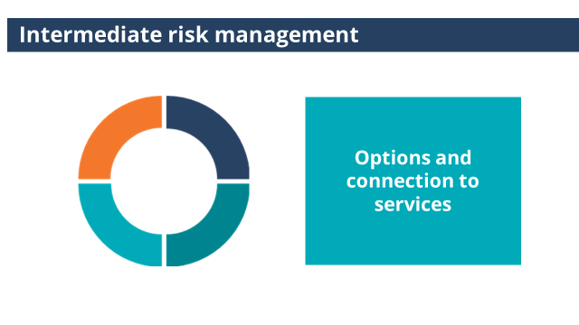 |  | - Part of Intermediate risk management is supporting a victim survivor to consider support options and connect them to services.
Slide 16: Options and connection to services  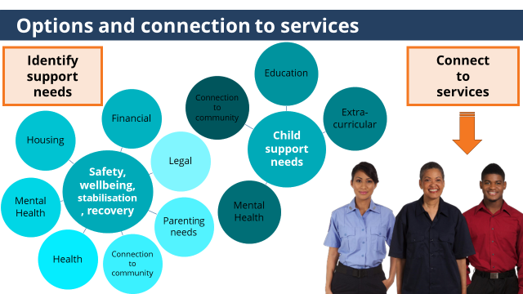 | It is important to consider a wide range of support needs that can contribute to safety, wellbeing stabilisation and recovery. | - Intermediate risk management involves talking to victim survivors about options and connecting them to relevant services:  - Which will involve  - Assisting the victim survivor to identify needs. Support needs may relate to:  (Click to reveal chart)  - Safety, wellbeing, stabilisation and recovery. For example, financial, legal, parenting needs, connection to community, health, mental health or housing.  - Each child’s individual safety, wellbeing and other needs should be considered.  (Click to reveal chart)  For example, education, extra-curricular, mental health and connection to community.  - And then to assist with considering options for support and connecting them to services.  (Click to reveal graphic)  Part of which is addressing any barriers to accessing services through advocacy, increasing system literacy, facilitating a warm referral and information sharing to limit a victim survivor having to retell their story.
Slide 17: Integrated service system  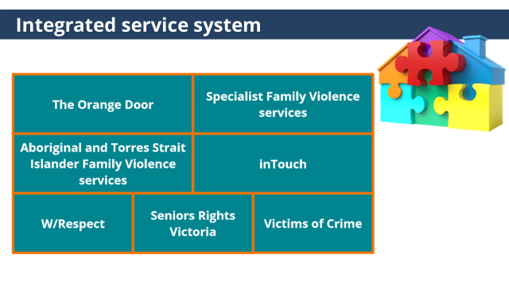 | Risk management is supported by a strong understanding of the services within the service system. | - Risk management is supported by a strong understanding of the services within the service system.  - Specialist family violence services can provide a rage of supports to victim survivors and provide secondary consultations to workers.  - Details about these services are also in your Participant Guide.
NOTES
If participants are unfamiliar with the specialist family violence services listed, Trainers may choose to provide further information. The information below is included in the Participant Guide.

Orange Door
- The Orange Door is being established across all areas of Victoria. (Roll out began in 2018).
- The Orange Door is the point of contact either in person or over the phone for adults, children and young people who are experiencing, or have experienced, family violence and families who need extra support with the care and wellbeing of their children.
- The Orange Door incorporates the intake services for specialist family violence services, perpetrator/men’s services, Child FIRST services, and workers from Aboriginal and Torres Strait Islander services.
- The Orange Door will connect people to a wide range of supports across the spectrum of prevention, early intervention and response.
- They can deliver an immediate response for people in crisis by linking people to specialist services, medical treatment and care, accommodation and practical assistance.
- The Orange Door will operate during business houses (9am-5pm) Monday to Friday.
- If there is no Orange Door in your area, victim survivors can contact their local specialist family violence service.

Specialist Family Violence services
- Are the point of contact for victim survivors when there is no Orange Door in their region.
- All the Specialist Family Violence Services in Victoria operate slightly differently, so it will be important for you to make contact with your local service to speak to them about what services they provide, their intake process and how referrals can be made.
- Most Specialist Family Violence services provide intake, crisis response and case management services and support for victim survivors who are attending court for an intervention order hearing.
- Most Specialist Family Violence services are open 9am-5pm Monday to Friday.

Local Aboriginal and Torres Strait Islander Family Violence services
- Provide a culturally safe service that assists Aboriginal and Torres Strait Islander people from the local area in their healing journey to address the impacts of family violence by providing opportunities to become strong individuals and families; live in safe communities and have healthy lives where pathways to recovery can be achieved.
- Contact your local service to find out what programs and services they offer.

inTouch
- inTouch Multicultural Centre Against Family Violence is a state-wide service that works with women and children from culturally and linguistically diverse (CALD) backgrounds who are victim survivors of domestic violence.
- The service has a pool of bilingual and bi-cultural workers who provide assistance and information for women and children escaping domestic violence.
- inTouch employs a registered migration agent who uses her knowledge of Australia’s migration procedures to offer advice or assistance to women wishing to obtain a visa or remain in Australia.

W/Respect
- W/Respect is a specialist LGBTIQ family violence service
- W/Respect supports people in LGBTIQ+ communities and their families affected by family violence. It also builds the capacity of the integrated family services and specialist family violence system.
- W/Respect is a partnership of four LGBTIQ specialist organisations:
o Queerspace
o Thorne Harbour Health
o Switchboard
o Transgender Victoria

Seniors Rights Victoria
- Seniors Rights Victoria provides information, support, advice and education to help prevent elder abuse and safeguard the rights, dignity and independence of older people.
- Seniors Rights Victoria can help any Victorian aged 60 and above, or any Indigenous Victorian aged 45 and above, on matters relating to elder abuse and ageing.
- Services include a helpline, specialist legal services, short-term support and advocacy for individuals and education.

Victims of Crime
- Provides support for people affected by crime and guidance through legal processes.
- Male victims of family violence can contact the Victims of Crime Helpline for information, advice, support, and access to the Victims Assistance Program.

Slide 18: Responding to safety  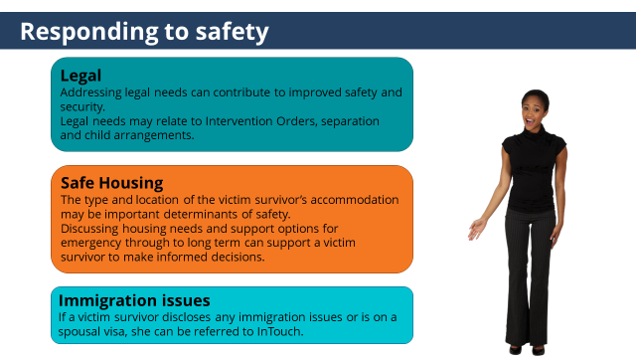 | Addressing legal, housing and immigration needs are important determinants of safety. | - We are now going to cover a few risk management responses specific to responding to safety.  (click to reveal first box)  - Legal  - Addressing legal needs can contribute to improved safety and security.  - Legal needs may relate to Intervention Orders, separation and child arrangements.  - If you are not familiar with Intervention Orders and the application process we encourage you to view the video by Northern Integrated Family Violence Services Partnership which covers this. A link can be found in your Participant Guide.  (click to reveal second box)  - Safe housing  - The type and location of the victim survivor’s accommodation may be important determinants of safety.  - Discussing housing needs and support options for emergency through to long term can support a victim survivor to make informed decisions.  - One service to be familiar with is Safe Steps  - Safe Steps is the 24-hour crisis response service in Victoria and is the access point if someone requires refuge or crisis accommodation as a result of not being safe due to family violence.  - Details about Safe Steps can be found in your Participant Guide.  (click to reveal third box)  - Immigration issues.  - If a victim survivor discloses any immigration issues or is on a spousal visa, she can be referred to InTouch.  - inTouch Multicultural Centre Against Family Violence is a state-wide service that works with women and children from culturally and linguistically diverse (CALD) backgrounds who are victim survivors of domestic violence.  - inTouch employs a registered migration agent who uses her knowledge of Australia’s migration procedures to offer advice or assistance to women wishing to obtain a visa or remain in Australia.  - More information about inTouch can be found in your Participant Guide
NOTES
Video: Northern Integrated Family Violence Services Partnership (2018) Knowledge to Advocate: Intervention Orders and Legal Support.
This video covers Intervention Orders and the application process and was developed by Northern Integrated Family Violence Services Partnership.
Trainers may also choose to play the video in the training. The video is 8.30mins in length.

Slide 19: Ongoing risk assessment and management  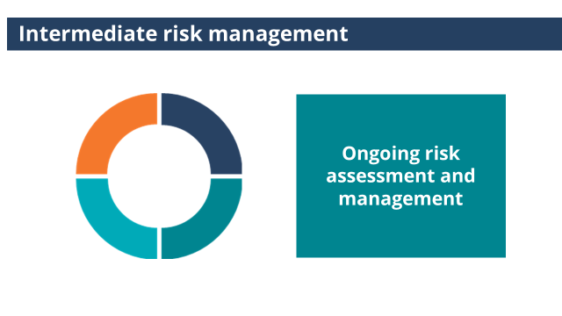 |  | - Part of Intermediate risk management is ongoing risk assessment and management.
Slide 19: Ongoing risk assessment and management  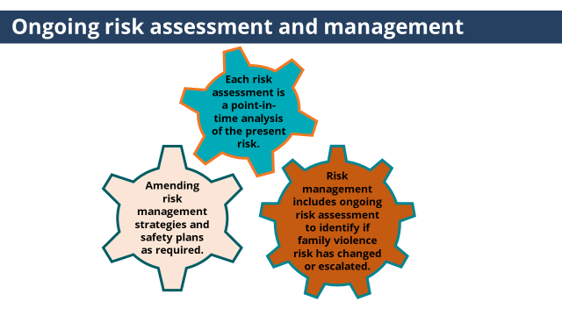 | It is important to regularly check in with victim survivors about changes in risk and amend risk management strategies and safety plans as required. | - A risk assessment is a point-in-time analysis of the present risk.  - Risk management includes ongoing risk assessment to identify if family violence risk has changed or escalated through regularly checking in with victim survivors and asking about changes in circumstances or experience of violence, observing changes in behaviour and considering a review of assessment information that has been received from other services.  - And then in collaboration with the victim survivor and other services amending risk management strategies and safety plans as required.
ACTIVITY TWO: Risk Management
Purpose: This purpose of this activity is to apply elements of Intermediate risk management in practice.

Time: 10mins

Instructions:
- Trainer to hand out a copy of Activity Two to each participant (or a few copies per group).
Trainer to choose the version of the activity with the professions that best fits with the roles of each participant.
- Trainer to introduce the activity by outlining the purpose of the activity.
- Trainer to ask participants to work in small groups and discuss the questions in the activity.
- Trainer to facilitate large group discussion about answer.
- Conclude activity with sentence such as ‘You are not expected to be family violence experts, collaborating with other services is part of effective risk management.’

Answers:

SOCIAL WORKER, MENTAL HEALTH CLINICIAN & CARE COORDINATOR
- In a conversation with Ania she indicated she would like support from a specialist family violence service.
Which services should you discuss with her and offer a referral to?
  - Specialist family violence service/The Orange Door
  - Legal service
  - Alcohol and Other Drug service
  - In Touch
Answer: Specialist family violence service/The Orange Door and InTouch
It is important to offer both mainstream and culturally specific services.

- When discussing Sabina’s needs Ania said she would like to talk to someone about supporting Sabina to re-engage in school.
Which of the following services would be appropriate to discuss with Ania and offer a referral to?
- Tweedle Child and Family Health Service
- The Orange Door/Child First
- Specialist family violence service
- All of the above

Answer: The Orange Door or Child First (if there is no Orange Door in your area).
The Orange Door is the point of contact for families who need extra support with the care and wellbeing of their children.
The Orange Door incorporates the intake services Child FIRST, alongside specialist family violence services and perpetrator/men’s services.
If The Orange Door is not established in your area Child FIRST can be contacted. Child First is an easily accessible, community-based point of entry for children, young people and families needing support.
NOTES
Tweddle Child and Family Health Service is an early parenting centre that offers a range of programs and services that aim to strengthen the family unit and build parenting skills and confidence.
Some specialist family violence services offer programs and support for children and young people and may be appropriate in some areas.

- Ania tells you she has not disclosed experiencing family violence to another service.
It will be important to offer advocacy to these services in the form of providing information around her experiences and impacts of family violence and Ania’s views and wishes, so this can be taken into consideration in the actions or support they provide.

How could you promote Ania’s agency through this process? (choose all that apply)
- Seek Ania’s view and wishes about what information should be shared.
- Ensure Ania understands your obligations under information sharing legislations.
- Enquire about any concerns Ania has about information sharing and address these concerns.
- Be transparent about what information will be shared or support Ania to share this information herself.
- Ensure the information shared does not victim blame (collude with perpetrators).
Answer: all
Taking steps to work with Ania and promote her agency is highly important. Sharing information without victim survivor consent or informed knowledge can lead to further limitations of the victim survivor’s agency, create barriers to accessing services and disclosing, and inadvertently impact safety. FVISS recognises and promotes the importance of seeking the views and promoting the agency of children and adults wherever appropriate, safe and reasonable to do so.

HOSPTIAL ADMISSION RISK PROGRAM (HARP) CLINICIAN

- In a conversation with Ania she indicated she would like support from a specialist family violence service.
Which services should you discuss with her and offer a referral to?
  - Specialist family violence service/The Orange Door
  - Legal service
  - Seniors Rights Victoria
  - In Touch
Answer: Specialist family violence service/The Orange Door, InTouch & Seniors Rights Victoria.
It is important to offer both mainstream and culturally specific services.

- When discussing Sabina’s needs Ania said she would like to talk to someone about supporting Sabina to re-engage in school.
Which of the following services would be appropriate to discuss with Ania and offer a referral to?
- Tweedle Child and Family Health Service
- The Orange Door/Child First
- Specialist family violence service
- All of the above

Answer: The Orange Door or Child First (if there is no Orange Door in your area).
The Orange Door is the point of contact for families who need extra support with the care and wellbeing of their children.
The Orange Door incorporates the intake services Child FIRST, alongside specialist family violence services and perpetrator/men’s services.
If The Orange Door is not established in your area Child FIRST can be contacted. Child First is an easily accessible, community-based point of entry for children, young people and families needing support.
NOTES
Tweddle Child and Family Health Service is an early parenting centre that offers a range of programs and services that aim to strengthen the family unit and build parenting skills and confidence.
Some specialist family violence services offer programs and support for child and young people and may be appropriate in some areas.

- Ania tells you she has not disclosed experiencing family violence to another service.
It will be important to offer advocacy to these services in the form of providing information around her experiences and impacts of family violence and Ania’s views and wishes, so this can be taken into consideration in the actions or support they provide.

How could you promote Ania’s agency through this process? (choose all that apply)
- Seek Ania’s view and wishes about what information should be shared.
- Ensure Ania understands your obligations under information sharing legislations.
- Enquire about any concerns Ania has about information sharing and address these concerns.
- Be transparent about what information will be shared or support Ania to share this information herself.
- Ensure the information shared does not victim blame (collude with perpetrators).
Answer: all
Taking steps to work with Ania and promote her agency is highly important. Sharing information without victim survivor consent or informed knowledge can lead to further limitations of the victim survivor’s agency, create barriers to accessing services and disclosing, and inadvertently impact safety. FVISS recognises and promotes the importance of seeking the views and promoting the agency of children and adults wherever appropriate, safe and reasonable to do so.

TOPIC: Keeping Perpetrators in View and Accountable
Purpose: To give participants an understanding of how they can support to keep perpetrators in view and accountable when working with a victim survivor.
Nominal duration: 15 minutes
Resources for Trainers
- MARAM Framework.
- MARAM Practice Guides: Responsibility 3: Intermediate Risk Assessment.

Slide | Key message/s | Facilitator dialogue
Slide 21: Keeping Perpetrators in View and Accountable  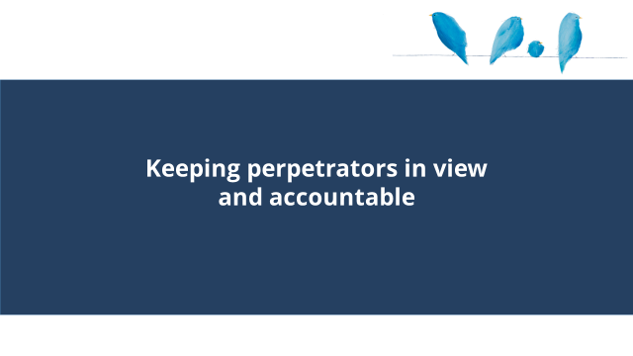 |  | - This section covers keeping perpetrators in view and accountable.
Slide 22: Keeping Perpetrators in View and Accountable  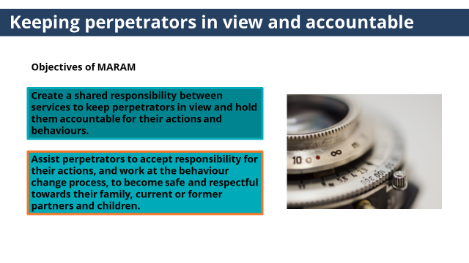 | Keep perpetrators in view and hold them accountable for their actions and behaviours is an objective of MARAM. This absolutely does not mean that practitioners have to start engaging with perpetrators. | - An objective of MARAM is to:  - Create a shared responsibility between services to keep perpetrators in view and hold them accountable for their actions and behaviours and  - Assist perpetrators to accept responsibility for their actions, and work at the behaviour change process, to become safe and respectful towards their family, current or former partners and children.  - This absolutely does not mean that practitioners have to start engaging directly with perpetrators about their use of violence.  - Engaging with perpetrators directly around their use of violence requires specialist skills. As challenging perpetrators on their behaviour can directly correlate with increased risk for the victim survivor.  - If engaging with perpetrators around their use of violence is part of your role, further guidance and training will be provided.
NOTES
The purpose of this section is to support participants to get a clearer idea of what keeping perpetrators in view and accountable can look like when working with victim survivors. Engaging with perpetrators around their use of violence is the role of the specialist services, and not the role of practitioners with Intermediate responsibilities under MARAM.

There may be practitioners in roles where they work directly with people who are perpetrating family violence, but where the support provided is not around their use of violence for example in mental health or AOD services. If this is brought up, it will be important for trainers to acknowledge this reiterate they are not expected to directly challenge perpetrators use of violence. Challenging this behaviour without the appropriate skillset can have unintended consequences including potentially increasing risk for the victim survivor. Unless they have been trained to work with perpetrators around their use of violence their engagement should remain task and role specific. This work recognises the benefits of providing support to perpetrators that address other needs including structural barriers in perpetrator’s lives. This may also support the perpetrator’s accountability and efforts to change their abusive behaviour. For example, supporting the perpetrator’s engagement in support around drug or alcohol use or trauma or accessing stable housing. Engagement also assists perpetrators to remain engaged with the service system which allows for opportunities to keep perpetrators in view of the service system and to monitor the family violence risk through information sharing obligations.

The Men’s Referral Service can provide secondary consultations for practitioners who are working with a male perpetrator of family violence. They provide advice and support around working in ways that do not collude with violence and promote safety of victim survivors.

Further guidance and training for those working with perpetrators attending health services for health needs not their use of violence is will be provided at a later stage. MARAM practice guides: Guidance for professionals working with adults using family violence can be found here, MARAM practice guides: Guidance for professionals working with adults using family violence | Victorian Government (www.vic.gov.au).

It is important to note here that family violence used by adolescents is a distinct form of family violence and requires a different response to family violence by adults. This area will also be supported by further specific training and guidance for practitioners.

Slide 23: Keeping Perpetrators in View and Accountable  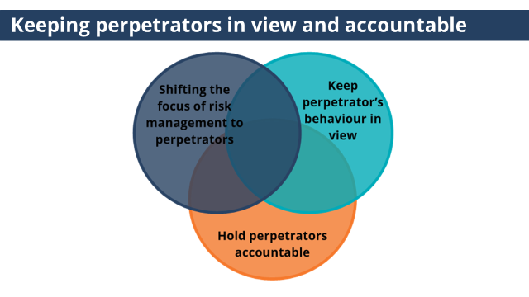 | There are many things you can do through your work with victim survivors to keep perpetrators in view and accountable. | Trainer to ask: What might keeping perpetrators in view and accountable look like when working with a victim survivor?  - There are many things you can do through your work with victim survivors to keep perpetrators in view and accountable, through:  - Shifting the focus of risk management to perpetrators  - Sharing information about risk with services whose role it is to engage with perpetrators.  - Coordinating risk management responses which create opportunities to keep perpetrators engaged with the service system and hold them accountable through the criminal and civil justice system.  For example: Supporting a victim survivor to report their experiences of violence to the police or Magistrates court in the process of applying for an Intervention Order.  - Keeping perpetrator’s behaviour in view of the service system  - Seek information from services with information about perpetrators to inform your risk assessment.  - Sharing information with other services to inform their risk assessment and risk management responses.  - Hold perpetrators accountable  This can be done in your direct work with victim survivors and professionals, and how you document information in referrals, case notes and reports. For example through  - Placing the responsibility on the person choosing to use violence, not the victim survivor.  - Challenge statements that excuse or minimise perpetrator behaviour.  - Linking the perpetrator’s behaviour directly to the harm and impact it has caused.
Slide 24: Check your understanding  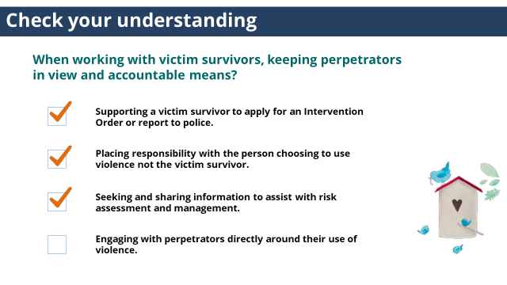 |  | Trainer to ask: When working with victim survivors, keeping perpetrators in view and accountable means: (choose all that apply)  - Engaging with perpetrators directly around their use of violence  - Seeking and sharing information to assist with risk assessment and management  - Placing responsibility with the person choosing to use violence not the victim survivor  - Supporting a victim survivor to apply for an Intervention Order or report to police.  Answer: All except the first option.  If your role is to work with victim survivors you should not engage a perpetrator directly around their use of violence. This role is reserved for specialists and attempting to do so is likely to increase risk for the victim survivor.

TOPIC: Workplace supports
Purpose: To give participants an understanding of workplace supports available to them and colleagues.
Nominal duration: 10 minutes
Resources for Trainers
- Refer to your organisation’s policy and procedures.

Slide | Key message/s | Facilitator dialogue
Slide 25: Workplace supports  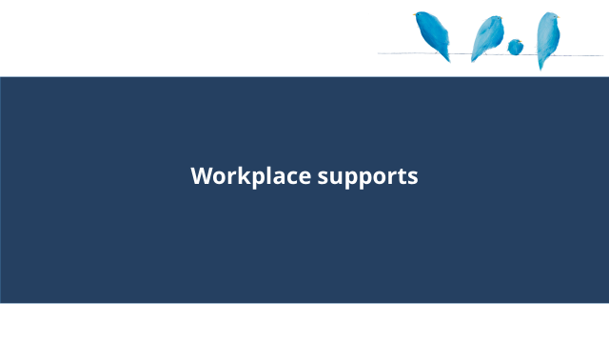 |  | - This section covers workplace supports.
Slide 26: Workplace supports  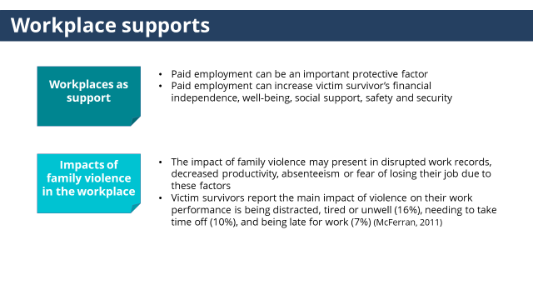 | Workplaces have an important role in supporting victim survivors. | - Workplaces have an important role in supporting victim survivors.  Trainer to ask: What workplace supports are available to staff experiencing family violence?  Trainer to ask: If a colleague disclosed experiencing family violence, how could you respond?  (click to reveal)  - Workplaces as support  - Paid employment can be an important protective factor for people affected by family violence  - Paid employment can increase victim survivor’s financial independence, well-being, social support, safety and security  (click to reveal)  - Impacts of family violence in the workplace  - The impact of family violence on the victim survivor is insidious, and may present in disrupted work records, decreased productivity, absenteeism or fear of losing their job due to these factors  - Victim survivors report the main impact of violence on their work performance is being distracted, tired or unwell (16%), needing to take time off (10%), and being late for work (7%) (McFerran, 2011)
Slide 27: Workplace supports  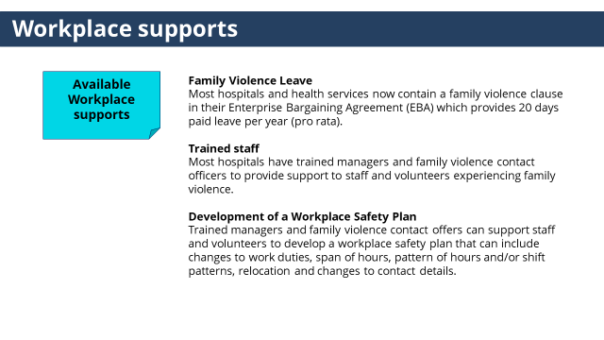 | Trained managers and family violence contact offers can talk to staff about workplace supports available to you. | - Available workplace supports  - Family Violence Leave  Most hospitals and health services now contain a family violence clause in their Enterprise Bargaining Agreement (EBA) which provides 20 days paid leave per year (pro rata).  - Trained staff  Most hospitals have trained managers and family violence contact officers to provide support to staff and volunteers experiencing family violence.  - Development of a Workplace Safety Plan  Trained managers and family violence contact offers can support staff and volunteers to develop a workplace safety plan that can include changes to work duties, span of hours, pattern of hours and/or shift patterns, relocation and changes to contact details.
Slide 28: Workplace supports  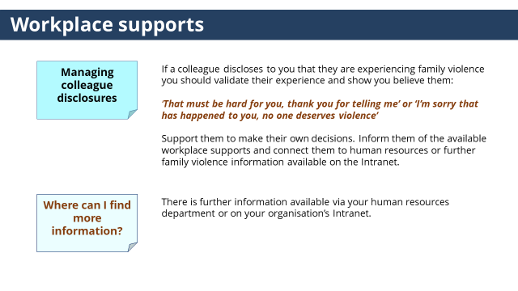 | If a colleague discloses to you that they are experiencing family violence you should validate their experience and show you believe them and let them know of available workplace supports. | (click to reveal)  - Managing colleague disclosures  - If a colleague discloses to you that they are experiencing family violence you should validate their experience and show you believe them:  ‘That must be hard for you, thank you for telling me’ or ‘I’m sorry that has happened to you, no one deserves violence’  - Support them to make their own decisions.  Inform them of the available workplace supports and connect them to human resources or further family violence information available on the Intranet.  (click to reveal)  - Where can I find more information?  - If you are a manager, you are required to undergo further training to learn how to best support your staff.  - There is further information available via your human resources department or on your organisation’s Intranet.
NOTES
Trainers should review their organisations workplace support policy and procedure and edit this section as required.

TOPIC: Conclusion
Time: 25 mins
ACTIVITY THREE: Quiz
Purpose: To check participants knowledge of key knowledge covered in the module.

Time: 5mins

Instructions:
- Handout: Activity Three.
- Trainer to ask participants to complete Quiz individually.
- Trainer to facilitate large group discussion about answers.

Answers:

- The name of the 24-hour family violence crisis response service in Victoria and the access point if someone requires refuge or crisis accommodation is?
- Safe Steps
- InTouch
Answer: Safe Steps
This was covered in slide 14 & slide 16.

- If a colleague discloses to you that they are experiencing family violence you should validate their experience and inform them of the support available within your workplace. True or False
Answer: True
This was covered in slide 24.

- Risk management should be collaborative and draw on the functions and expertise within the entire service system. True or False
Answer: True
This was covered in slide 7.

- Engaging with perpetrators directly around their use of violence can directly correlate with increased risk for the victim survivor and should only be undertaken if you have been trained and it is your role to do so. True or False
Answer: True
This was covered in slide 20.

Slide 29: Summary  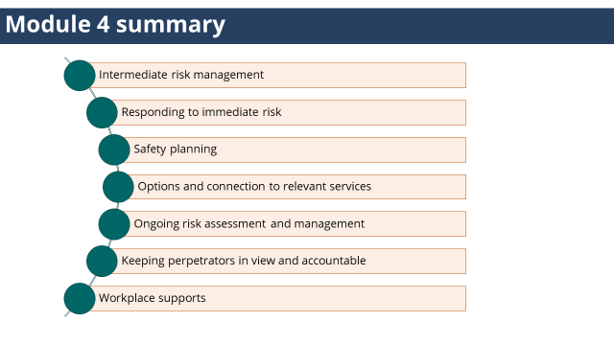 |  | - Module 4 summary  - Intermediate risk management  - Responding to immediate risk.  - Safety planning  - Options and connection to relevant services.  - Ongoing risk assessment and management  - Keeping perpetrators in view and accountable  - Workplace supports
Slide 30: Quotes from victim survivors  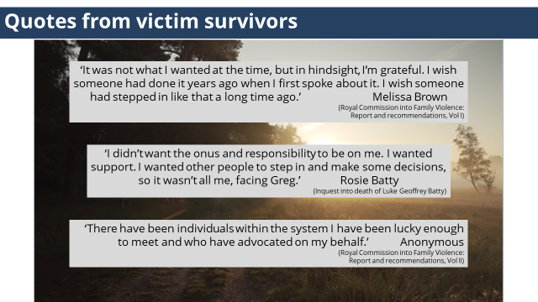 |  | - Here are some quotes from victim survivors about their engagement with the service system.  (click to reveal and hide each quote, allow time for participants to read each quote)
Slide 31: Reflection |  | Trainer to invite participants to turn to the person next to them and discuss the reflective questions on the slide.  Trainer to ask participants to share reflections.
Slide 32: Self-care  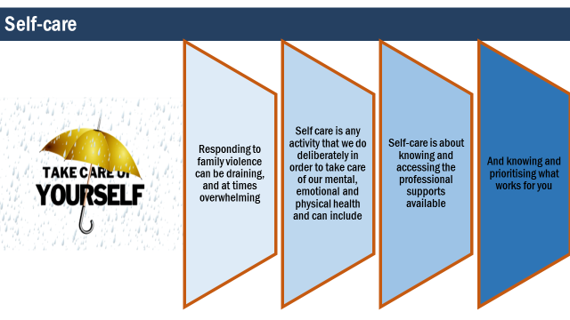 | Self-care should be a part of your work and is a shared responsibility between individuals, teams, organisations and systems. | - While this work can be experienced as a privilege, knowing the difference that we can make to the lives of those that we assist.  - It is important to acknowledge you can be personally affected by hearing about traumatic events, and by witnessing the impact and distress that it causes.  - It can also become personally draining, and at times overwhelming.  - Self-care should be a part of your work and is a shared responsibility between individuals, teams, organisations and systems.  - Self-care is about knowing and accessing the professional supports avilable.  - And knowing and prioritising what works for you.  Trainer to invite participants to turn to the person next to them and share two things that supports their self-care.
Slide 33: Thankyou |  | - Thank participants for coming.  - Remind them that links to the MARAM practice guides and other resources that cover the content of these training can be found in their Participant Guide.  - Encourage participants to complete the organisational’ specific (if applicable) and government evaluation survey that will be sent to them after the training.

ACTIVITY BOOKLET

Contents
MODULE 1
ACTIVITY ONE: Barriers to disclosure
Social Worker ………………………………….. | 157 | Care Coordinator …………………………….. | 161
Mental Health Clinician …………………… | 159 | HARP Clinician …………………………………. | 163
ACTIVITY TWO: Quiz ……………………………………….……………………………………………………….. |  |  | 165
MODULE 2
ACTIVITY ONE: Observable signs of trauma
Social Worker ………………………………….. | 166 | Care Coordinator …………………………….. | 168
Mental Health Clinician …………………… | 167 | HARP Clinician …………………………………. | 169
ACTIVITY TWO: Effective Engagement
Social Worker ………………………………….. | 170 | Care Coordinator …………………………….. | 174
Mental Health Clinician …………………… | 172 | HARP Clinician …………………………………. | 176
ACTIVITY THREE: Helpful and Unhelpful responses …………………………………………………. |  |  | 178
ACTIVITY FOUR: Working with diverse communities ………………………………………………. |  |  | 179
ACTIVITY FIVE: Child focused practice when working with adult victim survivors
Social Worker ………………………………….. | 180 | Care Coordinator …………………………….. | 182
Mental Health Clinician …………………… | 181 | HARP Clinician …………………………………. | 183
ACTIVITY SIX: Quiz …………………………………………………………………………………………………… |  |  | 184
MODULE 3
ACTIVITY ONE: Evidence-based risk factors |  |  | 185
ACTIVITY TWO: Risk assessment in practice – applying the Structured Professional Judgement Model
Social Worker ………………………………….. | 186 | Care Coordinator …………………………….. | 192
Mental Health Clinician …………………… | 189 | HARP Clinician …………………………………. | 195
ACTIVITY THREE: Assessment of seriousness of risk …….…………………………………………. |  |  | 198
ACTIVITY FOUR: Quiz ………………………………………………….……………………………………………. |  |  | 199
MODULE 4
ACTIVITY ONE: Safety planning ……………………………………………………………………………….. |  |  | 200
ACTIVITY TWO: Risk management
Social Worker ………………………………….. | 205 | Care Coordinator …………………………….. | 207
Mental Health Clinician …………………… | 206 | HARP Clinician …………………………………. | 208
ACTIVITY THREE: Quiz ……………………………………………….….…………………………………………. |  |  | 209

MODULE 1

ACTIVITY ONE: BARRIERS TO DISCLOSURE

SOCIAL WORKER IN A HOSPTIAL
CASE STUDY ONE
Patient background:
Phuong is attending your health service regularly for dialysis. She was referred to you after her treating team identified she was experiencing family violence. Phuong immigrated to Australia one year ago on a spousal visa to live with her husband Nittan. Phuong speaks multiple languages but has minimal English.

While undertaking a risk assessment, Phuong disclosed police recently attended her home after neighbours heard Nittan yelling at her. Phuong said she had difficulty understanding some of the questions and telling her story as no interpreter was used.

Below are some common barriers for a newly arrived individual to leave an abusive relationship.
In Phuong’s case what barrier has she described facing?
(choose the answer that most applies)

- Victim survivors on a spousal visa may have limited options to leave as they are not eligible for income support or public housing.
- Victim survivors with limited English may face barriers to accessing appropriate support.
- Fear of authority such as police due to experiences in their home country may create barriers to seeking support.
- Service responses that reinforce incorrect beliefs that wrongly attributing violence as being ‘part of her culture’.

CASE STUDY TWO
Patient background:
Darlene identifies as a Gunai Kurnai woman and has 2 children, Charlie and Kayla. Darlene is receiving radiation therapy for cancer and was referred to you after her treating team identified she was experiencing family violence.

During a conversation with Darlene, she disclosed she is reluctant to engage with mainstream services again, after previously being questioned about her Aboriginal identity and not feeling believed about her Aboriginal identity.

Below are some common barriers for an Aboriginal woman to seek support.
In Darlene’s case what barrier has she described facing?
(choose the answer that most applies)

- Lack of culturally safe services.
- Fear of police involvement due to high rates of Aboriginal and Torres strait islander deaths in custody.
- Previous experiences of racist attitudes that condone discrimination and violence towards Aboriginal peoples.
- Fear of children being taken away due to the historical context of child removal and current higher rates of Aboriginal children in care.

CASE STUDY THREE
Patient background:
Michael has chronic respiratory disease and was referred to you by his treating team after they identified he was experiencing family violence. Michael has been in a relationship with Dave for four years.

During a conversation to undertake a risk assessment, Michael said his family don’t accept his sexuality or relationship. Michael also said that if he told his friend’s about Dave’s abusive behaviour they wouldn’t believe him, as Dave presents as such a nice guy to others.

Below are some common barriers to seeking support for a gay man.
In Michael’s case what barrier has he described facing?
(choose the one that most applies)
- Current and historical discriminatory laws against people on the basis of sexuality contribute to a fear of reporting to police
- Homophobic attitudes that have resulted in isolation from their family or community of orgin may deter reporting due to fear of further isolation
- Poor levels of understanding by mainstream services about violence against gay people can limit support options.
- Communities who experience discrimination may face the additional burden of wanting to present a positive image of their community which can create barriers to disclosing and seeking support.

ACTIVITY ONE: BARRIERS TO DISCLOSURE

MENTAL HEALTH CLINICIAN
CASE STUDY ONE
Patient background:
Phuong is receiving treatment for anxiety disorder.
Phuong immigrated to Australia one year ago from Vietnam on a spousal visa to live with her husband Nittan. Phuong speaks multiple languages but has minimal English.
While undertaking a risk assessment, Phuong disclosed police recently attended her home after neighbours heard Nittan yelling at her.
Phuong said she had difficulty understanding some of the questions and telling her story as no interpreter was used.

Below are some common barriers for a newly arrived individual to leave an abusive relationship.
In Phuong’s case what barrier has she described facing?
(choose the answer that most applies)

- Victim survivors on a spousal visa may have limited options to leave as they are not eligible for income support or public housing.
- Victim survivors with limited English may face barriers to accessing appropriate support.
- Fear of authority such as police due to experiences in their home country may create barriers to seeking support.
- Service responses that reinforce incorrect beliefs that wrongly attributing violence as being ‘part of her culture’.

CASE STUDY TWO
Patient background:
Darlene identifies as a Gunai Kurnai woman. Darlene has 2 children, Charlie and Kayla.
Darlene is receiving treatment for a mood (affective) disorder.
After noticing a sign of family violence, you engage in a conversation with Darlene to identify if she is experiencing family violence. During this conversation, Darlene disclosed she is reluctant to engage with mainstream services again, after previously being questioned about her Aboriginal identity and not feeling believed about her Aboriginal identity.

Below are some common barriers for an Aboriginal woman to seek support.
In Darlene’s case what barrier has she described facing?
(choose the answer that most applies)

- Lack of culturally safe services.
- Fear of police involvement due to high rates of Aboriginal and Torres strait islander deaths in custody.
- Previous experiences of racist attitudes that condone discrimination and violence towards Aboriginal peoples.
- Fear of children being taken away due to the historical context of child removal and current higher rates of Aboriginal children in care.

CASE STUDY THREE
Patient background:
Michael was referred to your service from the Emergency Department after presenting with a mental and behavioural disorder due to psychoactive substance abuse. Michael has been in a relationship with Dave for four years.
After noticing a sign of family violence you engage in a conversation to identify if Michael is experiencing family violence. During the conversation, Michael said his family don’t accept his sexuality or relationship. Michael also said that if he told his friend’s about Dave’s abusive behaviour they wouldn’t believe him, as Dave presents as such a nice guy.

Below are some common barriers to seeking support for a gay man.
In Michael’s case what barrier has he described facing?
(choose the one that most applies)
- Current and historical discriminatory laws against people on the basis of sexuality contribute to a fear of reporting to police
- Homophobic attitudes that have resulted in isolation from their family or community of orgin may deter reporting due to fear of further isolation
- Poor levels of understanding by mainstream services about violence against gay people can limit support options.
- Communities who experience discrimination may face the additional burden of wanting to present a positive image of their community which can create barriers to disclosing and seeking support.

ACTIVITY ONE: BARRIERS TO DISCLOSURE

CARE COORDINATOR IN AN EMERGENCY DEPARTMENT
CASE STUDY ONE
Patient background:
Phuong presented with acute renal failure and was referred to you after disclosing experiencing family violence.
Phuong immigrated to Australia one year ago on a spousal visa to live with her husband Nittan. Phuong speaks multiple languages but has minimal English.
While undertaking a risk assessment, Phuong disclosed police recently attended her home after neighbours heard Nittan yelling at her. Phuong said she had difficulty understanding some of the questions and telling her story as no interpreter was used.

Below are some common barriers for a newly arrived individual to leave an abusive relationship.
In Phuong’s case what barrier has she described facing?
(choose the answer that most applies)

- Victim survivors on a spousal visa may have limited options to leave as they are not eligible for income support or public housing.
- Victim survivors with limited English may face barriers to accessing appropriate support.
- Fear of authority such as police due to experiences in their home country may create barriers to seeking support.
- Service responses that reinforce incorrect beliefs that wrongly attributing violence as being ‘part of her culture’.

CASE STUDY TWO
Patient background:
Darlene identifies as a Gunai Kurnai woman. She is receiving radiation therapy for cancer and presented to the Emergency Department due to side effects of the treatment.
Darlene was referred to you by her treating team when they identified she was experiencing family violence.
During a conversation to undertake a risk assessment, Darlene disclosed she is reluctant to engage with mainstream services again, after previously being questioned about her Aboriginal identity and not feeling believed about her Aboriginal identity.

Below are some common barriers for an Aboriginal woman to seek support.
In Darlene’s case what barrier has she described facing?
(choose the answer that most applies)

- Lack of culturally safe services.
- Fear of police involvement due to high rates of Aboriginal and Torres strait islander deaths in custody.
- Previous experiences of racist attitudes that condone discrimination and violence towards Aboriginal peoples.
- Fear of children being taken away due to the historical context of child removal and current higher rates of Aboriginal children in care.

CASE STUDY THREE
Patient background:
Michael has chronic respiratory disease and presented to the Emergency Department due to difficulty breathing.
He was referred to you by his treating team after disclosing he was experiencing family violence. Michael has been in a relationship with Dave for four years.
During a conversation to undertake a risk assessment, Michael said his family don’t accept his sexuality or relationship. Dave said that if he told his friend’s about Dave’s abusive behaviour they wouldn’t believe him, as Dave presents as such a nice guy.

Below are some common barriers to seeking support for a gay man.
In Michael’s case what barrier has he described facing?
(choose the one that most applies)
- Current and historical discriminatory laws against people on the basis of sexuality contribute to a fear of reporting to police
- Homophobic attitudes that have resulted in isolation from their family or community of orgin may deter reporting due to fear of further isolation
- Poor levels of understanding by mainstream services about violence against gay people can limit support options.
- Communities who experience discrimination may face the additional burden of wanting to present a positive image of their community which can create barriers to disclosing and seeking support.

ACTIVITY ONE: BARRIERS TO DISCLOSURE

HOSPTIAL ADMISSION RISK PROGRAM (HARP) CLINICIAN
CASE STUDY ONE
Patient background:
Phuong (72) is receiving regularly dialysis and presented with acute renal failure. She was referred to you after disclosing experiencing family violence. Phuong immigrated to Australia two years ago on a spousal visa to live with her husband Nittan. Phuong speaks multiple languages but has minimal English.
While undertaking a risk assessment, Phuong disclosed police recently attended her home after neighbours heard Nittan yelling at her. Phuong said she had difficulty understanding some of the questions and telling her story as no interpreter was used.

Below are some common barriers for a newly arrived individual to leave an abusive relationship.
In Phuong’s case what barrier has she described facing?
(choose the answer that most applies)

- Victim survivors on a spousal visa may have limited options to leave as they are not eligible for income support or public housing.
- Victim survivors with limited English may face barriers to accessing appropriate support.
- Fear of authority such as police due to experiences in their home country may create barriers to seeking support.
- Service responses that reinforce incorrect beliefs that wrongly attributing violence as being ‘part of her culture’.

CASE STUDY TWO
Patient background:
Darlene (65) is receiving radiation therapy for cancer and was referred to you for psychosocial support. Darlene identifies as a Gunai Kurnai woman.
After noticing a sign of family violence, you engage in a conversation with Darlene to identify if she is experiencing family violence. During this conversation, Darlene disclosed her son has become abusive towards her. Darlene said she is reluctant to engage with mainstream services again, after previously being questioned about her Aboriginal identity and not feeling believed about her Aboriginal identity.

Below are some common barriers for an Aboriginal woman to seek support.
In Darlene’s case what barrier has she described facing?
(choose the answer that most applies)

- Lack of culturally safe services.
- Fear of police involvement due to high rates of Aboriginal and Torres strait islander deaths in custody.
- Previous experiences of racist attitudes that condone discrimination and violence towards Aboriginal peoples.
- Fear of children being taken away due to the historical context of child removal and current higher rates of Aboriginal children in care.

CASE STUDY THREE
Patient background:
Michael (75) has chronic respiratory disease and was referred to you for support with managing his health.
Michael has been in a relationship with Dave for 24 years.
After noticing a sign of family violence, you undertake a risk assessment. During the conversation, Michael said his family don’t accept his sexuality or relationship. Michael also said that if he told his friend’s about Dave’s abusive behaviour they wouldn’t believe him, as Dave presents as such a nice guy.

Below are some common barriers to seeking support for a gay man.
In Michael’s case what barrier has he described facing?
(choose the one that most applies)
- Current and historical discriminatory laws against people on the basis of sexuality contribute to a fear of reporting to police
- Homophobic attitudes that have resulted in isolation from their family or community of orgin may deter reporting due to fear of further isolation
- Poor levels of understanding by mainstream services about violence against gay people can limit support options.
- Communities who experience discrimination may face the additional burden of wanting to present a positive image of their community which can create barriers to disclosing and seeking support.

ACTIVITY TWO: QUIZ
- As a staff member with Intermediate responsibilities under MARAM, my role includes:
(choose all that apply)
- Engaging respectfully, sensitively and safely with patients
- Identifying family violence
- Undertaking intermediate risk assessment
- Undertaking intermediate risk management
- Sharing information in line with my organisational policy to collaborate on family violence risk assessment and risk management
- Seek secondary consultation and make referrals as required
- Contribute to coordinated risk management
- Collaborative and ongoing risk assessment

2. True or False
Family violence differs from other forms of violence. It is generally a pattern of behaviour underpinned by coercion, control and domination by one person over another.

3. True or false
Gender inequality contributes to the murder of one women every week in Australia.

4. What groups are considered to be at greater risk of family violence?
- Aboriginal and Torres Strait Islander women
- Pregnant women
- Women separating from their partners
- All of the above

MODULE 2

ACTIVITY ONE: OBSERVABLE SIGNS OF TRAUMA

SOCIAL WORKER IN A HOSPITAL
Part 1
Ania has Multiple Sclerosis and attends your health service regularly for her physiotherapy appointments. She was referred to you by her physiotherapist for a psychosocial needs assessment. Ania is married to Imran and they have a daughter Sabina (7yo).

Ania has recently had a mental health inpatient stay and was on a Compulsory Treatment Order after a serious deterioration in her depression. During her inpatient stay Child Protection placed Sabina in out-of-home care for four months. Ania said her Muslim faith and community were a great source of strength for her during this time.

During your conversation with Ania to assess her needs, she disclosed the following:
Ania said things have been ‘stressful’ at home lately. When you asked what has been ‘stressful’ lately, Ania said Imran can be a bit of a ‘control freak’ and doesn’t want her spending time with friends at the moment with Sabina back in her care.
During her appointment, Ania kept responding to texts from Imran. Ania left her appointment early as she needed to be back home, and appeared stressed about this.

Below are observable signs of trauma. Which three observable signs are present for Ania?
Which three observable signs of trauma for an adult are present in Ania’s case?
- Isolation
- Indicators of strangulation
- Needing to be back home by a certain time and becoming stressed about this
- Describes a partner as controlling or prone to anger

Part 2
Ania said having Sabina returned to her care has been a ‘relief’ and a ‘happy time’. Being separated was hard for them both as Sabina ‘doesn’t like being apart’ and always ‘clings’ to her. But Sabina has been using ‘baby talk’ a lot lately which Imran gets annoyed about and she has found this stressful to manage.

Which two observable signs of trauma for a child or young person are present for Sabina?
- Acting like a much younger child
- Limited tolerance and poor impulse control
- Poor school performance
- Being excessively clingy to certain adults

ACTIVITY ONE: OBSERVABLE SIGNS OF TRAUMA

MENTAL HEALTH CLINICIAN
Part 1
Ania attends your service regularly for support for major depression. Ania is married to Imran and they have a daughter Sabina (7yo). Ania has previously had a mental health inpatient stay and was on a Compulsory Treatment Order after a serious deterioration in her depression. During her inpatient stay Child Protection place Sabina in out-of-home care for four months. Ania said her Muslim faith and community were a great source of strength for her during this time.

Ania feels she is managing her depression well. She can tell the medication is helping as although things have been a bit stressful at home lately, she has noticed she is not getting caught up in negative thinking like she used to. When you asked what has been ‘stressful’ lately, Ania said Imran can be a bit of a ‘control freak’ and doesn’t want her spending time with friends at the moment with Sabina back in her care. During her treatment, Ania kept responding to texts from Imran. Ania left her appointment early as she needed to be back home, and appeared stressed about this.

Below are observable signs of trauma. Which three observable signs are present for Ania?
Which three observable signs of trauma for an adult are present in Ania’s case?
- Isolation
- Indicators of strangulation
- Needing to be back home by a certain time and becoming stressed about this
- Describes a partner as controlling or prone to anger

Part 2
Ania said having Sabina returned to her care has been a ‘relief’ and a ‘happy time’. Being separated was hard for them both as Sabina ‘doesn’t like being apart’ and always ‘clings’ to her. But Sabina has been using ‘baby talk’ a lot lately which Imran gets annoyed about and she has found this stressful to manage.

Which two observable signs of trauma for a child or young person are present for Sabina?
- Acting like a much younger child
- Limited tolerance and poor impulse control
- Poor school performance
- Being excessively clingy to certain adults

ACTIVITY ONE: OBSERVABLE SIGNS OF TRAUMA

CARE COORDINATOR IN AN EMERGENCY DEPATMENT
Part 1
Ania has severe asthma and attended the emergency department presenting with severe breathlessness and wheezing with her daughter Sabina (7yo). Ania is married to Imran. Ania believes the asthma attack was caused by mould that had been building up in her house. She was referred to you after mentioning to her treating nurse that she couldn’t go home because of the mould and didn’t have anywhere else to stay.

During your conversation with Ania to explore whether she could stay with family or friends, she mentioned that Imran is a bit of a ‘control freak’ and doesn’t like her spending time with family and friends so she has lost contact with them so staying with them is not an option. Ania said things have been ‘stressful’ at home lately, but that her Muslim faith and community are a great source of strength for her. During your conversation, Ania kept responding to texts from Imran. Ania decided to return home as Imran wanted her back home, and appeared stressed about this.

Below are observable signs of trauma. Which three observable signs are present for Ania?
Which three observable signs of trauma for an adult are present in Ania’s case?
- Isolation
- Indicators of strangulation
- Needing to be back home by a certain time and becoming stressed about this
- Describes a partner as controlling or prone to anger

Part 2
Ania said returning home is probably the best option as Sabina has only just been returned to her care and if they become homeless she is worried Child Protection will place her in out-of-home care again. Ania has previously had a mental health inpatient stay and was on a Compulsory Treatment Order after a serious deterioration in her depression.

During her inpatient stay Child Protection place Sabina in out-of-home care for 4 months. Being separated was hard for them both as Sabina ‘doesn’t like being a part’ and ‘always clings’ to her. Ania said Sabina is a ‘good kid’, and is doing much better now she is linked in with a speech pathologist as she has delayed speech.

Which two observable signs of trauma for a child or young person are present for Sabina?
- Delayed or poor language skills
- Acting like a much younger child
- Being excessively clingy to certain adults
- Complaining of headaches or stomach pains

ACTIVITY ONE: OBSERVABLE SIGNS OF TRAUMA

HOSPTIAL ADMISSION RISK PROGRAM (HARP) CLINICIAN
Part 1
Ania (82) was recently discharged from hospital after another admission with chronic obstructive pulmonary disease. She has been referred to the HARP team for support and management in the community.​ During your conversation with Ania, she mentioned things have been ‘stressful’ lately. When you asked her what has been ‘stressful’ she disclosed the following:

Money is tight as she borrowed money for her son Imran (55) to buy a car which meant she can’t afford her medications. She said her Muslim faith and community are a great source of strength in stressful times. Ania said her health is getting worse and she is physically exhausted, and it was becoming harder to care for her granddaughter Sabina (12yo) who lives with her and her son. Imran works nightshift, so Ania is responsible for looking after Sabina and she doesn’t have any family or friend support to help out. Ania joked that she is lucky as Sabina is easy-going, since Imran is a bit of a ‘control freak’.

Below are observable signs of trauma. Which three observable signs are present for Ania?
Below three observable signs of trauma in adult victims are present for Patricia?
- No friends or family support
- Physical exhaustion
- Describes a partner, carer or family member as controlling or prone to anger
- Unconvincing explanations of any injuries

Part 2
Ania said Sabina is a good kid, and is doing much better now she is linked in with a speech pathologist as she has delayed speech. Sabina has been having trouble sleeping lately and has been complaining of headaches but their GP wasn’t concerned.

Which two observable signs of trauma for a child or young person are present for Sabina?
- Delayed or poor language skills
- Acting like a much younger child
- Sleep issues
- Complaining of headaches or stomach pains

ACTIVITY TWO: EFFECTIVE ENGAGEMENT

SOCIAL WORKER IN A HOSPITAL
CASE STUDY ONE:
Patient Background
Rahmo has recently separated from her partner and has 3 young children, Muhammad (7), Asha (5) and Abdo (2). Rahmo presented with unstable diabetes that has now been stabilised with medication. Rahmo was referred to you after disclosing family violence to her treating team. An Intervention Order was recently granted.

During your conversation with Rahmo she disclosed:

‘I’m pretty tired. I was so worried that my ex-partner would come to the house last night as he threatened to, that I didn’t sleep at all. I reported the threat to the police, I was hoping the Intervention Order was going to stop his behaviour.’

How might you respond to Rahmo in a way that makes her feel heard and validated?
(choose the answer that best applies)

- ‘It sounds like managing his behaviour is exhausting. You have done the right thing reporting the threat to the police. It’s not ok that he has threatened you and made you feel worried for your safety.’
- ‘It’s important you get enough sleep as lack of sleeps puts you at a higher risk of having elevated blood sugar’
- ‘Ok, has he ever physically hurt you in any way?’

CASE STUDY TWO
Patient Background
Kate is a renal patient that comes to the outpatient dialysis unit for regular dialysis. Kate was referred to the social work department after she disclosed an assault by her partner Karen.

During your conversation with Kate she disclosed:
‘I feel I have tried everything. I’ve tried doing what she asks, it makes no difference the violence doesn’t stop and she still blames me for her violence.’

How might you respond to Kate in a way that makes her feel heard and validated?
(choose the answer that best applies)

- ‘It sounds like you are doing everything you can to keep yourself safe’
- ‘What I’m hearing is that your partner blames you for her behaviour, and it sounds like that is pretty confusing and upsetting. It doesn’t matter what you did or didn’t do, there is never any excuse for violence.’
- That sounds difficult, it sounds like you and Karen might need some support.

CASE STUDY THREE
Patient Background
Bob was referred to you by his Geriatric Rehab clinician who has been working with him after his knee replacement. During treatment his Rehab clinician noticed some unusual bruising on his body and undertook a sensitive inquiry and identified that Bob was experiencing family violence.

During a conversation with Bob he disclosed:
‘My son hit me last night, it hurt a bit. His work is really stressful and he forgot to pick up my medication on his way home, so when I asked him he got angry and told me I’m difficult to deal with, which I know I can be’

How could you respond to Bob in a way that makes him feel heard and validated?
(choose the answer that best applies)

- ‘It sounds like the way your son behaved last night was hurtful and that your son is making you feel responsible for his behaviour. Violence is never ok. Stress doesn’t cause someone to use violence, we all deal with stress, but most people don’t choose to use violence when they are stressed.’
- It sounds like your son is a bad person, you should probably think about leaving?
- ‘That’s no good, I will talk to your son.’

ACTIVITY TWO: EFFECTIVE ENGAGEMENT

MENTAL HEALTH CLINICIAN
CASE STUDY ONE:
Patient Background
Rahmo has 3 young children, Muhammad (7), Asha (5) and Abdo (2). You have been working with Rahmo for 3 months. Rahmo been diagnosed with anxiety disorder and has recently separated from her partner after experiencing family violence. An Intervention Order was recently granted.

During your conversation with Rahmo she disclosed:

‘I’m pretty tired. I was so worried that my ex-partner would come to the house last night as he threatened to, that I didn’t sleep at all. I reported the threat to the police, I was hoping the Intervention Order was going to stop his behaviour.’

How might you respond to Rahmo in a way that makes her feel heard and validated?
(choose the answer that best applies)

- ‘It sounds like managing his behaviour is exhausting. You have done the right thing reporting the threat to the police. It’s not ok that he has threatened you and made you feel worried for your safety.’
- ‘It’s important you get enough sleep as lack of sleeps puts you at a higher risk of having elevated blood sugar’
- ‘Ok, has he ever physically hurt you in any way?’

CASE STUDY TWO
Patient Background
Kate is living with an eating disorder and has disclosed experiencing family violence. Kate has been in a relationship with Amanda for 2 years. You have been working with Kate for over a year. Kate is not wanting to engage with a specialist family violence service at the moment.
During each appointment with Kate, you check in about her safety and discuss options to enhance her safety.

During your conversation with Kate she disclosed:
‘I feel I have tried everything. I’ve tried doing what she asks, it makes no difference the violence doesn’t stop and she still blames me for her violence.’

How might you respond to Kate in a way that makes her feel heard and validated?
(choose the answer that best applies)

- ‘It sounds like you are doing everything you can to keep yourself safe’
- ‘What I’m hearing is that your partner blames you for her behaviour, and it sounds like that is pretty confusing and upsetting. It doesn’t matter what you did or didn’t do, there is never any excuse for violence.’
- That sounds difficult, it sounds like you and Karen might need some support.

CASE STUDY THREE
Patient Background
You have been working with Bob (67) for the past 8 months, he is living with severe depression and has multiple health issues. During treatment you noticed some unusual bruising on his face and undertook a sensitive inquiry to identify if Bob was experiencing family violence

During the conversation with Bob he disclosed:
‘My son hit me last night, it hurt a bit. His work is really stressful and he forgot to pick up my medication on his way home, so when I asked him he got angry and told me I’m difficult to deal with, which I know I can be’

How could you respond to Bob in a way that makes him feel heard and validated?
(choose the answer that best applies)

- ‘It sounds like the way your son behaved last night was hurtful and that your son is making you feel responsible for his behaviour. Violence is never ok. Stress doesn’t cause someone to use violence, we all deal with stress, but most people don’t choose to use violence when they are stressed.’
- It sounds like your son is a bad person, you should probably think about leaving?
- ‘That’s no good, I will talk to your son.’

ACTIVITY TWO: EFFECTIVE ENGAGEMENT

CARE COORDINATOR IN AN EMERGENCY DEPATMENT
CASE STUDY ONE:
Patient Background
Rahmo has 3 young children, Muhammad (7), Asha (5) and Abdo (2). Rahmo presented to the Emergency Department with unstable diabetes that has now been stabilised with medication. Due to previous presentations she is referred to you to review her discharge plan. During the conversation, Rahmo disclosed she has recently separated from her partner after experiencing family violence and an Intervention Order is in place.

During your conversation with Rahmo she disclosed:

‘I’m pretty tired. I was so worried that my ex-partner would come to the house last night as he threatened to, that I didn’t sleep at all. I reported the threat to the police, I was hoping the Intervention Order was going to stop his behaviour.’

How might you respond to Rahmo in a way that makes her feel heard and validated?
(choose the answer that best applies)

- ‘It sounds like managing his behaviour is exhausting. You have done the right thing reporting the threat to the police. It’s not ok that he has threatened you and made you feel worried for your safety.’
- ‘It’s important you get enough sleep as lack of sleeps puts you at a higher risk of having elevated blood sugar’
- ‘Ok, has he ever physically hurt you in any way?’

CASE STUDY TWO
Patient Background
Kate is a renal patient and has recently began regular dialysis in the outpatient clinic.
Kate was referred to you to talk through her treatment plan. After noticing an observable sign you undertook a sensitive enquiry and identified Kate was experiencing family violence from her partner Amanda.

During your conversation with Kate she disclosed:
‘I feel I have tried everything. I’ve tried doing what she asks, it makes no difference the violence doesn’t stop and she still blames me for her violence.’

How might you respond to Kate in a way that makes her feel heard and validated?
(choose the answer that best applies)

- ‘It sounds like you are doing everything you can to keep yourself safe’
- ‘What I’m hearing is that your partner blames you for her behaviour, and it sounds like that is pretty confusing and upsetting. It doesn’t matter what you did or didn’t do, there is never any excuse for violence.’
- That sounds difficult, it sounds like you and Karen might need some support.

CASE STUDY THREE
Patient Background
Bob was referred to you by his Geriatric Rehab clinician, who has been working with Bob after his knee replacement. During treatment the clinician noticed some unusual bruising on his body and undertook a sensitive inquiry and identified Bob was experiencing family violence.

During your conversation with Bob he disclosed:
‘My son hit me last night, it hurt a bit. His work is really stressful and he forgot to pick up my medication on his way home, so when I asked him he got angry and told me I’m difficult to deal with, which I know I can be’

How could you respond to Bob in a way that makes him feel heard and validated?
(choose the answer that best applies)

- ‘It sounds like the way your son behaved last night was hurtful and that your son is making you feel responsible for his behaviour. Violence is never ok. Stress doesn’t cause someone to use violence, we all deal with stress, but most people don’t choose to use violence when they are stressed.’
- It sounds like your son is a bad person, you should probably think about leaving?
- ‘That’s no good, I will talk to your son.’

ACTIVITY TWO: EFFECTIVE ENGAGEMENT

HOSPTIAL ADMISSION RISK PROGRAM (HARP) CLINICIAN
CASE STUDY ONE:
Patient Background
Rahmo (74) presented to the Emergency Department with unstable diabetes that has now been stabilised with medications. Due to previous presentations and multiple psychosocial needs Rahmo is referred to you for an ACAS assessment. After noticing an observable sign you undertook a sensitive enquiry and identified family violence.

During your conversation with Rahmo she disclosed:

‘I’m pretty tired. I was so worried that my ex-partner would come to the house last night as he threatened to, that I didn’t sleep at all. I reported the threat to the police, I was hoping the Intervention Order was going to stop his behaviour.’

How might you respond to Rahmo in a way that makes her feel heard and validated?
(choose the answer that best applies)

- ‘It sounds like managing his behaviour is exhausting. You have done the right thing reporting the threat to the police. It’s not ok that he has threatened you and made you feel worried for your safety.’
- ‘It’s important you get enough sleep as lack of sleeps puts you at a higher risk of having elevated blood sugar’
- ‘Ok, has he ever physically hurt you in any way?’

CASE STUDY TWO
Patient Background
Kate (82) is a renal patient that comes to the outpatient dialysis unit for regular dialysis.
Kate was referred to you for an ACAS assessment. After noticing an observable sign you undertook a sensitive inquiry and identified Kate was experiencing family violence from her partner Amanda.

During your conversation with Kate she disclosed:
‘I feel I have tried everything. I’ve tried doing what she asks, it makes no difference the violence doesn’t stop and she still blames me for her violence.’

How might you respond to Kate in a way that makes her feel heard and validated?
(choose the answer that best applies)

- ‘It sounds like you are doing everything you can to keep yourself safe’
- ‘What I’m hearing is that your partner blames you for her behaviour, and it sounds like that is pretty confusing and upsetting. It doesn’t matter what you did or didn’t do, there is never any excuse for violence.’
- That sounds difficult, it sounds like you and Karen might need some support.

CASE STUDY THREE
Patient Background
Bob (77) was referred to you by his Geriatric Rehab clinician, who has been working with him after his knee replacement.
During treatment his Rehab clinician noticed some unusual bruising on his body and undertook a sensitive inquiry and identified that Bob was experiencing family violence.

During a conversation with Bob he disclosed:
‘My son hit me last night, it hurt a bit. His work is really stressful and he forgot to pick up my medication on his way home, so when I asked him he got angry and told me I’m difficult to deal with, which I know I can be’

How could you respond to Bob in a way that makes him feel heard and validated?
(choose the answer that best applies)

- ‘It sounds like the way your son behaved last night was hurtful and that your son is making you feel responsible for his behaviour. Violence is never ok. Stress doesn’t cause someone to use violence, we all deal with stress, but most people don’t choose to use violence when they are stressed.’
- It sounds like your son is a bad person, you should probably think about leaving?
- ‘That’s no good, I will talk to your son.’

ACTIVITY THREE: HELPFUL AND UNHELPFUL RESPONSES
Match the key message with a helpful and unhelpful example.

Key  message | Helpful response | Unhelpful response
Challenge victim-blaming belief
Hold perpetrators accountable
Challenge the minimisation of the experience
Challenge any justification for the violence
Recognise experiences as family violence

Responses:
- It’s not your fault
- It sounds like an anger management issue
- He is responsible for his choice to use violence
- Violence is not ok, ever
- It mustn’t have been too bad or you would have left.
- He is a good dad
- What did you do before he became angry?
- We would consider that kind of behaviour as family violence
- It sounds like it’s been really difficult for you and the children
- I don’t like that behaviour

ACTIVITY FOUR: WORKING WITH DIVERSE GROUPS
Part 1: Aboriginal and Torres Strait Islander Communities - Prioritising and strengthening culture and self-determination
How would you acknowledge and support the culture of Aboriginal and Torres Strait Islander people?
How would you ensure your practice promotes self-determination?

Recommendations adapted from:
- Our Watch, (2018), ‘Changing the Picture, A national resource to support the prevention of violence against Aboriginal and Torres Strait Islander women and their children’.
- State of Victoria, Department of Health and Human Services, (2018), ‘Dhelk Dja: Safe Our Way - Strong Culture, Strong Peoples, Strong Families’.
Part 2: Culturally and Linguistically Diverse Groups
How might you demonstrate respect for culture in your practice?
What terms, concepts and services would you need to consider explaining in your practice about the family violence service system?

Recommendations adapted from:
- Kalapac, V, (2016), ‘inLanguage, inCulture, InTouch: Integrated model of support for CaLD women experiencing family violence’. Final Evaluation Report. Jean Hailes for Women’s Health, Melbourne, Australia.
- Immigrant Women’s Domestic Violence Service 2006, Rural Research Project.
- InTouch & 1800 Respect, ‘Working with women and children from culturally and linguistically diverse communities’, Video. https://intouch.org.au/how-we-can-help/information-for-professionals/resources-to-help-you-work-better/
Part 3: Individual with a Disability
How might you ensure resources and services are accessible for people with a disability?
How could you describe a person’s disability using factual language that doesn’t reinforce stereotypes, imply weakness or alienate them?

Recommendations adapted from:
- Women with Disabilities Victoria, (2014), ‘Our Right to Safety and Respect, Guidelines for developing resources with women with disabilities about safety from violence and abuse’.
- WDV DV Senate Inquiry submission (2016), ‘Invisible women, invisible violence: Understanding and improving data on the experiences of domestic and family violence and sexual assault for diverse groups of women: State of knowledge paper’.
- DVRCV & Women with Disabilities Victoria, ‘Working with Women with disabilities tip sheet’.

ACTIVITY FIVE: CHILD FOCSUED PRACTICE WHEN WORKING WITH AN ADULT VICTIM SURVIVOR

SOCIAL WORKER IN A HOSPITAL
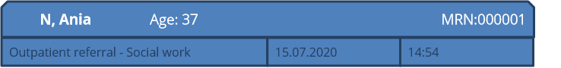
Ania said having Sabina returned to her care has been a ‘relief’ and a ‘happy time’. But Sabina has been using ‘baby talk’ a lot lately which Imran gets annoyed about and she has found this stressful to manage.

Ania said Sabina has been home from school a lot lately. Ania said she would like to go back to work, but Imran is not supportive of this. The other day when the family was eating dinner he became really angry when she mentioned going back to work.

In preparation for your appointment with Ania, review her medical record above.
Based on the case notes, what opportunities are there to bring in a child-focus during your conversation with Ania?

ACTIVITY FIVE: CHILD FOCSUED PRACTICE WHEN WORKING WITH AN ADULT VICTIM SURVIVOR

MENTAL HEALTH CLINICIAN

Ania said having Sabina returned to her care has been a ‘relief’ and a ‘happy time’. But Sabina has been using ‘baby talk’ a lot lately which Imran gets annoyed about and she has found this stressful to manage.

Ania said Sabina has been home from school a lot lately. Ania said she would like to go back to work, but Imran is not supportive of this. The other day when the family was eating dinner he became really angry when she mentioned going back to work.
In preparation for your appointment with Ania, review her medical record above.
Based on the case notes, what opportunities are there to bring in a child-focus during your conversation with Ania?

ACTIVITY FIVE: CHILD FOCSUED PRACTICE WHEN WORKING WITH AN ADULT VICTIM SURVIVOR

CARE COORDINATOR IN AN EMERGENCY DEPATMENT
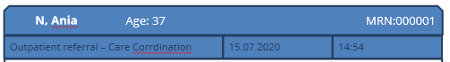
Ania said Sabina is a good kid, and is doing much better now she is linked in with a speech pathologist as she has delayed speech. Ania mentioned that Imran gets annoyed when Sabina acts like a little kid which she has being doing a lot lately.

Ania said Sabina has also been home from school a lot lately. Ania said she would like to go back to work but Imran is not supportive of this. The other day when the family was eating dinner Imran became really angry when she mentioned going back to work.

In preparation for your appointment with Ania, review her medical record above.
Based on the case notes, what opportunities are there to bring in a child-focus during your conversation with Ania?

ACTIVITY FIVE: CHILD FOCSUED PRACTICE WHEN WORKING WITH AN ADULT VICTIM SURVIVOR

HOSPTIAL ADMISSION RISK PROGRAM (HARP) CLINICIAN
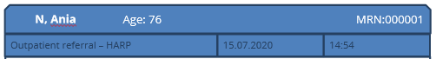
Ania said Sabina has been home from school a lot lately and has been a lot to handle, which is why she doesn’t want to stay in hospital for too long as Imran isn’t there to look after her.
Ania said the other day when the family was eating dinner Imran became really angry when she mentioned needing help with looking after Sabina because of her health issues.

In preparation for your appointment with Ania, review her medical record above.
Based on the case notes, what opportunities are there to bring in a child-focus during your conversation with Ania?

ACTIVITY SIX: QUIZ
- Observable signs of trauma are:
- Things we observe, hear or notice, that indicate that someone may be experiencing family violence.
- Are expressions of trauma that relate to a person’s physical or emotional presentation, behaviour or circumstance
- Can be expressed differently across a person’s lifespan
- All of the above

- True or False
When working with an Aboriginal person it is important to promote self-determination.

- True or False
Incorporating statements which challenge victim blaming beliefs and hold perpetrators responsible for their choice to use violence is an important part of effective egagement.

- A Child-focused practice: (choose the 3 that apply)
- Informs how we talk and work with parents/carers
- Always involves direct work with children
- Strengthens the mother/carer bond
- Is about understanding a child’s unique experience and needs

MODULE 3

ACTIVITY ONE: EVIDENCE-BASED RISK FACTORS
Below is a list of the evidence-based risk factors under MARAM.
Bold text denotes serious risk factors

Risk factors relevant to an adult victim’s  circumstances  - Physical assault while pregnant/following new birth  - Self-assessed level of risk  - Planning to leave or recent separation  - Escalation — increase in severity and/or frequency of violence  - Imminence  - Financial abuse/difficulties  Risk factors specific to children caused by perpetrator behaviours  - Exposure to family violence  - Sexualised behaviours towards a child by the perpetrator  - Child intervention in violence  - Behaviour indicating nonreturn of child  - Undermining the child-parent relationship  - Professional and statutory intervention  Risk factors specific to children’s circumstances  - History of professional involvement and/or statutory intervention  - Change in behaviour not explained by other causes  - Child is a victim of other forms of harm | Risk factors for adult or child victims caused by perpetrator behaviours  - Controlling behaviours  - Access to weapons  - Use of weapon in most recent event  - Has ever harmed or threatened to harm victim or family members  - Has ever tried to strangle or choke the victim  - Has ever threatened to kill victim  - Has ever harmed or threatened to harm or kill pets or other animals  - Has ever threatened or tried to self-harm or commit suicide  - Stalking of victim  - Sexual assault of victim  - Previous or current breach of court orders/ Intervention Orders  - History of family violence  - History of violent behaviour (not family violence)  - Obsession/jealous behaviour toward victim  - Unemployed / Disengaged from education  - Drug and/or alcohol misuse/abuse  - Mental illness / Depression  - Isolation  - Physical harm  - Emotional abuse  - Property damage

ACTIVITY TWO: RISK ASSESSMENT IN PRACTICE – APPLYING THE STRUCTURED PROFESSIONAL JUDGEMENT MODEL

SOCIAL WORKER IN A HOSPTIAL
Here you will learn more about Ania, Imran and Sabina who we met in Module 2 and apply the Structured Professional Judgement Model whilst performing a risk assessment.

Below is what we learnt about Ania, Imran and Sabina in Module 2.
Ania has Multiple Sclerosis and attends your health service regularly for her physiotherapy appointments. She was referred to you by her physiotherapist for a psychosocial needs assessment. Ania is married to Imran and they have a daughter Sabina (7yo).

Ania has recently had a mental health inpatient stay and was on a Compulsory Treatment Order after a serious deterioration in her depression. During her inpatient stay Child Protection placed Sabina in out-of-home care for 4 months. Ania said her Muslim faith and community were a great source of strength for her during this time.

During your conversation with Ania to assess her needs she disclosed the following:
Ania said things have been ‘stressful’ at home lately. When you asked what has been ‘stressful’ lately, Ania said Imran can be a bit of a ‘control freak’ and doesn’t want her spending time with friends at the moment with Sabina back in her care.

During her appointment, Ania kept responding to texts from Imran. Ania left her appointment early as she needed to be back home, and appeared stressed about this. Ania said having Sabina returned to her care has been a ‘relief’ and a ‘happy time’. Being separated was hard for them both as Sabina ‘doesn’t like being a part’ and always ‘clings’ to her. But Sabina has been using ‘baby talk’ a lot lately which Imran gets annoyed about and she has found this stressful to manage.

Part 1 – Evidence-based risk factors
During a conversation to undertake a risk assessment with Ania she disclosed the following:

Ania says Imran has always had a ‘bit of a temper’, and ‘pushes her around’ occasionally. He often comes home angry, yells a lot and breaks things and has done a lot of damage to their house.
Ania has to make sure Sabina is very well behaved otherwise he loses his temper at them both.
Ania says that things haven’t always been like this. She describes meeting Imran as a turning point in her life. Ania hasn’t told anyone about Imran’s behaviour. Her community view issues between couples as private and would dissuade her from seeking support from services.

Which three risk factors are present in this part of Ania’s story?
- Physical harm
- Emotional abuse
- Access to weapons
- Property damage
- Obsessive/jealous behaviour

Ania has a diagnosis of major depression, and has been hospitalised numerous times. She found these experiences traumatic but the stability of her relationship with Imran helped greatly. Ania is currently managing her depression well.

Imran wants another child, but Ania doesn’t as she wants to return to teaching. Imran won’t let her use contraception and says she is immoral to consider it. He often forces her to have sex, saying it’s her duty as his wife.

Which two risk factors are present in this part of Ania’s story?
- Planning to leave
- Has ever threatened to kill
- Imminent threat
- Controlling behaviours
- Sexual assault of victim

Ania was taking the pill secretly, but last week Imran found an empty packet in the bin. He hit her harder than he had before, then pinned her up against the wall. Ania was frightened that he would kill her.

When she managed to get away from him, she saw Sabina in the doorway looking terrified. Ania feels very confused and upset, as a lot of the time Imran is lovely and affectionate.

Which three risk factors are present in this part of Ania’s story
- Has ever tried to strangle or choke the victim
- Escalation (severity & frequency)
- Physical harm
- Stalking of victim
- Exposure to family violence (of a child)

Part 2: Victim survivors self-assessment
During a conversation to undertake a risk assessment with Ania she disclosed the following:

Ania assessed her current level of fear at 3 (on a scale from 1-5), citing the incident last week as a 5. Ania said that Imran has never physically assaulted Sabina, and doesn’t think he would.
Ania doesn’t have any immediate concerns for her or Sabina’s safety, but knows that there will be something else that will make Imran angry and he will be violent again.
Ania is petrified by the idea of leaving Imran as after this last incident, she is really worried what Imran could do if she left.

Which three of the following statements reflect Ania’s safety concerns and level of fear?
- Immediate safety concerns
- Current fear level 3 (on a scale from 1-5)
- Concerned Imran would become physically abusive to Sabina
- Potential for Imran’s behaviour to make her fear level 5 (on a scale from 1-5)
- Further violent behaviour is likely

Part 3: Information sharing

What two agencies might you consider requesting information from under FVISS to inform your understanding of the risk to Ania and Sabina?
- Child Protection
- Housing service
- Religious leaders
- Mental Health Service

Part 4: Intersectional Analysis
Identifying barriers to disclosure and support seeking
- Ania describing her hospitalisation for depression as ‘traumatic’ may have created a barrier to Ania’s future help seeking? True or False.

- In Australian ‘research has demonstrated that anti-Islamic and anti-Semitic sentiment, as well as racism, have led communities to avoid seeking help for fear of stigmatisation from secular services.’ (Vaughan et al, 2020)
Does the below disclosure form Ania indicate she may be experiencing this barrier?

Ania said she hasn’t told anyone about Imran’s behaviour, as her community view issues between couples as a private issue and would try to dissuade her from seeking help from services so not to present a negative image of the community.

Perpetrator tactics that capitalise on societal discrimination

Which tactic has Imran used that capitalises on aspects of Ania’s identity and health status (Muslim faith and living with a mental health issue) and the social situation of discrimination against those of Muslim faith and those living with a mental health issue?
- Threatening to tell police she was having an episode and needed mental health support so she would be hospitalised if she ever called the police.
- Using her faith as a way to justify controlling her use of contraception.
- Threatening to report to Child Protection that Ania is having another mental health episode, as a way to deter her from reporting his use of violence.

Protective Factors

Which protective factors is present for Ania and Sabina?
- An Intervention order is in place and being adhered to.
- Ania’ is employed and financially independent.
- Ania’s Muslim faith and community is a great source of strength.
- Sabina is engaged in school.

Contextual information

What other contextual information is likely to be relevant to understanding Ania and Sabina’s risk?
(Choose the answer that most applies)
- Nature of Child Protection involvement
- Impact of living with depression.
- Imran victim blaming attitudes towards his use of violence
- All of the above

RISK ASSESSMENT IN PRACTICE – APPLYING THE STRUCTURED PROFESSIONAL JUDGEMENT MODEL

MENTAL HEALTH CLINICIAN
Here you will learn more about Ania, Imran and Sabina who we met in Module 2 and apply the Structured Professional Judgement Model whilst performing a risk assessment.

Below is what we learnt about Ania, Imran and Sabina in Module 2.
Ania attends your service regularly for support for major depression. Ania is married to Imran and they have a daughter Sabina (7yo).

Ania has previously had a mental health inpatient stay and was on a Compulsory Treatment Order after a serious deterioration in her depression. During her inpatient stay Child Protection place Sabina in out-of-home care for 4 months. Ania said her Muslim faith and community were a great source of strength for her during this time. Ania feels she is managing her depression well. She can tell the medication is helping as although things have been a bit stressful at home lately, she has noticed she is not getting caught up in negative thinking like she used to.

When you asked what has been ‘stressful’ lately, Ania said Imran can be a bit of a ‘control freak’ and doesn’t want her spending time with friends at the moment with Sabina back in her care.
During her treatment, Ania kept responding to texts from Imran. Ania left her appointment early as she needed to be back home, and appeared stressed about this.

Ania said having Sabina returned to her care has been a ‘relief’ and a ‘happy time’. Being separated was hard for them both as Sabina ‘doesn’t like being a part’ and always ‘clings’ to her. But Sabina has been using ‘baby talk’ a lot lately which Imran gets annoyed about and she has found this stressful to manage. Ania said Sabina has been home from school a lot lately. Ania said she would like to go back to work, but Imran is not supportive of this. The other day when the family was eating dinner he became really angry when she mentioned going back to work.

Part 1 – Evidence-based risk factors
During a conversation to undertake a risk assessment with Ania she disclosed the following:

Ania says Imran has always had a ‘bit of a temper’, and ‘pushes her around’ occasionally. He often comes home angry, yells a lot and breaks things and has done a lot of damage to their house.
Ania has to make sure Sabina is very well behaved otherwise he loses his temper at them both.
Ania says that things haven’t always been like this. She describes meeting Imran as a turning point in her life. Ania hasn’t told anyone about Imran’s behaviour. Her community view issues between couples as private and would dissuade her from seeking support from services.

Which three risk factors are present in this part of Ania’s story?
- Physical harm
- Emotional abuse
- Access to weapons
- Property damage
- Obsessive/jealous behaviour

Ania has been hospitalised numerous times. She found these experiences traumatic but the stability of her relationship with Imran helped greatly. Ania is currently managing her depression well.

Imran wants another child, but Ania doesn’t as she wants to return to teaching. Imran won’t let her use contraception and says she is immoral to consider it. He often forces her to have sex, saying it’s her duty as his wife.

Which two risk factors are present in this part of Ania’s story?
- Planning to leave
- Has ever threatened to kill
- Imminent threat
- Controlling behaviours
- Sexual assault of victim

Ania was taking the pill secretly, but last week Imran found an empty packet in the bin. He hit her harder than he had before, then pinned her up against the wall. Ania was frightened that he would kill her.

When she managed to get away from him, she saw Sabina in the doorway looking terrified. Ania feels very confused and upset, as a lot of the time Imran is lovely and affectionate.

Which three risk factors are present in this part of Ania’s story
- Has ever tried to strangle or choke the victim
- Escalation (severity & frequency)
- Physical harm
- Stalking of victim
- Exposure to family violence (of a child)

Part 2: Victim survivors self-assessment
During a conversation to undertake a risk assessment with Ania she disclosed the following:

Ania assessed her current level of fear at 3 (on a scale from 1-5), citing the incident last week as a 5. Ania said that Imran has never physically assaulted Sabina, and doesn’t think he would.
Ania doesn’t have any immediate concerns for her or Sabina’s safety, but knows that there will be something else that will make Imran angry and he will be violent again.
Ania is petrified by the idea of leaving Imran as after this last incident, she is really worried what Imran could do if she left.

Which three of the following statements reflect Ania’s safety concerns and level of fear?
- Immediate safety concerns
- Current fear level 3 (on a scale from 1-5)
- Concerned Imran would become physically abusive to Sabina
- Potential for Imran’s behaviour to make her fear level 5 (on a scale from 1-5)
- Further violent behaviour is likely

Part 3: Information sharing

What two agencies might you consider requesting information from under FVISS to inform your understanding of the risk to Ania and Sabina?
- Child Protection
- Housing service
- Religious leaders
- Child First

Part 4: Intersectional Analysis
Identifying barriers to disclosure and support seeking
- Ania describing her hospitalisation for depression as ‘traumatic’ may have created a barrier to Ania’s future help seeking? True or False.

- In Australian ‘research has demonstrated that anti-Islamic and anti-Semitic sentiment, as well as racism, have led communities to avoid seeking help for fear of stigmatisation from secular services.’ (Vaughan et al, 2020)

Does the below disclosure form Ania indicate she may be experiencing this barrier?
Ania said she hasn’t told anyone about Imran’s behaviour, as her community view issues between couples as a private issue and would try to dissuade her from seeking help from services so not to present a negative image of the community.

Perpetrator tactics that capitalise on societal discrimination

Which tactic has Imran used that capitalises on aspects of Ania’s identity and health status (Muslim faith and living with a mental health issue) and the social situation of discrimination against those of Muslim faith and those living with a mental health issue?
- Threatening to tell police she was having an episode and needed mental health support so she would be hospitalised if she ever called the police.
- Using her faith as a way to justify controlling her use of contraception.
- Threatening to report to Child Protection that Ania is having another mental health episode, as a way to deter her from reporting his use of violence.

Protective Factors

Which protective factors is present for Ania and Sabina?
- An Intervention order is in place and being adhered to.
- Ania’ is employed and financially independent.
- Ania’s Muslim faith and community is a great source of strength.
- Sabina is engaged in school.

Contextual information

What other contextual information is likely to be relevant to understanding Ania and Sabina’s risk?
(Choose the answer that most applies)
- Nature of Child Protection involvement
- Impact of living with depression.
- Imran victim blaming attitudes towards his use of violence
- All of the above

RISK ASSESSMENT IN PRACTICE – APPLYING THE STRUCTURED PROFESSIONAL JUDGEMENT MODEL

CARE COORDINATOR IN AN EMERGENCY DEPARTMENT
Here you will learn more about Ania, Imran and Sabina who we met in Module 2 and apply the Structured Professional Judgement Model whilst performing a risk assessment.

Below is what we learnt about Ania, Imran and Sabina in Module 2.
Ania has severe asthma and attended the emergency department presenting with severe breathlessness and wheezing with her daughter Sabina (7yo). Ania is married to Imran. Ania believes the asthma attack was caused by mould that had been building up in her house. She was referred to you after mentioning to her treating nurse that she couldn’t go home because of the mould and didn’t have anywhere else to stay.

During your conversation with Ania to explore whether she could stay with family or friends, she mentioned that Imran is a bit of a ‘control freak’ and doesn’t like her spending time with family and friends so she has lost contact with them so staying with them is not an option.
Ania said things have been ‘stressful’ at home lately, but that her Muslim faith and community are a great source of strength for her. During your conversation, Ania kept responding to texts from Imran. Ania decided to return home as Imran wanted her back home, and appeared stressed about this.

Ania said returning home is probably the best option as Sabina has only just been returned to her care and if they become homeless she is worried Child Protection will place her in out-of-home care again. Ania has previously had a mental health inpatient stay and was on a Compulsory Treatment Order after a serious deterioration in her depression. During her inpatient stay Child Protection place Sabina in out-of-home care for 4 months. Being separated was hard for them both as Sabina ‘doesn’t like being a part’ and ‘always clings’ to her. Ania said Sabina is a ‘good kid’, and is doing much better now she is linked in with a speech pathologist as she has delayed speech. Ania mentioned that Imran gets annoyed when Sabina acts like a little kid which she has being doing a lot lately. Ania said Sabina has also been home from school a lot lately. Ania said she would like to go back to work but Imran is not supportive of this. The other day when the family was eating dinner Imran became really angry when she mentioned going back to work.

Part 1 – Evidence-based risk factors
During a conversation to undertake a risk assessment with Ania she disclosed the following:

Ania says Imran has always had a ‘bit of a temper’, and ‘pushes her around’ occasionally. He often comes home angry, yells a lot and breaks things and has done a lot of damage to their house.
Ania has to make sure Sabina is very well behaved otherwise he loses his temper at them both.
Ania says that things haven’t always been like this. She describes meeting Imran as a turning point in her life. Ania hasn’t told anyone about Imran’s behaviour. Her community view issues between couples as private and would dissuade her from seeking support from services.

Which three risk factors are present in this part of Ania’s story?
- Physical harm
- Emotional abuse
- Access to weapons
- Property damage
- Obsessive/jealous behaviour

Ania has been hospitalised numerous times. She found these experiences traumatic but the stability of her relationship with Imran helped greatly. Ania is currently managing her depression well.

Imran wants another child, but Ania doesn’t as she wants to return to teaching. Imran won’t let her use contraception and says she is immoral to consider it. He often forces her to have sex, saying it’s her duty as his wife.

Which two risk factors are present in this part of Ania’s story?
- Planning to leave
- Has ever threatened to kill
- Imminent threat
- Controlling behaviours
- Sexual assault of victim

Ania was taking the pill secretly, but last week Imran found an empty packet in the bin. He hit her harder than he had before, then pinned her up against the wall. Ania was frightened that he would kill her.

When she managed to get away from him, she saw Sabina in the doorway looking terrified. Ania feels very confused and upset, as a lot of the time Imran is lovely and affectionate.

Which three risk factors are present in this part of Ania’s story
- Has ever tried to strangle or choke the victim
- Escalation (severity & frequency)
- Physical harm
- Stalking of victim
- Exposure to family violence (of a child)

Part 2: Victim survivors self-assessment
During a conversation to undertake a risk assessment with Ania she disclosed the following:

Ania assessed her current level of fear at 3 (on a scale from 1-5), citing the incident last week as a 5. Ania said that Imran has never physically assaulted Sabina, and doesn’t think he would.
Ania doesn’t have any immediate concerns for her or Sabina’s safety, but knows that there will be something else that will make Imran angry and he will be violent again.
Ania is petrified by the idea of asking Imran to move out as after this last incident she is really worried what he could do.

Which three of the following statements reflect Ania’s safety concerns and level of fear?
- Immediate safety concerns
- Current fear level 3 (on a scale from 1-5)
- Concerned Imran would become physically abusive to Sabina
- Potential for Imran’s behaviour to make her fear level 5 (on a scale from 1-5)
- Further violent behaviour is likely

Part 3: Information sharing

What two agencies might you consider requesting information from under FVISS to inform your understanding of the risk to Ania and Sabina?
- Child Protection
- Housing service
- Religious leaders
- Mental Health Service

Part 4: Intersectional Analysis
Identifying barriers to disclosure and support seeking
- Ania describing her hospitalisation for depression as ‘traumatic’ may have created a barrier to Ania’s future help seeking? True or False.

- In Australian ‘research has demonstrated that anti-Islamic and anti-Semitic sentiment, as well as racism, have led communities to avoid seeking help for fear of stigmatisation from secular services.’ (Vaughan et al, 2020)

Does the below disclosure form Ania indicate she may be experiencing this barrier?
Ania said she hasn’t told anyone about Imran’s behaviour, as her community view issues between couples as a private issue and would try to dissuade her from seeking help from services so not to present a negative image of the community.

Perpetrator tactics that capitalise on societal discrimination

Which tactic has Imran used that capitalises on aspects of Ania’s identity and health status (Muslim faith and living with a mental health issue) and the social situation of discrimination against those of Muslim faith and those living with a mental health issue?
- Threatening to tell police she was having an episode and needed mental health support so she would be hospitalised if she ever called the police.
- Using her faith as a way to justify controlling her use of contraception.
- Threatening to report to Child Protection that Ania is having another mental health episode, as a way to deter her from reporting his use of violence.

Protective Factors

Which protective factors is present for Ania and Sabina?
- An Intervention order is in place and being adhered to.
- Ania’ is employed and financially independent.
- Ania’s Muslim faith and community is a great source of strength.
- Sabina is engaged in school.

Contextual information

What other contextual information is likely to be relevant to understanding Ania and Sabina’s risk?
(Choose the answer that most applies)
- Nature of Child Protection involvement
- Impact of living with depression.
- Imran victim blaming attitudes towards his use of violence
- All of the above

RISK ASSESSMENT IN PRACTICE – APPLYING THE STRUCTURED PROFESSIONAL JUDGEMENT MODEL

HOSPTIAL ADMISSION RISK PROGRAM (HARP) CLINICIAN
Here you will learn more about Ania, Imran and Sabina who we met in Module 2 and apply the Structured Professional Judgement Model whilst performing a risk assessment.

Below is what we learnt about Ania, Imran and Sabina in Module 2.
Ania (82) was admitted to hospital with chronic obstructive pulmonary disease. Her medical team referred her to you for an Aged Care Assessment Service (ACAS) assessment.
During your conversation with Ania, she mentioned things have been ‘stressful’ lately. Money is tight as she borrowed money for her son Imran (55) to buy a car which meant she can’t afford her medications. She said her Muslim faith and community are a great source of strength in stressful times.
Ania said her health is getting worse and she is physically exhausted, and it was becoming harder to care for her granddaughter Sabina (12yo) who lives with her and her son. Imran works nightshift, so Ania is responsible for looking after Sabina and she doesn’t have any family or friend support to help out. Ania joked that she is lucky as Sabina is easy-going, since Imran is a bit of a ‘control freak’.
Ania said Sabina is a good kid, and is doing much better now she is linked in with a speech pathologist as she has delayed speech. Sabina has been having trouble sleeping lately and has been complaining of headaches but their GP wasn’t concerned.
Ania said Sabina has been home from school a lot lately and has been a lot to handle, which is why she doesn’t want to stay in hospital for too long as Imran isn’t there to look after her.
Ania said the other day when the family was eating dinner Imran became really angry when she mentioned needing help with looking after Sabina because of her health issues.

Part 1 – Evidence-based risk factors
During a conversation to undertake a risk assessment with Ania she disclosed the following:

Ania says Imran ‘pushes her around’ occasionally. He often comes home angry, yells a lot and has done a lot of damage to their house. Ania has to make sure Sabina is well behaved otherwise Imran loses his temper at them both.
Ania says things haven’t always been like this. She describes Imran as being a very loving son, but his behaviour changed when he moved in with her 2 years ago.
Ania has a diagnosis of major depression, and has been admitted to hospital numerous times, and found these experiences very traumatic. Imran was very supportive during these experiences.

Which three risk factors are present in this part of Ania’s story?
- Physical harm
- Emotional abuse
- Access to weapons
- Property damage
- Obsessive/jealous behaviour

Imran has always had a ‘bit of a control freak’ and is constantly demanding money from her even though he has a job, telling her ‘that’s what parents are meant to do’, which meant she hadn’t been able to buy her asthma or arthritis medication.
Ania hasn’t told anyone about Imran’s behaviour. Her community view issues within families as private and would dissuade her from seeking support from services so not to present a negative image of the community. The whole family and well-liked members of their mosque community and she doesn’t want to jeopardise this.

Which two risk factors are present in this part of Ania’s story?
- Has ever threatened to kill
- Financial abuse
- Controlling behaviours
- Stalking of victim

Last week she spoke to Imran about repaying the money he borrowed he became very angry and pushed her harder than he had before, pinning her against the wall. When she managed to get away from him, she saw Sabina in the doorway looking terrified.
Ania threatened to call the police if Imran ever did something like that in front of Sabina again, but Imran said he would tell them she was having another mental health episode and she would be hospitalised again. Ania is very frightened of being back in hospital. Ania feels very confused and upset, as Imran can be very loving.

Which three risk factors are present in this part of Ania’s story
- Escalation (severity & frequency)
- Physical harm
- Unemployed
- Exposure to family violence (of a child)

Part 2: Victim survivors self-assessment
During a conversation to undertake a risk assessment with Ania she disclosed the following:

Ania assessed her current level of fear at 3 (on a scale from 1-5), citing the incident last week as a 5. Ania said that Imran has never physically assaulted Sabina, and doesn’t think he would.
Ania doesn’t have any immediate concerns for her or Sabina’s safety, but knows that there will be something else that will make Imran angry and he will be violent again.
Ania is petrified by the idea of leaving Imran as after this last incident, she is really worried what Imran could do if she left.

Which three of the following statements reflect Ania’s safety concerns and level of fear?
- Immediate safety concerns
- Current fear level 3 (on a scale from 1-5)
- Concerned Imran would become physically abusive to Sabina
- Potential for Imran’s behaviour to make her fear level 5 (on a scale from 1-5)
- Further violent behaviour is likely

Part 3: Information sharing

What agency might you consider requesting information from under FVISS to inform your understanding of the risk to Ania and Sabina?
- Child Protection
- Housing service
- Religious leaders
- Mental Health Service

Part 4: Intersectional Analysis
Identifying barriers to disclosure and support seeking
- Ania describing her hospitalisation for depression as ‘traumatic’ may have created a barrier to Ania’s future help seeking? True or False.

- In Australian ‘research has demonstrated that anti-Islamic and anti-Semitic sentiment, as well as racism, have led communities to avoid seeking help for fear of stigmatisation from secular services.’ (Vaughan et al, 2020)

Does the below disclosure form Ania indicate she may be experiencing this barrier?
Ania said she hasn’t told anyone about Imran’s behaviour, as her community view issues within families as a private issue and would try to dissuade her from seeking help from services so not to present a negative image of the community.

Perpetrator tactics that capitalise on societal discrimination

Which tactic has Imran used that capitalises on aspects of Ania’s identity and health status (Muslim faith and living with a mental health issue) and the social situation of discrimination against those of Muslim faith and those living with a mental health issue?
- Threatening to tell police she was having an episode and needed mental health support so she would be hospitalised if she ever called the police.
- Using her faith as a way to justify his abusive behaviour.
- Threatening to put her in an aged care home as a way to deter her from reporting his use of violence.

Protective Factors

Which protective factors is present for Ania and Sabina?
- An Intervention order is in place and being adhered to.
- Ania’ is employed and financially independent.
- Ania’s Muslim faith and community is a great source of strength.
- Sabina is engaged in school.

Contextual information

What other contextual information is likely to be relevant to understanding Ania and Sabina’s risk? (Choose the answer that most applies)
- Ania’s age and health needs
- Impact of living with depression.
- Imran victim blaming attitudes towards his use of violence
- All of the above

ACTIVITY THREE: ASSESSMENT OF SERIOUSNESS OF RISK

MARAM RISK CATEGORIES
AT RISK: High risk factors are not present. Some other recognized family violence risk factors are present, but protective factors and risk management strategies, such as advocacy, information and victim survivor support and referral are in place to manage (lessen or remove) the risk from the perpetrator. Victim survivor self-assessed level of fear, risk and safety is low.

ELEVATED RISK: A number of risk factors are present, including some high-risk factors, that are likely to continue if risk management is not initiated. The likelihood of a serious outcome is not high. However, the impact of risk from the perpetrator is affecting the victim survivor’s day-to-day functioning. Victim survivor self-assessed level of fear, risk and safety is elevated.

SERIOUS RISK: A number of high-risk factors are present related to likelihood of lethality or serious injury. Risk factors may have changed/escalated in frequency. Serious outcomes from current violence has occurred and it is indicated further serious outcomes from the use of violence by the perpetrator is likely, and may be imminent. Immediate risk management is required to lessen the level of risk or prevent a serious outcome from the identified threat posed by the perpetrator. Statutory and non-statutory services response is required, and coordinated and collaborative risk management and action planning may be required. Victim survivor self-assessed level of fear and risk is high-extremely high and safety is low.

Within serious risk, there is an additional category where the victim survivor also requires immediate protection. This requires a different response.
SERIOUS RISK AND REQUIRES IMMEDIATE PROTECTION: Previous strategies for risk management have been unsuccessful. Escalation of frequency of violence has occurred/is likely to occur. Formally structured coordination and collaboration of service and agency responses is required. The response will include involvement from statutory and non-statutory crisis response services (and may include referral for a RAMP response), for risk assessment and management planning and intervention to lessen or remove serious risk that is likely to result in lethality or serious physical or sexual violence. Victim survivor self-assessed level of fear and risk is high-extremely high and safety is extremely low.

Consider the information in the case study of Ania, Imran and Sabina (Activity Two). Which level you would rate Ania and Sabina’s risk? What is your rationale for this?
- At Risk
- Elevated
- Serious Risk
- Serious Risk Requiring Immediate protection

ACTIVITY FOUR: Quiz
- True or False
Risk Factors relate to the current and emerging evidence which research has indicated that when present, a victim survivor of family violence is statistically more likely to be killed or seriously injured.

- This Child Assessment tool should be used directly with an older child or young person if it is appropriate to their age and developmental stage and if it is your role to do so?

- The elements of the Structured Professional Judgement model are:
(choose all that apply)
- Victim/survivor self-assessment
- Evidence based risk factors
- Information Sharing
- Professional Judgement and Intersectional Analysis

- Which of the following risk categories is not used under MARAM when determining seriousness of risk.
- At risk
- Elevated risk
- Imminent risk
- Serious risk
- Serious risk and requires immediate protection

MODULE 4

ACTIVITY ONE: SAFETY PLANNING
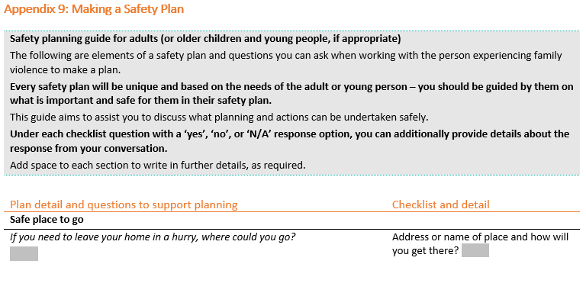
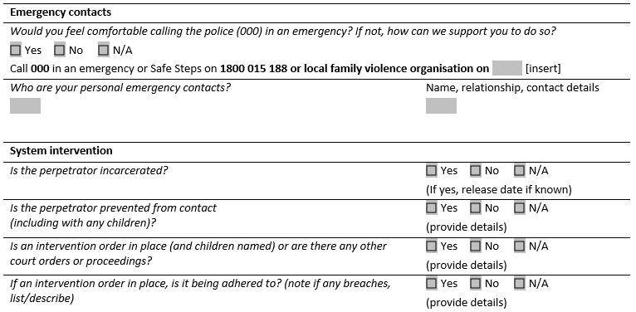
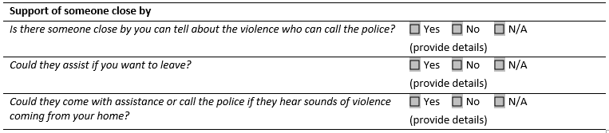
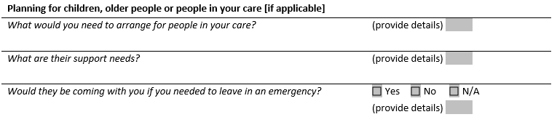
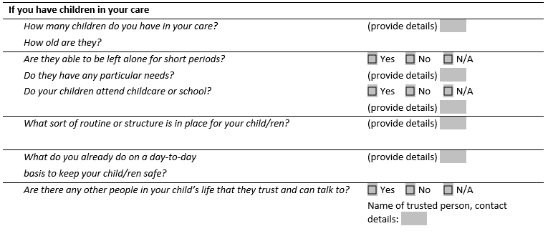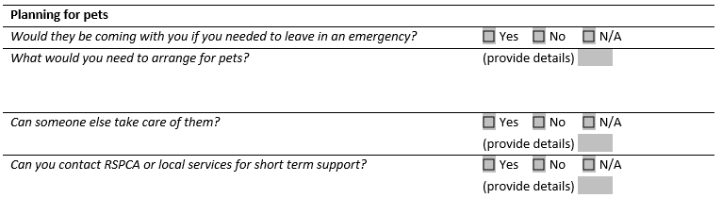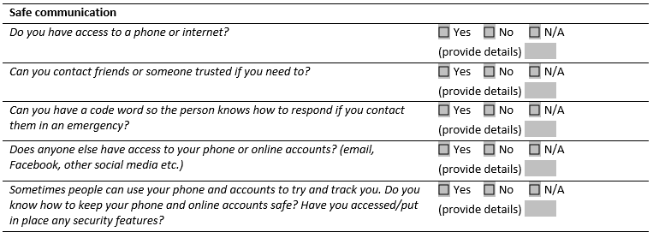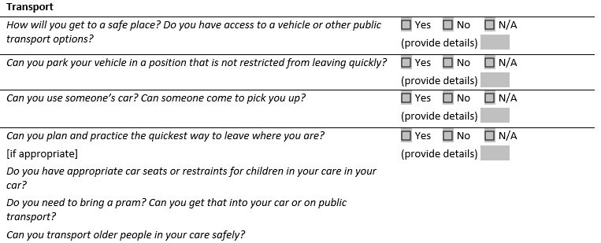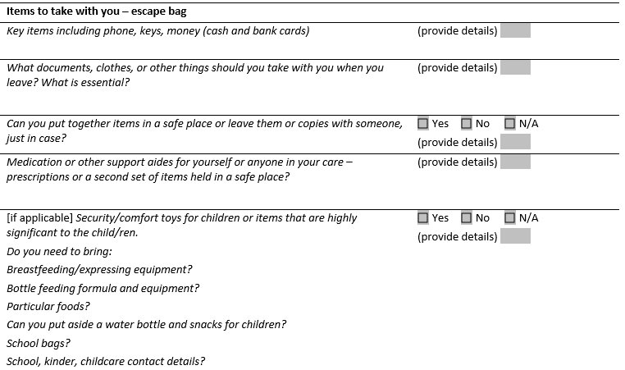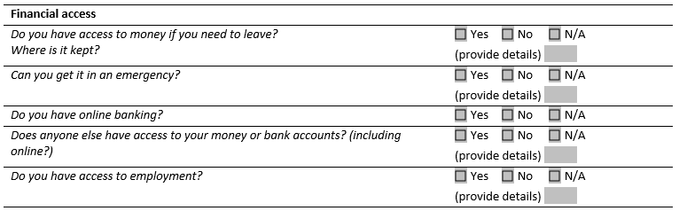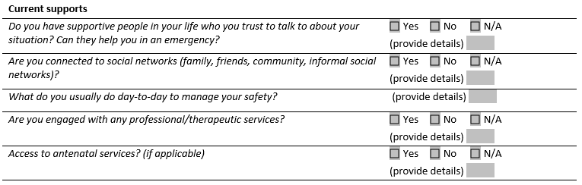

Questions
We are now going to return to the case study of Ania, Imran and Sabina. Review the information provided, and in small groups discuss the following questions.

- Case study: Contacting Police in an emergency.

When discussing contacting the Police in an emergency with Ania she disclosed:
She knows she can call the police if she is unsafe, but is concerned she will have another experience like last time. Last time the police attended she was overwhelmed and couldn’t speak to the police to tell them Imran had assaulted her, and Imran told them she was having an episode and needed mental health support so they called the CATT (Crisis Assistance and Treatment Team) and she was admitted to hospital.

How could you respond to Ania to address this concern and remove this barrier to seeking support?
- Validate her concern and previous experience
- Reiterate the role of police and her right to be safe
- Talk through how she might speak to police to ensure they understand her concerns for her safety
- Talk through ways she can manage feeling overwhelmed so she can communicate
- All of the above

- Case study: Discussing a Plan to leave in an emergency.

When discussing this with Ania she disclosed.
She would likely go to her neighbour’s house in an emergency, which they have done previously. She is unable to leave by car. Their car has not been modified to address her fine motor challenges associated with cerebral palsy so she is unable to drive their car.

Which three options could you discuss with Ania to strengthen this plan?
- Encourage her to talk to her neighbour about this plan and how they can keep safe until police arrive.
- Consider ways to gain access to the car keys so her neighbour can drive her to a safe place.
- Suggest she asks her neighbour to call the police if they hear sounds of violence coming from her home.
- Talking about where she would go if her neighbour is not at home.

- Case study: Planning for when leaving the home is not an option.

If Ania was living in a rural location and leaving was not an option (due to distance and having no access to a car), which two options could you discuss with her to enhance her safety in an emergency?
- When the situation begins to escalate ensuing her phone is with her so she can call the police when in a safe room.
- Avoid unsafe areas such as the kitchen and bathroom.
- Arranging to text a friend or family member so they can call the police on her behalf.
- Call the police before going into Sabina’s room

- Case study: Planning to leave when it is safe.

When discussing this with Ania, she said she has some friends that she might be able to stay with if she decided to leave. She said she would talk to them about this potential arrangement.
Ania said a safe time to leave would be at school drop off, as she always takes Sabina to school and Imran would be at work. Ania said she hadn’t thought through what she would take if she left.

Referring to the Safety Planning template above, what are some key items to talk to Ania about considering taking if she left?

- Case study: Safety planning with a child.

If Ania prefers to discuss safety planning with Sabina herself, which of the following actions could support Ania to prepare for this conversation? (choose four)
- Discuss how Ania can define family violence and help Sabina to understand what family violence is in a way that is age appropriate to her.
- Consider Sabina’s age and developmental stage and discuss her level of involvement in this process.
- Encourage Ania not to talk to Sabina about safety planning.
- Discuss ways Ania can let Sabina know they she is not to blame for the violence, or responsible for Ania’s or her safety.
- Go through the Child Safety Planning template with Ania, and discuss how she could open up the conversation with Sabina.

ACTIVITY TWO: RISK MANAGEMENT

SOCIAL WORKER IN A HOSPTIAL
We are now going to return to the case study of Ania, Imran and Sabina and consider collaborative risk management strategies. In small groups discuss the following questions.

- In a conversation with Ania she indicated she would like support from a specialist family violence service.
Which services should you discuss with her and offer a referral to?
- Specialist family violence service/The Orange Door
- Legal service
- Alcohol and Other Drug service
- In Touch

- When discussing Sabina’s needs Ania said she would like to talk to someone about supporting Sabina to re-engage in school.
Which of the following services would be appropriate to discuss with Ania and offer a referral to?
- Tweedle Child and Family Health Service
- The Orange Door/Child First
- Specialist family violence service
- All of the above

- Ania tells you she has not disclosed experiencing family violence to another service.

It will be important to offer advocacy to these services in the form of providing information around her experiences and impacts of family violence and Ania’s views and wishes, so this can be taken into consideration in the actions or support they provide.

How could you promote Ania’s agency through this process? (choose all that apply)
- Seek Ania’s view and wishes about what information should be shared.
- Ensure Ania understands your obligations under information sharing legislations.
- Enquire about any concerns Ania has about information sharing and address these concerns.
- Be transparent about what information will be shared or support Ania to share this information herself.
- Ensure the information shared does not victim blame (collude with perpetrators).

ACTIVITY TWO: RISK MANAGEMENT

MENTAL HEALTH CLINICIAN
We are now going to return to the case study of Ania, Imran and Sabina and consider collaborative risk management strategies. In small groups discuss the following questions.

- In a conversation with Ania she indicated she would like support from a specialist family violence service.
Which services should you discuss with her and offer a referral to?
- Specialist family violence service/The Orange Door
- Legal service
- Alcohol and Other Drug service
- In Touch

- When discussing Sabina’s needs Ania said she would like to talk to someone about supporting Sabina to re-engage in school.
Which of the following services would be appropriate to discuss with Ania and offer a referral to?
- Tweedle Child and Family Health Service
- The Orange Door/Child First
- Specialist family violence service
- All of the above

- Ania tells you she has not disclosed experiencing family violence to another service.

It will be important to offer advocacy to these services in the form of providing information around her experiences and impacts of family violence and Ania’s views and wishes, so this can be taken into consideration in the actions or support they provide.

How could you promote Ania’s agency through this process? (choose all that apply)
- Seek Ania’s view and wishes about what information should be shared.
- Ensure Ania understands your obligations under information sharing legislations.
- Enquire about any concerns Ania has about information sharing and address these concerns.
- Be transparent about what information will be shared or support Ania to share this information herself.
- Ensure the information shared does not victim blame (collude with perpetrators).

ACTIVITY TWO: RISK MANAGEMENT

CARE COORDINATOR IN AN EMERGENCY DEPATMENT
We are now going to return to the case study of Ania, Imran and Sabina and consider collaborative risk management strategies. In small groups discuss the following questions.

- In a conversation with Ania she indicated she would like support from a specialist family violence service.
Which services should you discuss with her and offer a referral to?
- Specialist family violence service/The Orange Door
- Legal service
- Alcohol and Other Drug service
- In Touch

- When discussing Sabina’s needs Ania said she would like to talk to someone about supporting Sabina to re-engage in school.
Which of the following services would be appropriate to discuss with Ania and offer a referral to?
- Tweedle Child and Family Health Service
- The Orange Door/Child First
- Specialist family violence service
- All of the above

- Ania tells you she has not disclosed experiencing family violence to another service.

It will be important to offer advocacy to these services in the form of providing information around her experiences and impacts of family violence and Ania’s views and wishes, so this can be taken into consideration in the actions or support they provide.

How could you promote Ania’s agency through this process? (choose all that apply)
- Seek Ania’s view and wishes about what information should be shared.
- Ensure Ania understands your obligations under information sharing legislations.
- Enquire about any concerns Ania has about information sharing and address these concerns.
- Be transparent about what information will be shared or support Ania to share this information herself.
- Ensure the information shared does not victim blame (collude with perpetrators).

ACTIVITY TWO: RISK MANAGEMENT

HOSPTIAL ADMISSION RISK PROGRAM (HARP) CLINICIAN
We are now going to return to the case study of Ania, Imran and Sabina and consider collaborative risk management strategies. In small groups discuss the following questions.

- In a conversation with Ania she indicated she would like support from a specialist family violence service.
Which services should you discuss with her and offer a referral to?
- Specialist family violence service/The Orange Door
- Legal service
- Seniors Rights Victoria
- In Touch

- When discussing Sabina’s needs Ania said she would like to talk to someone about supporting Sabina to re-engage in school.
Which of the following services would be appropriate to discuss with Ania and offer a referral to?
- Tweedle Child and Family Health Service
- The Orange Door/Child First
- Specialist family violence service
- All of the above

- Ania tells you she has not disclosed experiencing family violence to another service.

It will be important to offer advocacy to these services in the form of providing information around her experiences and impacts of family violence and Ania’s views and wishes, so this can be taken into consideration in the actions or support they provide.

How could you promote Ania’s agency through this process? (choose all that apply)
- Seek Ania’s view and wishes about what information should be shared.
- Ensure Ania understands your obligations under information sharing legislations.
- Enquire about any concerns Ania has about information sharing and address these concerns.
- Be transparent about what information will be shared or support Ania to share this information herself.
- Ensure the information shared does not victim blame (collude with perpetrators).

ACTIVITY THREE: QUIZ
- The name of the 24-hour family violence crisis response service in Victoria and the access point if someone requires refuge or crisis accommodation is?
- Safe Steps
- InTouch

- If a colleague discloses to you that they are experiencing family violence you should validate their experience and inform them of the support available within your workplace. True or False

- Risk management should be collaborative and draw on the functions and expertise within the entire service system. True or False

- Engaging with perpetrators directly around their use of violence can directly correlate with increased risk for the victim survivor and should only be undertaken if you have been trained and it is your role to do so. True or False

