Here are some prompting questions you can make to raise the subject of violence before asking questions that are more direct;
- “In our organisation, it is common that we ask questions about safety and relationship issues as these can affect your health and so we can connect people with appropriate support. Is it ok if I ask you a few questions about your safety and relationship?”
- “I noticed that you appear to be experiencing X, is there something worrying you that you would like to talk about?”
Here are the direct identification questions that you should ask a patient if they disclose or you are suspicious that they are experiencing family violence;
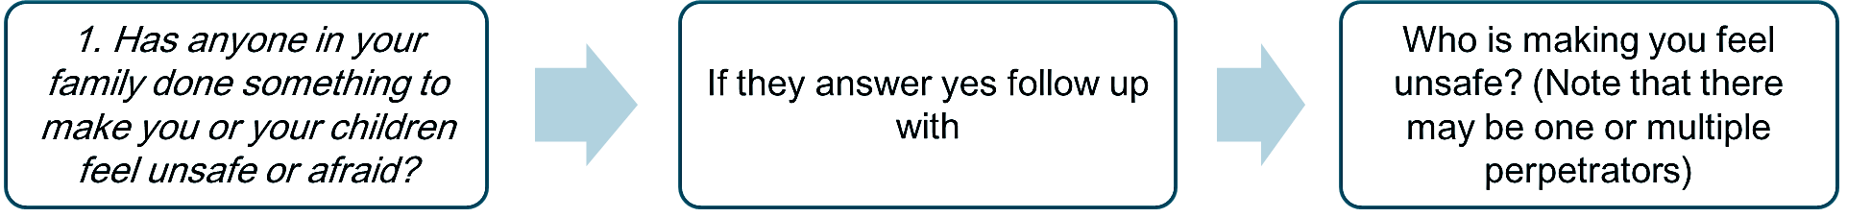
If a patient answers YES to ANY of the identification questions you should offer them first line support which should include a referral to your hospital’s social work department or other appropriate professional (as defined by your hospital’s Family Violence Procedure and referral pathways).
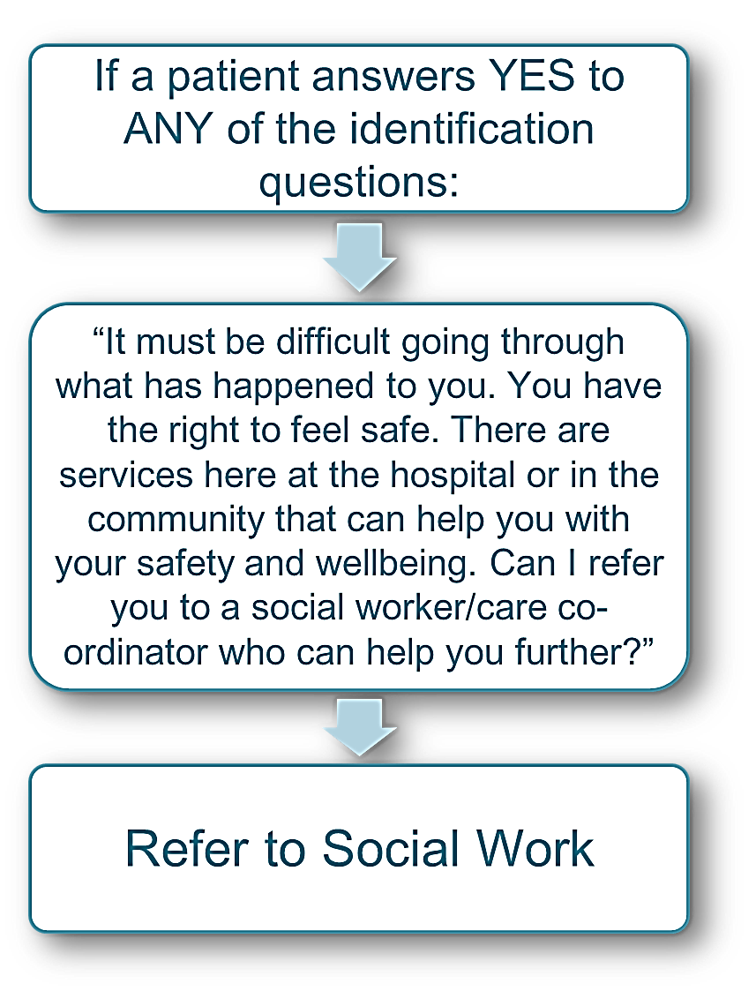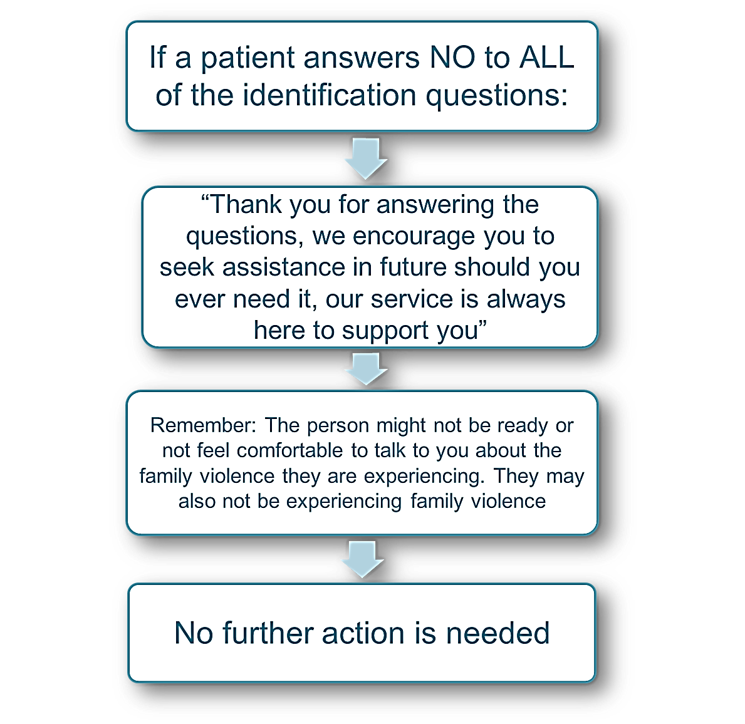

If a patient answers YES to ANY of the identification questions and DOES NOT consent to a referral you should ask the patient three immediate risk questions;
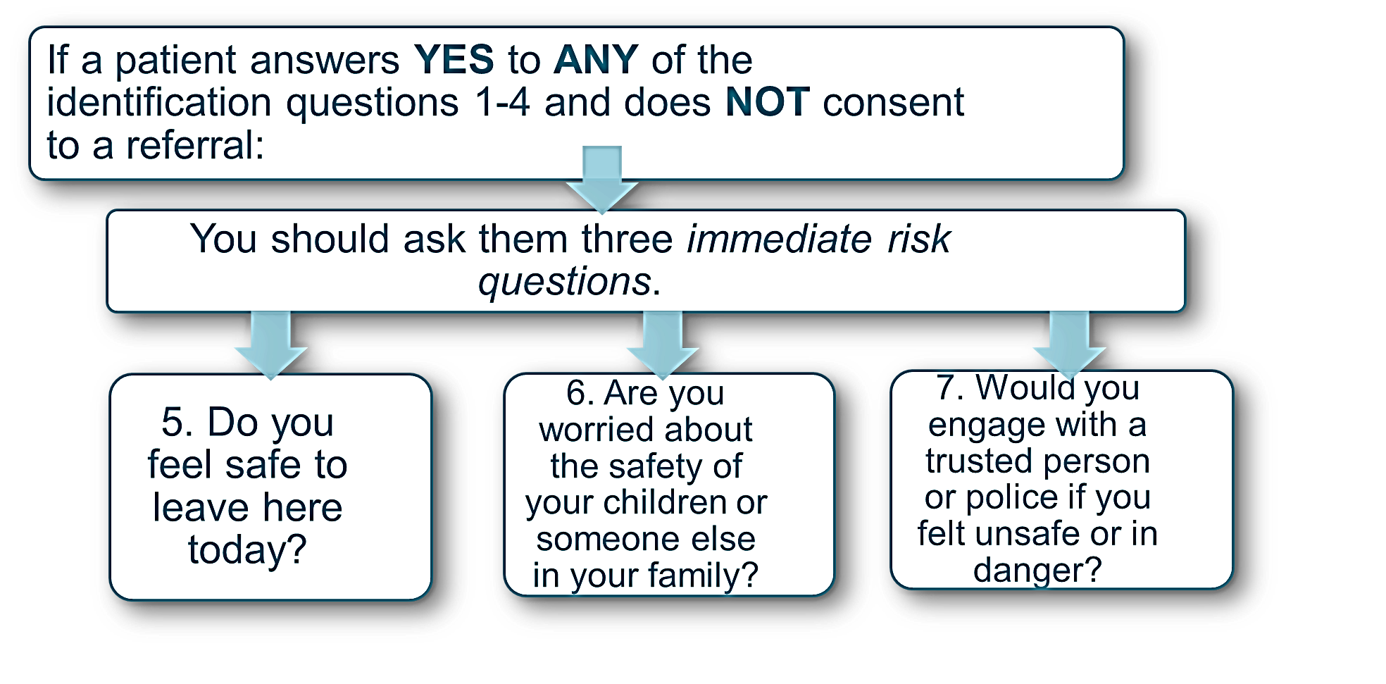If the patient answers YES to question 5 or NO to question 6 (in other words, the patient has let you know they are experiencing an immediate threat to their life and their health, safety or welfare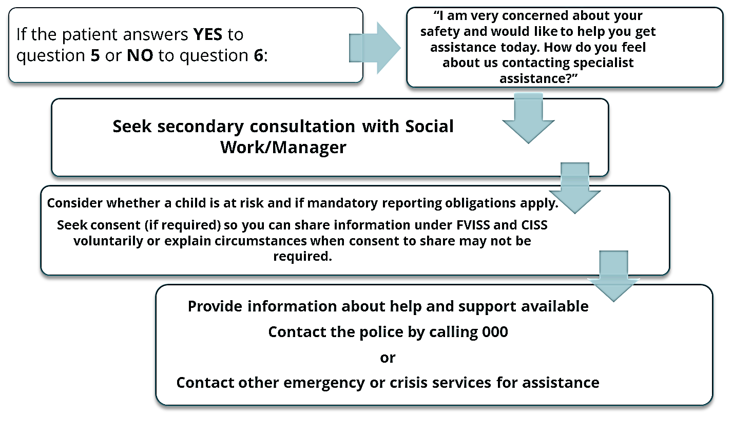
If the patient’s answers to question 5 and 6 indicate the patient is not in immediate danger, but is at serious risk you should: Seek secondary consultation with social work, your manager or a specialist family violence service as appropriate; Consider whether a child is at risk and mandatory reporting obligations apply; Provide information about help and support that is available.
If the patient DOES NOT want police assistance, consult with your manager or your social work department to determine if the police need to be contacted without the patient’s consent and whether your hospital needs to share information under FVISS and/or CISS.

If the patient has let you know they are experiencing an immediate or serious threat to their life, health, safety or welfare, there are some questions you can ask to help the patient make a plan:
- Explore if the patient has a safe place to go
- Do they have supports that they already access or could be available?
- Planning for people in their care (especially children or older person)
- Practical considerations (access to transport, money, phones)

The letters of the word LIVES can remind you of the five tasks that protect lives.
- Listen – Listen closely, with empathy and without judging
- Inquire about needs and concerns – Assess and respond to various needs and concerns
- Validate – Show that you understand and believe. Assure a woman she is not to blame.
- Enhance safety – Discuss a plan to protect herself form further harm if violence occurs gain.
- Support – Support her by helping her to connect to information, services and social support.

