Facilitator Guide

Family Violence Workplace Support Program Manager Training: 2.5 hours

Family Violence Workplace Support Program Training for Managers: 120 minutes

Introduction 4

Acknowledgements of contributions 4

About the guide 4

Background 4

Manager training alignment with MARAM 4

Recommended training participants 5

Key components and purpose of the training 6

Delivery mode 6

Training prerequisites 7

Tailoring the training to your hospital / health service 7

Who should deliver the training? 7

Pre reading for facilitators 8

Story-sharing 8

Use of gendered language 8

Managing participant resistance during training 9

Data and sources of information 9

Materials, participant training pack and room set up for face to face training 10

Materials, participant training pack for online training 10

Participant care during training 11

Facilitator care 12

Manager Training Part 1: Family Violence: Prevalent, serious and preventable - 35 minutes 13

FIRST SLIDE 13

INTRODUCTIONS 13

ACKNOWLEDGEMENTS 13

HOUSEKEEPING - face to face 14

LOOKING AFTER YOURSELF 15

PARTICIPANT INTRODUCTION 16

LEARNING OUTCOMES 16

DEFINING FAMILY VIOLENCE 17

STATISTICS AND THE GENDERED NATURE OF FAMILY VIOLENCE 18

THE GENDERED NATURE OF VIOLENCE 19

FAMILY VIOLENCE IS A HEALTH AND WELFARE ISSUE 19

SOME PEOPLE ARE MORE AT RISK OR FACE ADDITIONAL BARRIERS TO RECOVERY AND SUPPORT 20

VIOLENCE AGAINST ABORIGINAL WOMEN AND CHILDREN 21

FAMILY VIOLENCE IS COMPLEX 22

THE WORKPLACE AS A SETTING FOR PREVENTION 22

GENDER INEQUALITY SETS THE CONTEXT FOR VIOLENCE 24

THE DRIVERS OF VIOLENCE AGAINST ABORIGINAL WOMEN & CHILDREN 26

GENDER INEQUALITY IN THE WORKPLACE 28

ACTIONS TO PREVENT VIOLENCE AGAINST WOMEN 28

Manager Training Part 2: Family violence sensitive practice – 70 minutes 30

YOUR ROLE AS MANAGER 30

YOUR ROLE AS MANAGER Continued 30

DISCLOSURE AND HELP SEEKING IN THE WORKPLACE 31

SENSITIVE PRACTICE 32

TAILORING ENGAGEMENT TO BE CULTURALLY SAFE, ACCESSIBLE AND INCLUSIVE 32

COMMON MYTHS 34

NOTICE WORKPLACE INDICATORS / SIGNS OF FAMILY VIOLENCE 35

EVIDENCE BASED RISK FACTORS 36

ASK SENSITIVELY AND RESPOND RESPECTFULLY 36

POWER AND CONTROL 37

SENSITIVE PRACTICE IN A WORKPLACE SETTING 38

INQUIRING ABOUT FAMILY VIOLENCE WITH STAFF: OPENING THE DISCUSSION 39

IDENTIFYING WHETHER FAMILY VIOLENCE IS OCCURRING 40

RESPOND TO FAMILYVIOLENCE RISK 41

FV OCCURRING BUT NO IMMEDIATE THREAT 43

REFERRAL 44

COMMUNICATING WHEN STAFF ARE WORKING FROM HOME 44

KNOW THE LIMITS OF WHAT YOU CAN DO 44

PUTTING IT INTO PRACTICE 44

Manager Training Part 3: Workplace Support policy and procedures – 45 minutes 47

FV WORKPLACE POLICY & PROCEDURES – KEY FEATURES 47

UTILISE INTRANET INFORMATION 50

WORKPLACE SAFETY PLANNING 50

SAFETY PLANNING & SUPPORT 50

DOCUMENT 51

MANDATORY REPORTING 51

WORKPLACE RESPONSE TO PERPETRATORS 53

SELF CARE 55

KEY MESSAGES 55

CLOSING 55

Appendix A: Recommended Pre-Reading for presenters 56

Introduction

Acknowledgements of contributions
The Royal Women’s Hospital thank Grampians Community Health, Barwon Health and Ballarat Health Service for their input into components of this updated training.

About the guide
This Facilitator Guide has been developed to support those delivering Family Violence Workplace Support Program training for managers in the Victorian Public Health Sector. The guide should be read in conjunction with Family Violence Workplace Support Program Training for Managers PowerPoint slides.

Background
The aim of the Strengthening Hospital Responses to Family Violence (SHRFV) program is to support Victorian hospitals to implement a whole-of-hospital response to family violence (FV). Family violence is a workplace issue that impacts upon staff personally, often affecting attendance at work, performance, productivity and workplace safety. The approach recognises that as employers, we must prioritise the safety and wellbeing of our staff who personally experience family violence. Not only does this priority arise from our role as an employer, as a health service provider we must support our staff personally so that they can support patients experiencing family violence.
Research shows that the experiences of family violence of clinicians working in the Victorian public health sector are higher than those experienced by the general population. Prior to focusing on patients experiencing family violence it is strongly recommended that hospitals prioritise the development and implementation of a workplace program, including manager training, to support the personal experiences of their employees.
Further, since late 2016, renegotiated enterprise bargaining agreements within the Victorian public health sector have included a Family Violence Leave clause, covering most employees within the sector. A four-hour face to face training has been developed for the Workplace Support Program and can be located on the SHRFV website. The four-hour training has been designed to enhance managers’ understanding of the provisions of this clause and provide an opportunity to practice sensitive enquiry. This manager training also addresses the connection between workplace culture, practices and behaviours associated with the prevention of violence against women and how management practice contributes to this. As part of your hospital’s prevention work, you can expand on this during the training.

Manager training alignment with MARAM
Hospitals are prescribed entities under the information sharing laws and will be obliged, in certain circumstances to share information about patients in relation to family violence. Staff are not in scope for family violence information sharing, so this training does not talk specifically about the new information sharing legislation nor outline managers' responsibilities under MARAM. If there is a change in this situation, this managers’ training will be updated to reflect this change and you will be notified by the hospital through the usual channels.
This training and the updated Workplace Support policy and procedure are informed by the practice expectations under MARAM. MARAM is best practice for family violence risk assessment and management, based on current evidence and research relating to working with victim survivors. The resources reflect changes in practice outlined in the MARAM Victim Survivor Practice Guides; Responsibility 1: Respectful, sensitive and safe engagement, and Responsibility 2: Identification of family violence.

Given the prevalence of family violence, it is likely that many managers, whether clinicians or administrators, are likely to come into contact with people experiencing family violence and their practice should be guided by the MARAM Framework to identify how their staff can be better supported to disclose, be safe and recover from family violence. All Victorian workplaces are encouraged to understand the MARAM Framework, its application to their service users and incorporate relevant foundation knowledge and responsibilities into their work. It is recommended that participants are directed towards the MARAM tools to further their knowledge as all the information outlined in the MARAM guides is not able to be conveyed within training. It is recommended that managers take time to read the Foundation Practice Guide. The MARAM Framework and Practice Guides can be found at https://www.vic.gov.au/maram-practice-guides-and-resources.

Managers who do not have a role in assessing and managing family violence risk as part of their role are not expected to become ‘experts’ in family violence. Each hospital in Victoria is required to map MARAM responsibilities of all staff as part of MARAM alignment. It is each service’s responsibilities to ensure that managers receive the appropriate level of training.

Recommended training participants
It is recommended that those with leadership and/or management positions, however titled, in your hospital attend manager training. This includes those who may have day-to-day supervisory responsibilities such as supervisors, Associate Unit Managers and After-Hours Managers.
It is further recommended that participation in manager training is mandated through your hospital’s policy, including the frequency of refresher training. With the introduction of the Family Violence Leave clause, a hospital may see an increase in disclosures by those staff wishing to access leave. It is of utmost importance that managers know how to respond to those disclosures in a way that is safe and supportive for the staff member. Family violence can be highly complex and dangerous, particularly around the time of leaving a relationship. It is therefore important that a manager understands this and rigorously adheres to their boundaries. The manager’s role is to support the employee in a non-judgemental way and by offering information on the ways the workplace can support them. These boundaries are important so the manager does not give well intended, but inappropriate and dangerous advice to the employee about managing the family violence. Such advice is best given by a specialist family violence service.
Training non-compliance
As a note of caution in relation to training compliance for managers, health services should explore reasons for non-participation. Cautious and gentle inquiry into the reasons for non-participation may reveal that a manager has a past or current experience of family violence and may feel that training may be harmful for them. This is perfectly understandable and in consultation with the manager, alternatives may include:
- Provide training in a different way, such as 1:1 and modifying the material to focus more on operational issues such as how to take family violence leave and undertake safety planning
- Ascertain if the manager is seeking assistance in relation to family violence, in which case they may feel more prepared to undertake training in the future.
- Ensure that a second-in-charge or other senior team member undertakes the manager training
- Ensure that Family Violence Workplace Support staff training is actively promoted to the team
- Offer an optional in-service session to the team where the manager can absent themselves

Key components and purpose of the training
This training has been developed for managers within the Victorian public health sector to provide them with the knowledge and skills to recognise employees who are experiencing family violence and to respond appropriately.
This training in broken into three parts.
Part 1: Family Violence: Prevalent, serious and preventable delivers a shared understanding of family violence, including prevalence, risk factors, workplace indicators and gender inequality as a driver of violence against women. (30 minutes)
Part 2: Family violence sensitive practice is designed to support the manager’s transfer of family violence knowledge and skills into everyday practice. This includes sensitive inquiry in workplace settings and identifying and responding to workplace disclosures. (60 minutes)
Part 3: Workplace Support policy and procedures supports the operationalisation of the relevant policy and procedures (e.g. How to take family violence leave, safety planning, confidentiality, etc). (20 minutes)

Delivery mode
The training is designed to be delivered face to face as this facilitates the sharing of ideas and experience and the opportunity to build skills by participating in practical activities. A number of activities have been designed to be used with this training on an optional basis. It is not expected that you will use all of them in each session, but rather for you to consider what areas may be particularly important for you to focus on in the context of your organisation and to select the activities that enhance the learning in these areas.
To promote participation, it is recommended that number of participants in each session does not exceed 25.

Four-hour training v two-hour training.
This two-hour training is an abbreviated version of the four-hour face to face Workplace Support Managers’ Training. There are two options for delivering this training.
- A stand-alone two-hour session,
- Parts 2 and 3 can be delivered as a 90-minute session if participants have undertaken the SHRFV Foundational Practice Training (previously Module 1).
This shortened training does not allow time for in-depth discussion of family violence nor a facilitated practice of sensitive enquiry. The opportunity for managers to practice sensitive enquiry and to explore the complexities of family violence with a skilled facilitator is a key component of the Workplace Support training and essential for managers to be able to respond in a supporting manner to their staff. It is recommended that hospitals prioritise four-hour training and only offer this two-hour training as a refresher training for managers.

Training prerequisites
If only Parts 2 and 3 are delivered, a prerequisite to this training is the Strengthening Hospital Responses to Family Violence Foundational Training (previously Module 1) or the Foundational and Sensitive Practice training (previously Module 2).
It is recommended that participants watch a number of videos before attending. You might send it to them with the invitation or confirmation of enrolment.
- Our Watch Change the Story video; https://www.youtube.com/watch?v=fLUVWZvVZXw
- Futures without Violence, Supervisors can make a difference. Available at https://www.youtube.com/watch?v=HdNbnUAVFT4&feature=youtu.be
- WorkSafe BC, How to talk to an employee who might be experiencing domestic violence. Available at https://www.youtube.com/watch?v=KeJDtvs1NtQ
- Our Watch, 2020, Employee Support. Available from https://workplace.ourwatch.org.au/employee-support/
- 1800RESPECT, videos, Available from https://www.youtube.com/user/1800respect
- Family Safety Victoria, Family violence against LGBTI people: Insights from people with lived experience. Available from https://www.youtube.com/watch?v=3-627k0sOoI
- SBS, 2019, Domestic and Family violence. Available from https://malechampionsofchange.com/sbs-inclusion-program-domestic-and-family-violence/

Tailoring the training to your hospital / health service
Parts 1 and 2 require minimal tailoring. Health services may wish to brand the package and/or include regional statistics. Part 3 covers individual health service’s policies and procedures. It is expected that prior to delivery slides are updated with relevant service specific information.

Who should deliver the training?
It is recommended that a person with expertise and credibility in the area of family violence/prevention of violence against women should deliver Part 1: Family Violence: Prevalent, serious and preventable and can be drawn from within the health service or from an external provider. It is acknowledged that hospitals may not have the expertise or capacity to deliver training drawn from internal resources, and in such circumstance partnering with a credible external provider to deliver the training is suggested.
In a health service, professions that might typically have the depth of knowledge to enable them to deliver training on this issue include social workers, psychologists, sexual assault clinicians and trainers with relevant experience. It is important to note that not all clinical professionals undertake family violence training in their undergraduate degrees. Where this is the case, it is important that the trainer has undertaken additional education and continuing professional development in the area of family violence/violence against women in order to equip themselves with the required knowledge to deliver training.
Part 2: Family violence: Sensitive practice can usually be delivered by a Human Resources/People & Culture or Health, Safety and Wellbeing practitioner. It is the role of this person to train managers on what the implications of violence against women/family violence means for their role as a manager. While the person who delivers part 2 does not need to have specialist knowledge of violence against women/ family violence, a sound understanding of the issues is necessary. Reading the suggested reference material in Appendix A, as well as taking the opportunity to learn from the person who delivers Part 1 is a way to build such knowledge.
Part 3: Family violence: Workplace policy and procedures can usually be delivered by a Human Resources/People & Culture or Health, Safety and Wellbeing practitioner.
The presence of 2 facilitators increases safety in the training room. This is because one facilitator can observe the audience for signs of distress and can assist participants if needed outside of the training room without having to disrupt the session.

Pre reading for facilitators
A list of recommended research and websites is listed in Appendix A.

Story-sharing
Story-sharing can often be a useful technique for the facilitator to engage ‘hearts and minds’ by connecting the audience to the subject matter through sharing real life examples of those experiencing family violence within the workplace. Stories should be de-identified and the narrative broadened to ensure confidentiality. Providing too much detail may enable a participant to connect the story to the victim survivor. It is important to emphasise to participants at the outset of the session that if they wish to share a story that is about another’s experience of family violence, they are required to share it in a way that de-identifies those involved, including victim survivor, perpetrator and children (See group agreements).

Use of gendered language
Family violence is defined by the Family Violence Protection Act 2008 as broad, recognising that family violence can occur in any familial relationship, including same-sex relationships.
However, men and women typically have different experiences of violence with women experiencing significantly higher rates of family violence and suffer more severe consequences. Further, the most common form of family violence is intimate partner violence (IPV) committed by men against their current or former partner and that violence can often affect children.
While the Family Violence Workplace Support Program is titled as such to take into account that all people can experience family violence, it does recognise that family violence is a gendered issue and accordingly, this is reflected in the training.
It is for this reason that during the training, the language of ‘he’ as perpetrator and ‘she’ as victim survivor is predominantly used. Facilitators can select the choice of language that applies to those involved in family violence. For example, some prefer to use the word ‘survivor’ as it is suggestive of strength and recovery or some may prefer to use the word ‘victim’ as it suggests a blamelessness. Below are terms commonly used during training:
- Victim | - Perpetrator
- Survivor | - Person who uses violence
- Victim survivor
- Person experiencing family violence
It is suggested that when facilitators discuss the use of language in the training, that children are acknowledged. It is widely recognised that many women who experience family violence have children in their care and that exposure to family violence causes harm to the children. It should be acknowledged that reference to woman, victim survivor etc also includes children in their care.

Managing participant resistance during training
Resistance and backlash are often present when existing power structures are challenged. Where gender relations based on a hierarchical model where women are subordinate are threatened, aggression or violence may be used to protect the status quo (Our Watch 2015). It is best to anticipate resistance or backlash from participants during training and plan for it. To minimise the likelihood of participant resistance or backlash during the training, it is advisable to acknowledge early in the session:
- Men’s experience of violence
- That men and women experience violence differently
- That anyone can experience family violence
- Explain the reason for the use of gendered language, including the risks of collusion.
Our Watch (2017) Putting the prevention of violence against women into practice: How to Change the story has some tips on how to address resistance and backlash and engage men more generally.

Data and sources of information
Data is drawn from primarily from the Australian Institute of Health and Welfare (2018), Family, domestic and sexual violence in Australia report. For further a comprehensive list of resources please see recommended pre-reading in Appendix A.
Data is correct at the time of publication. To ensure currency of data, health services should re-check annually. Sources of information delivered in the training is noted where relevant so that the facilitator can read the original source if required.

Materials, participant training pack and room set up for face to face training
You will need:
A whiteboard and whiteboard markers or post-it notes
A/V equipment
A basic participant training pack includes the resources listed below.
- Session plan to have on tables
- Family Violence Workplace Support Manager Training: Pre-training survey
- Family Violence Workplace Support Manager Training: Post-training survey
- A copy of the training slides with space available for note taking
- Updated - Family Violence Workplace Support Family Violence Policy
- Updated - Family Violence Workplace Support Family Violence Procedure
- Family violence leave process flowchart
- The sensitive inquiry procedure outlined in Appendix B in the updated Workplace Support Procedure
- MARAM Response Options Following Identification of Family Violence Risk in the new Workplace Support Procedure
- New - Workplace Support Workplace Safety Planning Guidelines
- New - Workplace Support Information Handling Guidelines
- New - Family Violence - Workplace responses to staff who perpetrate family violence – Guidelines.
- Duluth Power and Control Wheel - https://www.theduluthmodel.org/wheels/
- Handout from Our Watch: https://www.ourwatch.org.au/getmedia/f5b5a777-15fb-49ed-934b-962d5c20a21c/Framework_4pp_A4_Online_AA.pdf.aspx
- Handout from ANROWS: https://20ian81kynqg38bl3l3eh8bf-wpengine.netdna-ssl.com/wp-content/uploads/2019/02/AIHW2018-Report-Fact-Sheet-PURPLE2.pdf
- Handout from ANROWS: https://20ian81kynqg38bl3l3eh8bf-wpengine.netdna-ssl.com/wp-content/uploads/2019/02/ANROWS-PSS2016-Fact-Sheet-HR.pdf

Materials, participant training pack for online training
You will need to book at a time using an online webinar or meeting platform such as Zoom, Webex or Skype. Book 15 minutes extra at either end to allow people to join early and to ask questions at the end. You will need to send the PDF of the training in advance as well as any other handouts.
You should set up the pre- and post-training surveys on an online survey tool.
A basic participant training pack includes the resources listed below.
- Family Violence Workplace Support Manager Training: Pre-training survey – sent in advance
- Family Violence Workplace Support Manager Training: Post-training survey – sent in advance
- A copy of the training slides with space available for note taking
- Updated - Family Violence Workplace Support Family Violence Policy
- Updated - Family Violence Workplace Support Family Violence Procedure
- Family violence leave process flowchart
- The sensitive inquiry procedure outlined in Appendix B in the updated Workplace Support Procedure. (please note that this is new and referred to in the training)
- MARAM Response Options Following Identification of Family Violence Risk in the new Workplace Support Procedure
- New - Workplace Support Workplace Safety Planning Guidelines
- New - Workplace Support Information Handling Guidelines
New - Family Violence - Workplace responses to staff who perpetrate family violence – Guidelines.
- Duluth Power and Control Wheel - https://www.theduluthmodel.org/wheels/
- Handout from Our Watch: https://www.ourwatch.org.au/getmedia/f5b5a777-15fb-49ed-934b-962d5c20a21c/Framework_4pp_A4_Online_AA.pdf.aspx
- Handout from ANROWS: https://20ian81kynqg38bl3l3eh8bf-wpengine.netdna-ssl.com/wp-content/uploads/2019/02/AIHW2018-Report-Fact-Sheet-PURPLE2.pdf
- Handout from ANROWS: https://20ian81kynqg38bl3l3eh8bf-wpengine.netdna-ssl.com/wp-content/uploads/2019/02/ANROWS-PSS2016-Fact-Sheet-HR.pdf

Participant care during training
It is important to keep in mind that the individual experiences of family violence for employees of health services will reflect those of the broader population of the community. It is therefore likely that you will have managers participating in training that have either a current or previous experience of family violence. It is recommended that facilitators note at the beginning of the session that the subject can be challenging for anyone, regardless of whether they have had an experience of family violence or not. Participants should be advised that if they need to take a break, they are welcome to leave the room without explanation and facilitators should sensitively and confidentially follow this up with the participant to ‘check in’ on their well-being.

Facilitator care
It is commonly acknowledged that working in the area of violence against women can have an effect on facilitator wellbeing. It is therefore important for facilitators to actively participate in self-care practices.
Professional self-care can include ensuring regular supervision, meeting and debriefing with others working in the same area, engaging with peer support networks, reflective practice journaling. There are many and diverse ways in which personal self-care can be achieved. Check out the Self Care Activity for suggestions.

Manager Training Part 1: Family Violence: Prevalent, serious and preventable - 35 minutes
Content | Slide and  resources
FIRST SLIDE  PRE-COMMENCEMENT - face to face  It is common for participants to arrive slightly before the commencement time, particularly if you have allowed for a pre session registration period. It is suggested that you use this time to ask people to complete the pre-training survey.  PRE-COMMENCEMENT - online  Join the online session (Zoom / WebEx / Skype etc) early and allow others to join early to sort out technical issues before you commence. Check with people if they understand the technology before you begin.  INTRODUCTIONS  Introduce self and other trainers as people arrive  - Please note that bulleted text in italics is verbatim text and can be read out verbatim | 1 minutes  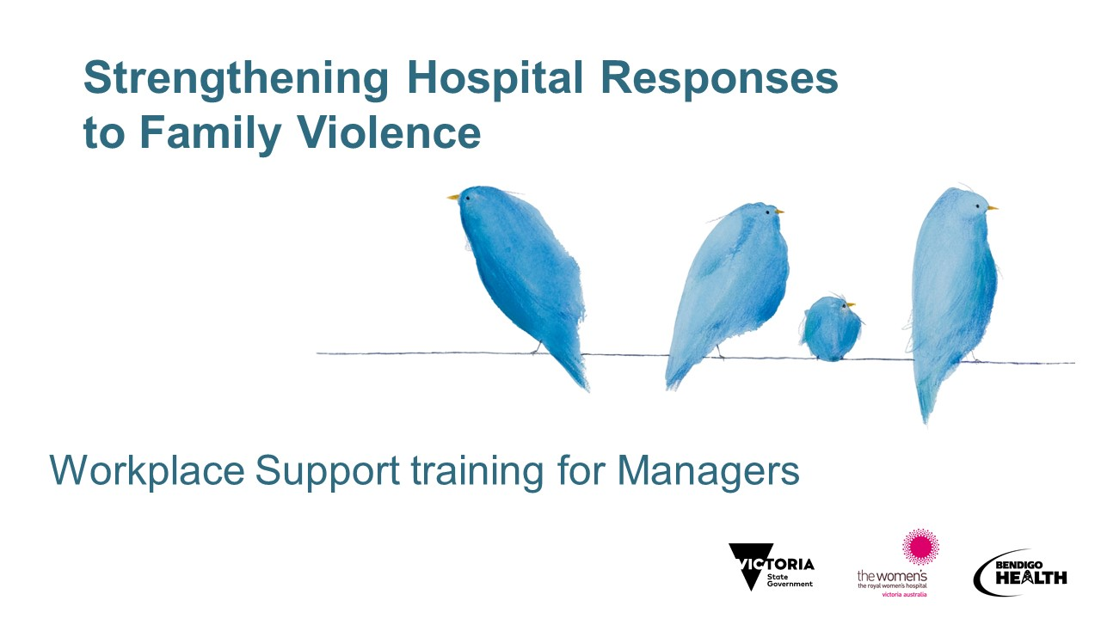  Pre-training survey
ACKNOWLEDGEMENTS  Acknowledgement of Country  Most health services will have a recommended Acknowledgement of Country to be used for meetings, presentations, etc. Where a health service does not have a recommended Acknowledgement of Country or where this is not immediately available to the trainer, the following can be used:  - [Insert name of health service] acknowledges and pays its respects to the people of the [name of traditional owners of the land – check with Local Land Council if unsure] the traditional owners of the country on which we are meeting today.  or  - We would like to acknowledge the traditional owners of the lands on which we are meeting today and pay our respect to Elders past, present and emerging.  For information about welcome to country protocols for your area, please see https://www.vic.gov.au/aboriginalvictoria/heritage/welcome-to-country-and-acknowledgement-of-traditional-owners.html  Acknowledgement of victim survivors of family violence:  - I would also like to acknowledge the many victim survivors of family violence and thank them for sharing their stories with us. Without their courage to share their stories, this work would not be possible  - To victim survivors that may be joining us today, we do hope what we discuss is empathetic and respectful to your experiences. . | 2 minutes
HOUSEKEEPING - face to face  - Length of the session - session plan to be on tables  - Location of bathroom facilities  - Emergency evacuation information  - Use of mobile phones – acknowledge that there may be an urgent issue that participants need to attend to in which case they are invited to step out of the room to address this. As per usual, mobile phones should be switched off or on silent  - Group agreements (see page 17 of SHRFV Training Manual)  - No-one knows everything – together we know a lot!  - Right to be inarticulate  - Be aware of time - we might need to keep moving  - Confidentiality in the training room for you and your staff  - Story-sharing – participants can share stories that are de-identified and should be mindful to not share too much detail so that other participants cannot connect the story to the victim survivor. Not a place to share personal stories. Not a therapeutic space  HOUSEKEEPING - if online  Group agreements (see page 17 of SHRFV Training Manual)  - No-one knows everything – together we know a lot!  - Right to be inarticulate  - Be aware of time - we might need to keep moving  - Confidentiality in the training room for you and your staff  - Ask to mute your mic (they will be muted at the start)  - Videos on or off depending on size and how session is run. Generally, have them off until times when participation is required  - This session is unfortunately not interactive in the same way that a face to face training would be – let know how will be interactive (perhaps break out rooms for practice if a small group)  - Explain the purpose of the ‘chat room’ if you will be using it. e.g.  - Explain chat room and how to ask questions  - [Name] will monitor the ‘chat’ room for technical issues during the session Please save questions about content and practice till the last few minutes and then type them into the chat. We will try to get through as many as possible. If time we will also come back together via video for questions.  - We have provided numbers on the slides for you to follow on the PDF if the video does not work for you, for example if you have phoned in.  - If you name is not coming up in the list of participants (you may be on a work laptop with just a number) please say hi with your name and hospital/health service in the chat so we can know you have attended.  NOTE: 1800RESPECT and other services information are on the next slide | 3 minutes  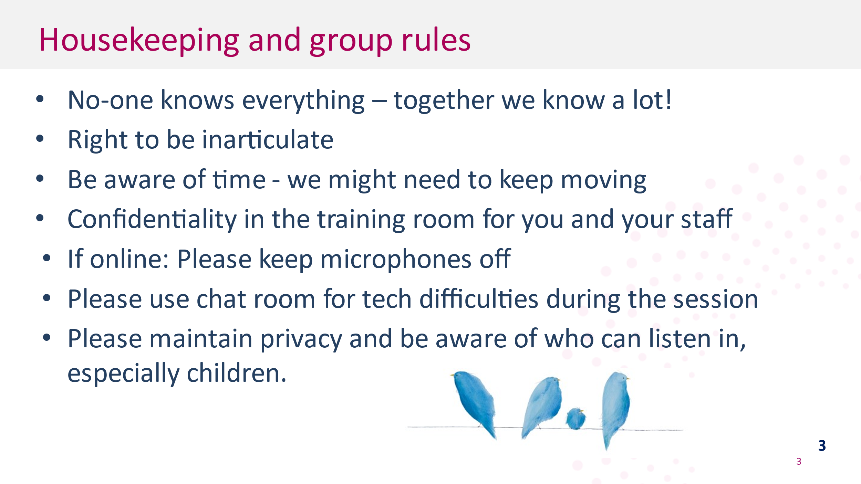
LOOKING AFTER YOURSELF  Note 1800 RESEPCT and other services  - Self-care during the training – acknowledge that the topic can be difficult and triggering for participants whether they have experienced family violence or not  - Today we will be discussing family and sexual violence. This topic can be distressing, particularly for people who have been impacted by violence.  - If the discussion today causes you any concern for yourself or a colleague or family member or friend, please contact one of these services for support. These are listed in your notes as well as local and workplace services you can access.  - 1800RESPECT and Safe Steps are 24-hour Sexual Assault Crisis Line (SACL) is an after-hours service.  - If you feel you need to discontinue at any time, you may do so, and we encourage to reach out to available supports.  - Advise participants that if they need to leave the session for personal reasons, they can take a break by leaving the room at any time without explanation  - It is suggested that a facilitator follow up with the participant after the training in such circumstances  - Note that there are a number of specialist family violence services available within Victoria which managers should be aware of – refer to the slide  IF ONLINE - additional text  - Please be mindful of who might also be able to hear and see this content as many of you will not be in a closed office.  - It is not appropriate subject matter for children to overhear or view so please be mindful if you have children at home.  - This training makes specific reference to family violence statistics related to Aboriginal women and children. We appreciate that these stats are well known to Aboriginal community members but not necessarily to non-Aboriginal members, hence being highlighted in the presentation. These stats will be discussed in slides 12 and 14 in case any Aboriginal or Torres Strait Islander colleagues joining us today wish to step out those points. We know that they can be distressing for many people. Again, we also know that many of you are joining us from at home we want to make sure we don’t cause any distress to any other family members. | 2 minutes  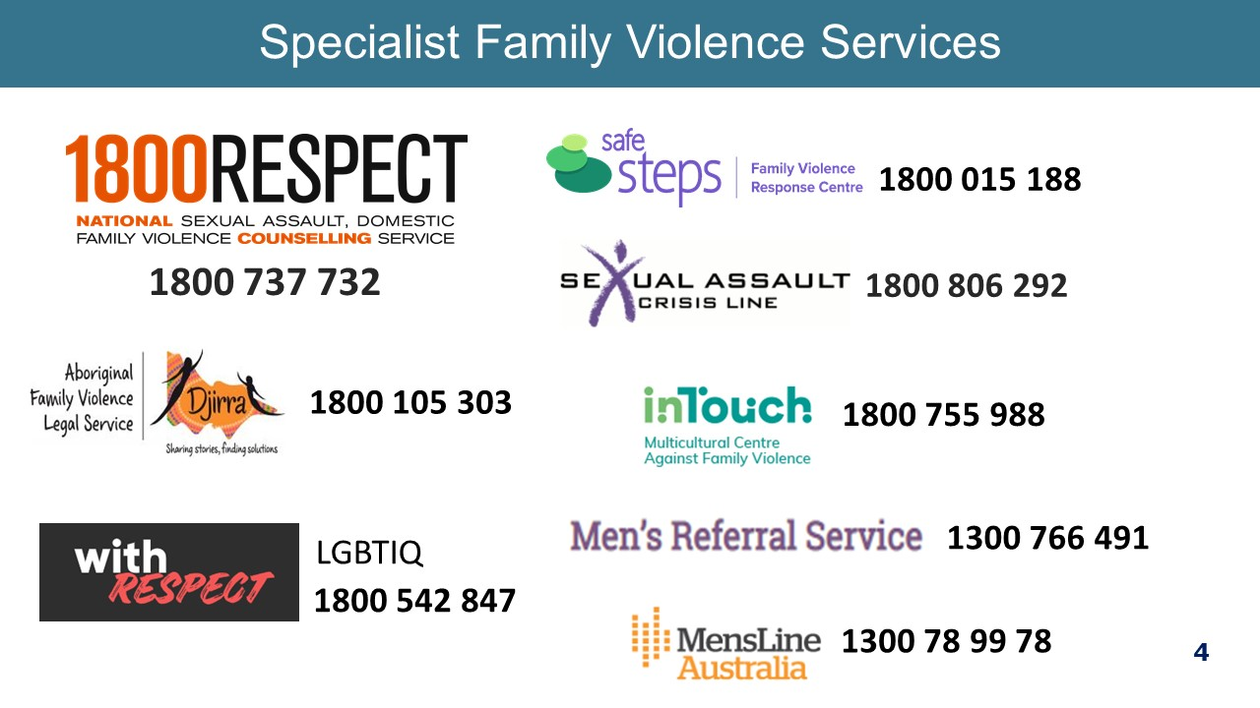
PARTICIPANT INTRODUCTION  - If face to face or small group online, ask participants to self-introduce – name & role only  - If large online group, just reiterate that everyone is welcome and there will be a chat at the end. | 2 minutes  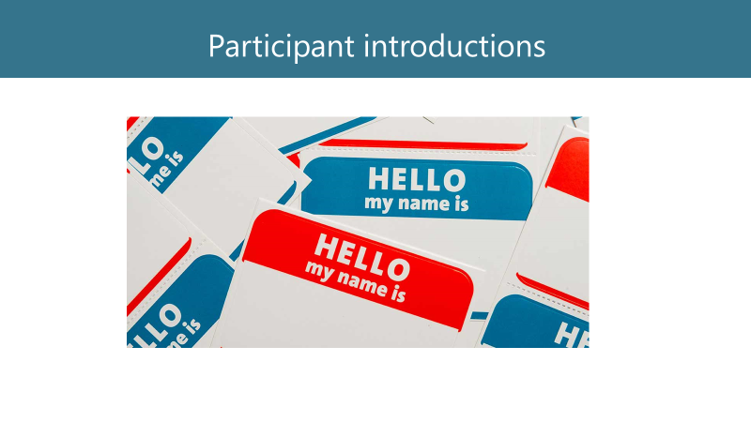
LEARNING OUTCOMES  Note the learning outcomes for this training  Note on MARAM alignment:  - This training is specifically about how you can safely support staff who are experiencing family violence. It is not about responding to patients. Much of the theory and practice is the same, but policies and procedures differ.  - Staff are currently not in scope for family violence information sharing, so this training does not talk specifically about the new information sharing legislation nor outline managers' responsibilities under MARAM. If there is a change in this situation, we will update managers’ training to reflect this and you will be notified by the hospital through the usual channels.  - What family violence is, including its impact in the workplace  - How gender inequality drives/causes family violence and the importance of a positive workplace culture  - How to recognise indicators of family violence  - The importance of prioritising safety and how to make a sensitive inquiry  - Your role in supporting staff who are victims of family violence  - What workplace supports are in place, such as leave and safety planning. | 2 minutes  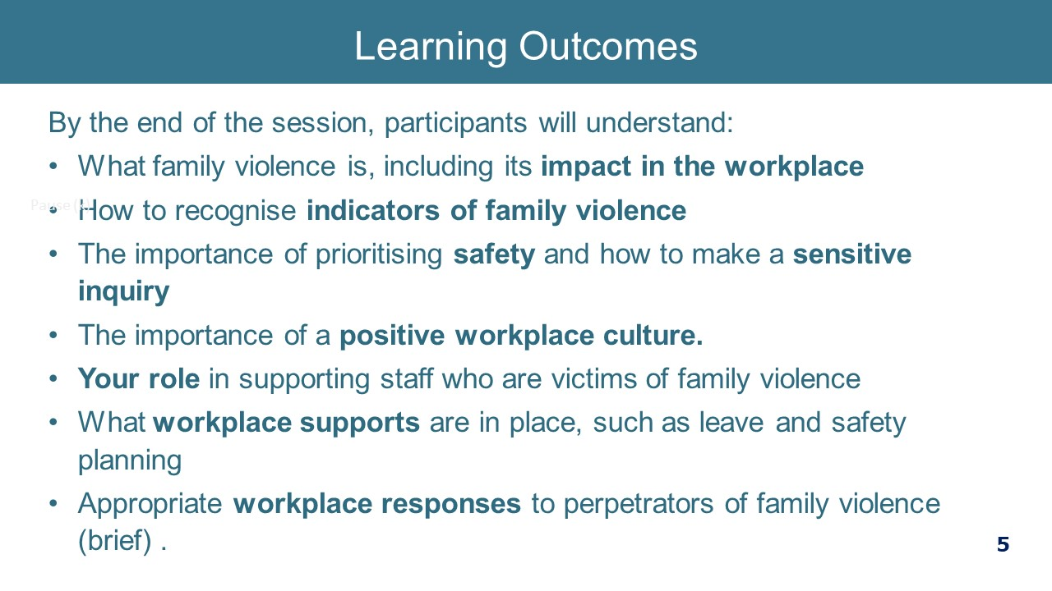
DEFINING FAMILY VIOLENCE  If face to face (or interactive online session) ask,  - What differentiates family violence from normal relationship conflict?  If a small group, then allow a couple of people to answer and discuss.  Answer: Family violence is distinguished by the use of coercive control causing victims to feel fear. Family violence also takes many forms, not just physical and not just an argument.  Give the participants a moment to read slide  - This is the definition used in Workplace Support which comes from the Family Violence Protection Act Vic.  - It can be any one of these behaviours. It is not just physical violence.  - The key words in the definition are ‘control’ and ‘fear’. This is what differentiates family violence from relationship conflict – it is the use of fear to ensure that one person retains power and control within the relationship.  - Not all types of violence are criminal offences, e.g. emotional abuse.  Definition of family  - The Act takes a very broad understanding of ‘family’ – it includes extended kinship structures in Aboriginal and Torres Strait Islander communities, and a carer of a person with a disability if that carer is in a ‘family-like’ relationships.  Children  - Children are to be recognised as victim survivors of family violence in their own right, whether they are directly targeted by a perpetrator, or being exposed to or witnessing violence or its impacts on other family members.  - Exposure to violence can also include:  • Hearing violence  • Being aware of violence or its impacts  • Being used or blamed as a trigger for family violence  • Seeing or experiencing the consequences of family violence, including impacts on availability of the primary caregiver and on the parent-child relationship  - More than half of the women who experience family violence have children in their care when the violence occurs.  - Sometimes we talk of intimate partner violence, which is part of family violence, but family violence is much broader than just your partner. Many of the statistics we have related to partner violence.  - NOTE: We will talk more about the signs and indicators later.  Key message: Family violence causes fear by exerting power and control. | 4 minutes  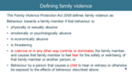
STATISTICS AND THE GENDERED NATURE OF FAMILY VIOLENCE  If face to face (or interactive online session), ask,  - Is family violence likely to be experienced in the same way by all people?  If small group, then allow a couple of people to answer and discuss.  Answer: No, there are gendered differences, and some women are more likely to be targeted for violence and face more barriers to accessing help.  This infographic illustrates the gendered nature of family violence – facilitator is to step through the various infographic data.  - Note the high rates of violence experienced by women and men by partners or ex partners but that women experience higher rates of violence, and also high rates of both physical and emotional violence.  Key message: Many people are affected by family violence and can be any one of our colleagues, so we should not make assumptions but have a non-judgemental curiosity.  Sources:  ANROWS Violence against women: Additional analysis of the Australian Bureau of Statistics’ Personal Safety Survey 2016  Note to facilitator: It is important that when citing statistics that the facilitator is familiar with terminology definitions. It is recommended that ANROWS Violence Against Women: Accurate use of key statistics is used to support this.  The following definitions are those used by the Australian Bureau of Statistics (ABS, 2017) will assist you to interpret the slide:  Intimate partner: “a current partner (living with), previous partner (has lived with), boyfriend/girlfriend/date and ex-boyfriend/ex-girlfriend (never lived with).”  Partner: a subset of ‘intimate partner’ that refers to “a person the respondent lives with, or lived with at some point, in a married or de facto relationship”. In this context, the term ‘partner’ may also be described as a ‘co-habiting partner’.  The key distinction is that the term ‘intimate partner’ includes dates and current and ex boyfriends and girlfriends with whom the respondent has not lived. | 1 minute  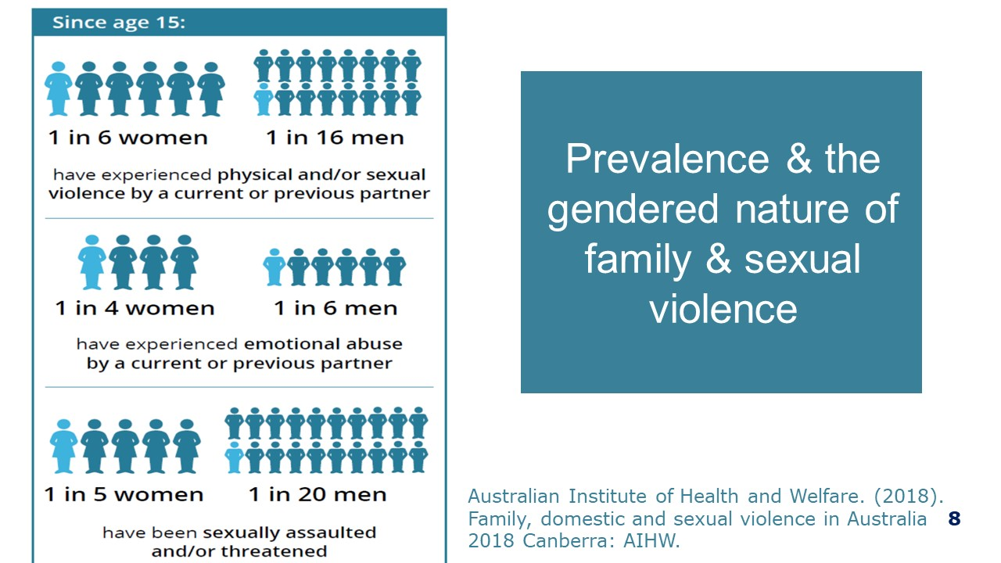
THE GENDERED NATURE OF VIOLENCE  Click through the information  - Family violence is a gendered issue. Overwhelmingly, the majority of acts of family violence and sexual assault are perpetrated by men against women and their children.  - Men and women have different experiences of violence, with men experiencing more physical violence than women  - While victims of family violence are predominantly women and children, males can also be victims, particularly as children.  - Women are much more likely to be living with this violence and fear over weeks, months, years, and lifetimes, so this is likely to have even more of an impact on their health and wellbeing.  Men’s experience of violence:  - “What about men’s experience of violence?” We acknowledge that all violence is wrong regardless of the sex of the victim or perpetrator, but there are distinct patterns in the perpetration and impact of violence that point to the fact that gender is a factor. For example, both men and women are more likely to experience violence at the hands of a man, with about 95% of all victims in Australia reporting the perpetrator as a male.  - However, the ABS survey shows that men are most at risk of violence outside of the home perpetrated by a stranger or neighbour, while women are most at risk of violence within their home from a man they know.  - Recognising the gendered patterns of violence doesn’t negate the experiences of male victims but it does point to the need for an approach that looks honestly at what the research tells us.  - Acknowledging the gendered nature of family violence is not to demonise men or to make them feel bad about themselves. Most violence is committed by men, but this does not mean that most men are violent. However, until we acknowledge the source of the issue, we will not be able to address the problem.  Key message: Victims of family violence are mostly women and children, perpetrators more likely to be men. | 2 minutes  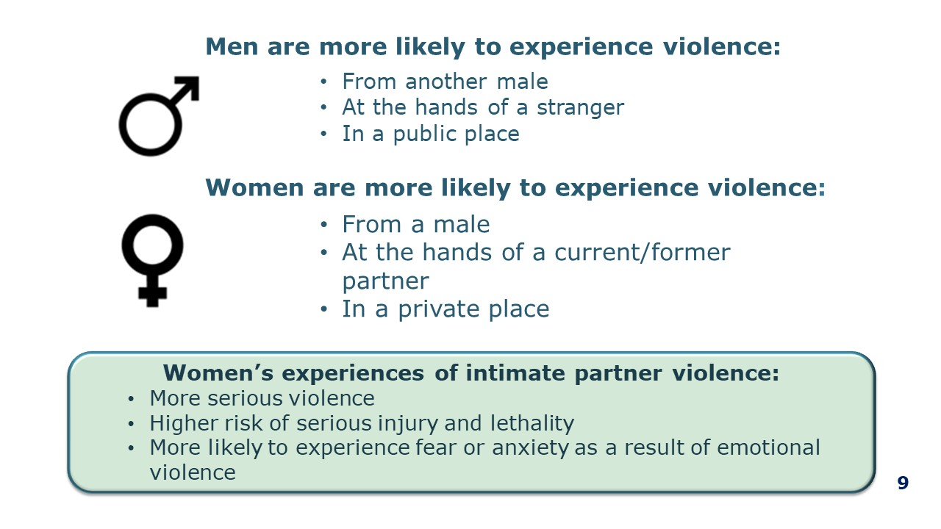
FAMILY VIOLENCE IS A HEALTH AND WELFARE ISSUE  - Family violence has severe and persistent impacts on a person’s physical, psychological and social wellbeing and is the leading cause of homelessness  - In 2016-2017, there were 1,328 people who presented to Victorian hospital emergency departments with a family violence related injury and of those, 40% had sustained a brain injury (Brain Injury Australia, 2018)  - Women who experience family violence rate their health as poorer and use health services more frequently than other women  - The psychological impacts of family violence - such as depression, anxiety, and post-traumatic stress disorder - are profound and endure long after the violence has stopped  - The social, behavioural, cognitive and emotional effects on children are significant and may have a lasting impact on their education and employment outcomes  Key message: Family violence is a health issue with severe and persistent impacts on a person’s physical, psychological and social wellbeing. | 1 minute  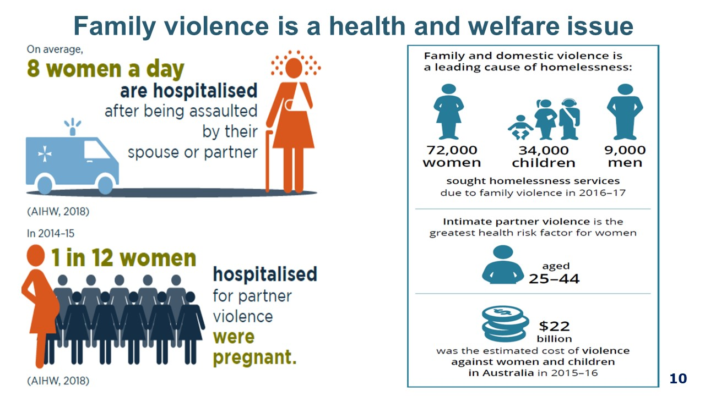
SOME PEOPLE ARE MORE AT RISK OR FACE ADDITIONAL BARRIERS TO RECOVERY AND SUPPORT  - In addition to family violence being gendered, there are certain groups of people in Australia who are more likely to experience family or sexual violence than other groups, or who face additional barriers in coping with and recovering from family, domestic and sexual violence.  - We can see from this list that the many of these groups are include people who experience discrimination high rates of discrimination and we know that people who experience multiple forms discrimination are more likely to experience violence and in different ways to other women.  - For example, women who have a disability are targeted for, and therefore experience much higher rates of family violence than women who don’t have a disability. It is not that these women and girls are inherently more vulnerable but the attitudes and structures that allow family violence to be perpetrated at such a high rate intersect with discriminatory attitudes that condone violence against people with disabilities. This results in women and girls with a disability being at least twice as likely to experience violence as those without disability.  - I have used disability as an example. People’s experiences are shaped by multiple identities, circumstances or situations including their age, gender identity, sexual orientation, ethnicity, cultural background, language, religion, visa status, class, socioeconomic status, ability (including physical, neurological, cognitive, sensory, intellectual or psychosocial impairment and/or disability) and geographic location.  - Discrimination and inequality based on these different aspects of a person’s identity can impact their access to services and support. For example, an Aboriginal woman may be the target of racist violence, gendered violence or experience violence that is both racist and gendered. Similarly, the structural and systemic barriers to her accessing support might be racist, sexist or both racist and sexist.  . Key messages:  - Some groups of people are more likely to experience family or sexual violence than other groups or face additional barriers in coping with and recovering from family, domestic and sexual violence.  - We need to be aware of our assumption and biases about who experiences family violence and what the violence looks like.  - We need to be aware that our attitudes, those of other and also structures and systems may be a barrier to some victims in disclosing and seeking help for family violence.  Note for facilitators: This is a difference in meaning for these terms. ‘At risk’ means they are more likely to experience violence, ‘vulnerable’ means more likely to experience (or have experienced) family or sexual violence, or face additional barriers in coping with and recovering from family, domestic and sexual violence. These are definitions used in the AIHW research reports.  Sources:  Australian Institute of Health and Welfare (2019). Family, domestic and sexual violence in Australia: continuing the national story 2019. Cat. no. FDV 3. Canberra: AIHW  Australian Institute of Health and Welfare. (2018). Family, domestic and sexual violence in Australia, 2018. Canberra: AIHW. | 2 minutes  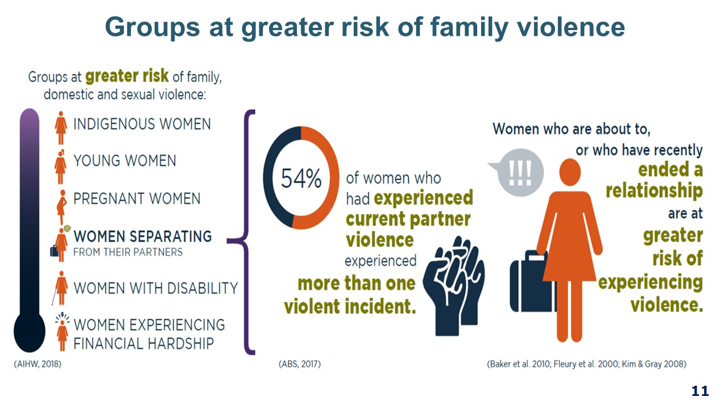
VIOLENCE AGAINST ABORIGINAL WOMEN AND CHILDREN  - Family violence is not part of Aboriginal culture. However, Aboriginal women are disproportionately impacted by family violence due to the structural inequalities and discrimination they experience underpinned by racist and sexist attitudes and the on-going impacts of colonisation.  - Violence towards Aboriginal people is often perpetrated by non-indigenous men. It is important that our hospitals are safe spaces for Aboriginal staff members to disclose and seek support.  - It is racist attitudes, practices and structures that mean that an Aboriginal woman who discloses family violence is often ignored and not offered assistance. Racism also translates into structures that make it difficult for Aboriginal victims to get help even though they are at greater risk. The ongoing cuts to Aboriginal family violence services is an example of that.  Key message: Racism drives the high rates of violence against Aboriginal women and children. | 1 minute  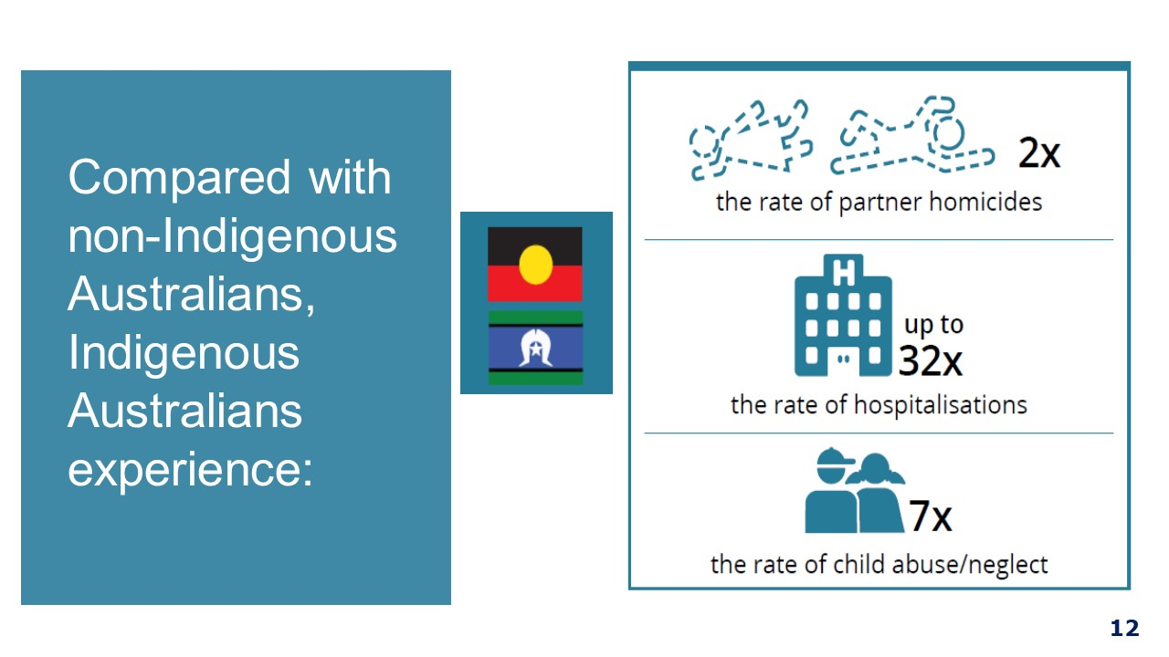
FAMILY VIOLENCE IS COMPLEX  Note: this side appears in three clicks. Work through them quickly to summarise what has come before  - Family violence is complex  - It occurs throughout the lifespan (pink)– it affects girls and boys, women and men  - There are many types of abuse (black) – all are a fundamental violation of human rights and unacceptable  - And many different perpetrators (blue) – not all are men  - Family violence occurs in all kinds of families, and in family relationships extending beyond intimate partners, parents, siblings, and blood relatives. It includes violence perpetrated by older relatives, by younger family members, or against a same-sex partner, or from a carer towards the person they are looking after  - Health professionals must always be mindful of this because you never know who has been affected and traumatised  Key messages:  - Family violence is complex, and it occurs right across the lifespan.  - Psychological trauma is commonly experienced by people affected by family violence – from both current and past experiences. | 2 minutes 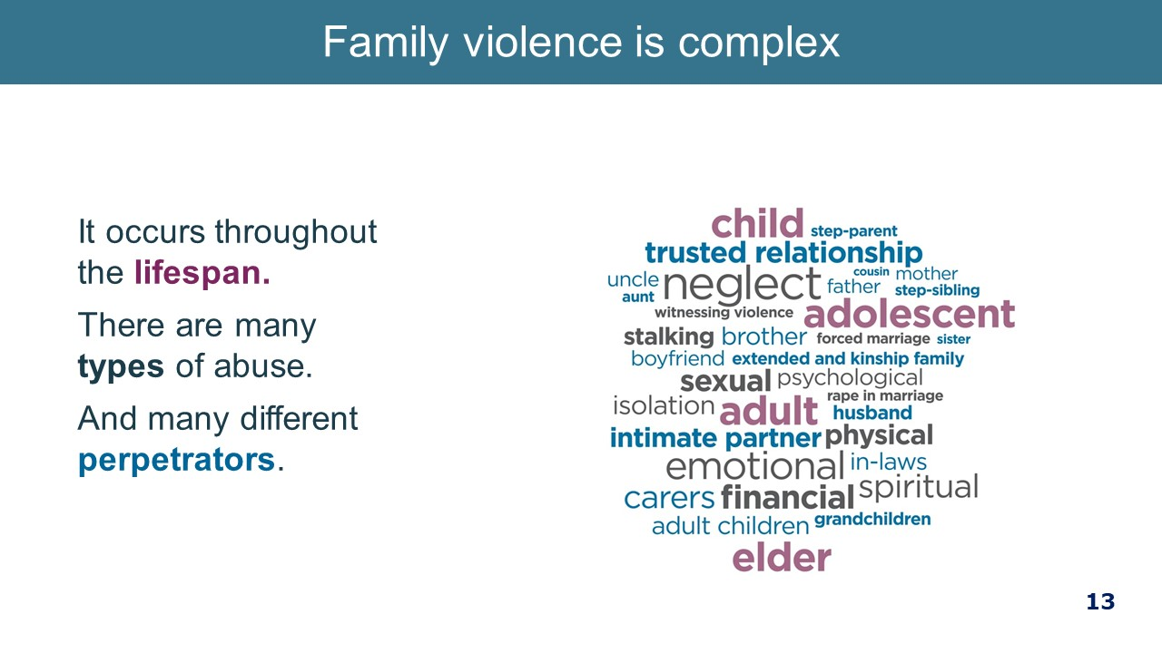
THE WORKPLACE AS A SETTING FOR PREVENTION  - We often get to this part of the training and are asked, “so, what can we do to prevent this violence and whose role is it?”  - There are many actions we can take to prevent family violence, both as individuals and workplaces. This work is already happening in our hospitals, with actions to build respectful workplace behaviours and to through the work to promote gender equality.  - Today we are focused on the work to support staff who may be experiencing family violence which is also a crucial part of this work. The Family Violence Workplace Support Program is our program for responding to staff experiencing family violence.  - Before we move into looking more closely at Workplace Support, we will take a moment to look at the workplace as a site of prevention of violence, and what this looks like.  - Workplace is an important site for prevention of violence against women, that is, challenging gender inequality. This work is now legislated through the Gender Equality Act 2020, which covers all Victorian public health services.  - Evidence suggests that stopping the violence before it begins will have the greatest impact on the prevalence of family violence.  - In the workplace, we have an opportunity to contribute to a culture that challenges gender inequality and rigid gender stereotypes and to create an environment where gender equity is valued by promoting equal and respectful relationships between women and men.  - As a manager, you are in a leadership role and it is the expectation that you will actively contribute to a culture that is respectful, promotes respectful relationships between women and men and enshrine gender equity measures.  - Lets take a look at a video that explains what this means.  Point for facilitator to be aware of:  Consider the relationship between the three circles. The intersection between these 3 circles is the prevention of family violence. As a manager, you have part to play in each of these circles that will contribute to responding to and preventing family violence.  Green circle – Family violence support  Today we are focusing on the Family Violence Workplace support circle, but we wish to note that the other two areas are important.  Red circle – Respectful Workplace Behaviours  The spectrum of physical and sexual violence against women is broad and encompasses a range of experiences and contexts, which can also include sexual harassment within the workplace.  Consider the similarities of an act of workplace sexual harassment and intimate partner violence:  - Both are about power and control with the overall impact being that a woman remains unequal to the man.  - Perpetrators use tactics to control and humiliate women into silence.  - Women who experience either IVP or sexual harassment often experience shame and embarrassment and are reluctant to disclose it.  - The woman can internalise blame or be blamed, e.g. did she provoke it or what did she do to avoid it?  - As a manager, your work in role modelling appropriate behaviour and addressing issues of sexist comments and sexual harassment contributes to prevention work.  Blue circle – Values and Strategy  - The [health service] values of [insert values] outline the expected conduct of staff.  - Respectful Workplace Behaviours Program is a reference to the health services policy, procedure, training, etc. on issues of sexual harassment, discrimination and workplace bullying. Facilitators can insert the appropriate terminology for this body of work as it applies at the individual health service.  Key messages:  - The workplace can contribute to the prevention of family violence through ensuring its culture is respectful and promoting gender equity measures.  Supporting our people affected by family violence is the right thing to do – and it aligns to our strategy. | 3 minutes  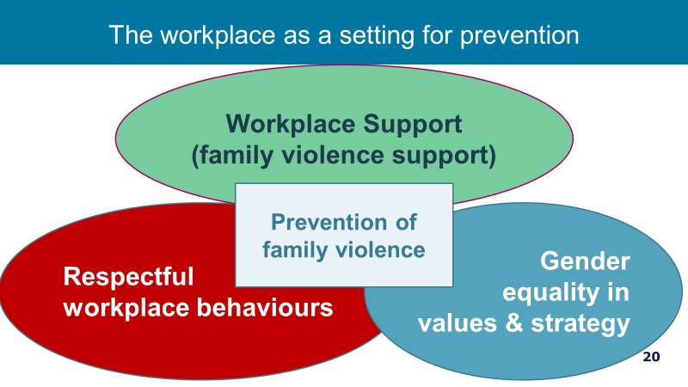
GENDER INEQUALITY SETS THE CONTEXT FOR VIOLENCE  To understand the high rates of family violence, especially against women and children, it is important to understand what causes or drives family violence.  There are currently two Australian frameworks can help us understand this.  Click for first image  The first is Change the Story which looks at the drivers of violence at a population level, and  Click to next image  And the second is Changing the Picture which explains the extremely high rates of violence against Aboriginal and Torres Strait Islander women and children. Both these frameworks also suggest actions we can take in the workplace and in health care setting to prevent such violence.  Click on next image to play video  We will now take a moment to look at the Change the story video  Show video (4.28)  The video talks about the four gendered drivers of violence, one being rigid gender stereotypes that dictate how society expects men and women and girls and boys to behave.  This stereotyping translates into what roles and jobs society deems is acceptable for men and women to hold and also what value it put son those roles, and so how much people are paid in different jobs  The outcome of this women on the whole, being paid less, having less superannuation and less choice and decision-making power both in family relationships and more broadly in society.  It has also translated into violence against women not being viewed as a serious health and welfare issue.  In sum, the less power and value you have in society the more you are likely to be targeted for violence. And whilst there have been gains particularly in the last few years, women are still not treated equally and with respect as is evident in the statistics.  Gender inequality is a driver and a result of violence against women.  For example, a woman who has to leave a family violence may have to move to another location, find new housing, schools and employment and is very likely to be significantly disadvantaged financially  As noted before, certain groups of women are more at risk of violence than others and the work we need to do needs to also address other forms of discrimination in addition to sexism.  Change the story does not seek to explain the high rates of violence against those groups who experience higher rates of violence. That work is ongoing.  Key message: As a society we need to promote respectful relationships and work to advance gender equality if we are to prevent men’s violence against women  https://www.youtube.com/watch?v=fLUVWZvVZXw (Our Watch “Change the Story”)  Alternate video: https://www.gwhealth.asn.au/ (Women’s Health Gippsland “Make the Link”)  Ask participants: What stood out for you about this short video? To what extent do you agree/disagree with the key messages of the video?  - Change the Story video shows that gender inequality sets the necessary context for family violence to occur as rather than being the direct cause.  - The video talks about the four gendered drivers of violence one being rigid gender stereotypes that dictate how society expects men and women and girls and boys to behave.  - This stereotyping translates into what roles and jobs society deems is acceptable for men and women to hold and also what value it put son those roles, and so how much people are paid in different jobs.  - The outcome of this women on the whole, being paid less, having less superannuation and less choice and decision-making power both in family relationships and more broadly in society.  - It has also translated into violence against women not being viewed as a serious health and welfare issue.  - In summary, the less power and value you have in society the more you are likely to be targeted for violence. And whilst there have been gains particularly in the last few years, women are still not treated equally and with respect as is borne out in the statistics.  - Gender inequality is a driver and a result of violence against women.  - For example, a woman who has to leave a family violence may have to move to another location, find new housing, schools and employment and is very likely to be significantly disadvantaged financially.  KEY MESSAGE: As a society we need to encourage the development of respectful relationships.  Note: this video might prompt disclosure | 5 minutes  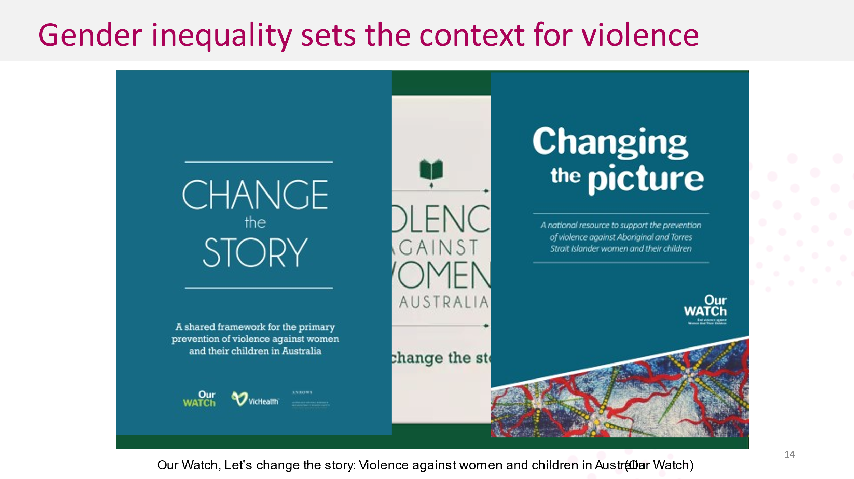  Hand out  Change the Story 4-page summary, if in person
THE DRIVERS OF VIOLENCE AGAINST ABORIGINAL WOMEN & CHILDREN  - Changing the picture describes the drivers of violence against Aboriginal and Torres Strait Islander women. It identifies the ongoing impacts and legacies of colonisation as a key driver of the disproportionate rates and impacts of violence against Aboriginal and Torres Strait Islander women and their children.  - Changing the Picture was released by Our Watch in 2018 and identifies what drives the disproportionate and severe violence against Aboriginal and Torres Strait Islander women and how this is connected to our history of colonisation.  - The way we understand the high rates of violence against Aboriginal and Torres Strait Islander women goes back to our colonial past, and the fact that the process of colonisation is violent, brought a particular gendered society to Australia (brought a way of thinking about how men and women should think and act) and that this process of colonisation is ongoing  - Changing the Picture also describes the actions we can take to end violence against Aboriginal and Torres Strait Islander women and the principles that underpin this work.  - We can prevent this violence by addressing these drivers, and good prevention actions are already occurring. Across Australia, we need greater investment, attention and focus on addressing these drivers  - Critical to challenge misconceptions about this violence  - Violence is not part of Aboriginal and Torres Strait Islander cultures  - There are serious and real barriers to reporting  - Alcohol is a contributing factor, and often a trigger for violence, but it is not the cause of this violence  Key messages:  - There are three intersecting drivers of violence against Aboriginal and Torres Strait Islander women – with colonisation, and its ongoing impacts, setting the underlying context  - The impacts of colonisation on Indigenous and non-Indigenous communities are deep and ongoing and intersect with the gendered drivers drive disproportionate and serve violence against Indigenous women  Trainer note: Describing the issue and challenging misconceptions  Important to emphasise these and dispel misconceptions.  - Violence is not part of Aboriginal and Torres Strait Islander cultures  - It is not part of traditional culture. When violence occurred prior to colonisation, it was regulated and controlled, and bore no resemblance to the kinds of violence and abuse seen today.  - Serious and real barriers to reporting:  - Experience of racism from services leading to a lack of trust in authorities, fear of family/community retribution, failures of and violence in the criminal justice system e.g. deaths in custody creating reluctance to report for some women  - Violence against Aboriginal and Torres Strait Islander women is perpetrated by Indigenous and non-Indigenous men  - Structural violence and discrimination (for example, failures of hospitals or police to protect women and children [in culturally-safe ways], or that cause harm [deaths in custody]. In this context, both men and women may be responsible for perpetrating systemic violence and discrimination.  - Alcohol is a contributing factor, and often a trigger for violence, but it is not the cause.  - Similarly, to the evidence in Change the story looking at the role of alcohol in fuelling violence against women across Australia, it alone does not explain violence against Aboriginal and Torres Strait Islander women.  - Where there is a correlation between alcohol and violence in some Aboriginal and Torres Strait Islander communities, this needs to be understood in the context of colonisation. Alcohol as a coping mechanism or self-medicating behaviour.  - Looking at alcohol as a supporting strategy could help to reduce severity or frequency of violence – however must address deeper drivers.  Source: Our Watch, 2017, Changing the Picture: A national resource to support the prevention of violence against Aboriginal and Torres Strait Islander women and their children, Melbourne, Our Watch, Available from https://d2bb010tdzqaq7.cloudfront.net/wp-content/uploads/sites/2/2019/11/05233003/Changing-the-picture-AA-3.pdf | 2 minutes  Hand out  Changing the picture 6-page summary.
GENDER INEQUALITY IN THE WORKPLACE  Show the slide and let participants read the four drivers.  Show the workplace examples and discuss that the drivers are not just something that happen out in the community but also in the workplace.  Note the four drivers are inter-related and create the social context (where women are valued less and less control over lives) and this is where violence can occur. It is not that these are a direct cause, e.g, stereotypes and what society values translates into what people are paid in different jobs which results in women having less superannuation and less resources and power.  - What the evidence tells us is that the four gendered drivers are at play across society including in the workplace as these examples show.  - There are changes happening across society, but slowly and we still have a long way to go. We may hear that women have achieved gender equality, but the reality is that there is still inequity in almost all areas of life.  According to research, men are more likely to perpetrate abuse if they hold negative attitudes towards women, including around traditional gender roles.  An example of structural inequalities could be: A woman goes into refuge, has to leave her own house, community, job, social supports, children may need to change schools. Perpetrator most often remains in the home. Note that gender inequality is the driver and consequence of violence against women.  Ask if they have any questions and provide with further resources.  Key message: Gender inequality is the driver and consequence of violence against women. | Note that the slide below is animated.  3 minutes  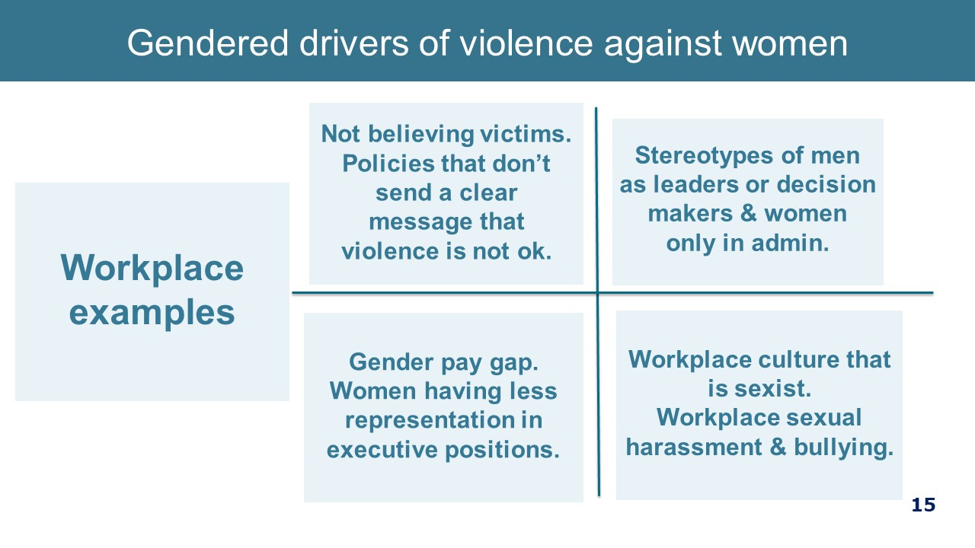  Hand out  Change the Story 4-page summary.
ACTIONS TO PREVENT VIOLENCE AGAINST WOMEN  - The good news is that there is hope and the is change afoot. We have multiple opportunities through our interactions with colleagues at work to prevent as well as respond to family violence.  - The work that your hospital / health service is doing as part of SHRFV challenges the condoning of violence against women through raising awareness of it, and structurally through supporting victim/survivors to access help, remain at work and maintain independence. The work to build respectful relationships at work also contributes to ending family violence.  Key message: We can prevent violence if we all work together. | 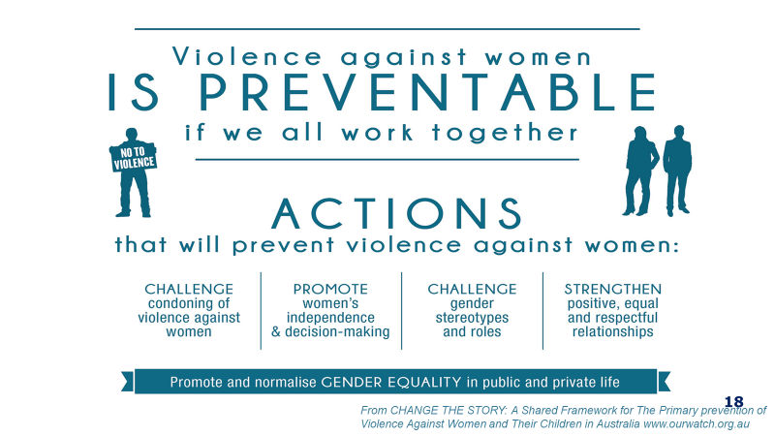
END OF PART 1  (30 minutes to here)  - Note there is lots of information on responding and preventing family violence on the web. | 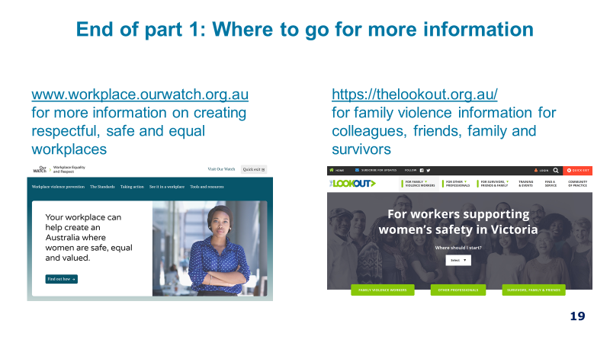

Manager Training Part 2: Family violence sensitive practice – 70 minutes
Content | Slide and  resources
YOUR ROLE AS MANAGER  - Everyone’s role is vital in an effective response to family violence.  - You have a specific role as a manager within a workplace context.  - This slide and the next covers what your role is. This is also outlined in the procedure and we will cover these points over the next 90 minutes. | 1 minute  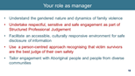
YOUR ROLE AS MANAGER Continued  - The Family Violence Multi-Agency Risk Assessment and Management Framework (MARAM) guides effective identification, assessment and management of family violence risk across the entire Victorian service system.  - Note that if a clinical manager their role may have additional responsibilities from September in relation to patients.  - As noted above today webinar covers role as it currently stands in relation to staff. And not patients. This may change if the new information sharing guidelines include staff.  - Today’s session will cover these briefly, but we recommend undertaking the four-hour session. | 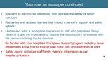
HOW DOES FV IMPACT THE WORKPLACE?  - Family violence can impact the victim survivor and others in the workplace in many ways. There are many negative impacts of family violence on victim survivors that you may see at work, including:  - Disrupted work, decreased productivity, absenteeism (high sick leave rates) resignation and a real fear of losing the job due to these productivity factors.  - Much of what we know comes from a study out of NSW, which reported the main impact was on work performance, with 16% of victims reporting being distracted, tired or unwell, 10% needing to take time off, and 7% being late for work (McFerran, 2011).  - As many victims report losing their job as a result of family violence and many victims will not disclose for fear of losing their jobs, our role is to be clear that rather than punish a victim survivor for coming forward, we will provide that staff member with the time and capacity to respond to their safety and wellbeing needs.  - Employment for the victim survivor is one of the most important protective factors, as it contributes to financial independence, and provides social support.  - The first study investigating family violence among female healthcare workers in Australia has found that almost half of them (45 per cent) have experienced family violence, including one in nine who had experienced abuse and violence by a partner during the previous 12 months.  - The study, involving 471 Victorian female healthcare workers, found that one in eight women had been sexually assaulted by a partner since the age of 16.  Key messages:  - Paid employment is an important protective factor for people affected by family violence.  - Work colleagues and managers are important sources of support.  Source: McFerran study – national online survey of domestic violence and the workplace, undertaken by Australian Domestic and Family Violence Clearinghouse (ADFVC) at the University of New South Wales.  McLindon, E., Humphreys, C. & Hegarty, K. “It happens to clinicians too”: an Australian prevalence study of intimate partner and family violence against health professionals. BMC Women's Health 18, 113 (2018). https://doi.org/10.1186/s12905-018-0588-y | 3 minutes 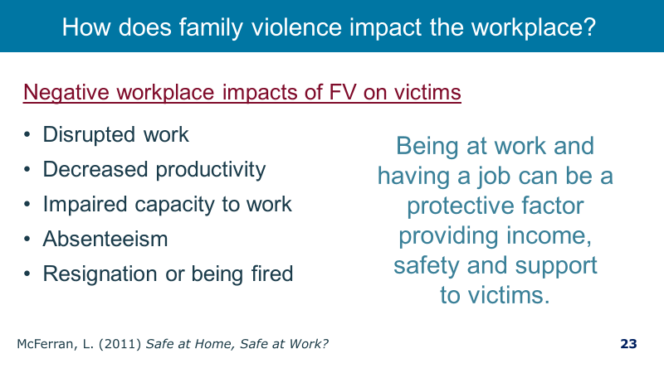
DISCLOSURE AND HELP SEEKING IN THE WORKPLACE  - So, what do we know about disclosure and help seeking in the workplace?  - 45% of respondents with recent experience of domestic violence discussed the violence with someone at work, primarily co-workers or friends rather than supervisors, HR staff or union representative.  - It is notable that 95% of women with violent stalking partners, were harassed in their workplaces. (Logan 2007)  - But rarely are workplaces named in Family Violence Intervention Orders.  - “It happens to clinicians too”: an Australian prevalence study of intimate partner and family violence against health professionals; This study suggests that intimate partner and family violence, including sexual assault, are frequent traumas in the lives of participating women health professionals. One in ten (11.5%) health professionals had felt fear of their partner, or experienced physical, emotional and/or sexual violence from them during the previous 12 months. The University of Melbourne 2018.  Key message: Work colleagues and managers are important sources of support.  Source: (McFerran, 2011)  Logan T, Shannon L, Cole J & Swanberg J 2007, Partner stalking and implications for women’s employment, Journal of Interpersonal Violence, vol. 22, issue 3, pp. 268-291 | 2 minutes  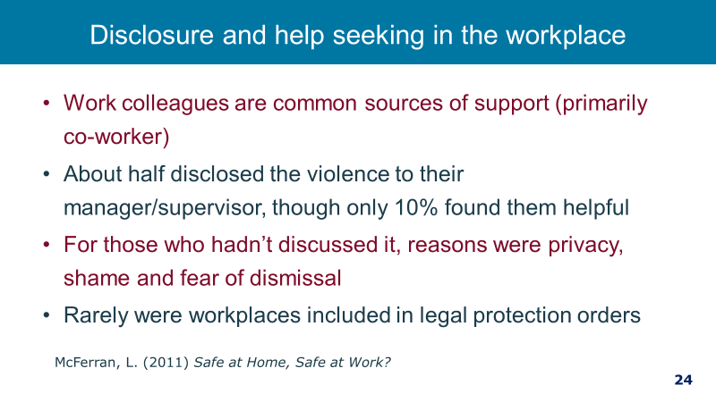
SENSITIVE PRACTICE  - So how do we support a staff member who is experiencing family violence? We use a technique called sensitive inquiry which relies on observation of signs and risk factors that may indicate family violence is occurring, and then confirming this by undertaking the identification questions.  - Sensitive practice involves understanding that victim survivors are often are the best judge of their own risk. But also, that they may not always be aware of the evidence-based risk factors.  Key message: The sensitive inquiry process relies on the elements of structured professional judgement to ascertain if family violence is occurring and the staff members’ level of risk. | 2 minutes  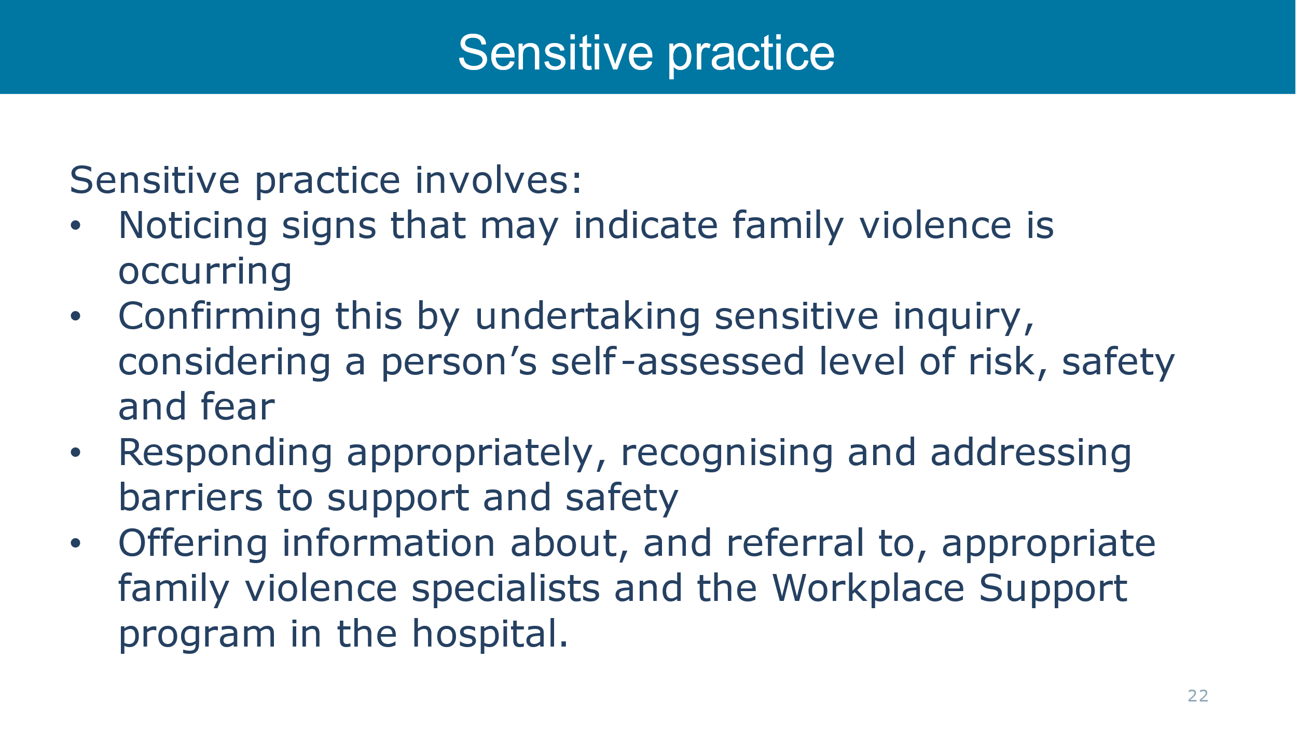
TAILORING ENGAGEMENT TO BE CULTURALLY SAFE, ACCESSIBLE AND INCLUSIVE  - How can we tailor engagement for staff to facilitate an accessible, inclusive and non-discriminatory service provision, including for Aboriginal people and people from diverse communities?  - All staff are responsible for facilitating an appropriate, accessible & culturally safe workplace environment which ensures staff feel & are safe to make a disclosure of family violence, will receive a response that is respectful and sensitive, meets their needs and ensures they can access the right support.  - Be mindful of your own biases and how they may influence your judgements and assumptions about a person’s experience of family violence or assessment of their risk.  - Be mindful to not reinforce stigma, stereotypes of discrimination by respecting their culture and identity  • We can do this by continuing to develop own knowledge about identities, barriers and experiences of family violence across the community  - Tailor your response to their identity and needs  • For example, consider if mainstream referral may be more appropriate rather than a culturally specific service. In smaller communities, the victim survivor may have concerns around privacy or perpetrator finding out.  - Hear and acknowledge how workplace and service systems place barriers on their access to support, and take steps to remove identified barriers  • upholding everyone’s right to receive a culturally safe and respectful service may involve advocating for changes to practices and structures internally and externally  - Recognise a victim survivor as the expert in their own experience and do not make decisions. Offer support not advice.  • This includes respecting an individual’s right to self-determination.  - Ensure any action taken are victim led; and that they have access to information and support from specialist services.  Key Messages: We need to put effort into ensuring we provide a culturally safe, accessible and inclusive response. This is partly looking at our practices and systems and also looking at our own attitudes.  Ensuring our response reaches and supports all victim / survivors: Additional notes for facilitators  - Victims of violence who experience multiple forms of discrimination also face additional barriers to accessing appropriate services and support. It is important that our policies, procedures and practices recognise the different experiences of staff and the impact of structural, and attitudinal discrimination on victim’s access to support and that we tailor our work so that our support reaches every person who needs it.  - Experiences of structural inequality, barriers or discrimination can also alter the way an individual or community experiences family violence, and in many instances contribute to increased risk and amplify barriers to disclosure and service access.  - Structural inequality, barriers and discrimination can be experienced by individuals and communities as oppression and domination resulting from the impacts of patriarchy, colonisation and dispossession, racism, ableism, ageism, homophobia and transphobia. This can also impact how we work with and respond to victim survivors of family violence.  - Your hospitals policies, practices and procedures can either address these inequalities, discrimination and the barriers through being not only inclusive but actively identifying and challenging them.  - Your role as managers is to understand where you might have beliefs that make it less likely for victims to ask for or receive support from you and others in your service.  - Your role is also to identify and address where those barriers to support might be structural, such as language barriers, financial barriers.  - Commitment to good practice suggests that you seek additional advice from services who work with diverse communities. You can do this before you speak with you staff member or afterwards if you are not able to plan the discussion in advance.  - When thinking about different aspects of a person’s identity that might affect their experiences of family violence, access to and appropriateness of services; it is important to consider the whole person. For example, while it is important to consider particular experiences and barriers for people with disabilities you also need to recognise this is only one aspect of their identity and other identities and experiences may affect their presentation and access to services including sexual orientation, gender identity and cultural background.  MARAM practice guide notes that ‘Diverse communities’ and ‘at-risk age groups’ is broadly defined to include diverse cultural, linguistic and faith communities; people with a disability; people experiencing mental health issues; lesbian, gay, bisexual, transgender and gender diverse, intersex and queer/questioning (LGBTIQ) people; women in or exiting prison or forensic institutions; people who work in the sex industry; people living in regional, remote and rural communities; male victim survivors; older people (aged 65 years, or 45 years for Aboriginal people; children (0–4 years of age are most at risk) and young people (12–25 years of age). | 3 minutes  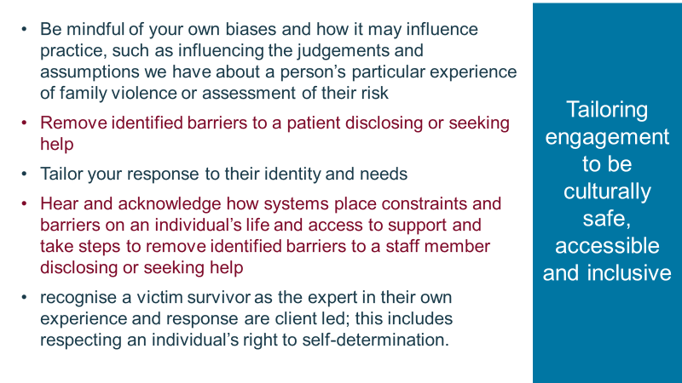
COMMON MYTHS  Note that the slide is animated.  - Ask the group to have a look at the statements.  - Note that they are things we may have heard at work, on TV or even at our own kitchen table.  - Ask if there are any others that come to mind (keep this brief).  Click to next part  Note that these mainly focus on what the person experiencing family violence does not do rather than questioning perpetrator behaviour – they excuse, justify, minimise or blame the victim.  - We all have our own unconscious biases, beliefs and values about violence and women have come from our family, culture and a lifetime of experiences. This will influence how we understand family violence and respond to disclosures from both victims and perpetrators.  - As managers we need to be aware of what our reaction to someone story is. Have we immediately put blame back on the victim, disbelieved her because of how she looks or speaks? Then we need to ask whether our beliefs are stopping us responding in a safe, non-judgemental and supportive manner.  Provide hand-out of myths. Explain that we don’t have time to unpack them all, but there is plenty of resources for you to explore your own beliefs and also to find out the facts.  Key message: Myths excuse, justify and minimise family violence. Respectful workplace culture is essential to support non-violent norms and practices. | 3 minutes  Note that the slide is animated.  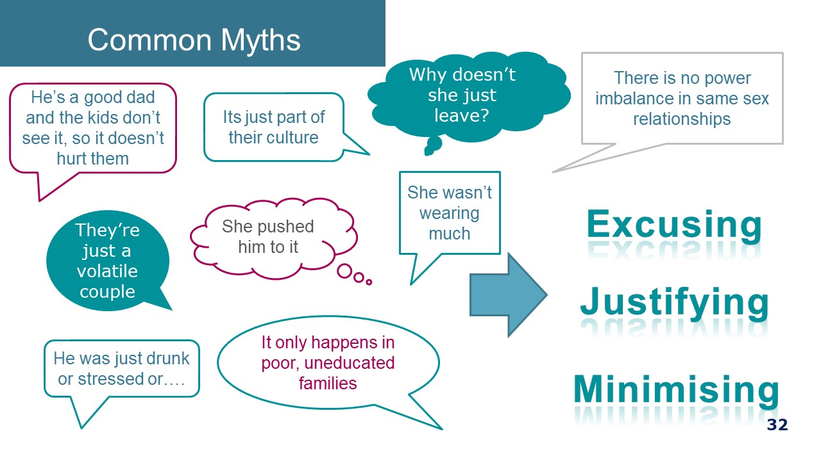
NOTICE WORKPLACE INDICATORS / SIGNS OF FAMILY VIOLENCE  - It is important to be aware of possible indicators of family violence in the workplace so that if they are present you can decide if it is appropriate to talk with your staff member about family violence.  - It is important to note that the presence if these indicators does not necessarily suggest the presence of family violence, but it may prompt you to inquire.  - It is not your role as a manager to screen for family violence, by asking team members routinely. However, if these indicators are present it may mean that family violence is present which in turn may lead to sensitive enquiry.  Key message: Be aware of signs or behaviours that could point to family violence.  Source: https://www.vic.gov.au/maram-practice-guides-and-resources | 3 minutes 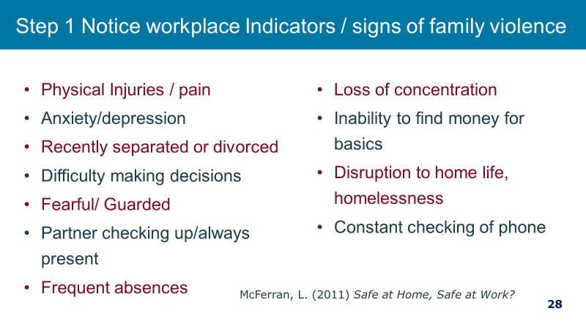
EVIDENCE BASED RISK FACTORS  Ask participants to take a moment to look through the risk factors  - Two key factors where women are at high risk and which you may be aware of as a manager are firstly when a women is planning to leave or has just left a relationship and secondly pregnancy or child dangerous time is pregnancy and following a new birth. You may be aware of these as a manager or colleague  - It is not your role to ask about these risk factors. That is the role of family violence specialist but it is your role to be aware if you hear about something that you.  Key message: Be aware of signs or behaviours that could point to family violence.  Source: https://www.vic.gov.au/maram-practice-guides-and-resources | 1 minute  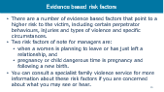
ASK SENSITIVELY AND RESPOND RESPECTFULLY  - So how do we support a staff member who is experiencing family violence? We use a technique called sensitive inquiry which relies on observation of signs and risk factors that may indicate family violence is occurring, and then confirming this by undertaking the identification questions.  - Sensitive practice involves understanding that victim survivors are often are the best judge of their own risk. But also that they may not always be aware of the risk factors.  - It is your role as managers to understand family violence, be aware of the risk factors and indicators above and then to make a sensitive inquiry if there are indicators.  - It is not intended that you take on the role of a Family Violence specialist. Instead we are providing a pathway to support – which is directed by the victim.  - The goal of inquiry is not disclosure, although a disclosure may come about as a result of sensitive enquiry. The goal of sensitive inquiry is to provide support and validation. You may need to say this several times during training to make sure this message is understood  - How managers respond is crucial to eliciting feelings of safety, respect and control for the staff member and it can make a big difference.  - LIVES is a World Health Organisation model – it is a way of reminding us how best to respond. LIVES is a first-line support that involves five simple tasks. It responds to both emotional and practical needs at the same time.  - LISTEN: being listened to can be an empowering experience for a person who has been abused. Listen with eyes, ears and heart - with empathy and without judging. ‘That must have been very frightening / difficult for you.’  - INQUIRE ABOUT NEEDS AND CONCERNS: assess and respond to her various needs and concerns—emotional, physical, social and practical (e.g. childcare)  - VALIDATE: show her that you understand and believe her. Assure her that she is not to blame. ‘Violence is unacceptable, and you do not deserve to be treated this way.’  - ENHANCE SAFETY: ask what the person’s immediate concerns are. ‘Are you concerned about your safety or the safety of your children or pets?’ Assist them to seek help from a more specialised service.  - SUPPORT: provide support by helping to connect to information, services and social support. ‘Would you like some support to help you deal with the situation?’  KEY MESSAGE: We should approach our staff in the same way as we approach our patients – sensitively.  The sensitive inquiry process relies on the elements of structured professional judgement to ascertain if family violence is occurring and the staff members’ level of risk | 6 minutes  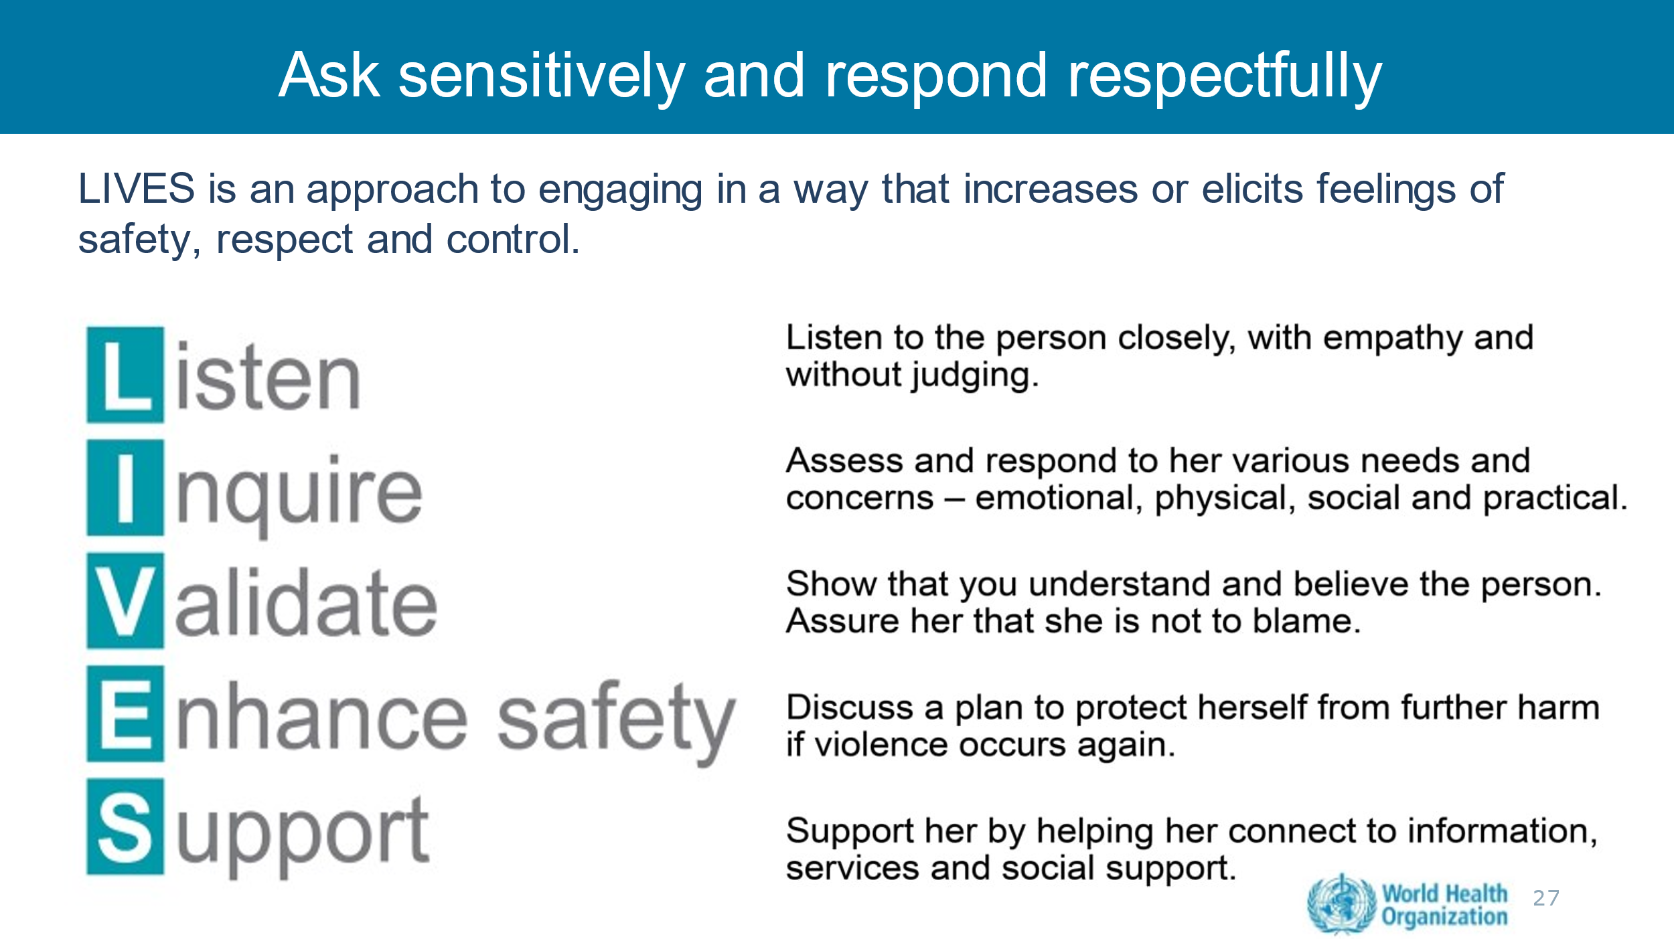
POWER AND CONTROL  - We have talked about what a sensitive inquiry is, and we will in a moment go through how this looks in practice. Before we do, we do want to make a note about power and control in the manager-staff relationship.  - Managers are in a position of power in relation to the staff that they manage. This is part of the authority a manager has in the exercise of their duties.  - However, in a discussion with a staff member about family violence we must be mindful of the positional power that exists and conduct ourselves in a way where that power is not used to control and dominate. This is important so as to not replicate the experience of the loss of power and control for the staff member.  Key message: Be mindful of your position of power in relation to your staff member and do not use that power to control or dominate. | 2 minutes  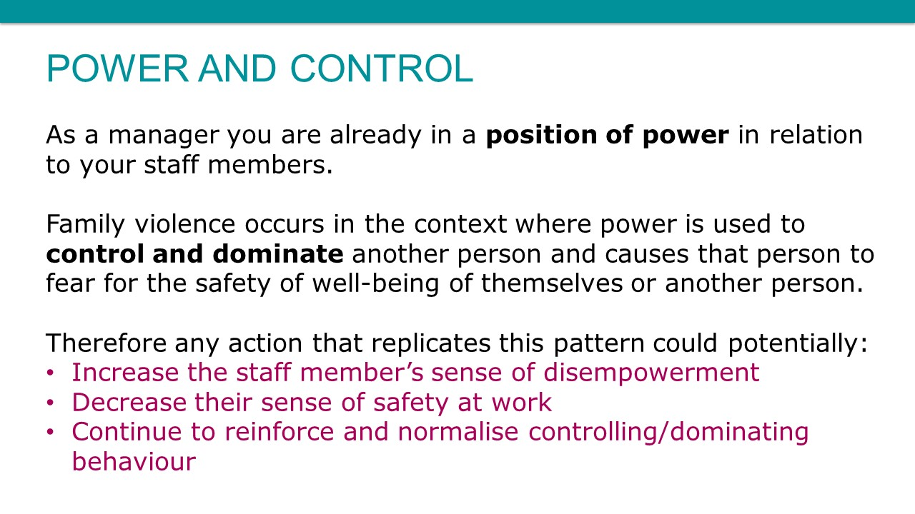
SENSITIVE PRACTICE IN A WORKPLACE SETTING  www.youtube.com/watch?v=KeJDtvs1NtQ  If you are on time watch this video  Note: It shows a clear example of safe and supportive practice. | 2 minutes 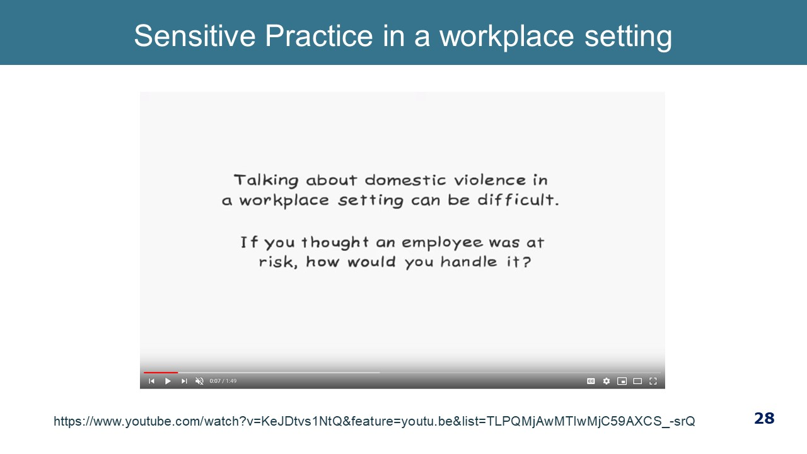  1min49secs
HELPFUL AND UNHELPFUL RESONSES  We will give you a minute to look at these helpful and unhelpful responses and think about what makes them helpful or not helpful.  A supportive response ensures that we:  - Acknowledge and endorse their decision to disclose  - Don’t minimise or excuse abusive behaviour  - De-stigmatize their situation  - Empower using rights-based statements  - support is unconditional.  Discuss - what is good about the helpful responses?  - they validate  - offer support to enhance safety  - rights based statements  - assigns accountability to the perpetrator  - places control with the person  Discuss - what is the problem with the “not helpful statements”?  - blames the person experiencing violence  - fails to understand the complexity of the issues  - judges as a poor parent  - diminishes perpetrator responsibility (anger management problem as opposed to choosing to use violence)  - offers support as conditional to the person leaving the relationship  Key message: A supportive and non-judgemental response in any disclosure is crucial. | 3 minutes  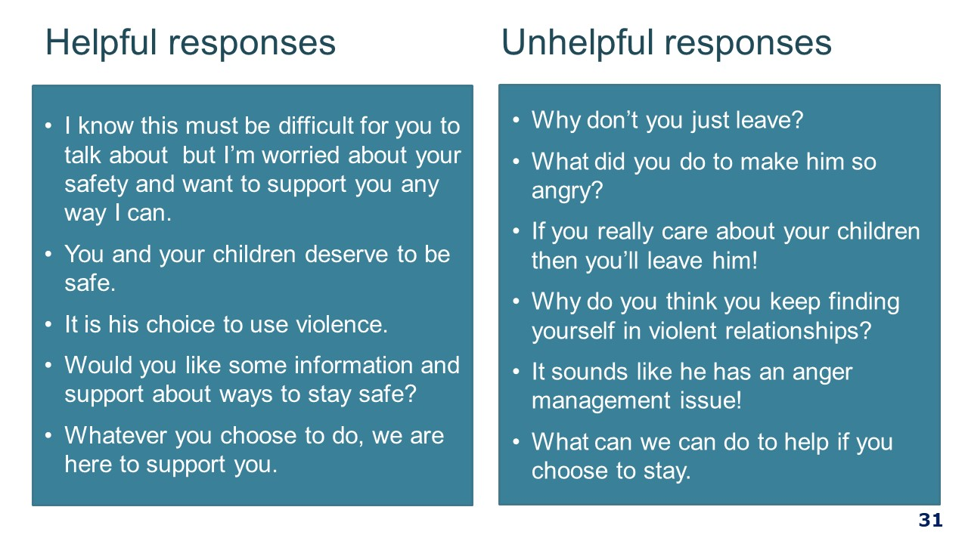
INQUIRING ABOUT FAMILY VIOLENCE WITH STAFF: OPENING THE DISCUSSION  - If family violence is disclosed or if indicators of family violence are observed, your role is to sensitively and respectfully open up a conversation.  - This procedure on how to have this conversation is outline in an Appendix in the Workplace Support Procedure.  - You are encouraged to ask an employee if they are experiencing family violence, but you are not required to do this.  - A relationship of trust with your employee and a supportive environment are important foundations to making sensitive inquiry as comfortable and safe as possible.  - Be truthful about limits of confidentiality and your duty of care.  - It is always good to start with a framing statement, such as:  I noticed that you seem to be quite withdrawn from the team and a bit distracted – is everything okay at home?  - The purpose of a framing statement is to position the inquiry about family violence as a routine part of hospital activities – to normalise it. Use open questions of enquiry – this gives the employee control over how much they choose to respond. They may want to give a little or a lot of information; this is the employee’s choice.  - This will make the person feel less ‘singled out’, reducing the stigma associated with being identified as a victim of family violence and/or sexual assault.  - You need to frame a statement that works for you so that it is authentic – not too scripted.  - Clinicians already ask a lot of uncomfortable questions in clinical practice, this too may take getting used to.  - Choose the setting carefully – a private space, a time when the workplace is not so hectic, at what point during the shift is it best to ask, what are the clinical demands of the person, do you have a plan in place if a disclosure is made and the person is too distressed to resume their duties.  - Non-verbal information (for example internet, poster or written material) can have a valuable educational impact – make reference to workplace support materials - if someone sees these it can alert them to the fact that they can talk with you or someone at the hospital another time – give them food for thought.  Key message: It is important to normalise inquiries about family violence – in the context of our workplace support program. | 3 minutes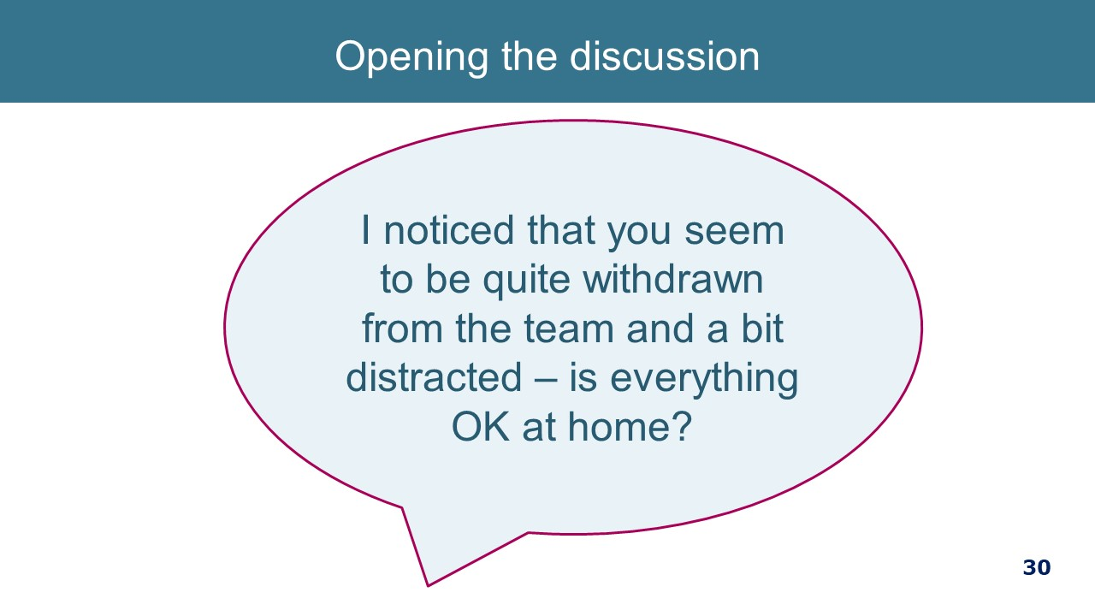  The sensitive inquiry procedure is outlined in Appendix B in the updated Workplace Support Procedure.
IDENTIFYING WHETHER FAMILY VIOLENCE IS OCCURRING  - So, you have asked the opening question. Such as “I noticed you aren’t quite yourself…”  - If someone isn’t ready to respond to your questions about family violence, you need to respect this and let them know that if they are ready in future to talk about anything that concerns them, you are open to doing this.  - If a staff member strongly suspects and/or has serious concerns for the staff member’s safety or the safety of their children, it is suggested that staff consult a senior staff member about these concerns.  - If they indicate that things are not ok at home, sensitively inquire about family violence using questions about their safety.  “Has anyone in your family done something to make you or your children feel unsafe or afraid?”  “Have they controlled your day-to-day activities (e.g. who you see, where you go) or put you down?”  “Have they threatened to hurt you in any way?”  “Have they hit, slapped, kicked or otherwise physically hurt you?”  - If responses to your questions indicate that no family violence is occurring, you must respect this. The person might not be ready or not feel comfortable to talk to you about the family violence they are experiencing. They may also not be experiencing family violence. Thank the person for answering the questions and inform them about the help that is available and that they are able to contact you or a family violence service in future should they ever experience family violence.  - Let them know about your staff Employee Assistance Program and any other internal services to promote health and wellbeing.  If the person’s responses indicate that they are experiencing family violence:  - Reassure the person that you believe them and state clearly that the violence is not their fault, and that all people have a right to be and feel safe  - Acknowledge any challenges and difficulties they have spoken of and validate their efforts to protect themselves and their family members.  - Offer a referral to the [appropriate local family violence service] who can undertake further assessment of the level or seriousness of risk, make a person safety plan with them and discuss other risk management strategies. You could say,  - “It must be difficult going through what has happened to you. You have the right to feel safe. There are services that can help you with your safety and wellbeing. Can I refer you to a service who can help you further?”  - If the victim is Aboriginal ask if they would like a referral to Djirra, the Victorian Aboriginal Family Violence Service – ph. 1800 105 303.  - If they are from a diverse community, ask if they would like a referral to the appropriate service:  - InTouch for immigrant and refugee women - ph.1800 755 988  - With Respect for victims from the Lesbian, Gay, Bisexual, Transgender and Intersex communities – ph. 1800 542 847  - At a suitable time, which may be after they have spoken with the family violence service, let them know their entitlements within the Workplace Support policy, including paid leave which they may use to attend appointments, or to leave home to go to a safe place.  - Let them know that they can access the Employee Assistance Program for counselling.  - Let them know that there are different services and options for people who experience family violence  - Consider child wellbeing & safety and consult your manager to share information if needed.  - If they are already a client of a FV service, find out if there is any information that they have (such as a safety plan) that it would be safe and useful for you to know. | 5 minutes  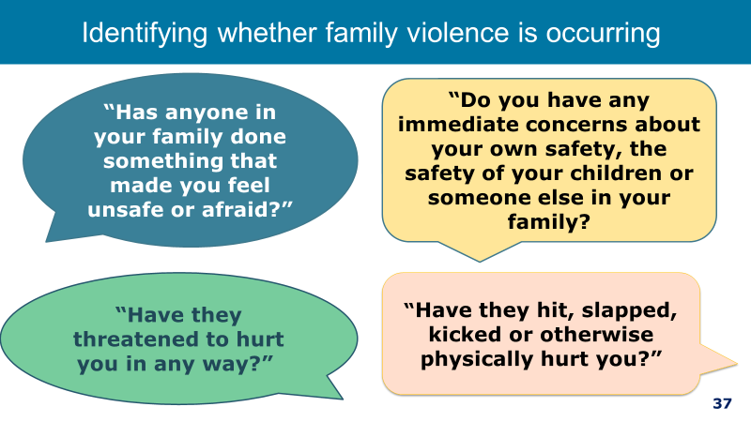
RESPOND TO FAMILYVIOLENCE RISK  If they identify that they do feel unsafe or afraid, ask about their immediate safety.  - “Do you have any immediate concerns about your own safety, the safety of your children or someone else in your family?  - “Do you feel safe to leave here today?”  - “Would you engage with a trusted person or police if you felt unsafe or in danger?  If the staff member says they have immediate concerns but feel it is safe to go home, staff member and /or children are not in immediate danger but at serious risk:  - Seek secondary consultation with your Manager or other senior staff member  - Consider whether a child is at risk and mandatory obligations apply.  - Provide information about help and support that is available.  If they say yes, that is If family violence is occurring and they do not feel safe to go home, an immediate risk management response is required (i.e., the person has let you know they are experiencing an immediate threat to their life, health, safety or welfare, or you have determined this based on their answers to your inquiry):  - Consider contacting the police or ambulance by calling 000 for assistance but ask the person about their views on calling police.  - Seek secondary consultation with your Manager, FVCO or other senior staff member  - Consider whether a child is at risk and mandatory obligations apply.  - “I am very concerned about your safety and would like to help you get assistance today. How do you feel about us contacting a specialist service such as the police?”  - You should always ask the victim survivor about their views on calling the police or other emergency and crisis services. If there is an immediate threat, calling the police is an appropriate response, however, if the person indicates that calling police may increase their risk:  - If they do not want police assistance, provide relevant information on how police respond and encourage them to contact police in an emergency. Let them know about the assistance specialist family violence services offer which include making a personal safety plan and referral to women’s refuge accommodation.  - You need to establish if there are children or someone else who may also be at risk of family violence. You should explain to them that you are assessing the limits of your confidentiality in regard to children. This is critical to enable them to make informed decisions about what information they share with you. It is best practice to, wherever safe, appropriate and reasonable, be transparent with parents/carers who are not a perpetrator about any information sharing to Child Protection or other services.  - All Victorians have reporting obligations related to child sexual abuse. If children are involved consult with your manager or HR consultant as to the appropriate action. Police or Child Protection may already be involved.  Be truthful about limits of confidentiality and your duty of care.  - If they do want you to call the police then find out where they are and make that call.  - If you can, and they are willing, facilitate them to call a family violence services. You may have to call more than once to get through. | 4 minutes  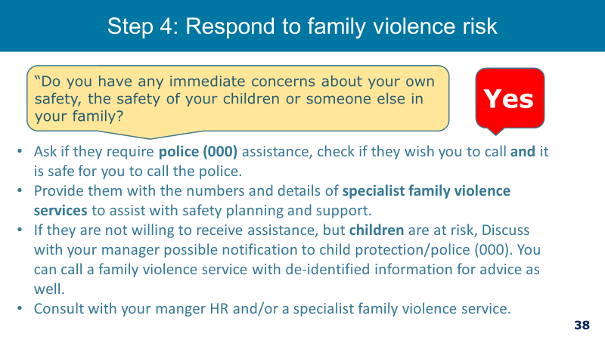
FV OCCURRING BUT NO IMMEDIATE THREAT  Explain workplace support (which we will talk about in a minute).  - These are suggested elements of a safety plan and questions you can ask to help the patient experiencing family violence make a plan.  - Every safety plan will be unique and based on the needs of the adult or young person. You should be guided by the victim survivor on what is important and safe for them in their basic safety plan.  - Below are some questions that can be used to explore these safety considerations. They have been taken from MARAM Practice Guide and form a basic safety plan.  If you need to leave your home in a hurry, where would you go?  - Would you feel comfortable calling the police (000) in an emergency? If not, how can we support you to do so?  - Where is the perpetrator right now?  - Is there someone close by you can tell about the violence who can call the police?  - How many children do you have in your care? Where are they right now?  - Do you have access to a phone or internet?  - Do you have access to a vehicle or other public transport options?  - What essential things like documents, keys, money, clothes or other things should you take with you when you leave?  - Do you have access to money if you need to leave?  Key message: Although managers are not expected to be family violence experts, when a staff member is declining an internal or external referral, it is important to explore how they would manage an immediate threat to their life, health, safety or welfare. | 3 minutes  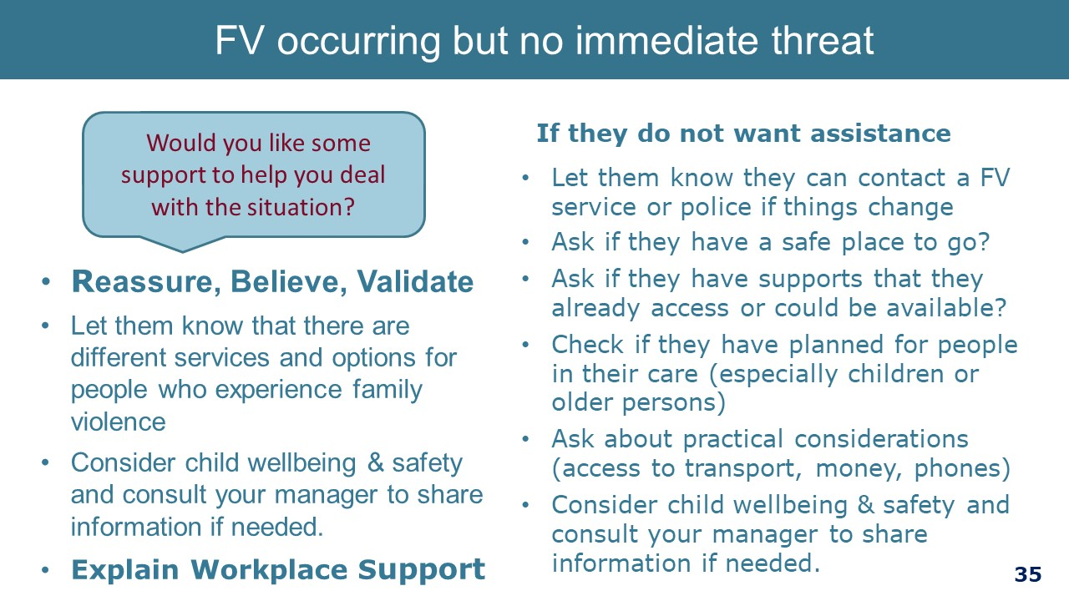
REFERRAL  - Tailor options to your health service.  Key message: There are services available for your staff (or others around you who may need help) as well as for you to consult with. | 1 minute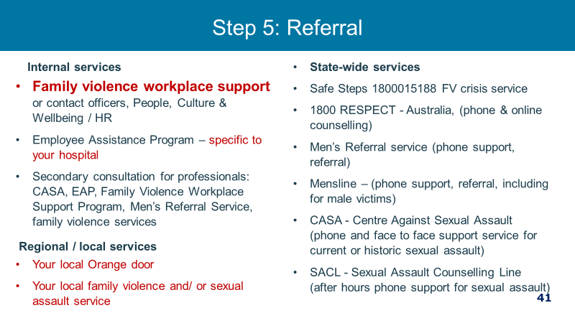
COMMUNICATING WHEN STAFF ARE WORKING FROM HOME  - Note the following tips on communicating with staff when they are working off site.  REFER TO THIS DURING COVID OR IF MANY STAFF WORKING OFF SITE. | 1 minute  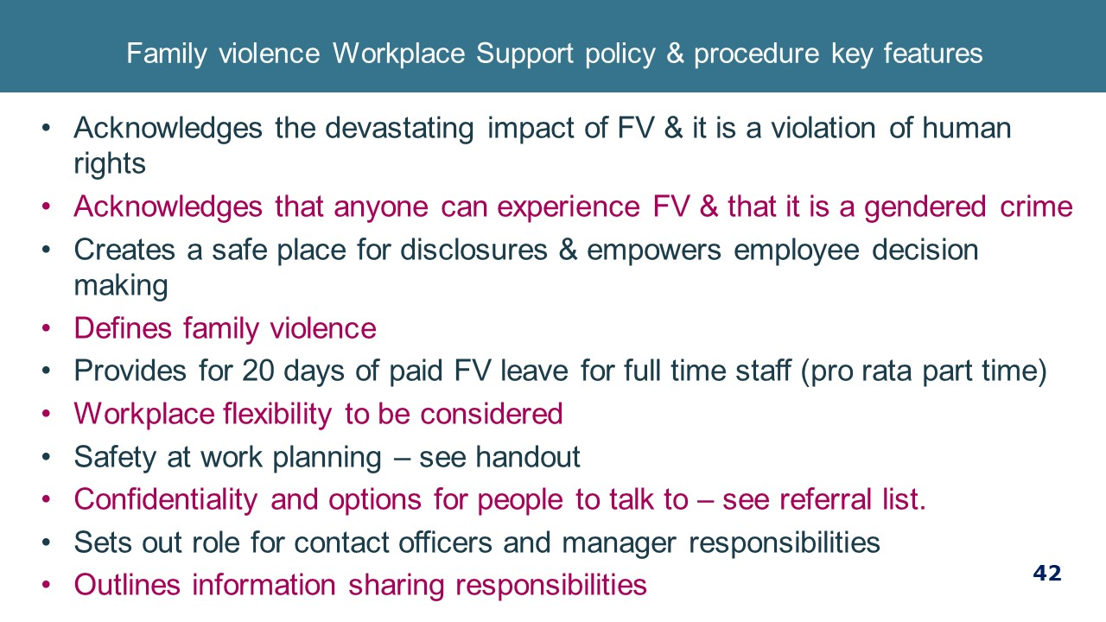
KNOW THE LIMITS OF WHAT YOU CAN DO  - Workplaces need to respond to family violence as a workplace issue and for all other matters to be able to refer employees to appropriate support services. This can be challenging where staff are friends or long-term colleagues or individuals feel a social responsibility to intervene.  Key message: Be clear about your role as a manager and there are boundaries in terms of what you as a manager should and should not do. | 2 minutes 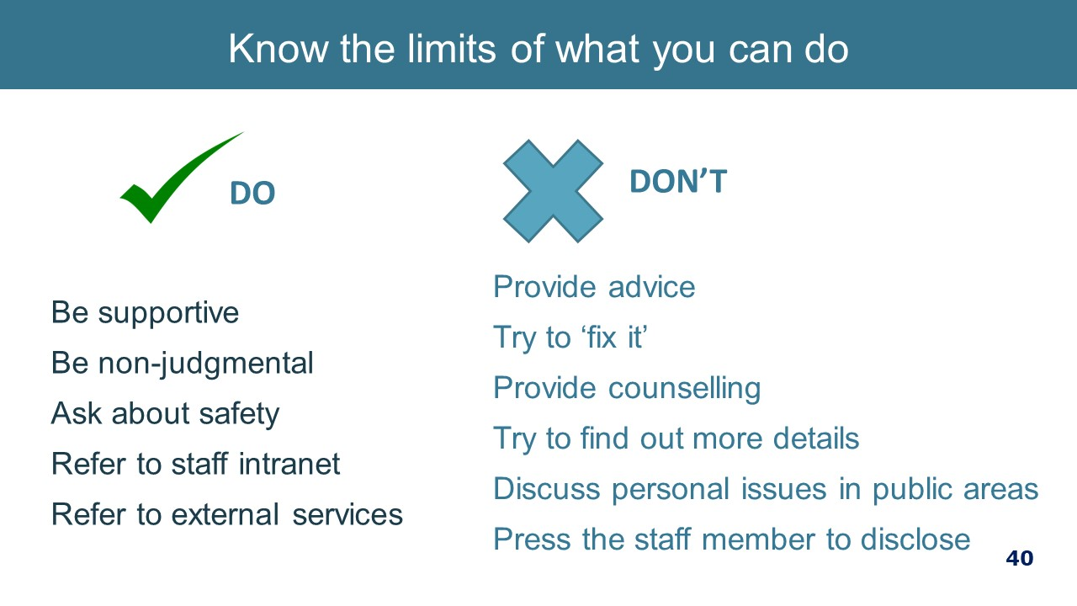
PUTTING IT INTO PRACTICE  Read over scenario and discuss using prompting questions.  Activity option: Role play.  “Hi Lee, how are you?  Good thank you, how are you?  I’m well thanks. I haven’t seen you for a while and it has been some time since our usual one on one in person, so I thought I would give you a call. Is now a good time to talk/have a chat?  Ahh Yes, I’ll just close the door as it gets loud.  Ok I did want to talk about work and how things are going working from home. Are you in a quiet space where we can chat?’  Sure, the kids are just watching tele but they are in another room.”  “Great, how are they coping with the rainy days?  It’s been pretty hard to get out, but we are doing the best we can.  It is tricky isn’t it?  I wanted to chat because I have noticed you seem a bit distracted and not quite yourself during team catch ups. You have even missed some meetings which is not like you. You have talked about some sleep difficulties as well. I wanted to check with you to see if everything is OK as the wellbeing of staff is very important to me.  OHH….OK sure.  I wanted to reassure you I am here to support you in any way I can, and you choose what you want to tell me.  Is it a good time to discuss how things are going now?”  Yes…..Ok  Things have been a bit hard here with everyone at home. Jo hasn’t got so much work and that’s difficult too. And it’s all of us here most of the day.  “That is very difficult and certainly a big change. Are you feeling safe working at home? Has anyone in your family doing anything that made you or your children feel unsafe or afraid?”  “Not really, Look I’m sure it’ll pass. It’s just so tense here at moment. I feel like we have to walk on eggshells around Jo and that’s hard with the kids. Sometimes I just can’t bring myself to call in. I wouldn’t call it unsafe but I feel uneasy and I just have to manage things at home to keep things calm…but I am trying really hard to get my work done”.  That sounds really difficult Lee, you have a right to be in a home where you feel safe and secure, and I want to assure you that I’m ringing out of concern for you and your family, not to talk about your work performance.  I also need to let you know I will respect your right to privacy and maintain confidentiality, as long as you are aware I may have obligations to report any safety concerns especially for children if I come to know they are in danger, okay?  ‘Ok’  “So we can discuss the support available to you, it helps for me to know a bit more about what is going on for you…if that’s ok? Do you have any immediate concerns about your own safety, the safety of your children or someone else in your family?  ​“No not right now, Jo is out”  “Ok if anything changes, if they come home, I can call back at another time if need be, you can always text me as well when a good time to talk is. I have also put information in my signature panel.  “ah huh”  “The way you have talked about what is going on at home sounds like family violence. What is happening isn’t your fault and you and your children have a right to be safe at home, regardless of what is going on.  There are a number of services you can call, some of them are available 24 hours a day to get advice on staying safe or just chat to about what is happening. I am not trained as a family violence specialist, but I can talk you through the different services that are available. The hospital also has help available and can plan with you to keep you safe whilst you are at work. You can also access the workplace counselling service for free.  “Ohh, that’s a lot to take in, I don’t know what to do”  “I realise that it’s a very difficult thing to talk about and I am not here to tell you what to do but to support your choices. Would you like me to tell you some more about the family violence services you can call?  Yes please.  OK. There is more information on the intranet as well too if you don’t feel safe writing any numbers down, And I did want to let you know that the police are able to provide assistance 24 hours a day if you need them. The number to call is 000, would you be comfortable calling the police if you are unsafe?  Yes I would. Thanks, look, I’ve got to go but I will text you a time when it is good to talk to you again. I will find some time to look at some of that information on the Intranet as well. I better go as its lunch time. ​  Ok, thanks Lee, and remember I am here if you need to talk more or need more information. Take care.  Bye. | 9 minutes 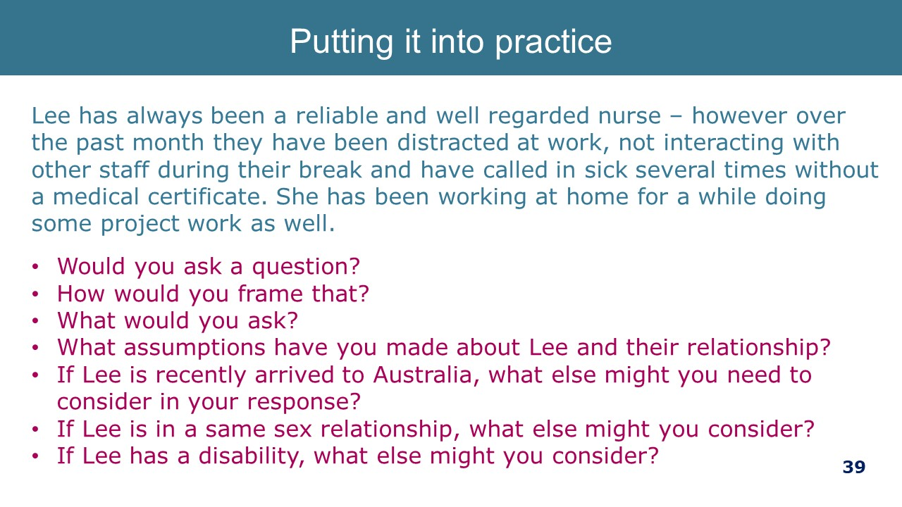
End of Part 2 (60 Minutes) (90 Minutes to here) | 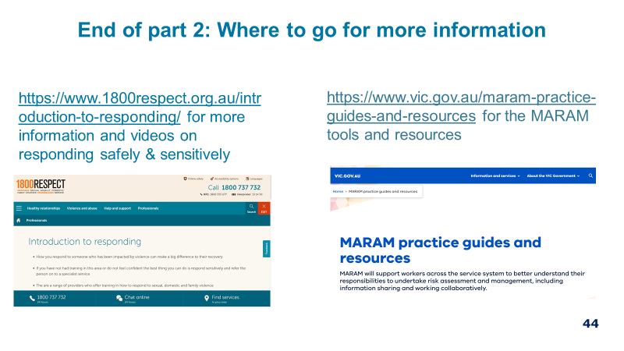

Manager Training Part 3: Workplace Support policy and procedures – 45 minutes
Note to facilitator: Because Part 3 is largely based on your health service’s internal processes and you may need to adapt much of the content below to reflect the local context.

Much of the information in Part 3 is a reminder for managers about staff support processes and entitlements and where to go for further information, rather than a training regarding processes. If managers need training on procedures, such as safety planning, this will need to be organised separately.
Content | Slide and  resources
FV WORKPLACE POLICY & PROCEDURES – KEY FEATURES  - The health service understands the devastating impacts of family violence and that family violence is a violation of human rights and victims are not to blame. We understand that family violence is a workplace issue and that our staff are ‘the community’ and therefore some of our staff will be currently experience family violence or will have experienced it in the past.  - By having a family violence program in place we hope to support victim survivors to maintain employment as we know that employment is a protective factor and may reduce the impact to staff and their children.  Defines family violence  As Per Family Violence Protection Act 2008.  Provides 20 days of paid family violence leave  Note to facilitator: Most health services require limited, if any, evidentiary requirements to support family violence leave. There may be some expressions of concern from participants that this leaves family violence leave open to inappropriate use. To address any concerns, it is recommended that it is made clear that supplying documentation to take family violence leave can be burdensome and add stress to an already stressful situation and that the priority is the well-being of the employee. It might also be helpful to refer to the McFerran study that shows that family violence leave is rarely abused. In fact, there can be a number of barriers to people accessing the leave, with concerns about confidentiality being a key barrier.  At the time of writing this guide, family violence leave is available to most craft-groups through their enterprise agreement. Over time, it is expected that the clause will be included all EBAs in the Victorian public health sector. Unless it is your health services policy to extend the family violence leave to all employees regardless of the entitlement under their industrial instruments, you will need to periodically check to see if the clause is inserted into newly negotiated EAs.  Detail about taking family violence leave is reflected in the procedure. There are a few key things to note about family violence leave:  - 20 days is for a full time staff member, part time staff are entitled to this on a pro rata basis. Casuals are not entitled to paid leave but are entitled to time away/unpaid leave.  - A year is a calendar year.  - FV leave is available for employees who are experiencing family violence and facilitates their absence from the workplace to attend counselling appointments, medical appointments, legal proceedings or appointments and other activities related to and as a consequence of family violence.  - There is no exhaustive ‘menu’ of events for which an employee can take family violence leave. Rather it is important to keep in mind the connection behind the absence to family violence – it may be a health, legal, housing, child welfare reason and still fall within the scope of the right to take leave. It is also important to be mindful of the family violence leave clause that makes leave available for “other activities related to and as a consequence of family violence”.  - At times there may be a gap between an action of family violence and leave needed to deal with that action. For example, the employee may not need leave immediately following an act of physical violence (the action) but may wish to take leave to attend court to address the physical violence (activity as a consequence of family violence).  - There is often not a linear relationship between disclosure and action taken to address family violence, so be mindful that just because an employee discloses their experience of family violence, this does not necessarily mean that they require family violence leave right now to deal with the issue.  - It should also been kept in mind that it is often not the case that taking family violence leave will ‘fix’ the issue; the violence may decrease for a period of time but increase on or around significant events such as court appearances, intervention orders, birthdays and days of cultural or religious significance. Working through the impact of family violence can take some time it is unreasonable to expect that an employee will return from a period of FV leave with the matter completely resolved.  - Evidentiary requirements are outlined in the procedure – [insert the evidentiary requirements particularly to your health service].  - Employees can also use their sick leave to support a person experiencing family violence to accompany them to court or hospital or to care for children. The person they are supporting can be anyone experiencing family violence. This is different to the usual way of using sick leave as carers leave where the relationship to that person is limited to immediate family or household.  - The family violence leave application process- refer participants to the family violence leave application process if you have developed such a resource.  - Family violence leave is not intended for those who perpetrate family violence.  Confidentiality and options for people to talk to  Note to facilitator: Each health service will have their own particular information regarding Family Violence Contact Officers and Employee Assistance Program provider that needs to be inserted into the presentation.  - The requirement to have Family Violence Contact Officers is a requirement of the Family Violence Leave Clause.  - The Family Violence Contact Officer is an employee who has been trained to be a first point of contact for someone experiencing family violence so they can access information about what workplace supports are available.  - In this hospital, Family Violence Contact Officers are [insert names, title, location, where to find their contact details].  - Employees can also contact EAP for a confidential discussion.  There can be a number of reasons why an employee does not wish to disclose their experience of family violence. This is why Contact Officers are necessary. Reasons for seeking out other people to talk to may include:  - Shame and embarrassment  - Fear of being pitied or stigmatised  - Fear of being viewed as dysfunctional  - Fear of missing out on future job or other workplace opportunities  - Employee compartmentalises their life  - Manager has a poor reputation of keeping confidentiality  - Manager engages in violence supportive behaviour  - Previous history of conflict between employee and manager.  - For reasons that may be related or unrelated to the relationship between the employee and the manager, it is good practice to have an alternative source of information rather than a manager.  Sources: (1) UNSW Australia (2013) Domestic and Family Violence Clauses in your Workplace: Implementation and good practice, Gendered Research Network | 4 minutes  Resources:  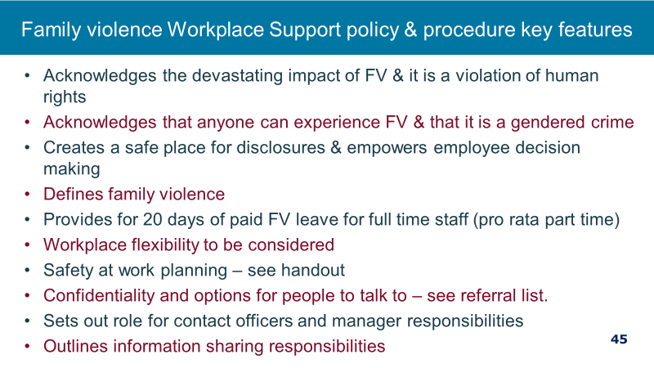  Family Violence Workplace Support Policy & Procedure  FV leave application process flowchart
UTILISE INTRANET INFORMATION  If you have developed an intranet site for workplace support information, you can take the opportunity to introduce/remind managers of this resource. | 2 min  Blank slide  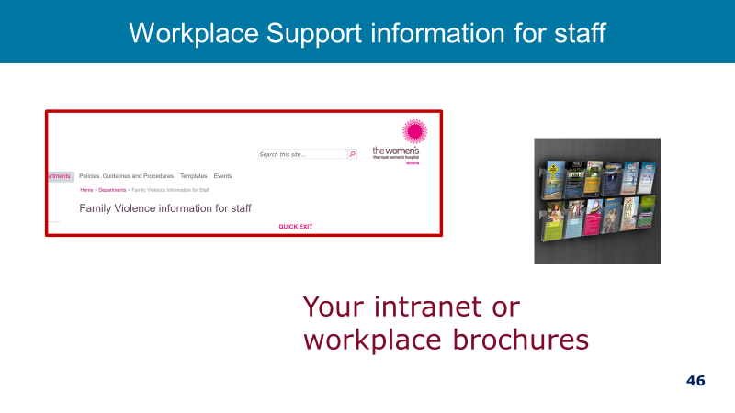
WORKPLACE SAFETY PLANNING  - Safety planning at work is one of the most important aspects of supporting staff experiencing FV.  - One of the essential responses to an employee is to support their safety at work and try to minimise the risk of due to family violence while at work. The procedure goes into some depth about this and includes a safety planning template.  - Each hospital should have a procedure for Workplace safety planning for staff.  - This is different to a personal safety plan that is usually made in consultation with a specialist service.  - It is recommended that a workplace one also is made in collaboration with a family violence specialist service.  Explain workplace safety planning template:  - The New Workplace Safety Planning Guidelines outlines a safety planning process to enhance safety and minimise the risk of an act of family violence perpetration during work time.  - It is important that you always remember that family violence victims experience loss of control and power and so that your approach is to ensure that your actions do not exacerbate this.  - The employee’s own assessment of their risk is one of the primary elements of risk assessment as it provides intimate knowledge of their lived experience. As an employer we respect this and build on their assessment through a collaborate approach. This helps ensure that the employee’s needs are met and that we do not override their decision making.  Source: ANROWS National Risk Assessment Principles for domestic and family violence | 3 Minutes  Resource: Safety planning template from Family Violence Workplace Support Procedure  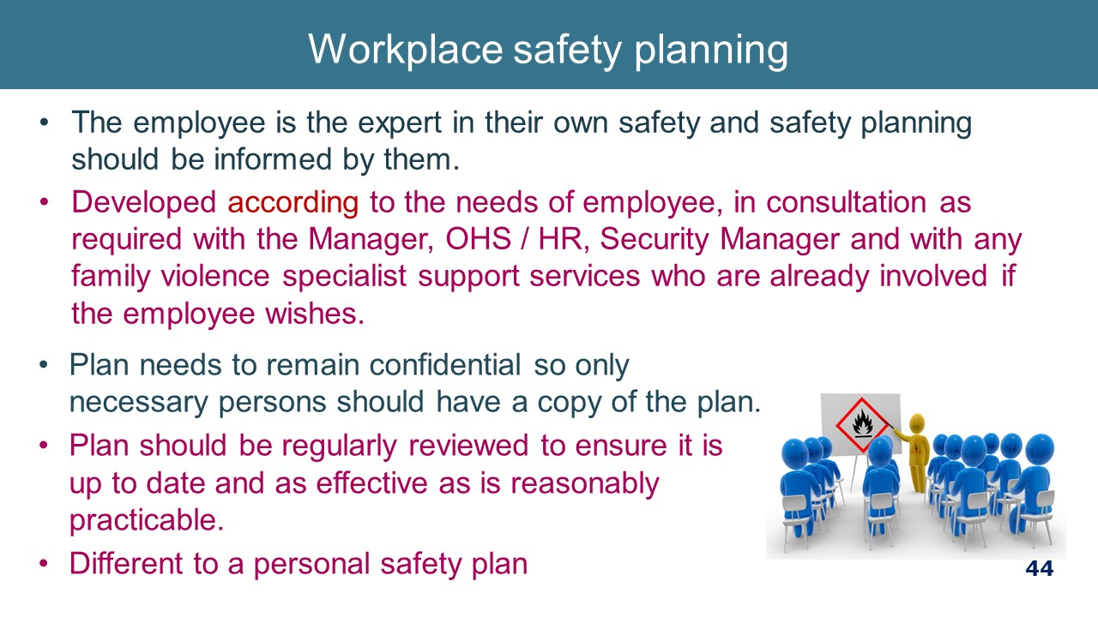
SAFETY PLANNING & SUPPORT  - Ways in which a hospital may typically be able to support the safety of the staff member includes changing location of work, changing the phone number or email address, notifying security and reception to alert them to the perpetrator entering the workplace and required action, relocating their car park, security escort to and from their car.  - There are a number of options available in relation to workplace flexibility where this is needed to support an employee experiencing FV and/or to enhance their safety. Some of the ways in which we can offer this include modification to shifts/hours of work and duties  Video option: “How do develop a personal safety plan for time at work” https://www.youtube.com/watch?v=CqL61xeomd8  Key message: Safety Planning is important for all staff. Seek advice from FV service if in doubt of how to do this. | 2 minutes  www.youtube.com/  watch?v=CqL61xeomd8  1min29min
DOCUMENT  The only documentation of family violence disclosures from staff must relate to:  - Records of family violence (FV) leave taken by individual staff members (FV leave record)  - Records related to safety planning, work planning and performance management (Family violence employee file).  - HR will manage documentation. Refer to new Workplace Support Information Handling Guidelines. | 1 minute  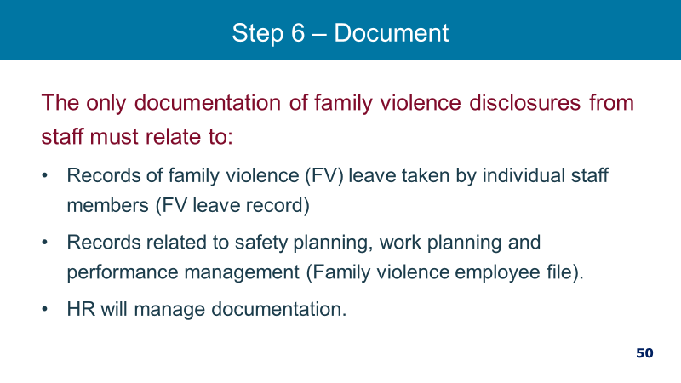
MANDATORY REPORTING  Health services should seek legal advice on the below and tailor their training to reflect that advice.  - Mandatory reporting obligations where a mandated reported has concerns about the well-being of a staff members child.  - Obligations under the Crimes Act 1958.  - Obligations under the Commission for Children and Young People’s Report Conduct Scheme.  - Obligations under the FVISS and CISS schemes (as of Sept. 2020).  - We all have a responsibility to keep children safe and report certain conducts. If children are involved, consult with your manager / HR or legal. You can also ring a specialist services for information, providing de-identified information if you are unsure about your obligations to report.  - KEY MESSAGE: We have clear reporting obligations under the law and we need to understand them.  From WS procedure  - Child Protection / child safety reporting requirements  - In your conversations with a staff member you may become aware that there are children who are or may be at risk. There are three main legislative reporting obligations which all staff members should be aware of as all staff have obligations in relation to children.  - The three main legislative reporting obligations are:  1. Crimes Act (Vic) 1958 requires all adults to report to Victoria Police if there is a reasonable belief that a sexual offence has been committed by an adult against a child under the age of 16 years.  2. Reportable Conduct Scheme under the Child Wellbeing and Safety Act 2005 (the Act) requires the head of an organisation to report allegations the following by staff or volunteers of:  - sexual offences against, with or in the presence of a child  - misconduct against, with or in the presence of a child  - physical violence against, with or in the presence of a child  - behaviour that causes significant emotional or physical harm of a child  - significant neglect of a child  - These behaviours include but are not limited to sexual abuse, grooming, sexting, inappropriate physical contact, sexualised behaviour with a child.  - Where a staff member believes any of the above may be occurring, [HR] should be immediately and confidentially notified.  3. Mandatory reporting obligations under the Children, Youth and Families Act 2005.  - This obligation arises for a class of employees who, in the course of practising his or her profession or carrying out the duties of his or her office, position or employment, forms the belief on reasonable grounds that a child is in need of protection. Please refer to [Mandatory Reporting Policy] for which roles have mandatory reporting obligations under the Children, Youth & Families Act 2005.  - Any staff member may seek confidential advice from the Women’s in-house legal team about mandatory reporting obligations and duty of care obligations.  - Reports to Child Protection or the Police should be done in a respectful and transparent manner. The limits to confidentiality should be explained prior to a conversation related to family violence to support a disclosure of family violence being made with informed knowledge of how information is shared in Victoria.  - It is best practice to share information with consent and involvement of the adult victim survivor, and their information knowledge of what information is being reported so they can manage their safety and the safety of the children accordingly. Sharing information without the informed knowledge of a victim survivor of family violence can increase their risk. | 2 min  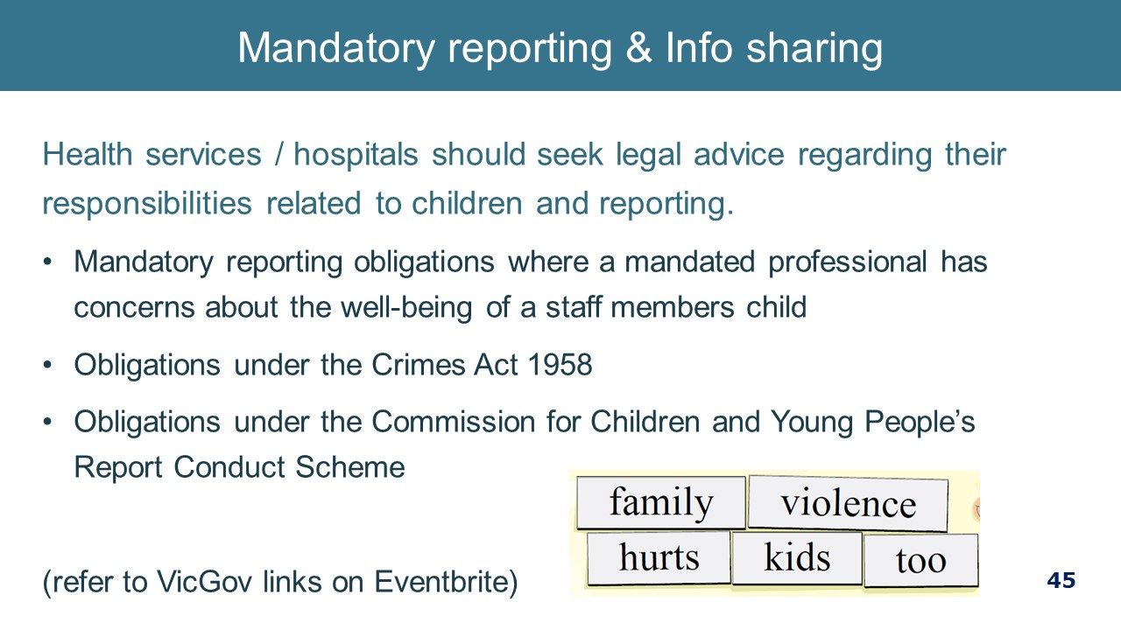
WORKPLACE RESPONSE TO PERPETRATORS  Note: There is not time in the 2.5-hours session to discuss perpetrators at length. Refer managers to the new Perpetrators documents in the Toolkit.  Below are just some considerations.  Note to facilitator: While a workplace response to perpetrators (or people who chose to use violence) is important, there are a number of complexities to consider. That response will be guided by the overall approach that an individual health service chooses to take and what organisational policies, procedures and other mechanisms are in place to support that approach. Accordingly, this part may need to be adapted to local circumstances.  Be mindful that a response to perpetrators as employees, while important, will not have a large impact on the reducing the prevalence of violence against women. For this reason, focusing more attention on broader organisational cultural factors that contribute to the elimination of violence against women is more productive in the long term.  Below is a summary of considerations:  - Safety as a priority  The safety of victim survivors, other staff and patients should guide any actions we take in relation to staff who perpetrate violence  - Our role as an employer  It is important to keep in mind that as an employer, we are in an employment relationship with an employee who perpetrates family violence. This is distinct from The Women’s as a health service provider to patients.  It is the role of the hospital to:  - provide a safe work environment;  - provide a safe clinical service for patients; and  - to set and uphold expected codes of behaviour for our employees.  Be aware of collusion  - While FV perpetration is a workplace issue for many reasons, including those noted above, it is not the responsibility of the employer to ‘rehabilitate’ a perpetrating employee. Unskilled or misguided attempts at this work can be highly unsafe and outside the remit of an employer. Such work is to be done by those with specialist skills in FV perpetration and behaviour change.  - Perpetrators have highly reinforced ways of justifying their behaviour or making themselves out to be the victim (although it is important to keep in mind that a perpetrator may have a past experience as a victim survivor of family violence). Do not be drawn in by perpetrator invitations to support their behaviour (such as comments about their partner’s mental instability, incompetence, etc.) as you will inadvertently colluding with them. It is important to ensure that the workplace culture is not violence supportive (e.g. the telling of sexist jokes is not tolerated) so that the perpetrator’s behaviour is not reinforced by what they see around them at work.  Possible workplace responses  - Consider your source of obligations and enablers – Health and Safety Act (e.g. obligation to provide a safe workplace, employee obligation to comply with instructions to maintain a safe workplace), contract of employment, industrial instruments, policies/procedures/guidelines, Victorian Public Sector Code of Conduct, emergency response procedures (e.g. code grey, code black).  - Disciplinary Procedure provides that if an employee commits an act of violence during work time or utilising the hospitals resources, it may result in disciplinary action or even termination of employment. IT Usage Agreement and Social Media Policy aligns with this.  - Practically managing FV between 2 staff members – options may include monitoring the situation, referral to a support service, temporary adjustment to work, a behavioural contract or MoU (which includes consequences of breaching this), temporary absence from work.  - Promotion of referral information, including information about your EAP service– on the intranet, through flyers or posters located in change rooms or bathrooms  - Intervention orders – IVOs are a civil matter, a breach of an IVO is a criminal matter. You may have in your contract of employment, the obligation to report a criminal conviction. Keep in mind that an employer cannot discriminate against an employee on the basis of their criminal record unless the criminal record means that he or she is unable to perform the inherent requirements of the role. This needs to be determine on a case by case basis having regard to the nature of the conviction and the inherent requirements of the role.  - The behaviour may have an impact on the professional registration of your employee.  - The behaviour may invoke the employer obligations under the CCYP Reportable Conduct Scheme as mentioned earlier.  Key message: There are many considerations when responding to an employee who uses family violence.  Sources:  Workplace Support responding to staff who perpetrate family violence – Policy and Guidelines.  Domestic and family violence, A workplace approach to employees who use or may use violence and abuse: A resource for all Queensland workplaces  North West Metropolitan Region Primary Care Partnerships Guides for engaging with people who cause family violence harm: Policy Guidelines  www.humanrights.gov.au | 4 minutes  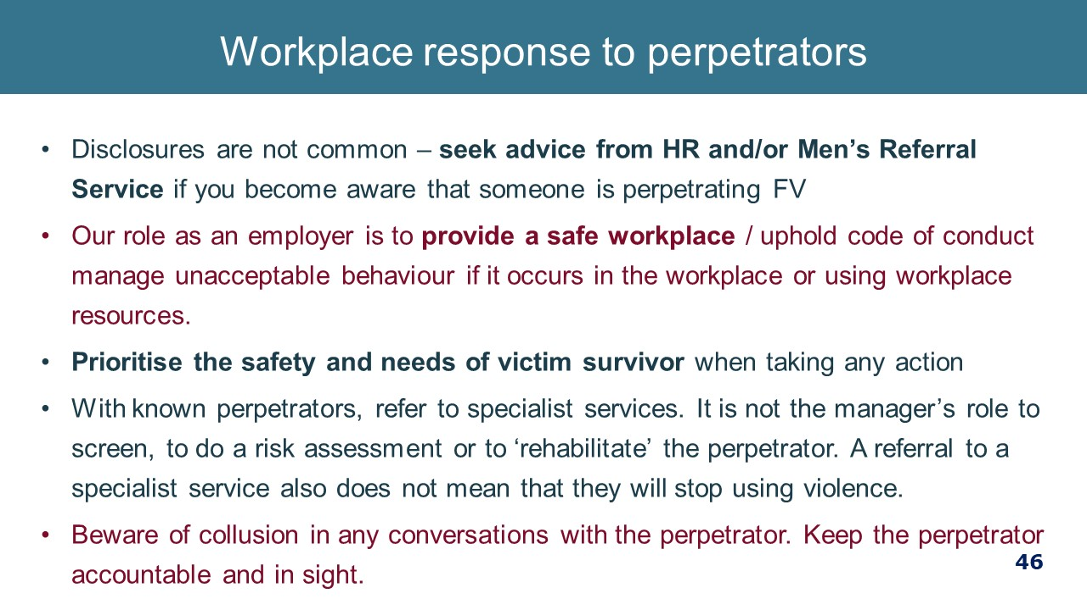  Workplace Support responding to staff who perpetrate family violence - Guidelines.
SELF CARE  - Be aware of the importance of your own self-care. We encourage you to actively undertake professional and personal self-care initiatives to help build resilience to the demands of your role.  - While this is important more broadly, it is really important when managing disclosures of family violence from staff and particularly if you have your own past or current experience of family violence.  KEY MESSAGE: Working with and supporting anyone affected by family violence can have an impact – take care of yourself. | 2 minutes 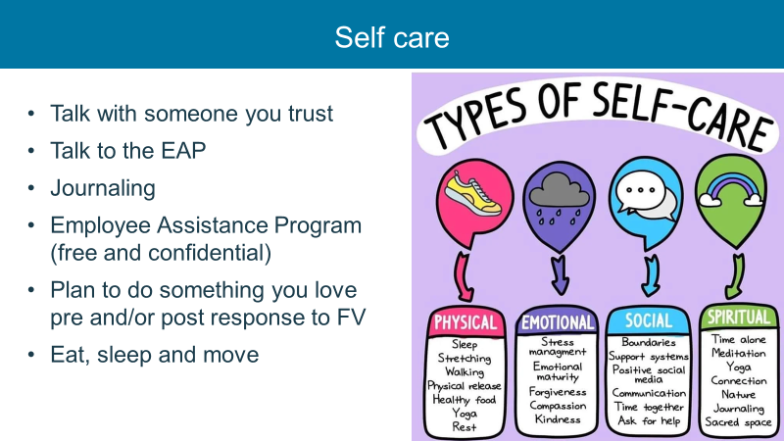
KEY MESSAGES  - Participants will retain the most information they hear at the commencement and conclusion of the training session. This is an opportunity to restate your key messages.  - Reiterate where to go for more information. | 1 minute 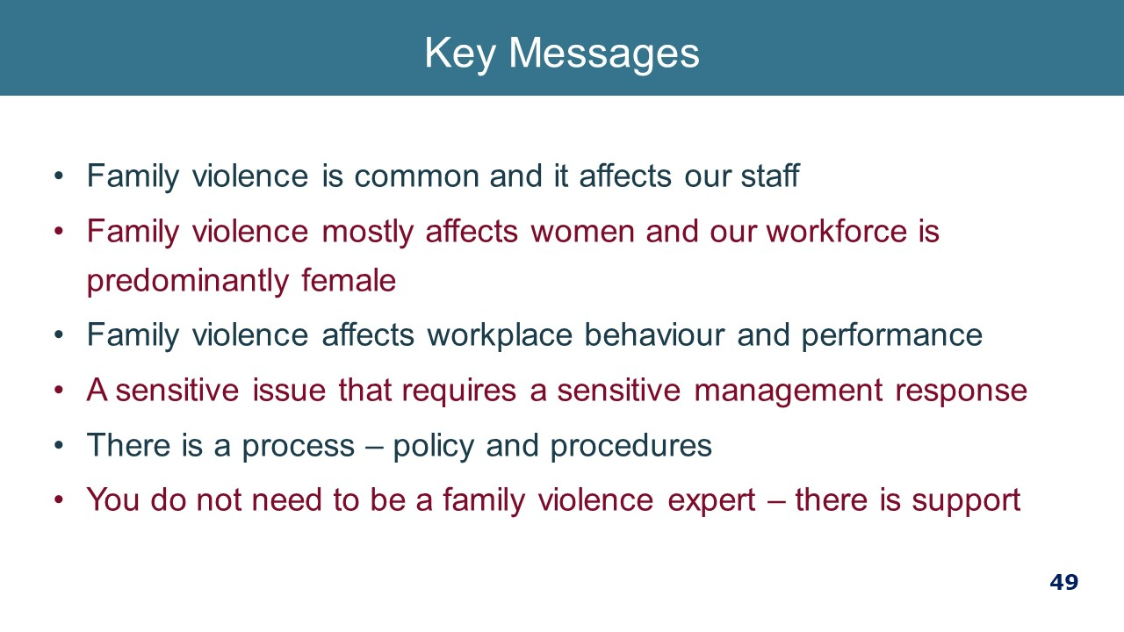
CLOSING  - Remind participants of where they can access further information and support.  - Thank participants for their attendance.  - Remind participants to complete the post-training survey.  - We now have time for questions.  - We will also hand out / send around the link to a short evaluation form and I have asked if some of you are happy to have a short chat about how it went from your end.  End of Part 3 (30 minutes with time at the end for questions) (150 minutes total) | 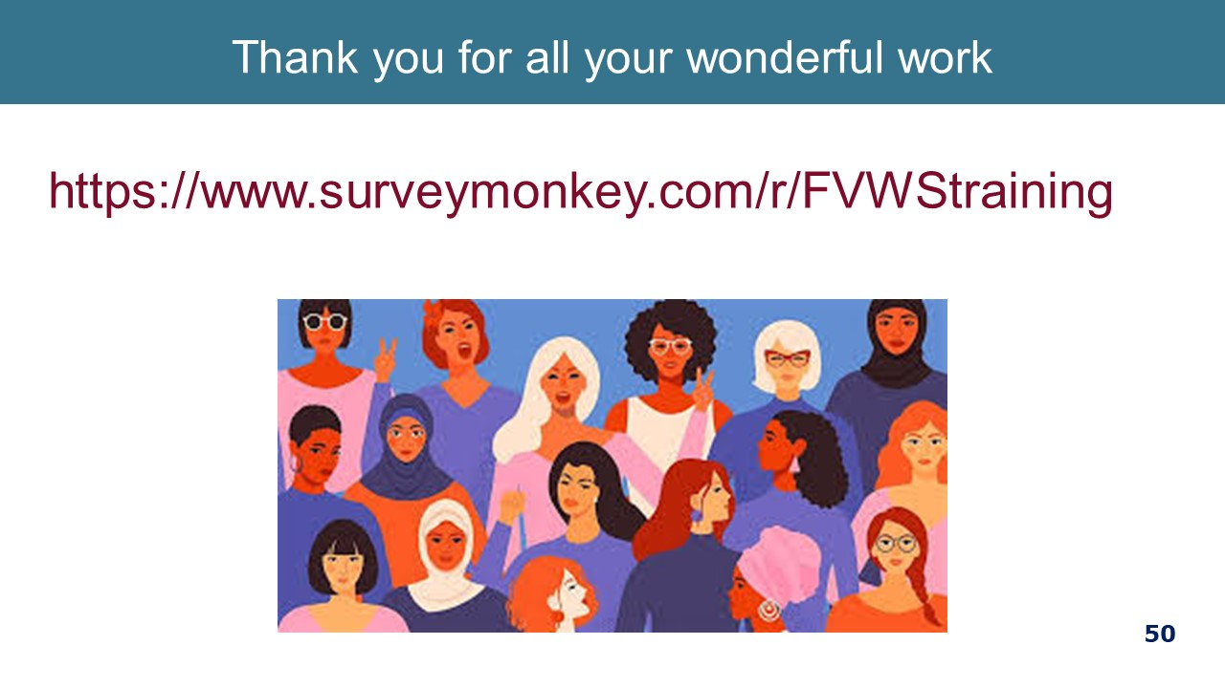

Appendix A: Recommended Pre-Reading for presenters
The following list is minimum recommended reading for facilitators.
- Australian Bureau of Statistics. (2017). Personal safety, Australia, 2016. Canberra, ACT: Author. Available at: http://www.abs.gov.au/ausstats/abs@.nsf/mf/4906.0
- Australian Institute of Health and Welfare (2018), Family, domestic and sexual violence in Australia. Available at https://www.aihw.gov.au/reports-data/behaviours-risk-factors/domestic-violence/reports
- Australian Institute of Health and Welfare (2019), Family, domestic and sexual violence in Australia: continuing the national story. Available at https://www.aihw.gov.au/reports-data/behaviours-risk-factors/domestic-violence/reportsfrom%20https:/www.aihw.gov.au/reports-data/behaviours-risk-factors/domestic-violence/reports
- McFerran, L. (2011) Safe at Home, Safe at Work? National Domestic Violence and the Workplace Survey, A project of the Centre for Gender Related Violence Studies and Micromex Research. Available at https://www.arts.unsw.edu.au/sites/default/files/documents/Key_Findings__National_Domestic_Violence_and_the_Workplace_Survey_2011.pdf
- Our Watch (2015), Change the Story: A shared framework for the primary prevention of violence against women and their children in Australia. Available at https://www.ourwatch.org.au/getmedia/0aa0109b-6b03-43f2-85fe-a9f5ec92ae4e/Change-the-story-framework-prevent-violence-women-children-AA-new.pdf.aspxhttp://www.ourwatch.org.au/
- Our Watch (2017) Practice guidance: Dealing with backlash. Available at, https://workplace.ourwatch.org.au/resource/practice-guidance-dealing-with-backlash/
- Our Watch (2017) Putting the prevention of violence against women into practice: How to Change the story. Available at https://handbook.ourwatch.org.au/
- Our Watch, 2017, Changing the Picture: A national resource to support the prevention of violence against Aboriginal and Torres Strait Islander women and their children, Melbourne, Our Watch. Available at https://d2bb010tdzqaq7.cloudfront.net/wp-content/uploads/sites/2/2019/11/05233003/Changing-the-picture-AA-3.pdf
- Victorian Hospitals Industrial Association (2017), Family Violence Leave User Notes,
- World Health Organisation (2014) Health care for women subjected to intimate partner violence or sexual violence: A clinical handbook. Available at https://www.who.int/reproductivehealth/publications/violence/vaw-clinical-handbook/en/
- State of Victoria (2019) MARAM Victim Survivor Practice Guides: Foundation knowledge and Responsibility. Available at https://www.vic.gov.au/sites/default/files/2019-07/MARAM-practice-guides-foundation-knowledge.pdf
- ANROWS Violence Against Women: Accurate use of key statistics, https://d2rn9gno7zhxqg.cloudfront.net/wp-content/uploads/2019/01/19030556/ANROWS_VAW-Accurate-Use-of-Key-Statistics.1.pdf
- ANROWS (2018) National Risk Assessment Principles for domestic and family violence. Available at www.anrows.org.au,
- Women’s Health West, Speaking publicly about preventing men’s violence against women: curly questions and language considerations. Available at https://whwest.org.au/resource/speaking-publicly-about-preventing-mens-violence-against-women/
- Strengthening Hospital Responses to Family Violence Project Overview. Available at https://www.thewomens.org.au/health-professionals/clinical-resources/strengthening-hospitals-response-to-family-violence/shrfv-resource-centrelink
- Strengthening Hospital Responses to Family Violence Project Management Guidelines. Available at https://www.thewomens.org.au/health-professionals/clinical-resources/strengthening-hospitals-response-to-family-violence/shrfv-resource-centrelink,
- Strengthening Hospital Responses to Family Violence Project Overview Training Manual, https://www.thewomens.org.au/health-professionals/clinical-resources/strengthening-hospitals-response-to-family-violence/shrfv-resource-centrelink
Websites of interest:
- 1800RESPECT: www:1800respect.org.au and www:1800respect.org.au
- Australian Government: https://www.respect.gov.au/
- Domestic Violence Resource Centre: https://www.dvrcv.org.au/
- DV@worknet: www.dvatworknet.org
- Our Watch: www.ourwatch.org.au
- Women’s Health Victoria: https://whv.org.au

