Facilitator Guide

Manager Training: Workplace Support Policy and Procedures - 60 minutes

Family Violence Workplace Support Program Training for Managers: 120 minutes

Introduction 3

Acknowledgements of contributions 3

About the guide 3

Background 3

Recommended training participants 3

Key components and purpose of the training 4

Delivery mode 4

Training prerequisites 4

Tailoring the training to your hospital / health service 5

Who should deliver the training? 5

Pre reading for facilitators 5

Story-sharing 5

Use of gendered language 6

Managing participant resistance during training 6

Data and sources of information 7

Materials, participant training pack and room set up for face to face training 7

Participant care during training 7

Facilitator care 8

Manager Training: Workplace Support Policy and Procedures - 60 minutes 9

OPENING SLIDE 9

ACKNOWLEDGEMENTS 9

HOUSEKEEPING 9

LOOKING AFTER YOURSELF 10

DEFINING FAMILY VIOLENCE 11

FAMILY VIOLENCE IS GENDERED AND A HEALTH AND WELFARE ISSUE 12

SOME PEOPLE ARE MORE AT RISK OR FACE ADDITIONAL BARRIERS TO RECOVERY AND SUPPORT 12

THE WORKPLACE AS A SETTING FOR PREVENTION 13

YOUR ROLE AS MANAGER 15

DISCLOSURE AND HELP SEEKING IN THE WORKPLACE 16

SENSITIVE PRACTICE 16

TAILORING ENGAGEMENT TO BE CULTURALLY SAFE, ACCESSIBLE AND INCLUSIVE 17

SAFE AT HOME, SAFE AT WORK SURVEY 19

FAMILY VIOLENCE AFFECTS CAPACITY TO WORK 19

WHAT MAKES IT DIFFICULT FOR PEOPLE TO DISCLOSE FAMILY VIOLENCE? 20

NOTICE WORKPLACE INDICATORS / SIGNS OF FAMILY VIOLENCE 21

EVIDENCE BASED RISK FACTORS 21

SENSITIVE PRACTICE 22

POWER AND CONTROL 22

SENSITIVE PRACTICE IN A WORKPLACE SETTING 22

HELPFUL AND UNHELPFUL RESPONSES 23

INQUIRING ABOUT FAMILY VIOLENCE WITH STAFF: 23

REFERRAL 24

KNOW THE LIMITS OF WHAT YOU CAN DO 24

FV WORKPLACE POLICY & PROCEDURES – KEY FEATURES 25

UTILISE INTRANET INFORMATION 27

WORKPLACE SAFETY PLANNING 28

SAFETY PLANNING & SUPPORT 28

DOCUMENT 29

MANDATORY REPORTING 29

WORKPLACE RESPONSE TO PERPETRATORS 31

SUPPORT SERVICES 33

MANAGERS CAN MAKE A DIFFERENCE 33

SELF CARE 33

CLOSING 34

Appendix A: Recommended reading for facilitators 35

Introduction

Acknowledgements of contributions
The Royal Women’s Hospital thank Grampians Community Health, Barwon Health and Ballarat Health Service for their input into components of this updated training.

About the guide
This Facilitator Guide has been developed to support those delivering Family Violence Workplace Support Program training for managers in the Victorian Public Health Sector. The guide should be read in conjunction with Family Violence Workplace Support Program Training for Managers PowerPoint slides.

Background
The aim of the Strengthening Hospital Responses to Family Violence (SHRFV) program is to support Victorian hospitals to implement a whole-of-hospital response to family violence (FV). Family violence is a workplace issue that impacts upon staff personally, often affecting attendance at work, performance, productivity and workplace safety. The approach recognises that as employers, we must prioritise the safety and wellbeing of our staff who personally experience family violence. Not only does this priority arise from our role as an employer, as a health service provider we must support our staff personally so that they can support patients experiencing family violence.
Research shows that the experiences of family violence of clinicians working in the Victorian public health sector are higher than those experienced by the general population. Prior to focusing on patients experiencing family violence it is strongly recommended that hospitals prioritise the development and implementation of a workplace program, including manager training, to support the personal experiences of their employees.
Further, since late 2016, renegotiated enterprise bargaining agreements within the Victorian public health sector have included a Family Violence Leave clause, covering most employees within the sector. This four-hour training has been designed to enhance managers’ understanding of the provisions of this clause and provide an opportunity to practice sensitive enquiry. This manager training also addresses the connection between workplace culture, practices and behaviours associated with the prevention of violence against women and how management practice contributes to this. As part of your hospital’s prevention work, you can expand on this during the training.

Recommended training participants
It is recommended that those with leadership and/or management positions, however titled, in your hospital attend manager training. This includes those who may have day-to-day supervisory responsibilities such as supervisors, Associate Unit Managers and After-Hours Managers.
It is further recommended that participation in manager training is mandated through your hospital’s policy, including the frequency of refresher training. With the introduction of the Family Violence Leave clause, a hospital may see an increase in disclosures by those staff wishing to access leave. It is of utmost importance that managers know how to respond to those disclosures in a way that is safe and supportive for the staff member. Family violence can be highly complex and dangerous, particularly around the time of leaving a relationship. It is therefore important that a manager understands this and rigorously adheres to their boundaries. The manager’s role is to support the employee in a non-judgemental way and by offering information on the ways the workplace can support them. These boundaries are important so the manager does not give well intended, but inappropriate and dangerous advice to the employee about managing the family violence. Such advice is best given by a specialist family violence service.
Training non-compliance
As a note of caution in relation to training compliance for managers, health services should explore reasons for non-participation. Cautious and gentle inquiry into the reasons for non-participation may reveal that a manager has a past or current experience of family violence and may feel that training may be harmful for them. This is perfectly understandable and in consultation with the manager, alternatives may include:
- Provide training in a different way, such as 1:1 and modifying the material to focus more on operational issues such as how to take family violence leave and undertake safety planning
- Ascertain if the manager is seeking assistance in relation to family violence, in which case they may feel more prepared to undertake training in the future.
- Ensure that a second-in-charge or other senior team member undertakes the manager training
- Ensure that Family Violence Workplace Support staff training is actively promoted to the team
- Offer an optional in-service session to the team where the manager can absent themselves

Key components and purpose of the training
This training has been developed for managers within the Victorian public health sector to provide them with knowledge about workplace Support policies and procedures. It is expected that Managers undertaking this training have undertaken previous training in sensitive practice as a pre requisite. It supports the operationalisation of the relevant policy and procedures (e.g. How to take family violence leave, safety planning, confidentiality, etc).

Delivery mode
The training is designed to be delivered face to face as this facilitates the sharing of ideas and experience and the opportunity to build skills by participating in practical activities. A number of activities have been designed to be used with this training on an optional basis. It is not expected that you will use all of them in each session, but rather for you to consider what areas may be particularly important for you to focus on in the context of your organisation and to select the activities that enhance the learning in these areas.
To promote participation, it is recommended that number of participants in each session does not exceed 25.

Training prerequisites
The Foundational and Sensitive Practice SHRFV training is a prerequisite for this training. This module has been developed to support managers understand Workplace Support policies and procedures, but does not provide foundational information about family violence or how to undertake a sensitive inquiry.
Suggested videos to share with participants:
- Futures without Violence, Supervisors can make a difference. Available at https://www.youtube.com/watch?v=HdNbnUAVFT4&feature=youtu.be
- WorkSafe BC, How to talk to an employee who might be experiencing domestic violence. Available at https://www.youtube.com/watch?v=KeJDtvs1NtQ
- Our Watch, 2020, Employee Support. Available from https://workplace.ourwatch.org.au/employee-support/
- 1800RESPECT, videos, Available from https://www.youtube.com/user/1800respect
- Family Safety Victoria, Family violence against LGBTI people: Insights from people with lived experience. Available from https://www.youtube.com/watch?v=3-627k0sOoI
- SBS, 2019, Domestic and Family violence. Available from https://malechampionsofchange.com/sbs-inclusion-program-domestic-and-family-violence/

Tailoring the training to your hospital / health service
The sections of this training that speak specifically about health services policies, procedures, referral pathways and information sources should be tailored to your service.

Who should deliver the training?
This training can usually be delivered by a Human Resources/People & Culture or Health, Safety and Wellbeing practitioner, provided they have a good understanding of family violence and its impacts in the workplace.
The presence of 2 facilitators increases safety in the training room. This is because one facilitator can observe the audience for signs of distress and can assist participants if needed outside of the training room without having to disrupt the session.

Pre reading for facilitators
A list of recommended research and websites is listed in Appendix A.

Story-sharing
Story-sharing can often be a useful technique for the facilitator to engage ‘hearts and minds’ by connecting the audience to the subject matter through sharing real life examples of those experiencing family violence within the workplace. Stories should be de-identified and the narrative broadened to ensure confidentiality. Providing too much detail may enable a participant to connect the story to the victim survivor. It is important to emphasise to participants at the outset of the session that if they wish to share a story that is about another’s experience of family violence, they are required to share it in a way that de-identifies those involved, including victim survivor, perpetrator and children (See group agreements).

Use of gendered language
Family violence is defined by the Family Violence Protection Act 2008 as broad, recognising that family violence can occur in any familial relationship, including same-sex relationships.
However, men and women typically have different experiences of violence with women experiencing significantly higher rates of family violence and suffer more severe consequences. Further, the most common form of family violence is intimate partner violence (IPV) committed by men against their current or former partner and that violence can often affect children.
While the Family Violence Workplace Support Program is titled as such to take into account that all people can experience family violence, it does recognise that family violence is a gendered issue and accordingly, this is reflected in the training.
It is for this reason that during the training, the language of ‘he’ as perpetrator and ‘she’ as victim survivor is predominantly used. Facilitators can select the choice of language that applies to those involved in family violence. For example, some prefer to use the word ‘survivor’ as it is suggestive of strength and recovery or some may prefer to use the word ‘victim’ as it suggests a blamelessness. Below are terms commonly used during training:
- Victim | - Perpetrator
- Survivor | - Person who uses violence
- Victim survivor
- Person experiencing family violence
It is suggested that when facilitators discuss the use of language in the training, that children are acknowledged. It is widely recognised that many women who experience family violence have children in their care and that exposure to family violence causes harm to the children. It should be acknowledged that reference to woman, victim survivor etc also includes children in their care.

Managing participant resistance during training
Resistance and backlash are often present when existing power structures are challenged. Where gender relations based on a hierarchical model where women are subordinate are threatened, aggression or violence may be used to protect the status quo (Our Watch 2015). It is best to anticipate resistance or backlash from participants during training and plan for it. To minimise the likelihood of participant resistance or backlash during the training, it is advisable to acknowledge early in the session:
- Men’s experience of violence
- That men and women experience violence differently
- That anyone can experience family violence
- Explain the reason for the use of gendered language, including the risks of collusion.
Our Watch (2017) Putting the prevention of violence against women into practice: How to Change the story has some tips on how to address resistance and backlash and engage men more generally.

Data and sources of information
Data is drawn from primarily from the Australian Institute of Health and Welfare (2018), Family, domestic and sexual violence in Australia report. For further a comprehensive list of resources please see recommended pre-reading in Appendix A.
Data is correct at the time of publication. To ensure currency of data, health services should re-check annually. Sources of information delivered in the training is noted where relevant so that the facilitator can read the original source if required.

Materials, participant training pack and room set up for face to face training
You will need:
A whiteboard and whiteboard markers or post-it notes
A/V equipment
The facilitators’ role play script in Appendix B
The participants’ role play instructions in Appendix C
A basic participant training pack includes the resources listed below.
- Session plan to have on tables
- A copy of the training slides with space available for note taking
- Updated - Family Violence Workplace Support Family Violence Policy
- Updated - Family Violence Workplace Support Family Violence Procedure, including Appendices
- New - Workplace Support Workplace Safety Planning Guidelines
- New - Workplace Support Information Handling Guidelines
- New - Family Violence - Workplace responses to staff who perpetrate family violence – Guidelines.

Participant care during training
It is important to keep in mind that the individual experiences of family violence for employees of health services will reflect those of the broader population of the community. It is therefore likely that you will have managers participating in training that have either a current or previous experience of family violence. It is recommended that facilitators note at the beginning of the session that the subject can be challenging for anyone, regardless of whether they have had an experience of family violence or not. Participants should be advised that if they need to take a break, they are welcome to leave the room without explanation and facilitators should sensitively and confidentially follow this up with the participant to ‘check in’ on their well-being.

Facilitator care
It is commonly acknowledged that working in the area of violence against women can have an effect on facilitator wellbeing. It is therefore important for facilitators to actively participate in self-care practices.
Professional self-care can include ensuring regular supervision, meeting and debriefing with others working in the same area, engaging with peer support networks, reflective practice journaling. There are many and diverse ways in which personal self-care can be achieved. Check out the Self Care Activity for suggestions.
Manager training alignment with MARAM Victorian health services and hospitals will be prescribed as ‘framework organisations’ under the Family Violence Prevention Act (2008) in 2021. Direction has not been provided by the Victorian Government about the application of the Multi-Agency Risk Assessment and Management Framework (MARAM), the Family Violence Information Sharing Scheme (FVISS) or the Child Information Sharing Scheme (CISS) to staff, or whether these laws are intended to apply only to clients and patients of hospitals.
This training cannot therefore provide specific guidance relating to responsibilities under MARAM, FVISS or CISS for clinical and non-clinical Managers, Human Resources consultants and others in positions of leadership responsible for responding to staff experiencing family violence until further advice is received. When there is further direction about the application of MARAM, FVISS and CISS to staff, this training will be updated if required.
This training and the updated Workplace Support policy and procedure are informed by the practice expectations under MARAM. MARAM is best practice for family violence risk assessment and management, based on current evidence and research relating to working with victim survivors. The resources reflect changes in practice outlined in the MARAM Victim Survivor Practice Guides; Responsibility 1: Respectful, sensitive and safe engagement, and Responsibility 2: Identification of family violence.

Given the prevalence of family violence, it is likely that many managers, whether clinicians or administrators, are likely to come into contact with people experiencing family violence and their practice should be guided by the MARAM Framework to identify how their staff can be better supported to disclose, be safe and recover from family violence. All Victorian workplaces are encouraged to understand the MARAM Framework, its application to their service users and incorporate relevant foundation knowledge and responsibilities into their work. It is recommended that participants are directed towards the MARAM tools to further their knowledge as all the information outlined in the MARAM guides is not able to be conveyed within training. It is recommended that managers take time to read the Foundation Practice Guide. The MARAM Framework and Practice Guides can be found at https://www.vic.gov.au/maram-practice-guides-and-resources.
Managers who do not have a role in assessing and managing family violence risk as part of their role are not expected to become ‘experts’ in family violence. Each hospital in Victoria is required to map MARAM responsibilities of all staff as part of MARAM alignment. It is each service’s responsibilities to ensure that managers receive the appropriate level of training.

Manager Training: Workplace Support Policy and Procedures - 60 minutes
Content | Slide and  resources
OPENING SLIDE | 1 minute  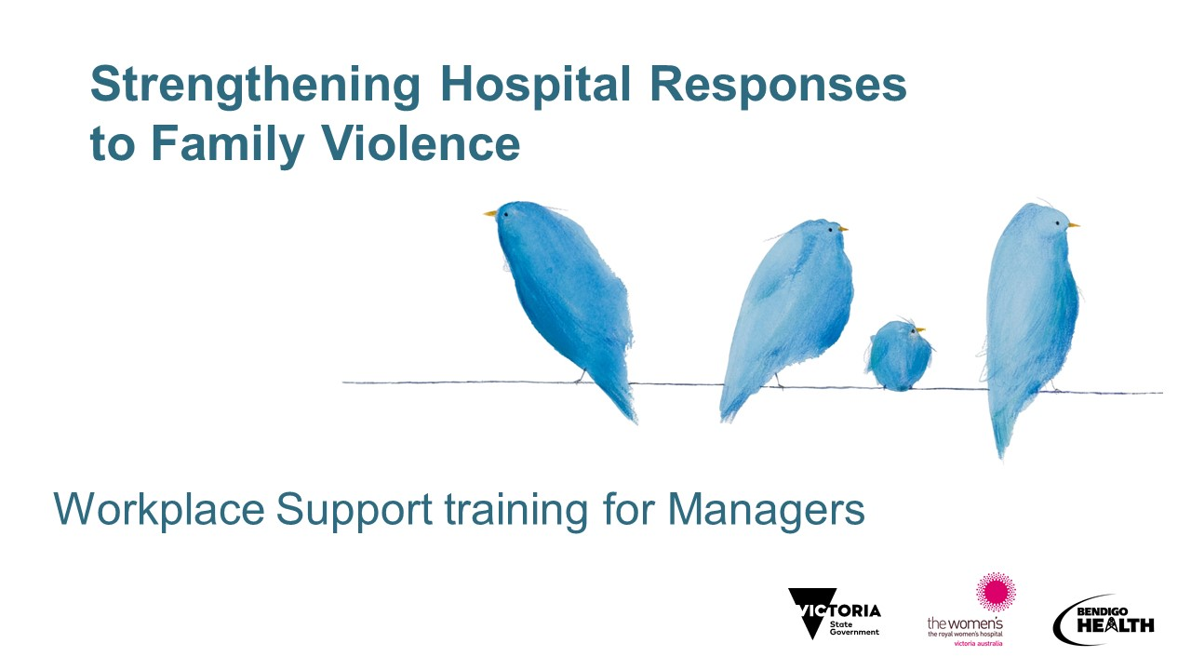
ACKNOWLEDGEMENTS  Acknowledgement of Country  Most health services will have a recommended Acknowledgement of Country to be used for meetings, presentations, etc. Where a health service does not have a recommended Acknowledgement of Country or where this is not immediately available to the trainer, the following can be used:  - [Insert name of health service] acknowledges and pays its respects to the people of the [name of traditional owners of the land – check with Local Land Council if unsure] the traditional owners of the country on which we are meeting today.  or  - We would like to acknowledge the traditional owners of the lands on which we are meeting today and pay our respect to Elders past, present and emerging.  For information about welcome to country protocols for your area, please see https://www.vic.gov.au/aboriginalvictoria/heritage/welcome-to-country-and-acknowledgement-of-traditional-owners.html  Acknowledgement of victim survivors of family violence:  - I would also like to acknowledge the many victim survivors of family violence and thank them for sharing their stories with us. Without their courage to share their stories, this work would not be possible. | 1 minute
HOUSEKEEPING  - Length of the session - session plan to be on tables  - Location of bathroom facilities  - Emergency evacuation information  - Use of mobile phones – acknowledge that there may be an urgent issue that participants need to attend to in which case they are invited to step out of the room to address this. As per usual, mobile phones should be switched off or on silent  - Group agreements (see page 17 of SHRFV Training Manual)  - No-one knows everything – together we know a lot!  - Right to be inarticulate  - Be aware of time - we might need to keep moving  - Confidentiality in the training room for you and your staff  - Story-sharing – participants can share stories that are de-identified and should be mindful to not share too much detail so that other participants cannot connect the story to the victim survivor. Not a place to share personal stories. Not a therapeutic space  - Ask participants to introduce themselves  NOTE: 1800RESPECT and other services information are on the next slide | 1 minute  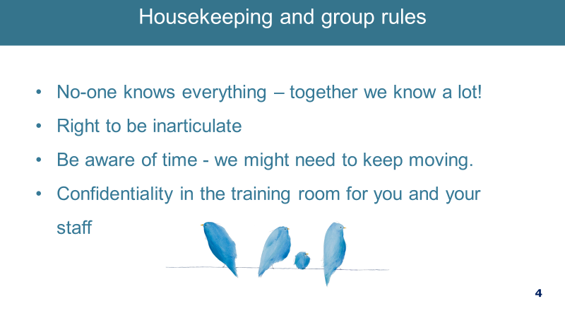
LOOKING AFTER YOURSELF  Note 1800 RESEPCT and other services  - Self-care during the training – acknowledge that the topic can be difficult and triggering for participants whether they have experienced family violence or not  - Today we will be discussing family and sexual violence. This topic can be distressing, particularly for people who have been impacted by violence.  - If the discussion today causes you any concern for yourself or a colleague or family member or friend, please contact one of these services for support. These are listed in your notes as well as local and workplace services you can access.  - 1800RESPECT and Safe Steps are 24-hour Sexual Assault Crisis Line (SACL) is an after-hours service.  - If you feel you need to discontinue at any time, you may do so, and we encourage to reach out to available supports.  - Advise participants that if they need to leave the session for personal reasons, they can take a break by leaving the room at any time without explanation  - It is suggested that a facilitator follow up with the participant after the training in such circumstances  - Note that there are a number of specialist family violence services available within Victoria which managers should be aware of – refer to the slide  - Also please note we will be speaking about Violence against Aboriginal women and children in the next hour. We do highlight family violence against Aboriginal people as a urgent issue that our country needs to address. If there are any Aboriginal or Torres Strait Islander participants or others for whom this is going to cause distress, feel free to leave or do whatever you need to do to be safe. | 1 minute  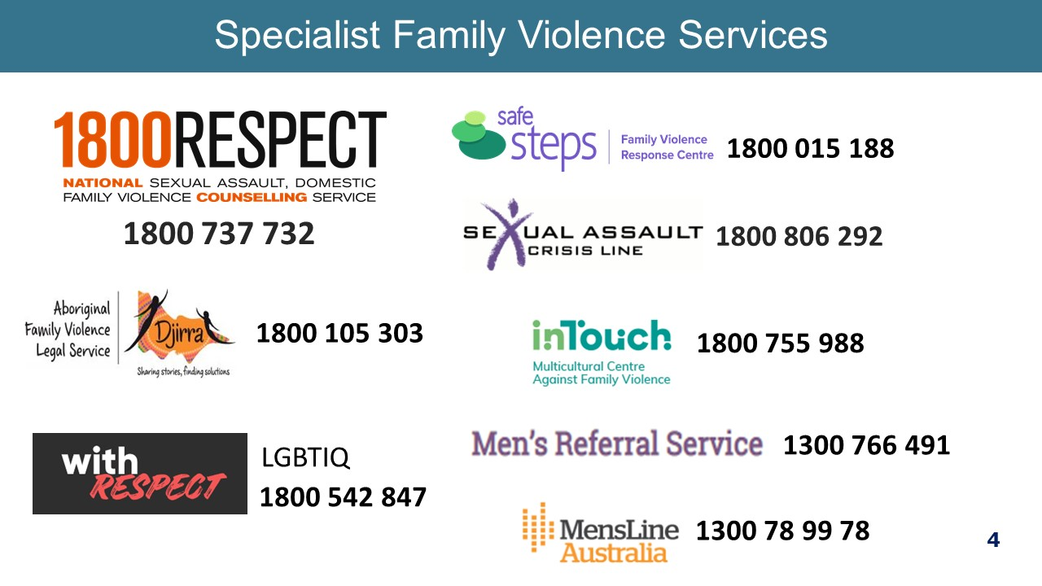
DEFINING FAMILY VIOLENCE  Remind participants of the definition which is what our policies and procedures use as the definition.  - This is the definition used in Workplace Support which comes from the Family Violence Protection Act Vic.  - It can be any one of these behaviours. It is not just physical violence.  - The key words in the definition are ‘control’ and ‘fear’. This is what differentiates family violence from relationship conflict – it is the use of fear to ensure that one person retains power and control within the relationship.  - Not all types of violence are criminal offences, e.g. emotional abuse.  Definition of family  - The Act takes a very broad understanding of ‘family’ – it includes extended kinship structures in Aboriginal and Torres Strait Islander communities, and a carer of a person with a disability if that carer is in a ‘family-like’ relationships.  Children  - Children are to be recognised as victim survivors of family violence in their own right, whether they are directly targeted by a perpetrator, or being exposed to or witnessing violence or its impacts on other family members.  - Exposure to violence can also include:  • Hearing violence  • Being aware of violence or its impacts  • Being used or blamed as a trigger for family violence  • Seeing or experiencing the consequences of family violence, including impacts on availability of the primary caregiver and on the parent-child relationship  - More than half of the women who experience family violence have children in their care when the violence occurs.  - Sometimes we talk of intimate partner violence, which is part of family violence, but family violence is much broader than just your partner. Many of the statistics we have related to partner violence.  - NOTE: We will talk more about the signs and indicators later.  Key message: Family violence causes fear by exerting power and control. | 1 minute  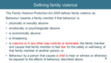
FAMILY VIOLENCE IS GENDERED AND A HEALTH AND WELFARE ISSUE  - Family violence is a gendered issue. Overwhelmingly, the majority of acts of family violence and sexual assault are perpetrated by men against women and their children.  - Men and women have different experiences of violence, with men experiencing more physical violence than women  - While victims of family violence are predominantly women and children, males can also be victims, particularly as children.  - Women are much more likely to be living with this violence and fear over weeks, months, years, and lifetimes, so this is likely to have even more of an impact on their health and wellbeing.  - Family violence has severe and persistent impacts on a person’s physical, psychological and social wellbeing and is the leading cause of homelessness  - In 2016-2017, there were 1,328 people who presented to Victorian hospital emergency departments with a family violence related injury and of those, 40% had sustained a brain injury (Brain Injury Australia, 2018)  - Women who experience family violence rate their health as poorer and use health services more frequently than other women  - The psychological impacts of family violence - such as depression, anxiety, and post-traumatic stress disorder - are profound and endure long after the violence has stopped  - The social, behavioural, cognitive and emotional effects on children are significant and may have a lasting impact on their education and employment outcomes  Key message: Family violence is a health issue with severe and persistent impacts on a person’s physical, psychological and social wellbeing. | 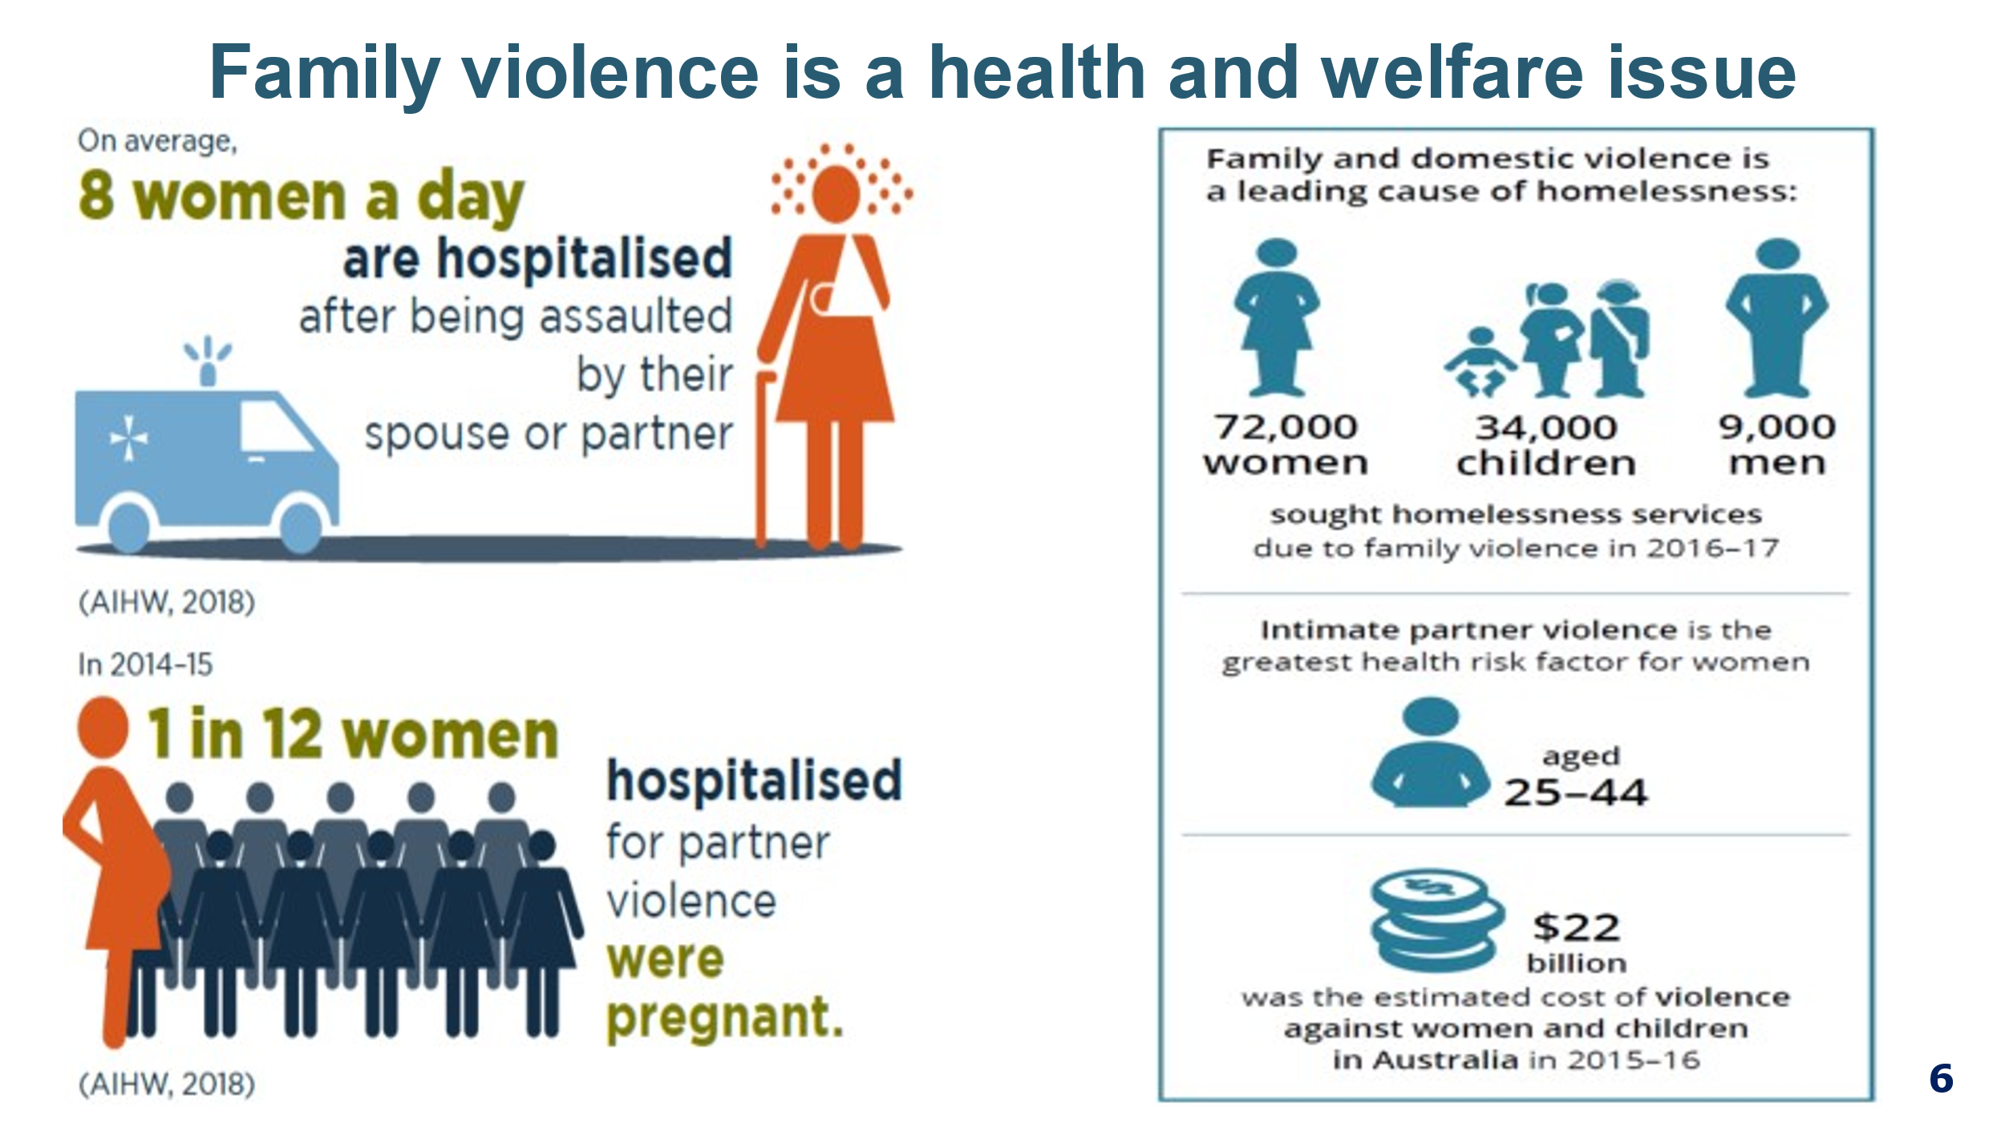
SOME PEOPLE ARE MORE AT RISK OR FACE ADDITIONAL BARRIERS TO RECOVERY AND SUPPORT  - Some groups of people are more likely to experience family or sexual violence than other groups or face additional barriers in coping with and recovering from family, domestic and sexual violence.  - We need to be aware of our assumption and biases about who experiences family violence and what the violence looks like.  - We need to be aware that our attitudes, those of other and also structures and systems may be a barrier to some victims in disclosing and seeking help for family violence.  Sources:  Australian Institute of Health and Welfare (2019). Family, domestic and sexual violence in Australia: continuing the national story 2019. Cat. no. FDV 3. Canberra: AIHW  Australian Institute of Health and Welfare. (2018). Family, domestic and sexual violence in Australia, 2018. Canberra: AIHW. | 2 minutes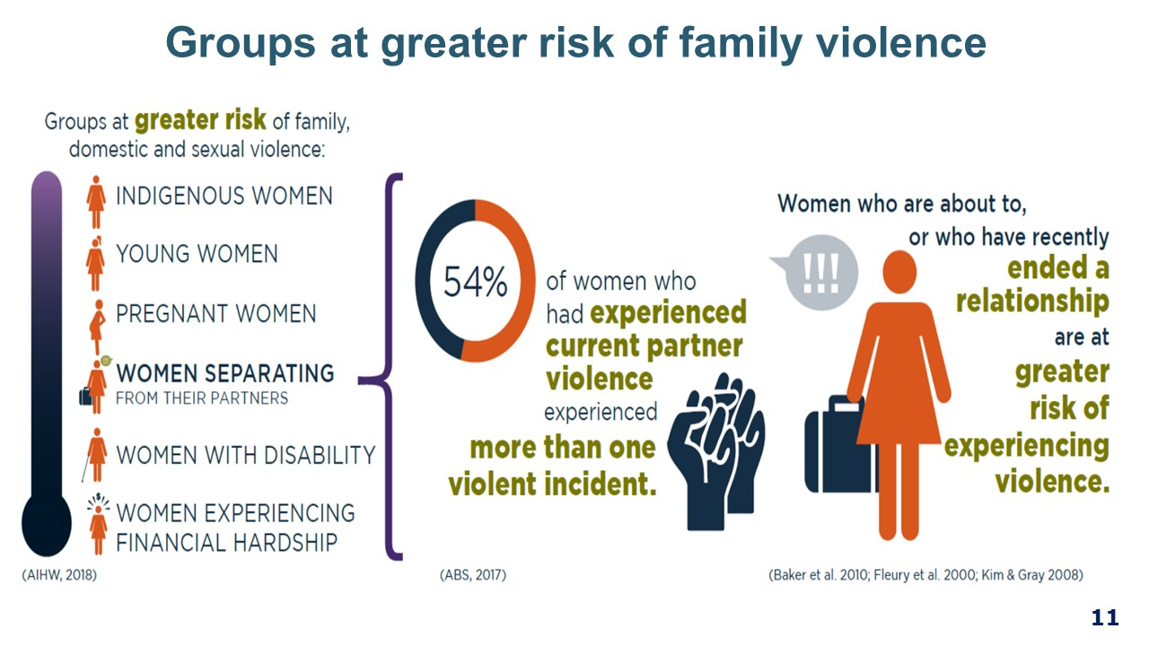
THE WORKPLACE AS A SETTING FOR PREVENTION  - We often get to this part of the training and are asked, “so, what can we do to prevent this violence and whose role is it?”  - There are many actions we can take to prevent family violence, both as individuals and workplaces. This work is already happening in our hospitals, with actions to build respectful workplace behaviours and to through the work to promote gender equality.  - Today we are focused on the work to support staff who may be experiencing family violence which is also a crucial part of this work. The Family Violence Workplace Support Program is our program for responding to staff experiencing family violence.  - Before we move into looking more closely at Workplace Support, we will take a moment to look at the workplace as a site of prevention of violence, and what this looks like.  - Workplace is an important site for prevention of violence against women, that is, challenging gender inequality. This work is now legislated through the Gender Equality Act 2020, which covers all Victorian public health services.  - Evidence suggests that stopping the violence before it begins will have the greatest impact on the prevalence of family violence.  - In the workplace, we have an opportunity to contribute to a culture that challenges gender inequality and rigid gender stereotypes and to create an environment where gender equity is valued by promoting equal and respectful relationships between women and men.  - As a manager, you are in a leadership role and it is the expectation that you will actively contribute to a culture that is respectful, promotes respectful relationships between women and men and enshrine gender equity measures.  Point for facilitator to be aware of:  Consider the relationship between the three circles. The intersection between these 3 circles is the prevention of family violence. As a manager, you have part to play in each of these circles that will contribute to responding to and preventing family violence.  Green circle – Family violence support  Today we are focusing on the Family Violence Workplace support circle, but we wish to note that the other two areas are important.  Red circle – Respectful Workplace Behaviours  The spectrum of physical and sexual violence against women is broad and encompasses a range of experiences and contexts, which can also include sexual harassment within the workplace.  Consider the similarities of an act of workplace sexual harassment and intimate partner violence:  - Both are about power and control with the overall impact being that a woman remains unequal to the man.  - Perpetrators use tactics to control and humiliate women into silence.  - Women who experience either IVP or sexual harassment often experience shame and embarrassment and are reluctant to disclose it.  - The woman can internalise blame or be blamed, e.g. did she provoke it or what did she do to avoid it?  - As a manager, your work in role modelling appropriate behaviour and addressing issues of sexist comments and sexual harassment contributes to prevention work.  Blue circle – Values and Strategy  - The [health service] values of [insert values] outline the expected conduct of staff.  - Respectful Workplace Behaviours Program is a reference to the health services policy, procedure, training, etc. on issues of sexual harassment, discrimination and workplace bullying. Facilitators can insert the appropriate terminology for this body of work as it applies at the individual health service.  Key messages:  - The workplace can contribute to the prevention of family violence through ensuring its culture is respectful and promoting gender equity measures.  - Supporting our people affected by family violence is the right thing to do – and it aligns to our strategy. | 3 minutes  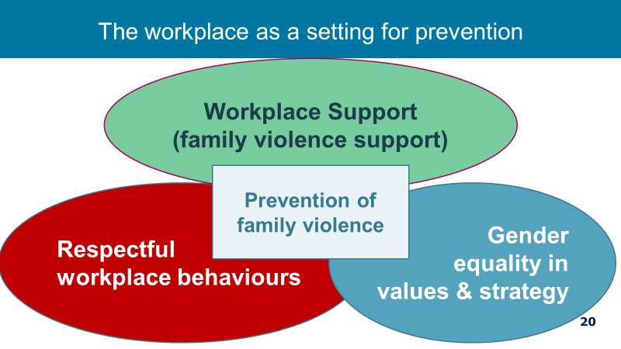
YOUR ROLE AS MANAGER  - Everyone’s role is vital in an effective response to family violence.  - You have a specific role as a manager within a workplace context.  - This slide and the next covers what your role is. This is also outlined in the procedure and we will cover these points over the next 60 minutes. | 2 minutes  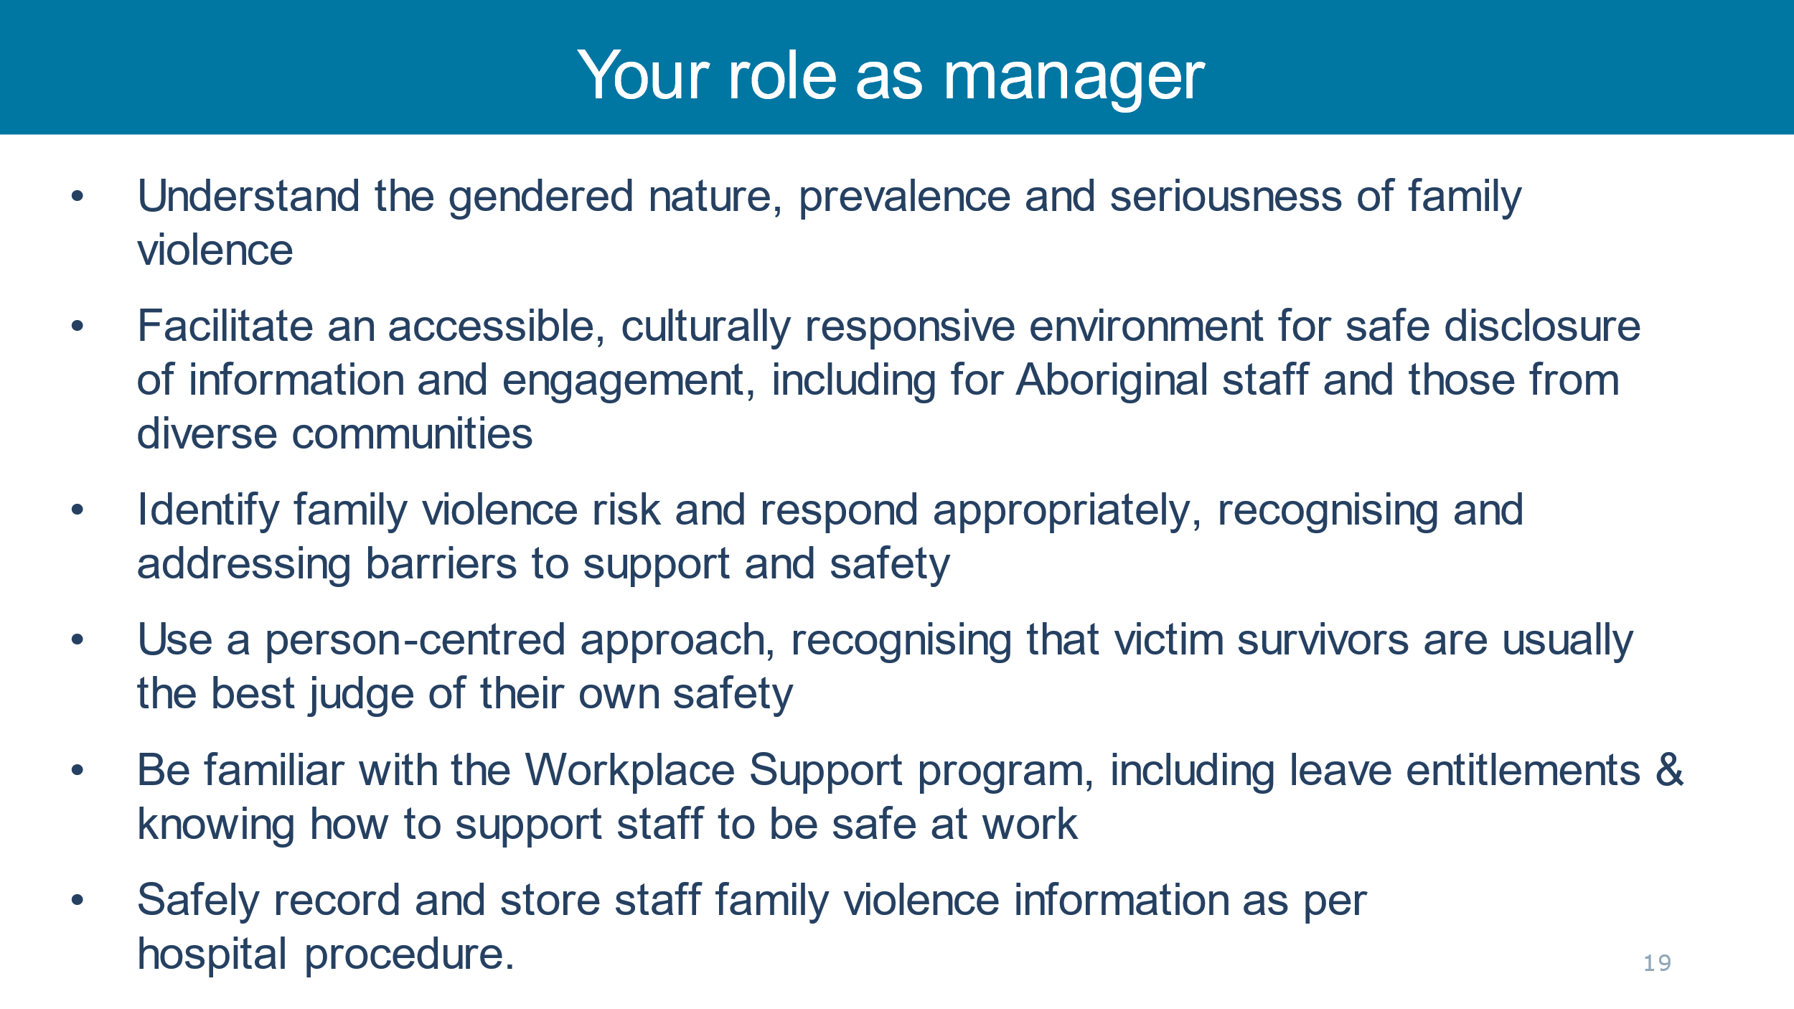
HOW DOES FV IMPACT THE WORKPLACE?  - Family violence can impact the victim survivor and others in the workplace in many ways. There are many negative impacts of family violence on victim survivors that you may see at work, including:  - Disrupted work, decreased productivity, absenteeism (high sick leave rates) resignation and a real fear of losing the job due to these productivity factors.  - Much of what we know comes from a study out of NSW, which reported the main impact was on work performance, with 16% of victims reporting being distracted, tired or unwell, 10% needing to take time off, and 7% being late for work (McFerran, 2011).  - As many victims report losing their job as a result of family violence and many victims will not disclose for fear of losing their jobs, our role is to be clear that rather than punish a victim survivor for coming forward, we will provide that staff member with the time and capacity to respond to their safety and wellbeing needs.  - Employment for the victim survivor is one of the most important protective factors, as it contributes to financial independence, and provides social support.  - The first study investigating family violence among female healthcare workers in Australia has found that almost half of them (45 per cent) have experienced family violence, including one in nine who had experienced abuse and violence by a partner during the previous 12 months.  - The study, involving 471 Victorian female healthcare workers, found that one in eight women had been sexually assaulted by a partner since the age of 16.  Key messages:  - Paid employment is an important protective factor for people affected by family violence.  - Work colleagues and managers are important sources of support.  Source: McFerran study – national online survey of domestic violence and the workplace, undertaken by Australian Domestic and Family Violence Clearinghouse (ADFVC) at the University of New South Wales.  McLindon, E., Humphreys, C. & Hegarty, K. “It happens to clinicians too”: an Australian prevalence study of intimate partner and family violence against health professionals. BMC Women's Health 18, 113 (2018). https://doi.org/10.1186/s12905-018-0588-y | 3 minutes 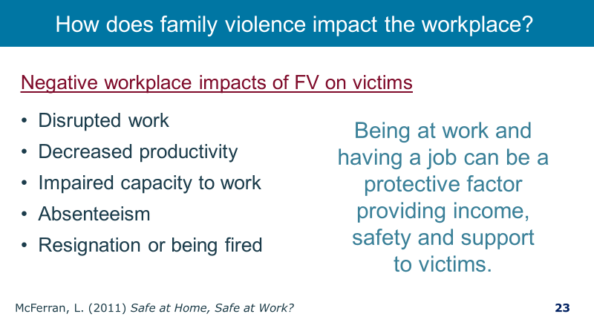
DISCLOSURE AND HELP SEEKING IN THE WORKPLACE  - So, what do we know about disclosure and help seeking in the workplace?  Read out slide  - 45% of respondents with recent experience of domestic violence discussed the violence with someone at work, primarily co-workers or friends rather than supervisors, HR staff or union representative.  - But rarely are workplaces named in Family Violence Intervention Orders.  - It’s important that we build a safe space for staff who are victims of family violence to disclose and receive appropriate support.  Key message: Work colleagues and managers are important sources of support.  Source: (McFerran, 2011) | 2 minutes  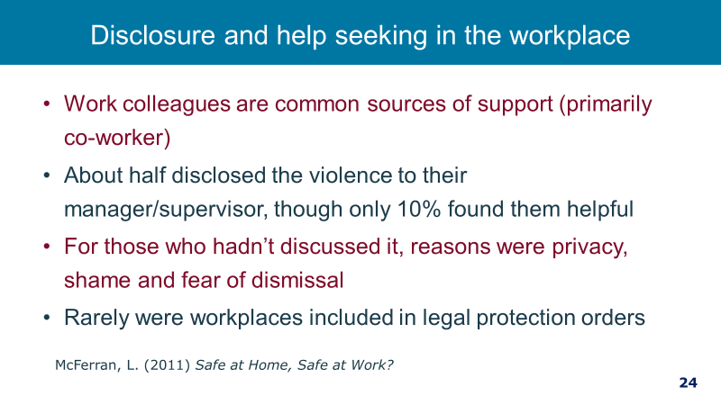
SENSITIVE PRACTICE  - So how do we support a staff member who is experiencing family violence? We use a technique called sensitive inquiry which relies on observation of signs and risk factors that may indicate family violence is occurring, and then confirming this by undertaking the identification questions.  - Sensitive practice involves understanding that victim survivors are often are the best judge of their own risk. But also, that they may not always be aware of the evidence-based risk factors.  Key message: The sensitive inquiry process relies on the elements of structured professional judgement to ascertain if family violence is occurring and the staff members’ level of risk. | 2 minutes  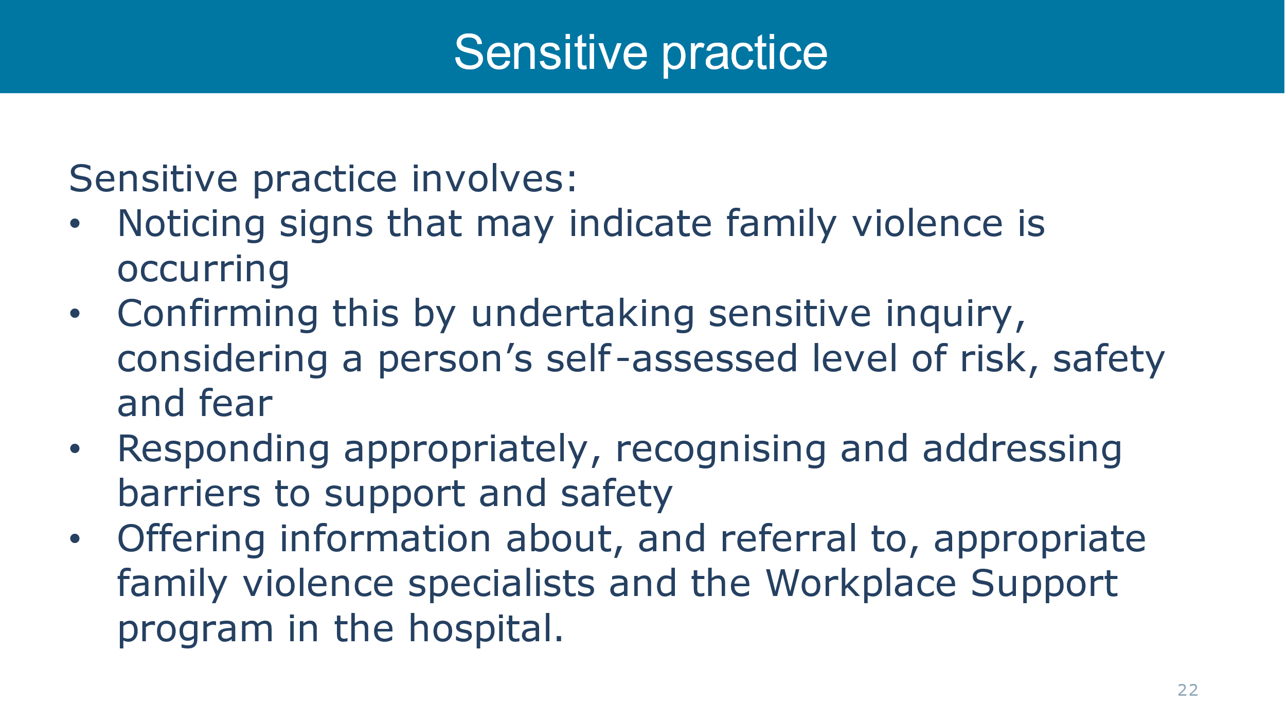
TAILORING ENGAGEMENT TO BE CULTURALLY SAFE, ACCESSIBLE AND INCLUSIVE  - How can we tailor engagement for staff to facilitate an accessible, inclusive and non-discriminatory service provision, including for Aboriginal people and people from diverse communities?  - All staff are responsible for facilitating an appropriate, accessible & culturally safe workplace environment which ensures staff feel & are safe to make a disclosure of family violence, will receive a response that is respectful and sensitive, meets their needs and ensures they can access the right support.  - Be mindful of your own biases and how they may influence your judgements and assumptions about a person’s experience of family violence or assessment of their risk.  - Be mindful to not reinforce stigma, stereotypes of discrimination by respecting their culture and identity  • We can do this by continuing to develop own knowledge about identities, barriers and experiences of family violence across the community  - Tailor your response to their identity and needs  • For example, consider if mainstream referral may be more appropriate rather than a culturally specific service. In smaller communities, the victim survivor may have concerns around privacy or perpetrator finding out.  - Hear and acknowledge how workplace and service systems place barriers on their access to support, and take steps to remove identified barriers  • upholding everyone’s right to receive a culturally safe and respectful service may involve advocating for changes to practices and structures internally and externally  - Recognise a victim survivor as the expert in their own experience and do not make decisions. Offer support not advice.  • This includes respecting an individual’s right to self-determination.  - Ensure any action taken are victim led; and that they have access to information and support from specialist services.  Key Messages: We need to put effort into ensuring we provide a culturally safe, accessible and inclusive response. This is partly looking at our practices and systems and also looking at our own attitudes.  Ensuring our response reaches and supports all victim / survivors: Additional notes for facilitators  - Victims of violence who experience multiple forms of discrimination also face additional barriers to accessing appropriate services and support. It is important that our policies, procedures and practices recognise the different experiences of staff and the impact of structural, and attitudinal discrimination on victim’s access to support and that we tailor our work so that our support reaches every person who needs it.  - Experiences of structural inequality, barriers or discrimination can also alter the way an individual or community experiences family violence, and in many instances contribute to increased risk and amplify barriers to disclosure and service access.  - Structural inequality, barriers and discrimination can be experienced by individuals and communities as oppression and domination resulting from the impacts of patriarchy, colonisation and dispossession, racism, ableism, ageism, homophobia and transphobia. This can also impact how we work with and respond to victim survivors of family violence.  - Your hospitals policies, practices and procedures can either address these inequalities, discrimination and the barriers through being not only inclusive but actively identifying and challenging them.  - Your role as managers is to understand where you might have beliefs that make it less likely for victims to ask for or receive support from you and others in your service.  - Your role is also to identify and address where those barriers to support might be structural, such as language barriers, financial barriers.  - Commitment to good practice suggests that you seek additional advice from services who work with diverse communities. You can do this before you speak with you staff member or afterwards if you are not able to plan the discussion in advance.  - When thinking about different aspects of a person’s identity that might affect their experiences of family violence, access to and appropriateness of services; it is important to consider the whole person. For example, while it is important to consider particular experiences and barriers for people with disabilities you also need to recognise this is only one aspect of their identity and other identities and experiences may affect their presentation and access to services including sexual orientation, gender identity and cultural background.  MARAM practice guide notes that ‘Diverse communities’ and ‘at-risk age groups’ is broadly defined to include diverse cultural, linguistic and faith communities; people with a disability; people experiencing mental health issues; lesbian, gay, bisexual, transgender and gender diverse, intersex and queer/questioning (LGBTIQ) people; women in or exiting prison or forensic institutions; people who work in the sex industry; people living in regional, remote and rural communities; male victim survivors; older people (aged 65 years, or 45 years for Aboriginal people; children (0–4 years of age are most at risk) and young people (12–25 years of age). | 3 minutes  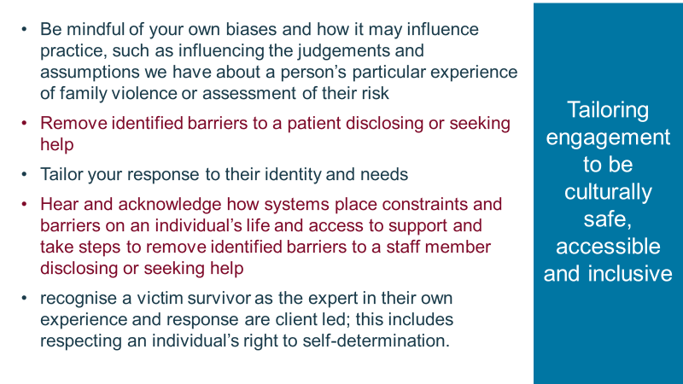
SAFE AT HOME, SAFE AT WORK SURVEY  Discuss these case examples with the group.  - Ask participants what stands out about these cases? Note that none of these examples involve physical violence, although all involve controlling behaviours  - It is notable that 95% of women with violent stalking partners, were harassed in their workplaces. But rarely are workplaces named in IVOs.  - “It happens to clinicians too”: an Australian prevalence study of intimate partner and family violence against health professionals; This study suggests that intimate partner and family violence, including sexual assault, are frequent traumas in the lives of participating women health professionals. One in ten (11.5%) health professionals had felt fear of their partner, or experienced physical, emotional and/or sexual violence from them during the previous 12 months. The University of Melbourne 2018.  KEY MESSAGE: The impact of family violence is very serious for the victim/survivor and not always physical.  Source: Logan T, Shannon L, Cole J & Swanberg J 2007, Partner stalking and implications for women’s employment, Journal of Interpersonal Violence, vol. 22, issue 3, pp. 268-291 | 2 minutes  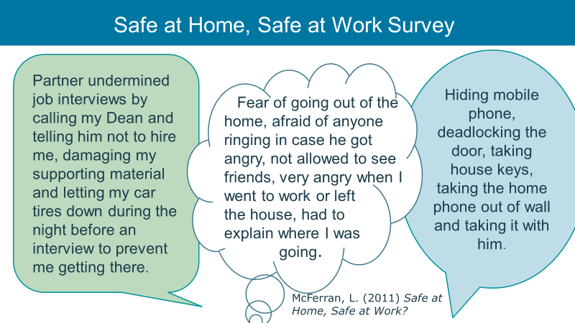
FAMILY VIOLENCE AFFECTS CAPACITY TO WORK  Discuss the case examples with the group. Ask participants what they notice about these experiences?  Note that the use of children features prominently, e.g.  - Not providing care  - Threatening to Go to the pub when looking after children  - Threatening to call DHHS  KEY MESSAGE: Family Violence can impact negatively on a person’s capacity to work effectively. | 1 minutes  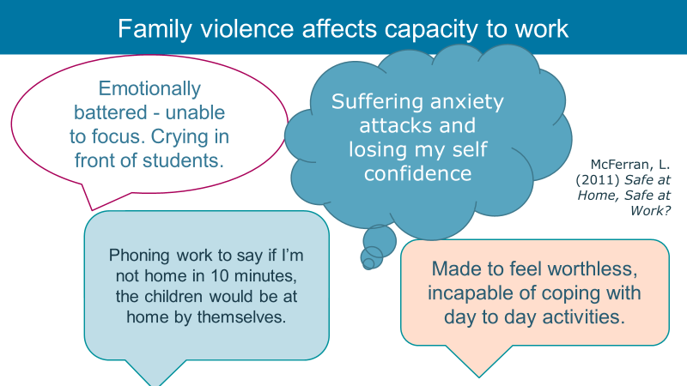
WHAT MAKES IT DIFFICULT FOR PEOPLE TO DISCLOSE FAMILY VIOLENCE?  Discuss: What stops people from disclosing? Some suggestions below to encourage responses:  - They have never been asked  - They have had a bad experience in the past and lack trust ‘in the system’  - Don’t know their rights or understand what behaviours constitutes family violence  - Worried about privacy and confidentiality  - Feelings of shame and judgement  Discuss: Which groups are less likely to disclose family violence?  - Aboriginal or Torres Islanders communities  - Culturally and linguistically diverse communities as well as refugees and asylum seekers  - People with disability  - People who experience mental health issues  - People experiencing homelessness  - People who have experienced incarceration  - Lesbian, gay, bisexual, transgender, intersex and androgynous people  - People living in rural and regional settings  - People experiencing alcohol or drug dependency  Discuss: Why might some of these groups be less likely to disclose family violence?  - Structural inequalities in our society such as sexism, ableism, racism, homophobia, transphobia, ageism, and mental health discrimination can lead to services being inaccessible to particular groups  - This creates systemic barriers for these groups to find appropriate and adequate support and responses that increase their safety  - How barriers manifest for an individual will differ, and will depend on their lived experience  - Barriers may result from past experiences of inadequate system responses, experiences of services that haven’t been accessible or responsive to their needs  - Shame, fear of not being believed, language barriers, visa status, experiences of discrimination, historic and ongoing systemic oppression, fear of reprisals or ostracisation, and concerns about their safety.  - Fear of authority, fear of having children removed - stolen generation or past history with child protection  - Loss of connection with family-fear of being shifted into care, causing family conflict or alienation.  Key message: Hospital and health services must work to overcome these barriers to ensure accessible, inclusive and non-discriminatory services that promote the safety for all victim survivors. | 2 minutes  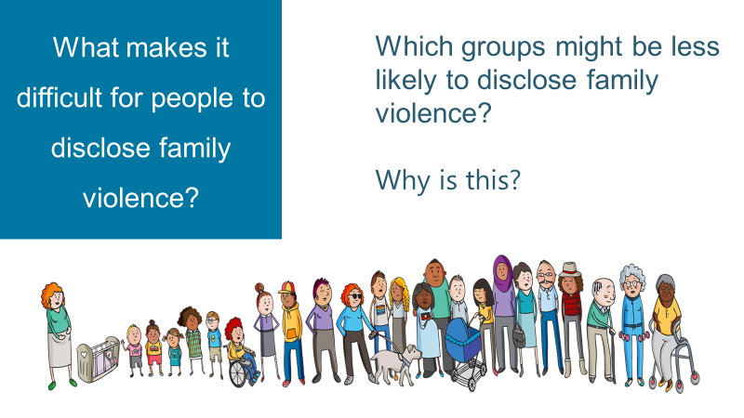
NOTICE WORKPLACE INDICATORS / SIGNS OF FAMILY VIOLENCE  - It is important to be aware of possible indicators of family violence in the workplace so that if they are present you can decide if it is appropriate to talk with your staff member about family violence.  - It is important to note that the presence if these indicators does not necessarily suggest the presence of family violence, but it may prompt you to inquire.  - It is not your role as a manager to screen for family violence, by asking team members routinely. However, if these indicators are present it may mean that family violence is present which in turn may lead to sensitive enquiry.  Key message: Be aware of signs or behaviours that could point to family violence.  Source: https://www.vic.gov.au/maram-practice-guides-and-resources | 3 minutes 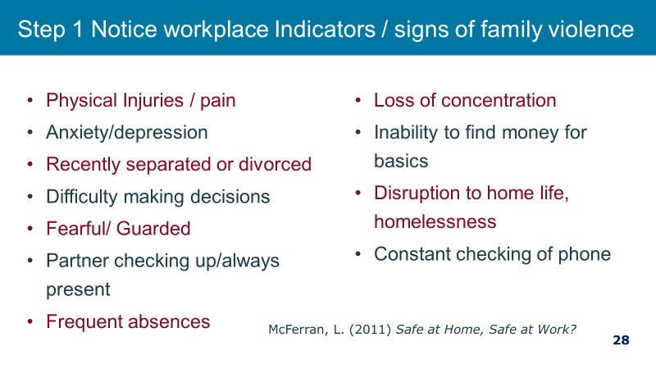
EVIDENCE BASED RISK FACTORS  - Two key factors where women are at high risk and which you may be aware of as a manager are firstly when a women is planning to leave or has just left a relationship and secondly pregnancy or child dangerous time is pregnancy and following a new birth. You may be aware of these as a manager or colleague  - It is not your role to ask about these risk factors. That is the role of family violence specialist but it is your role to be aware if you hear about something that you.  Key message: Be aware of signs or behaviours that could point to family violence.  Source: https://www.vic.gov.au/maram-practice-guides-and-resources | 1 minute (30 mins to here)  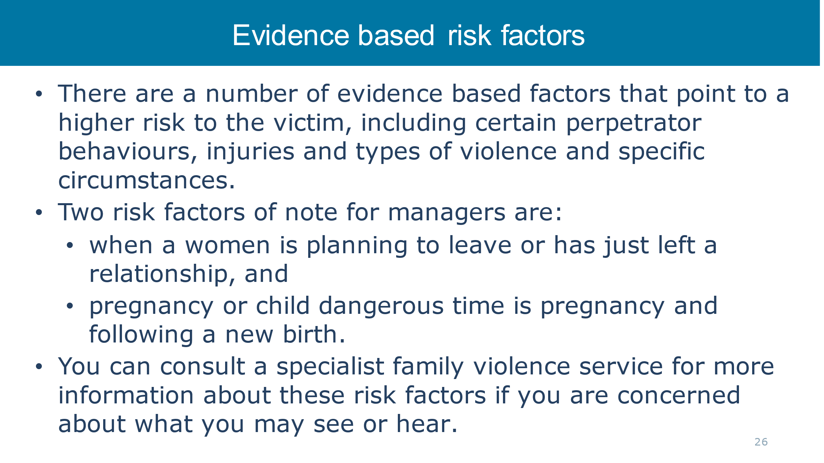
SENSITIVE PRACTICE  Read slide  These were covered in other training such as SHRFV training. | 1 minute
POWER AND CONTROL  - We have talked about what a sensitive inquiry is, and we will in a moment go through how this looks in practice. Before we do, we do want to make a note about power and control in the manager-staff relationship.  - Managers are in a position of power in relation to the staff that they manage. This is part of the authority a manager has in the exercise of their duties.  - However, in a discussion with a staff member about family violence we must be mindful of the positional power that exists and conduct ourselves in a way where that power is not used to control and dominate. This is important so as to not replicate the experience of the loss of power and control for the staff member.  Key message: Be mindful of your position of power in relation to your staff member and do not use that power to control or dominate. | 1 minute  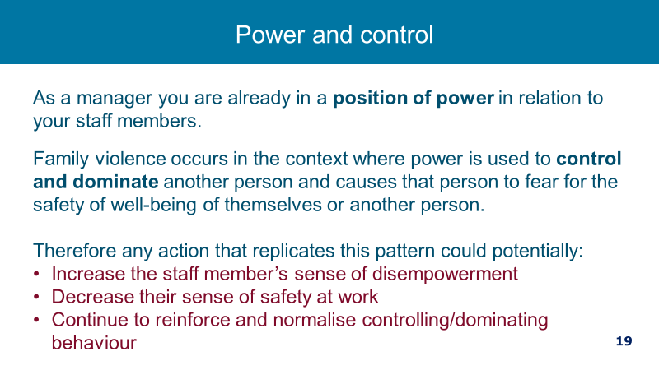
SENSITIVE PRACTICE IN A WORKPLACE SETTING  www.youtube.com/watch?v=KeJDtvs1NtQ  If you are on time watch this video  Note: It shows a clear example of safe and supportive practice. | 3 minutes 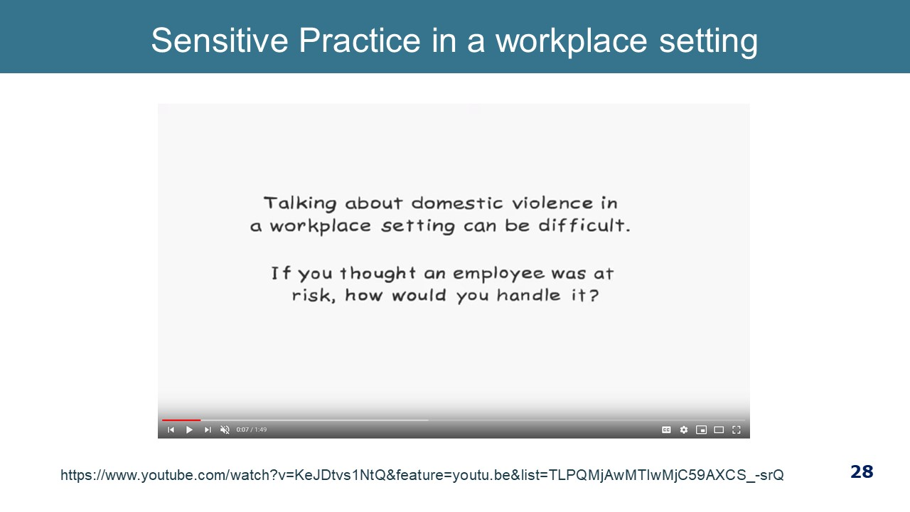  1min49secs
HELPFUL AND UNHELPFUL RESPONSES  We will give you a minute to look at these helpful and unhelpful responses and think about what makes them helpful or not helpful.  A supportive response ensures that we:  - Acknowledge and endorse their decision to disclose  - Don’t minimise or excuse abusive behaviour  - De-stigmatize their situation  - Empower using rights-based statements  - support is unconditional.  Discuss - what is good about the helpful responses?  - they validate  - offer support to enhance safety  - rights based statements  - assigns accountability to the perpetrator  - places control with the person  Discuss - what is the problem with the “not helpful statements”?  - blames the person experiencing violence  - fails to understand the complexity of the issues  - judges as a poor parent  - diminishes perpetrator responsibility (anger management problem as opposed to choosing to use violence)  - offers support as conditional to the person leaving the relationship  Key message: A supportive and non-judgmental response in any disclosure is crucial. | 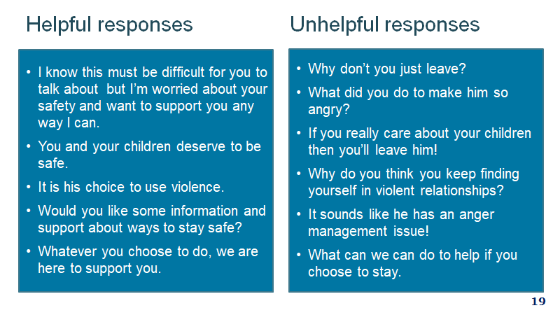
INQUIRING ABOUT FAMILY VIOLENCE WITH STAFF:  - If family violence is disclosed or if indicators of family violence are observed, your role is to sensitively and respectfully open up a conversation.  - This procedure on how to have this conversation is outlined in the Workplace Support Procedure. (see Appendix B)  - You are encouraged to ask an employee if they are experiencing family violence, but you are not required to do this.  - A relationship of trust with your employee and a supportive environment are important foundations to making sensitive inquiry as comfortable and safe as possible.  - Be truthful about limits of confidentiality and your duty of care.  - It is always good to start with a framing statement, such as:  I noticed that you seem to be quite withdrawn from the team and a bit distracted – is everything okay at home?  - The purpose of a framing statement is to position the inquiry about family violence as a routine part of hospital activities – to normalise it. Use open questions of enquiry – this gives the employee control over how much they choose to respond. They may want to give a little or a lot of information; this is the employee’s choice.  - This will make the person feel less ‘singled out’, reducing the stigma associated with being identified as a victim of family violence and/or sexual assault.  - You need to frame a statement that works for you so that it is authentic – not too scripted.  - Clinicians already ask a lot of uncomfortable questions in clinical practice, this too may take getting used to.  - Choose the setting carefully – a private space, a time when the workplace is not so hectic, at what point during the shift is it best to ask, what are the clinical demands of the person, do you have a plan in place if a disclosure is made and the person is too distressed to resume their duties.  - Non-verbal information (for example internet, poster or written material) can have a valuable educational impact – make reference to workplace support materials - if someone sees these it can alert them to the fact that they can talk with you or someone at the hospital another time – give them food for thought.  Key message: It is important to normalise inquiries about family violence – in the context of our workplace support program. | 3 minutes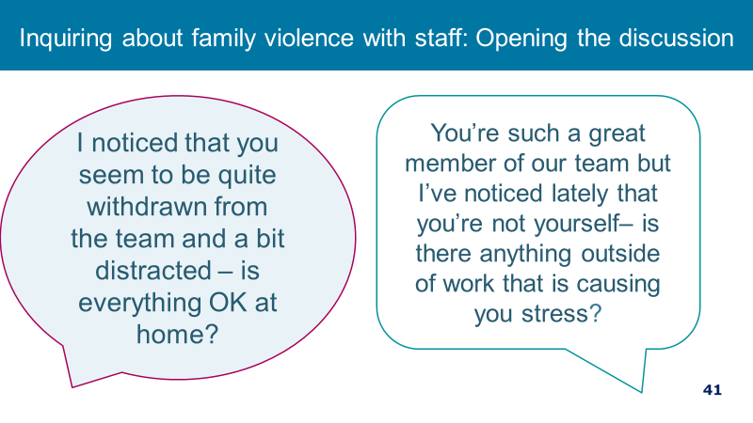  The sensitive inquiry procedure outlined in Appendix B in the updated Workplace Support Procedure on the SHRFV website.
REFERRAL  - Tailor options to your health service.  Key message: There are services available for your staff (or others around you who may need help) as well as for you to consult with. | 1 minutes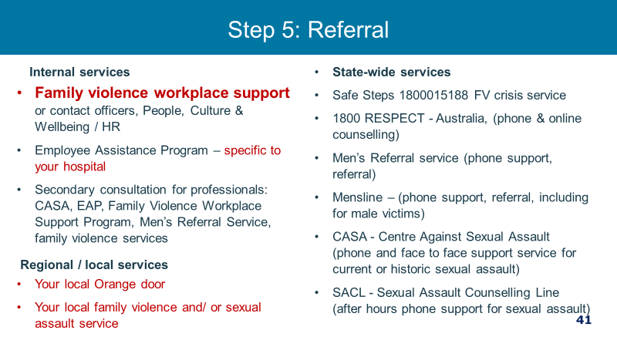
KNOW THE LIMITS OF WHAT YOU CAN DO  - Workplaces need to respond to family violence as a workplace issue and for all other matters to be able to refer employees to appropriate support services. This can be challenging where staff are friends or long-term colleagues or individuals feel a social responsibility to intervene.  Key message: Be clear about your role as a manager and there are boundaries in terms of what you as a manager should and should not do. | 2 minutes 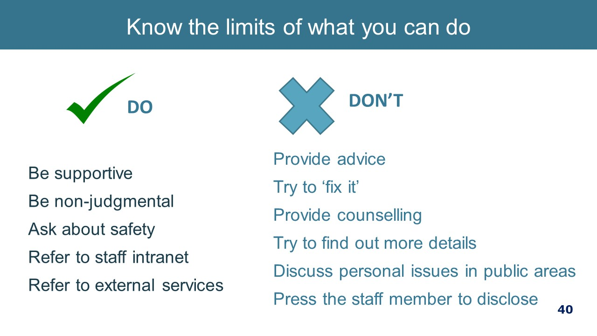
FV WORKPLACE POLICY & PROCEDURES – KEY FEATURES  - The health service understands the devastating impacts of family violence and that family violence is a violation of human rights and victims are not to blame. We understand that family violence is a workplace issue and that our staff are ‘the community’ and therefore some of our staff will be currently experience family violence or will have experienced it in the past.  - By having a family violence program in place we hope to support victim survivors to maintain employment as we know that employment is a protective factor and may reduce the impact to staff and their children.  Defines family violence  As Per Family Violence Protection Act 2008.  Provides 20 days of paid family violence leave  Note to facilitator: Most health services require limited, if any, evidentiary requirements to support family violence leave. There may be some expressions of concern from participants that this leaves family violence leave open to inappropriate use. To address any concerns, it is recommended that it is made clear that supplying documentation to take family violence leave can be burdensome and add stress to an already stressful situation and that the priority is the well-being of the employee. It might also be helpful to refer to the McFerran study that shows that family violence leave is rarely abused. In fact, there can be a number of barriers to people accessing the leave, with concerns about confidentiality being a key barrier.  At the time of writing this guide, family violence leave is available to most craft-groups through their enterprise agreement. Over time, it is expected that the clause will be included all EBAs in the Victorian public health sector. Unless it is your health services policy to extend the family violence leave to all employees regardless of the entitlement under their industrial instruments, you will need to periodically check to see if the clause is inserted into newly negotiated EAs.  Detail about taking family violence leave is reflected in the procedure. There are a few key things to note about family violence leave:  - 20 days is for a full time staff member, part time staff are entitled to this on a pro rata basis. Casuals are not entitled to paid leave but are entitled to time away/unpaid leave.  - A year is a calendar year.  - FV leave is available for employees who are experiencing family violence and facilitates their absence from the workplace to attend counselling appointments, medical appointments, legal proceedings or appointments and other activities related to and as a consequence of family violence.  - There is no exhaustive ‘menu’ of events for which an employee can take family violence leave. Rather it is important to keep in mind the connection behind the absence to family violence – it may be a health, legal, housing, child welfare reason and still fall within the scope of the right to take leave. It is also important to be mindful of the family violence leave clause that makes leave available for “other activities related to and as a consequence of family violence”.  - At times there may be a gap between an action of family violence and leave needed to deal with that action. For example, the employee may not need leave immediately following an act of physical violence (the action) but may wish to take leave to attend court to address the physical violence (activity as a consequence of family violence).  - There is often not a linear relationship between disclosure and action taken to address family violence, so be mindful that just because an employee discloses their experience of family violence, this does not necessarily mean that they require family violence leave right now to deal with the issue.  - It should also been kept in mind that it is often not the case that taking family violence leave will ‘fix’ the issue; the violence may decrease for a period of time but increase on or around significant events such as court appearances, intervention orders, birthdays and days of cultural or religious significance. Working through the impact of family violence can take some time it is unreasonable to expect that an employee will return from a period of FV leave with the matter completely resolved.  - Evidentiary requirements are outlined in the procedure – [insert the evidentiary requirements particularly to your health service].  - Employees can also use their sick leave to support a person experiencing family violence to accompany them to court or hospital or to care for children. The person they are supporting can be anyone experiencing family violence. This is different to the usual way of using sick leave as carers leave where the relationship to that person is limited to immediate family or household.  - The family violence leave application process- refer participants to the family violence leave application process if you have developed such a resource.  - Family violence leave is not intended for those who perpetrate family violence.  Confidentiality and options for people to talk to  Note to facilitator: Each health service will have their own particular information regarding Family Violence Contact Officers and Employee Assistance Program provider that needs to be inserted into the presentation.  - The requirement to have Family Violence Contact Officers is a requirement of the Family Violence Leave Clause.  - The Family Violence Contact Officer is an employee who has been trained to be a first point of contact for someone experiencing family violence so they can access information about what workplace supports are available.  - In this hospital, Family Violence Contact Officers are [insert names, title, location, where to find their contact details].  - Employees can also contact EAP for a confidential discussion.  There can be a number of reasons why an employee does not wish to disclose their experience of family violence. This is why Contact Officers are necessary. Reasons for seeking out other people to talk to may include:  - Shame and embarrassment  - Fear of being pitied or stigmatised  - Fear of being viewed as dysfunctional  - Fear of missing out on future job or other workplace opportunities  - Employee compartmentalises their life  - Manager has a poor reputation of keeping confidentiality  - Manager engages in violence supportive behaviour  - Previous history of conflict between employee and manager  - For reasons that may be related or unrelated to the relationship between the employee and the manager, it is good practice to have an alternative source of information rather than a manager  Ask if they have questions  Sources: (1) UNSW Australia (2013) Domestic and Family Violence Clauses in your Workplace: Implementation and good practice, Gendered Research Network | 5 minutes  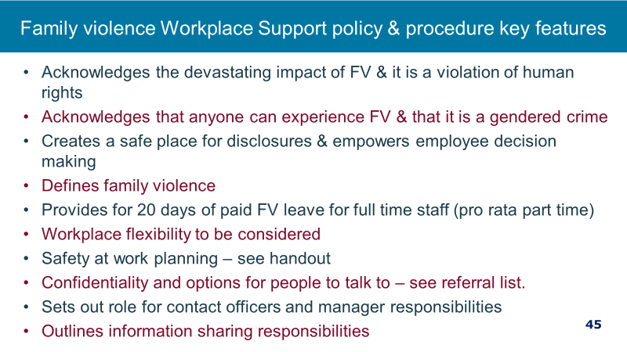  Resources:  Family Violence Workplace Support Policy & Procedure  Resource:  FV leave application process flowchart
UTILISE INTRANET INFORMATION  If you have developed an intranet site for workplace support information, you can take the opportunity to introduce/remind managers of this resource. | 1 minutes  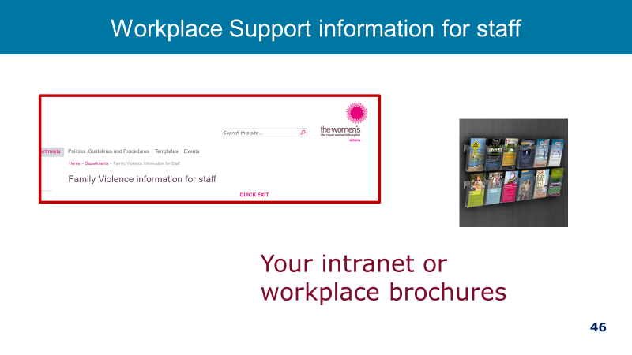
WORKPLACE SAFETY PLANNING  - Safety planning at work is one of the most important aspects of supporting staff experiencing FV.  - One of the essential responses to an employee is to support their safety at work and try to minimise the risk of due to family violence while at work. The procedure goes into some depth about this and includes a safety planning template.  - Each hospital should have a procedure for Workplace safety planning for staff.  - This is different to a personal safety plan that is usually made in consultation with a specialist service.  - It is recommended that a workplace one also is made in collaboration with a family violence specialist service.  Explain workplace safety planning template:  - The New Workplace Safety Planning Guidelines outlines a safety planning process to enhance safety and minimise the risk of an act of family violence perpetration during work time.  - It is important that you always remember that family violence victims experience loss of control and power and so that your approach is to ensure that your actions do not exacerbate this.  - The employee’s own assessment of their risk is one of the primary elements of risk assessment as it provides intimate knowledge of their lived experience. As an employer we respect this and build on their assessment through a collaborate approach. This helps ensure that the employee’s needs are met and that we do not override their decision making.  Source: ANROWS National Risk Assessment Principles for domestic and family violence | 2 minutes  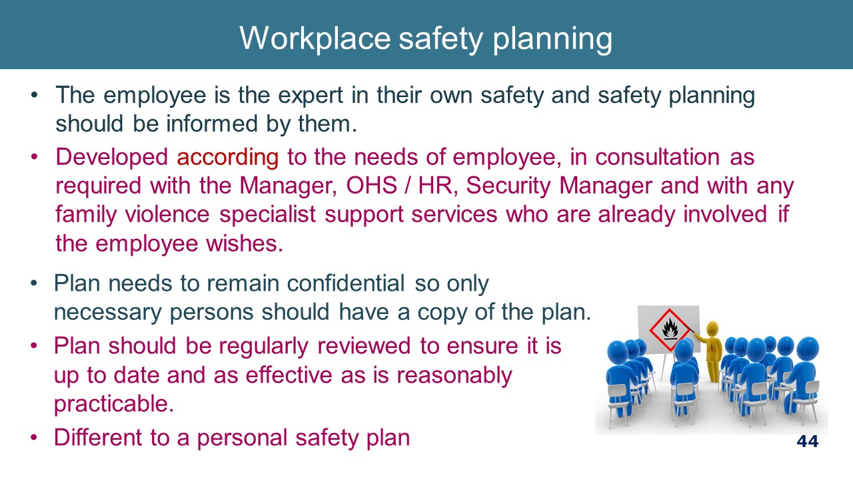  Resource: Safety planning template from Family Violence Workplace Support Procedure
SAFETY PLANNING & SUPPORT  - Ways in which a hospital may typically be able to support the safety of the staff member includes changing location of work, changing the phone number or email address, notifying security and reception to alert them to the perpetrator entering the workplace and required action, relocating their car park, security escort to and from their car.  - There are a number of options available in relation to workplace flexibility where this is needed to support an employee experiencing FV and/or to enhance their safety. Some of the ways in which we can offer this include modification to shifts/hours of work and duties  Video option: “How do develop a personal safety plan for time at work” https://www.youtube.com/watch?v=CqL61xeomd8  Key message: Safety Planning is important for all staff. Seek advice from FV service if in doubt of how to do this. | 1 minutes  www.youtube.com/  watch?v=CqL61xeomd8  1min29min
DOCUMENT  The only documentation of family violence disclosures from staff must relate to:  - Records of family violence (FV) leave taken by individual staff members (FV leave record)  - Records related to safety planning, work planning and performance management (Family violence employee file).  - HR will manage documentation. Refer to new Workplace Support Information Handling Guidelines. | 1 minutes  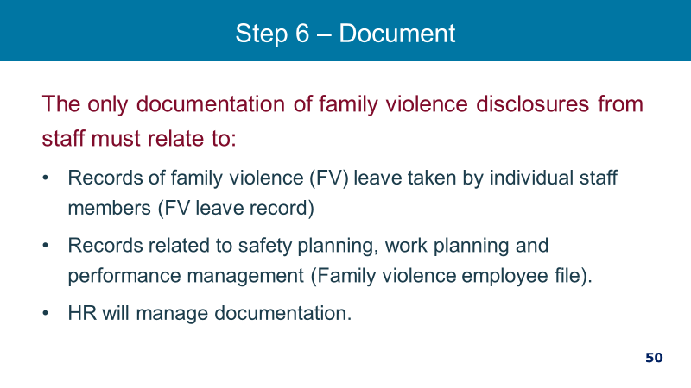
MANDATORY REPORTING  Health services should seek legal advice on the below and tailor their training to reflect that advice.  - Mandatory reporting obligations where a mandated reported has concerns about the well-being of a staff members child.  - Obligations under the Crimes Act 1958.  - Obligations under the Commission for Children and Young People’s Report Conduct Scheme.  - Obligations under the FVISS and CISS schemes (as of Sept. 2020).  - We all have a responsibility to keep children safe and report certain conducts. If children are involved, consult with your manager / HR or legal. You can also ring a specialist services for information, providing de-identified information if you are unsure about your obligations to report.  - KEY MESSAGE: We have clear reporting obligations under the law and we need to understand them.  From WS procedure  - Child Protection / child safety reporting requirements  - In your conversations with a staff member you may become aware that there are children who are or may be at risk. There are three main legislative reporting obligations which all staff members should be aware of as all staff have obligations in relation to children.  - The three main legislative reporting obligations are:  1. Crimes Act (Vic) 1958 requires all adults to report to Victoria Police if there is a reasonable belief that a sexual offence has been committed by an adult against a child under the age of 16 years.  2. Reportable Conduct Scheme under the Child Wellbeing and Safety Act 2005 (the Act) requires the head of an organisation to report allegations the following by staff or volunteers of:  - sexual offences against, with or in the presence of a child  - misconduct against, with or in the presence of a child  - physical violence against, with or in the presence of a child  - behaviour that causes significant emotional or physical harm of a child  - significant neglect of a child  - These behaviours include but are not limited to sexual abuse, grooming, sexting, inappropriate physical contact, sexualised behaviour with a child.  - Where a staff member believes any of the above may be occurring, [HR] should be immediately and confidentially notified.  3. Mandatory reporting obligations under the Children, Youth and Families Act 2005.  - This obligation arises for a class of employees who, in the course of practising his or her profession or carrying out the duties of his or her office, position or employment, forms the belief on reasonable grounds that a child is in need of protection. Please refer to [Mandatory Reporting Policy] for which roles have mandatory reporting obligations under the Children, Youth & Families Act 2005.  - Any staff member may seek confidential advice from the Women’s in-house legal team about mandatory reporting obligations and duty of care obligations.  - Reports to Child Protection or the Police should be done in a respectful and transparent manner. The limits to confidentiality should be explained prior to a conversation related to family violence to support a disclosure of family violence being made with informed knowledge of how information is shared in Victoria.  - It is best practice to share information with consent and involvement of the adult victim survivor, and their information knowledge of what information is being reported so they can manage their safety and the safety of the children accordingly. Sharing information without the informed knowledge of a victim survivor of family violence can increase their risk. | 2 minutes  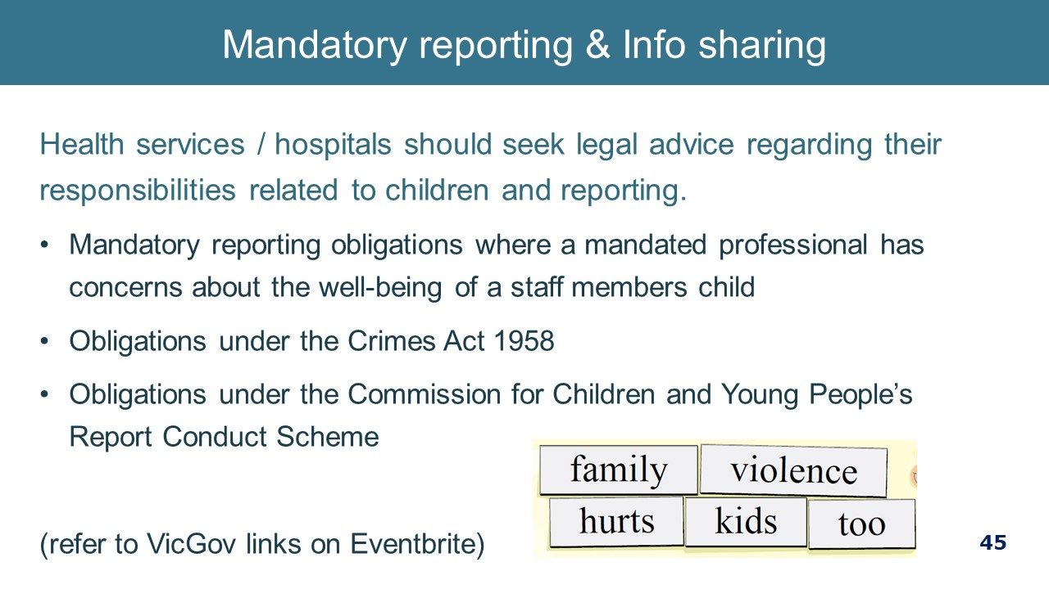
WORKPLACE RESPONSE TO PERPETRATORS  Refer managers to the new Perpetrators documents in the Toolkit.  Note to facilitator: While a workplace response to perpetrators (or people who chose to use violence) is important, there are a number of complexities to consider. That response will be guided by the overall approach that an individual health service chooses to take and what organisational policies, procedures and other mechanisms are in place to support that approach. Accordingly, this part may need to be adapted to local circumstances.  Be mindful that a response to perpetrators as employees, while important, will not have a large impact on the reducing the prevalence of violence against women. For this reason, focusing more attention on broader organisational cultural factors that contribute to the elimination of violence against women is more productive in the long term.  Below is a summary of considerations:  - Safety as a priority  The safety of victim survivors, other staff and patients should guide any actions we take in relation to staff who perpetrate violence  - Our role as an employer  It is important to keep in mind that as an employer, we are in an employment relationship with an employee who perpetrates family violence. This is distinct from The Women’s as a health service provider to patients.  It is the role of the hospital to:  - provide a safe work environment;  - provide a safe clinical service for patients; and  - to set and uphold expected codes of behaviour for our employees.  Be aware of collusion  - While FV perpetration is a workplace issue for many reasons, including those noted above, it is not the responsibility of the employer to ‘rehabilitate’ a perpetrating employee. Unskilled or misguided attempts at this work can be highly unsafe and outside the remit of an employer. Such work is to be done by those with specialist skills in FV perpetration and behaviour change.  - Perpetrators have highly reinforced ways of justifying their behaviour or making themselves out to be the victim (although it is important to keep in mind that a perpetrator may have a past experience as a victim survivor of family violence). Do not be drawn in by perpetrator invitations to support their behaviour (such as comments about their partner’s mental instability, incompetence, etc.) as you will inadvertently colluding with them. It is important to ensure that the workplace culture is not violence supportive (e.g. the telling of sexist jokes is not tolerated) so that the perpetrator’s behaviour is not reinforced by what they see around them at work.  Possible workplace responses  - Consider your source of obligations and enablers – Health and Safety Act (e.g. obligation to provide a safe workplace, employee obligation to comply with instructions to maintain a safe workplace), contract of employment, industrial instruments, policies/procedures/guidelines, Victorian Public Sector Code of Conduct, emergency response procedures (e.g. code grey, code black).  - Disciplinary Procedure provides that if an employee commits an act of violence during work time or utilising the hospitals resources, it may result in disciplinary action or even termination of employment. IT Usage Agreement and Social Media Policy aligns with this.  - Practically managing FV between 2 staff members – options may include monitoring the situation, referral to a support service, temporary adjustment to work, a behavioural contract or MoU (which includes consequences of breaching this), temporary absence from work.  - Promotion of referral information, including information about your EAP service– on the intranet, through flyers or posters located in change rooms or bathrooms  - Intervention orders – IVOs are a civil matter, a breach of an IVO is a criminal matter. You may have in your contract of employment, the obligation to report a criminal conviction. Keep in mind that an employer cannot discriminate against an employee on the basis of their criminal record unless the criminal record means that he or she is unable to perform the inherent requirements of the role. This needs to be determine on a case by case basis having regard to the nature of the conviction and the inherent requirements of the role.  - The behaviour may have an impact on the professional registration of your employee.  - The behaviour may invoke the employer obligations under the CCYP Reportable Conduct Scheme as mentioned earlier.  Key message: There are many considerations when responding to an employee who uses family violence.  Sources:  Workplace Support responding to staff who perpetrate family violence – Policy and Guidelines.  Domestic and family violence, A workplace approach to employees who use or may use violence and abuse: A resource for all Queensland workplaces  North West Metropolitan Region Primary Care Partnerships Guides for engaging with people who cause family violence harm: Policy Guidelines  www.humanrights.gov.au | 2 minutes  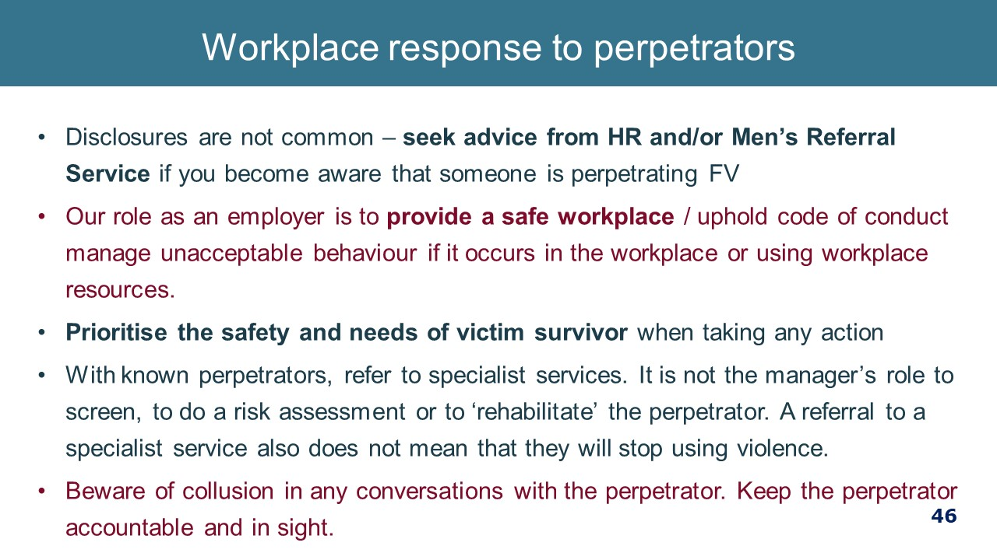  Resource: Workplace Support responding to staff who perpetrate family violence - Guidelines.
SUPPORT SERVICES  - Tailor to your hospital arrangements  - Remember they are there for you if you wish to get support for yourself or a secondary referral  KEY MESSAGE: Working with and supporting anyone affected by family violence can have an impact – take care of yourself | 1 minute 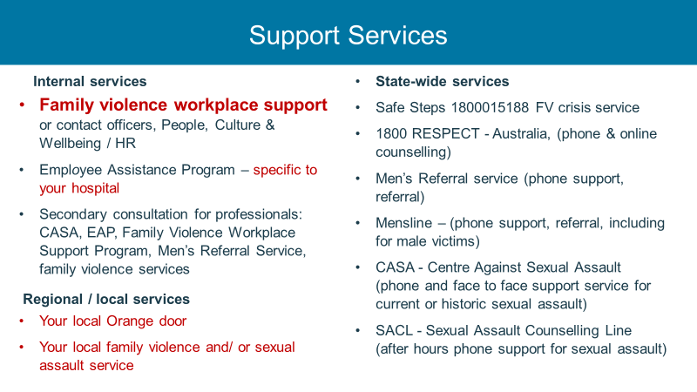
MANAGERS CAN MAKE A DIFFERENCE  https://youtu.be/1QN-_RyAxBs  Video should be ended at 4 minutes 30 seconds. The rest is a repeat.  If you have a long time you could show: Supervisors can make a difference. it goes for 21 minutes:  https://www.youtube.com/watch?v=HdNbnUAVFT4  Supervisors can make all the difference: The impact of domestic and sexual violence and stalking  - After the video, this is also a good opportunity to explore with the group if they have had an experience of the managing performance of an employee experiencing family violence.  - What worked  - What did not work  - Did they realise at the time what was doing on in the employee’s personal life? Is there anything they would do differently now that they have done some training on FV? | The video goes for 5 minutes But you can end at 4:30  (watch and discuss if you have time but otherwise let them know that it covers the issues discussed.  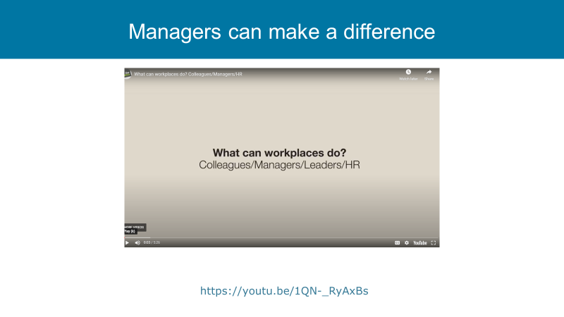
SELF CARE  - Be aware of the importance of your own self-care. We encourage you to actively undertake professional and personal self-care initiatives to help build resilience to the demands of your role.  - While this is important more broadly, it is really important when managing disclosures of family violence from staff and particularly if you have your own past or current experience of family violence.  KEY MESSAGE: Working with and supporting anyone affected by family violence can have an impact – take care of yourself. | 1 minute  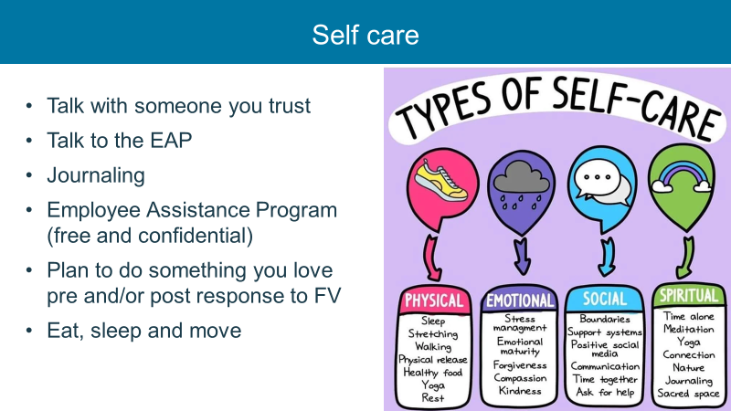
CLOSING  - (remining time is for questions)  - Remind participants of where they can access further information and support.  - Thank participants for their attendance.  - Remind participants to complete the post-training survey. | 1 minute  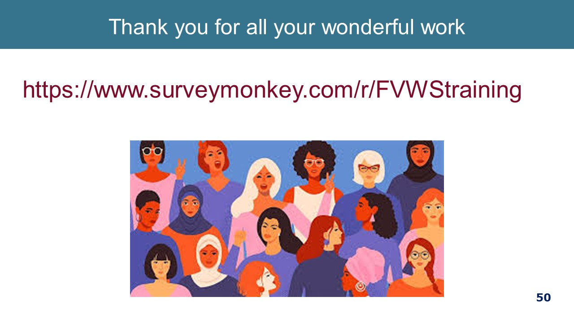

Appendix A: Recommended reading for facilitators
The following list is minimum recommended reading for facilitators.
- Australian Bureau of Statistics. (2017). Personal safety, Australia, 2016. Canberra, ACT: Author. Available at: http://www.abs.gov.au/ausstats/abs@.nsf/mf/4906.0
- Australian Institute of Health and Welfare (2018), Family, domestic and sexual violence in Australia. Available at https://www.aihw.gov.au/reports-data/behaviours-risk-factors/domestic-violence/reports
- Australian Institute of Health and Welfare (2019), Family, domestic and sexual violence in Australia: continuing the national story. Available at https://www.aihw.gov.au/reports-data/behaviours-risk-factors/domestic-violence/reportsfrom%20https:/www.aihw.gov.au/reports-data/behaviours-risk-factors/domestic-violence/reports
- McFerran, L. (2011) Safe at Home, Safe at Work? National Domestic Violence and the Workplace Survey, A project of the Centre for Gender Related Violence Studies and Micromex Research. Available at https://www.arts.unsw.edu.au/sites/default/files/documents/Key_Findings__National_Domestic_Violence_and_the_Workplace_Survey_2011.pdf
- Our Watch (2015), Change the Story: A shared framework for the primary prevention of violence against women and their children in Australia. Available at https://www.ourwatch.org.au/getmedia/0aa0109b-6b03-43f2-85fe-a9f5ec92ae4e/Change-the-story-framework-prevent-violence-women-children-AA-new.pdf.aspxhttp://www.ourwatch.org.au/
- Our Watch (2017) Practice guidance: Dealing with backlash. Available at, https://workplace.ourwatch.org.au/resource/practice-guidance-dealing-with-backlash/
- Our Watch (2017) Putting the prevention of violence against women into practice: How to Change the story. Available at https://handbook.ourwatch.org.au/
- Our Watch, 2017, Changing the Picture: A national resource to support the prevention of violence against Aboriginal and Torres Strait Islander women and their children, Melbourne, Our Watch. Available at https://d2bb010tdzqaq7.cloudfront.net/wp-content/uploads/sites/2/2019/11/05233003/Changing-the-picture-AA-3.pdf
- Victorian Hospitals Industrial Association (2017), Family Violence Leave User Notes,
- World Health Organisation (2014) Health care for women subjected to intimate partner violence or sexual violence: A clinical handbook. Available at https://www.who.int/reproductivehealth/publications/violence/vaw-clinical-handbook/en/
- State of Victoria (2019) MARAM Victim Survivor Practice Guides: Foundation knowledge and Responsibility. Available at https://www.vic.gov.au/sites/default/files/2019-07/MARAM-practice-guides-foundation-knowledge.pdf
- ANROWS Violence Against Women: Accurate use of key statistics, https://d2rn9gno7zhxqg.cloudfront.net/wp-content/uploads/2019/01/19030556/ANROWS_VAW-Accurate-Use-of-Key-Statistics.1.pdf
- ANROWS (2018) National Risk Assessment Principles for domestic and family violence. Available at www.anrows.org.au,
- Women’s Health West, Speaking publicly about preventing men’s violence against women: curly questions and language considerations. Available at https://whwest.org.au/resource/speaking-publicly-about-preventing-mens-violence-against-women/
- Strengthening Hospital Responses to Family Violence Project Overview. Available at https://www.thewomens.org.au/health-professionals/clinical-resources/strengthening-hospitals-response-to-family-violence/shrfv-resource-centrelink
- Strengthening Hospital Responses to Family Violence Project Management Guidelines. Available at https://www.thewomens.org.au/health-professionals/clinical-resources/strengthening-hospitals-response-to-family-violence/shrfv-resource-centrelink,
- Strengthening Hospital Responses to Family Violence Project Overview Training Manual, https://www.thewomens.org.au/health-professionals/clinical-resources/strengthening-hospitals-response-to-family-violence/shrfv-resource-centrelink
Websites of interest:
- 1800RESPECT: www:1800respect.org.au and www:1800respect.org.au
- Australian Government: https://www.respect.gov.au/
- Domestic Violence Resource Centre: https://www.dvrcv.org.au/
- DV@worknet: www.dvatworknet.org
- Our Watch: www.ourwatch.org.au
- Women’s Health Victoria: https://whv.org.au

