Updated 3 June 2020

Family Violence Workplace Support Program Manager Training Activities

Quiz
Description: Participants will further develop their understanding of Family Violence through the use of a Quiz to explore prior knowledge and introduce new information. This activity has a number of different ways it can be implemented depending on the facilitator’s preference, time constraints and target audience.

Objective: As a training activity, the Quiz has several purposes:

1. To assess the level of knowledge that participants already have about Family Violence. Adult learners are a valuable resource because they bring the richness and diversity of their lives with them. Therefore, they should be given the opportunity to use their existing knowledge and experience, which they can apply to new learning experiences.

2. Introduce new information about Family Violence, particularly statistics that assist in forming understanding about the prevalence and complexities of Family Violence

3. Group discussion; this provides the opportunity to further explore the issues and further develop the shared understanding of Family Violence, which will make the learning and retention of the information more meaningful.

Materials: Quiz Handout “What do I already know about Family Violence?” can be given to each participant. A Master copy with the correct answers will also be required by the facilitator.
Directions: The Quiz can be used in a number of different ways;
- Give the Quiz as a handout and ask participants to complete individually, then answers are provided by the facilitator in a group discussion.
- Give the Quiz as a handout and the facilitator reads questions out loud, with answers provided by the facilitator in a group discussion.
- The Quiz is not provided as a handout to participants, but the facilitator reads the questions and provides the answers out loud as a group discussion

NOTE: It is important to note that the Quiz has not been designed to be used simply in a question/answer format, it is to be used as a tool to drive and give structure to a group discussion.

Discussion/Wrap‐up:

Remind participants that the purpose of this activity is to explore the participant’s prior knowledge about Family Violence and not to point out what people don’t know or make participants feel uncomfortable for not knowing. Facilitators are encouraged to elaborate further on discussion points if knowledge and time permits.

Time: Depending on the method used and how much discussion is generated, 10-15 minutes
Quiz: What do I already know about family violence | Some discussion points for each question in the Quiz | Relevant slide
- Which of the following are examples of family violence?  - Hitting, slapping or kicking  - Threatening to upload intimate personal photos to the internet if the partner ever leaves the relationship  - Taking the rent money and spending it without telling the other partner  - Children assisting to clean up after a violent episode  - Failing to provide adequate meals for a dependant elderly family member  - All of the above | This demonstrates that family violence can take many forms, the most recognisable signs can be from physical injuries, however some of the other forms can be just as dangerous or anxiety producing for the victim/survivor.  Family Violence Protection Act (VIC )Behaviour by a person towards a family member that is: physically or sexually abusive, emotionally or psychologically abusive, economically abusive, threatening, coercive or in any other way controls or dominates the family member and causes that family member to feel fear for the safety or wellbeing of that family member or another person. This definition also includes behaviours that cause a child to witness, hear or otherwise be exposed to the effects of family violence. Fear for the safety and wellbeing is what differentiates family violence from relationship conflict. Family violence involves abusive and controlling behaviour that causes a person to fear for their or others safety or wellbeing, including children, and cause a person to change their behaviours in order to be safe. | 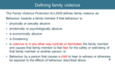  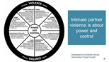
- On average how often are women killed in the context of family violence?  - One woman every 9 days  - One woman every fourteen days  - One woman per month | AIHW report that 1 woman was killed every 9 days and 1 man every 29 days by a partner between 2014–15 and 2015–16. This demonstrates that it is a prevalent issue and is why it is important to address family violence through increasing awareness and understanding as primary intervention.  https://www.aihw.gov.au/reports-data/behaviours-risk-factors/domestic-violence/overview | 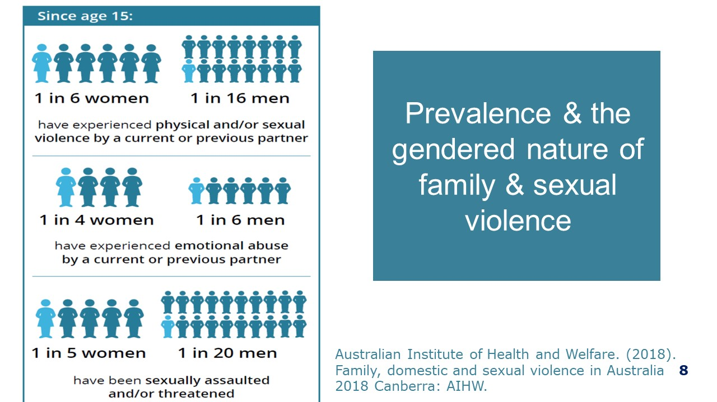
- How many boys under age 15 have experienced sexual assault?  - 1:20  - 1:10  - 1:6  - 1:3 | According to the most recent 2016 Australian Bureau of Statistics Personal Safety Survey (ABS, 2017), 11% of women and 5% of men in Australia report having been sexually abused before the age of 15 years.
- Statistically, how many of your female staff are likely to have experienced violence from a current or former partner?  - 1:4  - 1:10  - 1:20  - 1:30 | Based on the ANROWS additional analysis of the 2016 ABS Personal Safety Survey (ABS, 2017)
- Which of the following statements is true?  - A woman is most at risk at being a victim of violence when walking alone late at night  - Men are most likely to be the victim of violence that is perpetrated by a male stranger  - Men are most at risk of being the victim of violence when fighting with their partner within the home | The majority of men reported that their most recent incident of physical assault by another man was perpetrated by a stranger. The location was most often a place of entertainment (28%) or an outside location (28%). If you examine all types of violence, men experience more incidents than women by any type of perpetrator, but women experience more violence from a partner. Most of the violence against men is perpetrated by other men (ABS, 2017). | 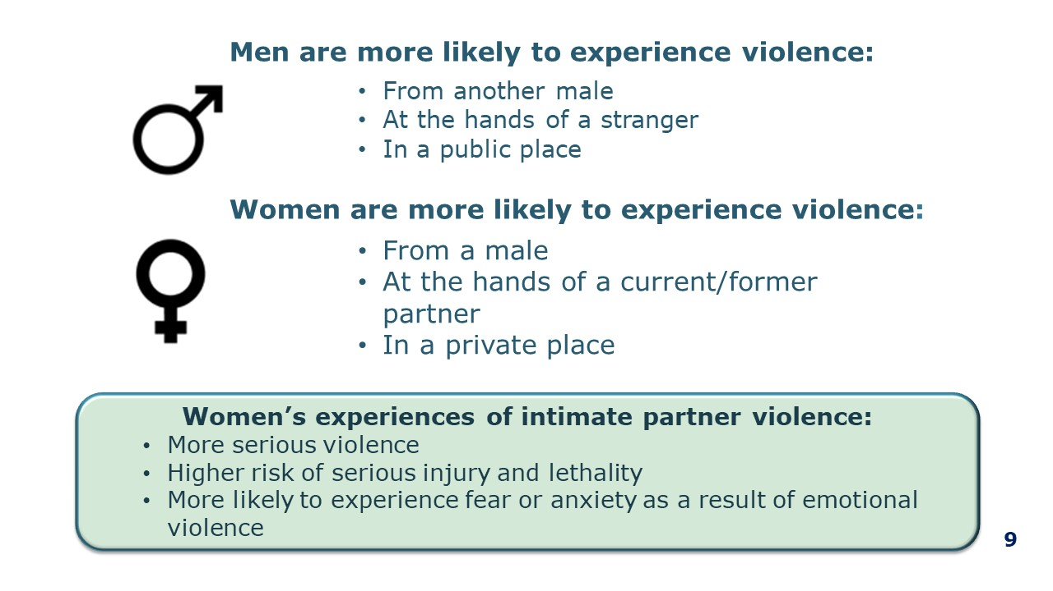
- What percentage of people seeking support from specialist homeless services are escaping family violence?  - 1:3  - 2:5  - 1:10 | Disadvantage, marginalisation and discrimination also intersect with gender, creating additional barriers for some women and children who experience family violence. This contributes to high rates of family violence for women from particular communities. Overall, 40% of clients (or 114,757) seeking Specialist Homelessness Services were experiencing domestic and family violence. This is an increase from 38% in 2015–16. (AIHW, 2019)  In 2016–17, SHS agencies assisted 115,000 family and domestic violence clients. Of these clients  - More than 9 in 10 (94%, or 108,000) were women and children  - 3 in 10 (30%, or 34,000) were children aged 14 and under  - 6 in 10 (62%, or 72,000) were females aged 15 and over- fewer than 1 in 10 (8%, or 9,000) were males aged 15 and over  (AIHW 2018 Report).  Domestic and family violence is one of the main reasons women and children become homeless in Australia. A recent report by Mission Australia can be accessed for more details. https://www.missionaustralia.com.au/news-blog/news-media/domestic-and-family-violence-and-affordable-home-shortage-pushes-thousands-into-homelessness | 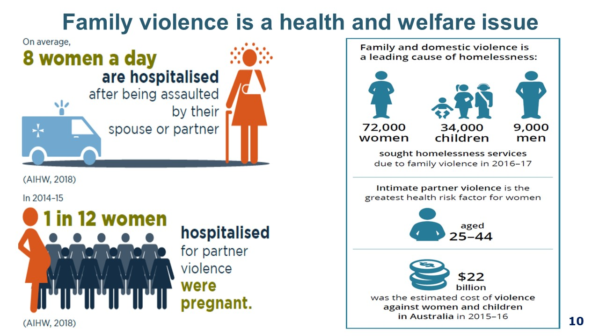
- How many LGBTI Australians report having been in a relationship where their partner was abusive?  - 1:3  - 1:5  - 1:10 | Similar instances to general population numbers.  There are additional unique forms of family violence in LGBTIQ communities. It is also important to understand the context of historical and contemporary discrimination and the limited effectiveness of applying a heterosexual, gendered lens to family and intimate partner violence among LGBTIQ people: for example, response models and interventions based on binary notions of victim/perpetrator.  A recent literature review by Our Watch has found:  - Rates of intimate partner violence within lesbian, gay and queer relationships are as high as the rates experienced by cisgender women in intimate heterosexual relationships.  - Lesbians are more likely than gay men to report having been in an abusive relationship.  - Rates of intimate partner violence may be higher for bisexual, transgender and gender diverse people.  - It is unknown how rates of intimate partner and/or family violence against people with intersex people compare as there is a research gap.  Violence from other family members may also be higher, particularly against transgender and gender-diverse young people. Some examples are:  - Young people who come out about their sexuality or gender being kicked out of the family home.  - Elderly, dependant transgender women being denied access to hormone treatment by their children. | 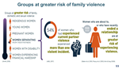
- Women and girls with disabilities are twice as likely to experience violence throughout their lives compared with women and girls without disabilities:  - False  - True | People with a disability or a long-term health condition were around twice as likely to have experienced violence from a current or previous cohabiting partner in the year before the 2016  PSS. For women, 2.5% (72,300 women) of those with a disability or long-term health condition had experienced partner violence compared with 1.3% (83,700 women) without a disability or long-term health condition. AIHW 2018 Report. 2016 ABS Personal Safety Survey  NOTE: It is important to emphasis here how disadvantage, marginalisation and discrimination also intersect/overlap with gender and structural inequalities in our society such as sexism, ableism, racism, homophobia, transphobia, ageism, and mental health discrimination can lead to services being inaccessible to particular groups. This creates systemic barriers for these groups to find appropriate and adequate support and responses that increase their safety. How barriers manifest for an individual will differ and will depend on their lived experience. Barriers may result from past experiences of inadequate system responses, experiences of services that haven’t been accessible or responsive to their needs, shame, fear of not being believed, language barriers, visa status, experiences of discrimination, historic and ongoing systemic oppression, fear of reprisals or being ostracised, and concerns about their safety.
- A woman is most at risk of being killed by her partner:  - When she fights back  - When she attempts to leave the relationship  - When her partner has a mental health condition  - When her partner has been using drugs or alcohol | Evidence/research indicates that a woman is most at risk when attempting to Women who are about to, or who have recently ended a relationship are at greater risk of experiencing violence. Australian Institute of Health and Welfare. (2018). MARAM Practice Guide (Family Safety Victoria, 2019), also identify Planning to leave or recent separation as an evidence-based risk factor for family violence. Evidence/research indicates that a woman is most at risk when attempting to leave the relationship, with 3-6 months post-separation as the most dangerous time. It is thought to be the case due to the perpetrator realising they no longer have the power or control in that relationship and this can then escalate the violence.  Facilitators could also explore reinforcing factors of mental health conditions and use of drugs and alcohol not as causes but they impact risk of family violence, use the opportunity to explore the misconceptions around these being the main drivers of family violence if time permits. There is no significant evidence to indicate that fighting back increase risk. Victim survivors often report that it does not matter what she does, he still is abusive
- What are the rates of hospitalisation for family violence assaults for Aboriginal and Torres Strait Islander women in comparison to non-Aboriginal women?  - 10 times  - 26 times  - 32 times | Disadvantage, marginalisation and discrimination also intersect with gender, creating additional barriers for some women and children who experience family violence. This contributes to the high rates of family violence for Aboriginal women and children.  Indigenous women were 32 times as likely to be hospitalised due to family violence as non-Indigenous women. Family violence occurs at higher rates in Aboriginal and Torres Strait Islander communities than in the general population; it must be understood as both a cause and an effect of social disadvantage and intergenerational trauma. Indigenous family violence is likely to be under-reported.  NOTE: It is important to reiterate that these rates do not mean Indigenous men are more violent than non-indigenous men and this is why the rates are higher. It is important to emphasis here how disadvantage, marginalisation and discrimination also intersect/overlap with gender and structural inequalities in our society such as sexism, ableism, racism, homophobia, transphobia, ageism, and mental health discrimination can lead to services being inaccessible to particular groups.  This creates systemic barriers for these groups to find appropriate and adequate support and responses that increase their safety. How barriers manifest for an individual will differ and will depend on their lived experience. Barriers may result from past experiences of inadequate system responses, experiences of services that haven’t been accessible or responsive to their needs, shame, fear of not being believed, language barriers, visa status, experiences of discrimination, historic and ongoing systemic oppression, fear of reprisals or being ostracised, and concerns about their safety. | 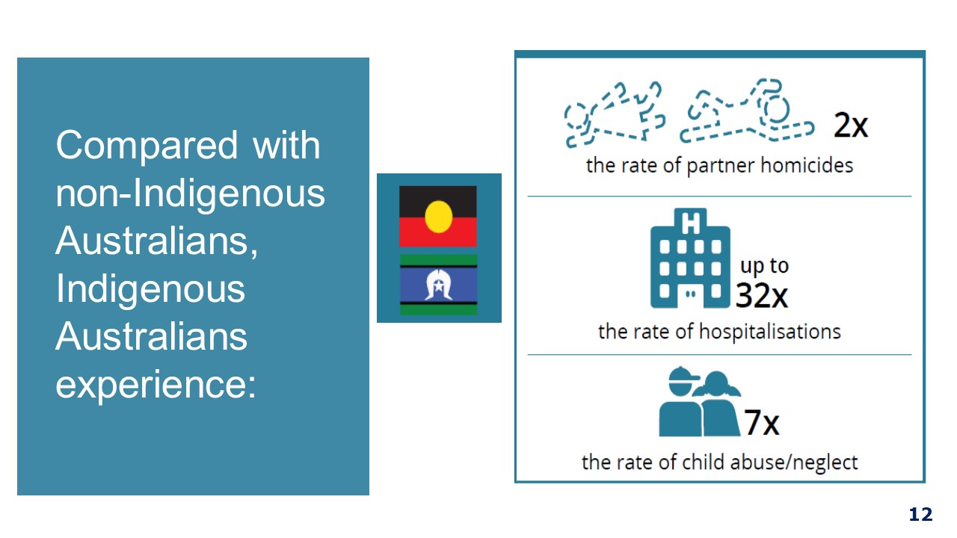
- Which of the following statements are true?  - Physical, financial, neglect, sexual, psychological and social area all forms of elder abuse  - Elder abuse is under reported  - Regardless of abuse most older people want to maintain family relationships  - One of the biggest fears of disclosing elder abuse is being shifted into care  - All of the above | Elder abuse is any form of violence or mistreatment that causes harm to an older person, and occurs within a relationship of trust. Elder abuse can include acts of psychological, financial, physical, social and sexual abuse, as well as neglect. Some older people may describe this type of behaviour as disrespect or mistreatment, rather than abuse or violence. Elder abuse can happen in many contexts, including the home and residential aged care. ‘Elder Abuse as Family Violence Discussion Paper- Senior Rights Victoria 2018. Elder abuse can be under recognised and under reported due to people not necessarily identifying it as violence or fear for the victim of being shifted into care if they speak up.

Quiz: What do I already know about family violence: Handout

Quiz: What do I already know about family violence
- Which of the following are examples of family violence?
- Hitting, slapping or kicking
- Threatening to upload intimate personal photos to the internet if the partner ever leaves the relationship
- Taking the rent money and spending it without telling the other partner
- Children assisting to clean up after a violent episode
- Failing to provide adequate meals for a dependant elderly family member
- All of the above
- On average how often are women killed in the context of family violence?
- One woman per week
- One woman a fortnight
- One woman per month

- How many boys under age 15 have experienced sexual assault?
- 1:20
- 1:10
- 1:6
- 1:3

- Statistically, how many of your female staff are likely to have experienced violence from a current or former partner?
- 1:4
- 1:10
- 1:20
- 1:30
- Which of the following statements is true?
- A woman is most at risk at being a victim of violence when walking alone late at night
- Men are most likely to be the victim of violence that is perpetrated by a male stranger
- Men are most at risk of being the victim of violence when fighting with their partner within the home
- What percentage of people seeking support from specialist homeless services are escaping family violence?
- 1:3
- 1:5
- 1:10
- How many LGBTI Australians report having been in a relationship where their partner was abusive?
- 1:3
- 1:5
- 1:10
- Women and girls with disabilities are twice as likely to experience violence throughout their lives compared with women and girls without disabilities:
- False
- True

- A woman is most at risk of being killed by her partner:
- When she fights back
- When she attempts to leave the relationship
- When her partner has a mental health condition
- When her partner has been using drugs or alcohol
- What are the rates of hospitalisation for family violence assaults for Aboriginal and Torres Strait Islander women in comparison to non-Aboriginal women?
- 10 times
- 26 times
- 32 times
- Which of the following statements are true?
- Physical, financial, neglect, sexual, psychological and social area all forms of elder abuse
- Elder abuse is under reported
- Regardless of abuse most older people want to maintain family relationships
- One of the biggest fears of disclosing elder abuse is being shifted into care
- All of the above

